We Can! Book 6: REVISION

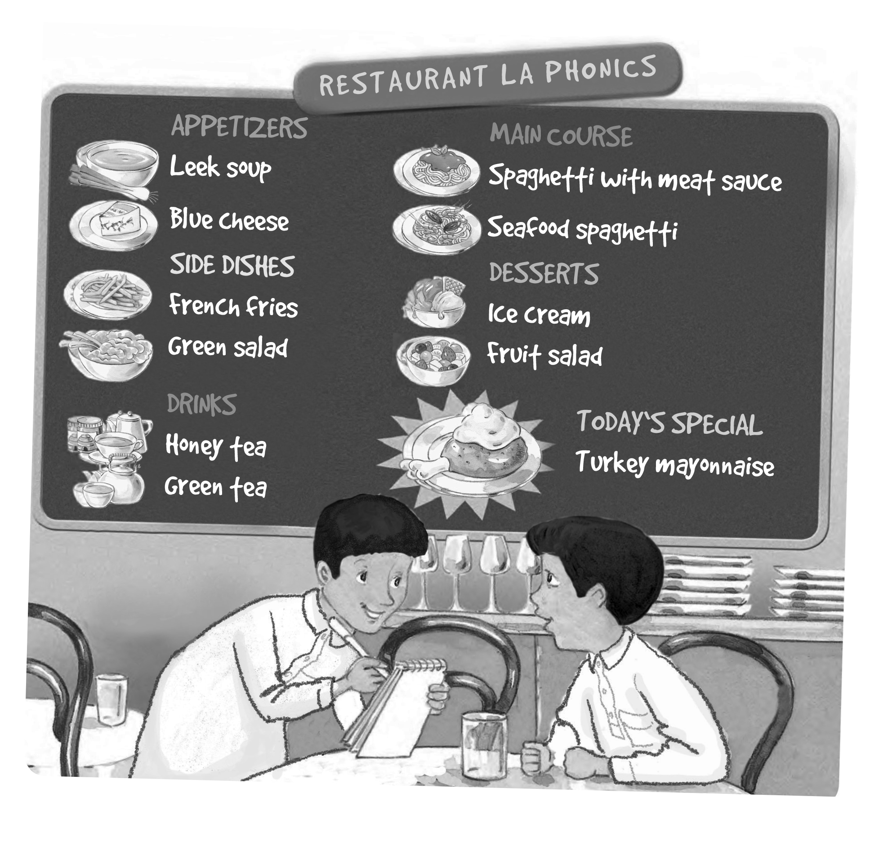
1. Listen and fill in the missing words.

A: What _________ you like?
B: I’d like a _________ and _________please.
A: Sure. Just a _________,

Write your own dialog.

A: What _________ you _________?
B: I’d like a ___________ and ___________ please.
_________.
A: Just a _________,
2. Read and match words and phrases. Write.

I cleaned ___________ yesterday. | football.
Rana cooked __________ last night. | for the test.
Ted stayed ________last Saturday. | the ball.
My brother played ___________ over the weekend | dinner
We practiced ___________ over the weekend. | our English.
They watched ________ last night. | at home
You studied ___________last week. | a DVD.
He kicked __________ and scored a goal. | my room

3. Answer the questions about your school.

1. What’s the name of your school?
_________________________________________
2. How many students are there in your class?
_________________________________________
3. Do you have school lunch at your school?
_________________________________________
4. Does your school have school buses?
_________________________________________
5. Do you have school uniforms?
_________________________________________
6. What time does school start in the morning?
_________________________________________
7. How do you get to school?
_________________________________________
8. Which grade are you in this year?
_________________________________________
9. Which grade were you in, last year?
_________________________________________
10. Which grade are you going to be in next year?

_________________________________________
4. Fill in the blanks with should or shouldn’t.

A: I have a headache!
B: You ________ spend so many hours in front of the computer.

A: I have a toothache!
B: You ________ brush your teeth every day.

A: I have a bad stomachache.
B: You ________ eat so much junk food.

A: I feel sick in the morning.
B: You ________ always eat breakfast before you leave.

5. Check and write about your friend.

 | always | usually | sometimes | never
get up early | √
brush my teeth
eat breakfast
take a shower
eat junk food
stay up late

Example: He/ She always gets up early.
1. _______________________________________

2. _______________________________________

3. _______________________________________

4. _______________________________________

5. _______________________________________

