**BIOLAB REVISION**

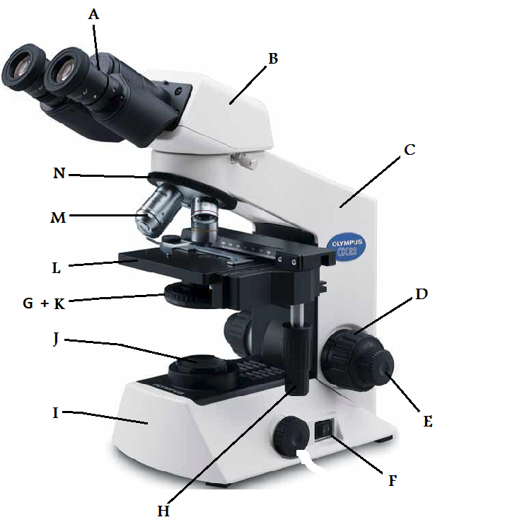

1. **Ocular Lens**
2. **Body Tube**
3. **Arm**
4. **Coarse adjustment knob**
5. **Fine adjustment knob**
6. **Power switch**
7. **Condenser**
8. **Stage adjustment knob**
9. **Base**
10. **Light source**
11. **Iris diaphragm**
12. **Stage**
13. **Objective lens**
14. **Rotating (Revolving) nosepiece**

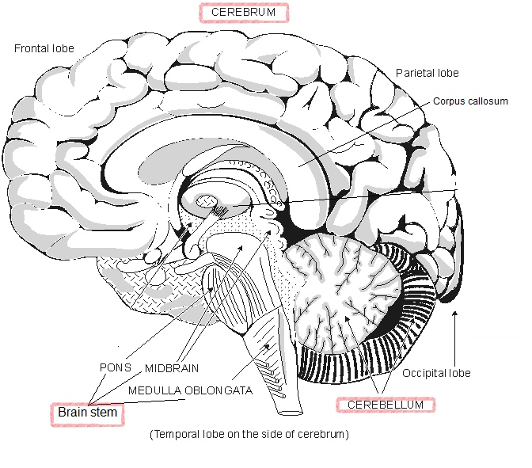

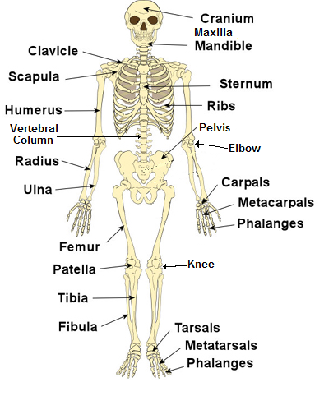

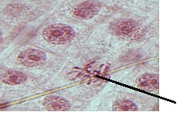 **Prophase**

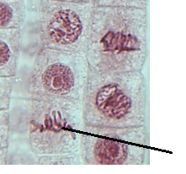 **Metaphase**

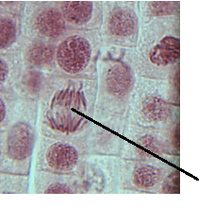 **Anaphase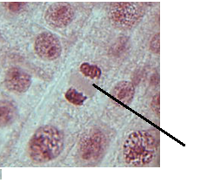 Telophase**

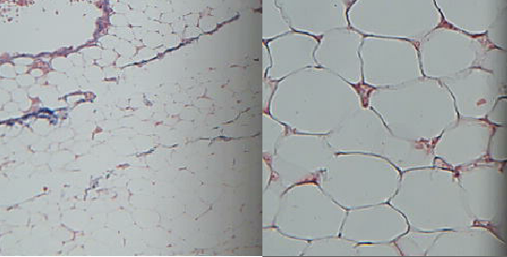 **Adipose connective tissue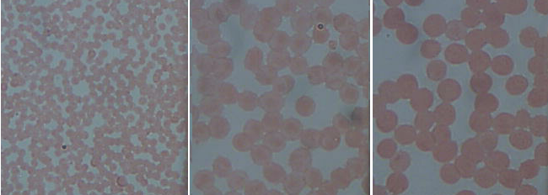 Blood connective tissue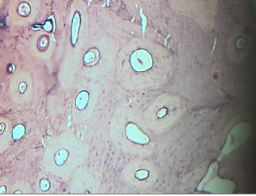 Bone connective tissue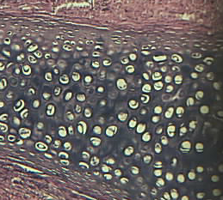 cartilage connective tissue**

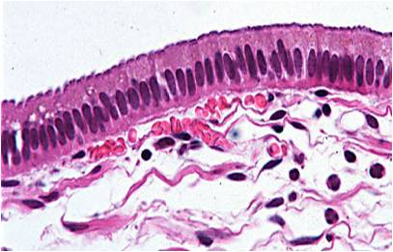 **Simple columnar epithelium tissue**

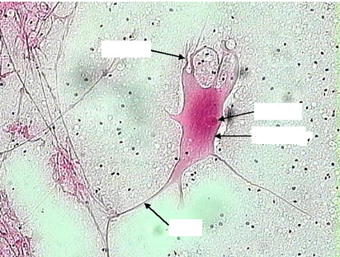 **Nerve cell (neuron)**

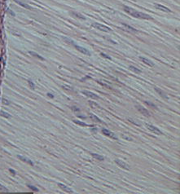 **Smooth Muscle**

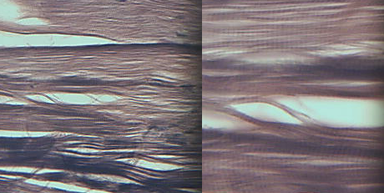**Skeletal Muscle**

**\***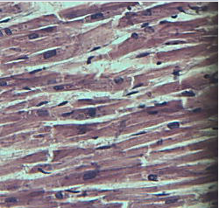**Cardiac Muscle**

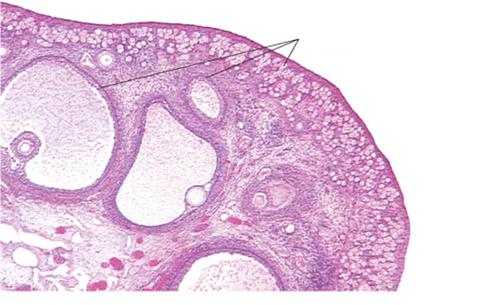

**Ovary**

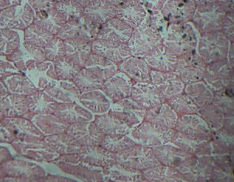  **Testis**

