We Can! Book 2 Unit 1: Toys and Things

1. Listen and number.

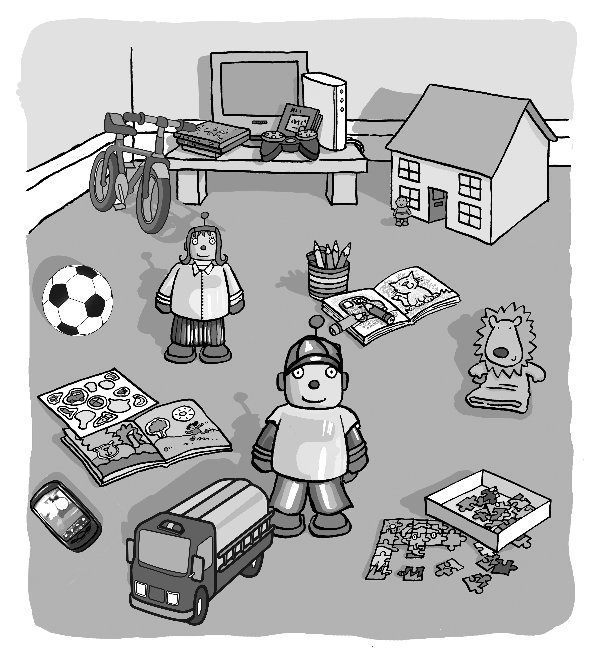
[Play CD1 07 or read the script.]
[Answers: Please see We Can! 2, Student’s Book, page 6 for numbering]

2. How many do you have? Count and write.
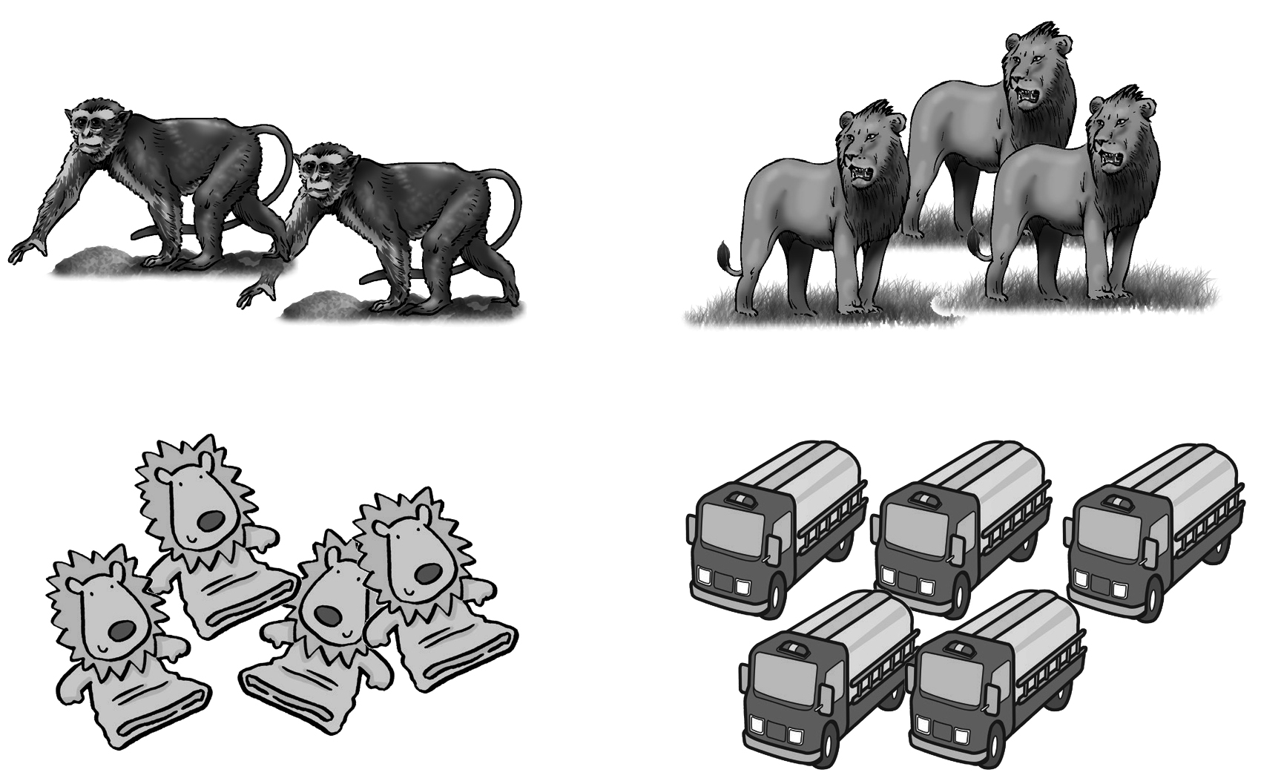
1 one 2 two 3 three 4 four 5 five

1. I have __two__ monkeys.
2. I have ___three___ lions.
3. I have ____four___ puppets.
4. I have ____five___ trucks.
3. Draw and write.

I have __________________
4. Listen and number. Then write.

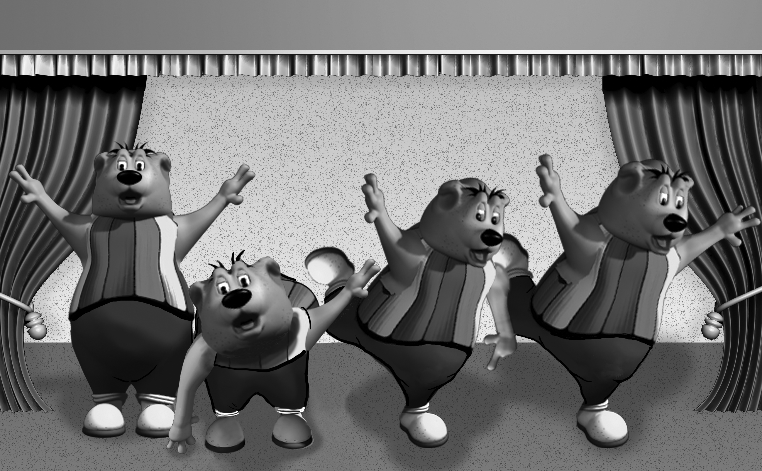

1. Robot bear, robot bear,
__turn around ________.
2. Robot bear, robot bear,
__touch the ground ____.
3. Robot bear, robot bear,
__show your shoe ______.
4. Robot bear, robot bear,
__you’re out, too ______.

touch the ground 2 | turn around 1
show your shoe 3 | you’re out, too 4

[Play CD1 04 or read the script.]

