English Language Final Exam
Term: 1 – 1444 Session: 1
Time: 2:30 hrs
Grade: 2 - Mega Goal 2.1

Kingdom of Saudi Arabia
Ministry of Education
__________ Gen. Dept. of Education
__________ Secondary School

Graded by: | ________________________________________  ________________________________________ |  | Mark out of  30
Revised by:

اختبار مادة (اللغة الإنجليزية 2.1- الفصل الدراسي الأول - الدور الأول) للصف الثاني ثانوي - للعام الدراسي 1444هـ - نظام المسارات
اسـم الطالب : ___________________________________________________________ رقم الجلوس : ________ اللجنة : ________

اللَّهمَّ لا سَهلَ إلَّا ما جَعَلتَه سَهلًا، وأنتَ تَجعَلُ الحَزْنَ إذا شِئتَ سَهلً
- Reading Comprehension (1 mark each)
6

Read the following text, and then answer the questions below:

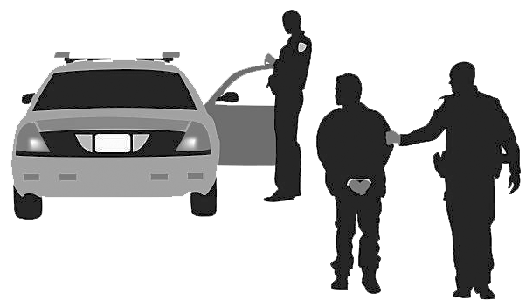
A man had driven to the local grocery store, parked his car, and gone into the store to do some shopping. When he came out of the store, carrying his bags, he saw that his car was missing from the parking lot. He called the police and reported that his car had been stolen. He told the police that he had left his cell phone in the car. The police thought hard about how to use the cell phone to find the stolen car. Finally, one of the police officers had a brilliant idea.
A police officer called the man’s cell phone, and the thief answered the phone. The officer explained that he had seen an advertisement in the newspaper about the car for sale and that he was interested in buying the car. The officer asked a few information questions about the car and arranged a meeting for him to take a look at the car later that day.
A few hours later, the thief drove the car to the meeting place, expecting to be paid for the car that he had just stolen. He was arrested on the spot and the car was returned to its owner. What a silly criminal!

- Where did the man park his car? ______________________________________
- Who called the thief? ______________________________________

- Choose the correct answer

- The underlined pronoun " he" refers to the _________.
a) car's owner b) thief c) police officer d) reporter

- Put ( T ) for true or ( F ) for false sentences :

- The car was missing from the owner's house. [______]
- A day later, the thief went to the arranged meeting place. [______]
- Calling the thief was an officer's idea. [______]
Page: 1 out of 4
P.T.O
- Vocabulary (½ mark each)
6

- Fill the blanks with the correct words

cozy - hijack(ed) - version - loner - remote

- Faisal is a/an ___________________. He likes to spend time by himself.
- A man stole jewelry then ___________________ a car.
- Luckily, the hotel provides ___________________ sleeping bags for the guests.
- I like the software ___________________ of my cell phone.

- Match each phrase/expression with its meaning

Phrase / Expression |  | Meaning
- get a kick out of |  | - disappointment
- drag |  | - overnight
- easy mark |  | - wait
- hold on |  | - enjoy
 |  | - likely victim

- Write the correct word and its picture
igloo - contestant - networking - asthma - inmate

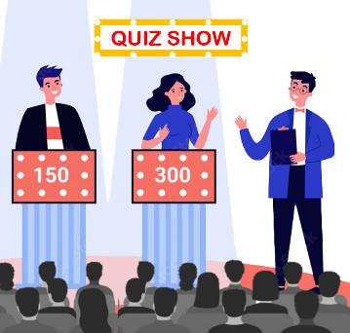
 | 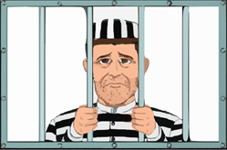
____________ | ____________ | ____________ | ____________
Page: 2 out of 4
P.T.O
- Grammar (½ mark each)
6

- Circle the correct answers

1) | He _____________ use his phone every day.
a- | don't | b- | doesn't | c- | hasn't | d- | haven't
2) | The Tv needs to be _____________
a- | fix | b- | fixes | c- | fixed | d- | fixing
3) | The robber _____________ by the police two days ago.
a- | arrest | b- | arrested | c- | was arrested | d- | is arrested
4) | We _____________ when the robbery took place.
a- | were play | b- | were playing | c- | was playing | d- | are playing
5) | The food _____________ for me.
a- | was tasty too | b- | was too tasty | c- | too was tasty | d- | too tasty was
6) | She _____________ new shoes.
a- | going to buy | b- | are going to buy | c- | are going buying | d- | is going to buy
7) | Sara: _____________ are you doing tonight? Nora: I'm studying for final exams.
a- | What | b- | Where | c- | Who | d- | Why
8) | He passed _____________.
a- | me the salad | b- | the salad me | c- | for me the salad | d- | to me the salad

- Unscramble the Comparative Sentence
- the tallest / Jamal / in his class / student / is
________________________________________________________________

- Make it Negative
- We used to go to the gym in the past.
We _____________________________ to the gym in the past.

- Complete with a correct Relative Pronoun
- The popcorn ______________________ I ate made me thirsty.

- Circle the Indirect Object
- Jinan translated a text for Amal.

Page: 3 out of 4
P.T.O
- Composition
- GUIDED COMPOSITION (6 Marks)
6
- Of no less than (70) words, write about your Favorite Tv Show.
- Your writing should answer the followings

- What is your favorite Tv show?
- What kind of Tv show is it?
- Why do you like it?
- What channel does the TV show air on?
- Give a brief description about it.

_____________________________________________________________________
_____________________________________________________________________
_____________________________________________________________________
_____________________________________________________________________
_____________________________________________________________________
_____________________________________________________________________
_____________________________________________________________________
_____________________________________________________________________
_____________________________________________________________________

- FREE COMPOSITION (6 Marks)
6
- Choose ONE topic and write a paragraph about it of no less than (50) words.

- Unusual Hotel you lived in, heard or read
- Describe Your Personality

_____________________________________________________________________
_____________________________________________________________________
_____________________________________________________________________
_____________________________________________________________________
_____________________________________________________________________
_____________________________________________________________________
_____________________________________________________________________
_____________________________________________________________________
Finished & Good Luck
Regards - ___________________

Page: 4 out of 4
Done by: Essa Al Hussaini

