

Worksheet – we can3

3rd grade Unit 5 Yesterday and Today

Name ………………………………… Class ………………………………

__________________________________________________________________________________________

General Questions

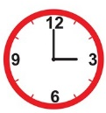
1 – What time is it ?
A . It is six o'clock. B . It is three o'clock.
2 –What is the time? 10:30
A . It is ten o'clock. B. It is ten thirty.


____________________________________________________________________________________________________

Reading short sentences

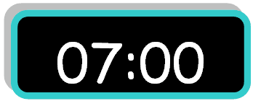
1. It is seven o'clock.

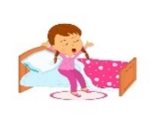
2. I eat my lunch.


___________________________________________________________________________________________

Controlled writing
______________________ |  |  | 1– brush - I – teeth – my. ( rearrange )
two | four | five |   2. It is ____o'clock. ( complete )


Grammar
got | get | go | 1 – I usually ____ up at 5:00 .
go | came | come | 2-ysterday, I ____ home at 1:00 .

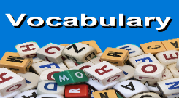
_____________________________________________________________________________________________________

Vocabulary
clock – get up – brush – take a bath

 |  | 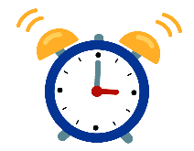 | 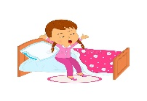
---------- | ---------- | --------- | ---------


_____________________________________________________________________________________________________
Orthography (spelling)
Choose the correct letter: ( nk - ng - ck - )

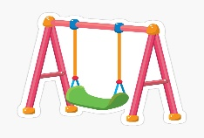 |  | 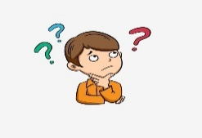 |  | 
swi_ _ | i_ _ | thi_ _ | ri_ _ | dri_ _

Controlled writing

4

Good luck T.

