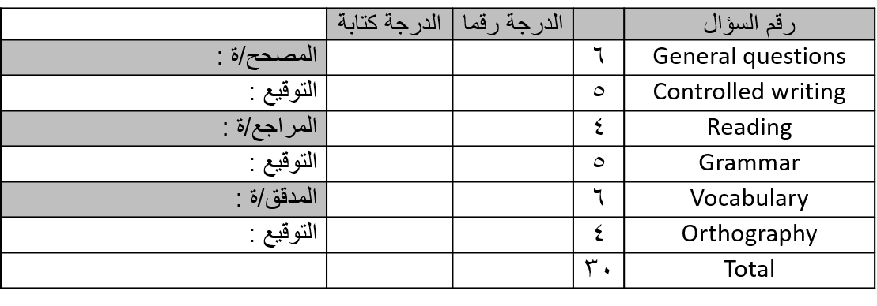
معلم/ ـة المادة: -

............................................
تعليمات عامة: -
- يسمح بالقلم الأزرق فقط.
- لا يسمح بالقلم الأزرق الذي يُمسح.
- لا يسمح باستخدام المرسام.
التوقيع: ..............................
التوقيع: ..............................
التوقيع: ..............................
جمع: ...............................
مراجعة: ...........................
تدقيق: ..............................
الاختبار النهائي لمادة اللغة الإنجليزية الصف ................... الفصل الدراسي الثاني للعام الدراسي1444 هـ
اسم الطالب / ـة ................................................................... رقم الجلوس ...................................

General Questions
6
A)- Choose the correct answer: -

1- How many seasons in the year?
a)- 12 seasons b)- 4 seasons

2- Good morning
a)- nice to meet you too b)- good morning

3)- whose book is this?
a)- It's Ahmed's b)- No, I don't

Grammar
5
A)- Choose the correct answer: -

are | is | am | 1)- She …………. playing
are | is | am | 2)- I ……………. sitting
are | is | am | 3)- They …………. cycling
is | an | a | 4)- watch out! It's …………. car
or | but | and | 5)- I have a sandwich …………. a juice

Reading short sentences
4



1)- Elephant is big

2)- Lemons are sweet
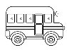

1)- It's a car
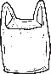
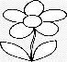
2)- Flowers are beautiful

B)- choose the correct answer: -

A)- Read the sentences the choose or :: -

Controlled writing
A)- Do as shown between brackets: -

5
 |  |  |  | 1)- is – He – playing (rearrange)
 | salty | hot | cold |  | 2)- Ice cream is
 | fall | spring | Winter |  | 3)- flower are out! it's
 | stop | wait | go |  | 4)- When you see a red light

Vocabulary
Cat – stars – bus – winter – strong – tiger
A)- Write the correct words under each picture: -

6

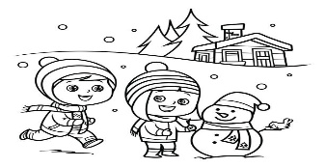 | 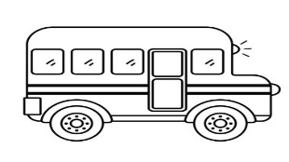 | 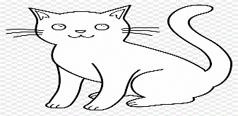
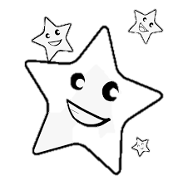 | 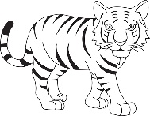 | 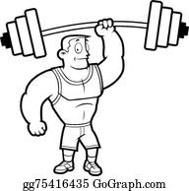

B)- Choose the correct answer: -

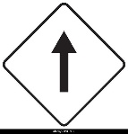  stop  Go straight | 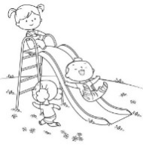  playing  walking | Bus  Car
  cold  hot | 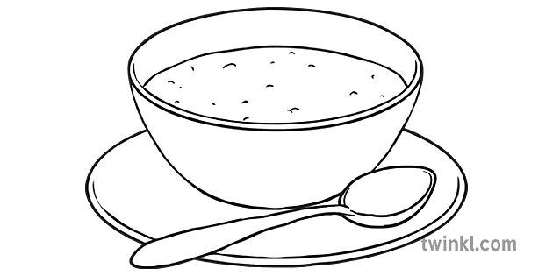  apple  soup | 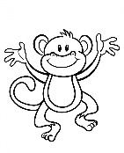  monkey  snake

Orthography
sh – oo – fl – gl – cr – sh – cl – ch – sl
A)- Fill in the missing letter: -

4
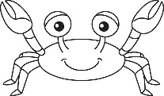 |  | 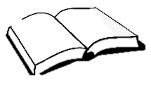 | 
……ab | ……ass | b….k | …….ag
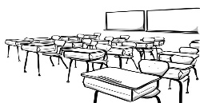 | 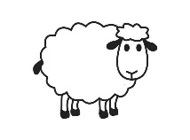 | 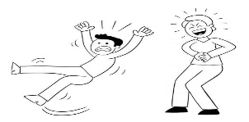 | 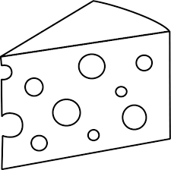
…..ass | ….. eep | …..ip | ……eese


Best of luck
معلم/ ـة المادة: -

............................................
تعليمات عامة: -
- يسمح بالقلم الأزرق فقط.
- لا يسمح بالقلم الأزرق الذي يُمسح.
- لا يسمح باستخدام المرسام.
التوقيع: ..............................
التوقيع: ..............................
التوقيع: ..............................
جمع: ...............................
مراجعة: ...........................
تدقيق: ..............................
الاختبار النهائي لمادة اللغة الإنجليزية الصف ................... الفصل الدراسي الثاني للعام الدراسي1444 هـ
اسم الطالب / ـة ................................................................... رقم الجلوس ...................................

General Questions
6
A)- Choose the correct answer: -

1- How many seasons in the year?
a)- 12 seasons b)- 4 seasons

2- Good morning
a)- nice to meet you too b)- good morning

3)- whose book is this?
a)- It's Ahmed's b)- No, I don't

Grammar
5
A)- Choose the correct answer: -

are | is | am | 1)- She …………. playing
are | is | am | 2)- I ……………. sitting
are | is | am | 3)- They …………. cycling
is | an | a | 4)- watch out! It's …………. car
or | but | and | 5)- I have a sandwich …………. a juice

Reading short sentences
4
1)- Elephant is big
2)- Lemons are sweet
1)- It's a car
2)- Flowers are beautiful

B)- choose the correct answer: -

A)- Read the sentences the choose or :: -

Controlled writing
A)- Do as shown between brackets: -

5
 |  |  |  | 1)- is – He – playing (rearrange)
 | salty | hot | cold |  | 2)- Ice cream is
 | fall | spring | Winter |  | 3)- flower are out! it's
 | stop | wait | go |  | 4)- When you see a red light
He is playing
Vocabulary
Cat – stars – bus – winter – strong – tiger
A)- Write the correct words under each picture: -

6

Cat
Bus
Winter
stars | tiger | strong

B)- Choose the correct answer: -

stop  Go straight | playing  walking | Bus  Car
cold  hot | apple  soup | monkey  snake

Orthography
sh – oo – fl – gl – cr – sh – cl – ch – sl
A)- Fill in the missing letter: -

4
 |  | oo
……ab | ……ass | b….k  cr  gl  Fl | …….ag
…..ass  cl | ….. eep | …..ip | ……eese  ch  sl  sh

https://t.me/madty4/4726
Best of luck

المملكة العربية السعودية  وزارة التعليم  الإدارة العامة للتعليم بـن  مدرسة م ن الابتدائية |   بسم الله الرحمن الرحيم    اختبار الفصل الدراسي الثاني  للعام الدراسي 1444 هـ | المادة | لغة انجليزية
 |  | الصف
 |  | الزمن | ساعة ونصف
 |  | الفصل | -----
اسم الطالب رباعيا: ............................................................................................................رقم الجلوس:....................
السؤال | 1 | 2 | 3 | 4 | 5 | 6 | المجموع
الدرجة
الدرجة | 6 | 5 | 4 | 5 | 6 | 4 | 30
المصحح


I- General Questions:
https://t.me/abokhaledamer

6
Q1: A- Choose the correct answer:
1. Look. It’s a flower.
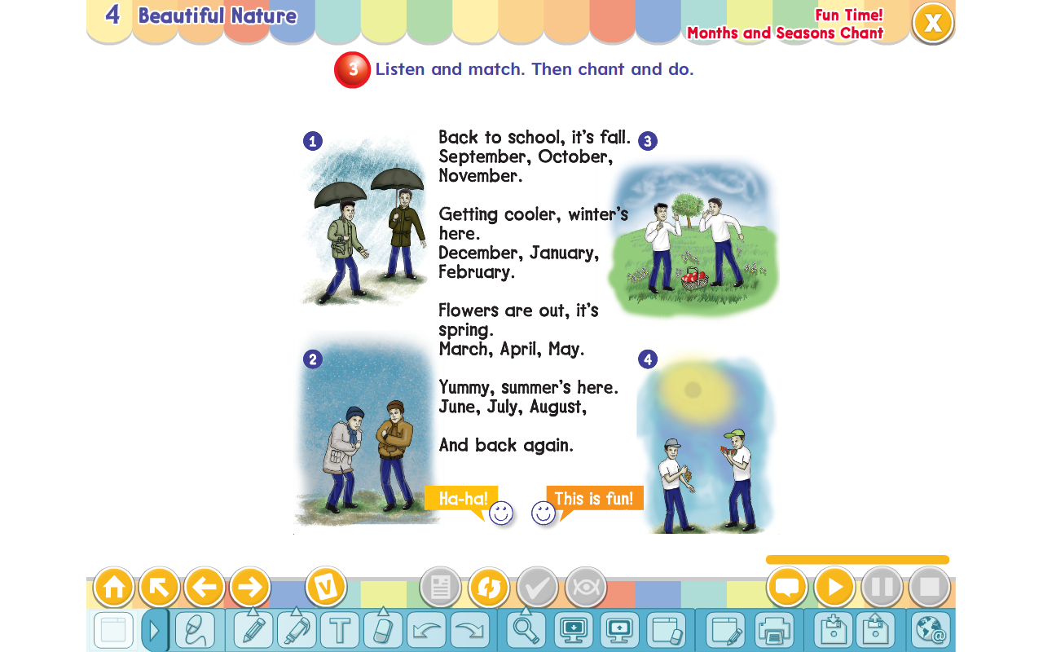
( It’s ugly. – It’s beautiful. – It’s bad. )

2. What’s the weather like in winter?
( It’s cold. – It’s sunny. – It’s hot. )

3. Where is Ali?
( He’s at school. - He’s tall. – He’s eating. )
B- Match the questions in column (A) with the correct answers in column (B):
B | A
( ) by the tail.  ( ) Walk straight then turn left.  ( ) It’s over there. | 1. Where’s the lion? 2. I will catch a tiger 3. Where is the train station?

5
II- Controlled Writing:
Q2: Do as shown between brackets:
1. go – How – you – to – do – school? (Rearrange)> ________________.
2. have – Elephants – trunks – big (Rearrange)> _______________.
3. Is he playing football? (Answer)> _______________________.
4.January, _____________, March. (Complete)>
5. When you see red light, _____________. (Complete)
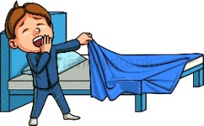
III- Reading Short Sentence:

4
Q3: Match the sentence with the pictures:

1. I love the mountains.


2. Let’s go to bed.

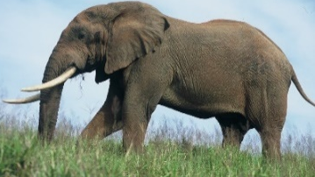
3. Look. It’s an elephant.

4. I go to the airport by taxi.
IV- Grammar:

5
Q4: Choose the correct answer:
1- Excuse me. (Why – When – Where) is the hospital?
2- Chimpanzees (am – is – are) smart.
3- That is (a – an – at) octopus.
4- I have breakfast (in – on – at) the morning.
5- The word “cats” is pronounced as ( Z – S – IZ )

6
V- Vocabulary:
Q5: Write the number under picture:
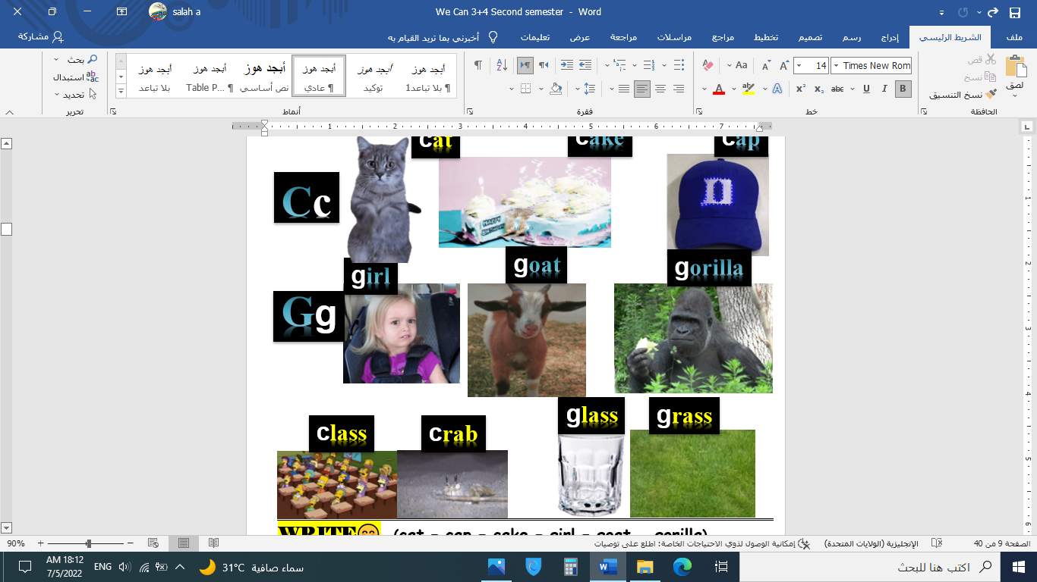
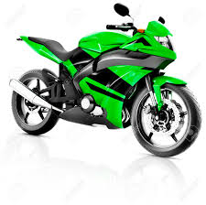
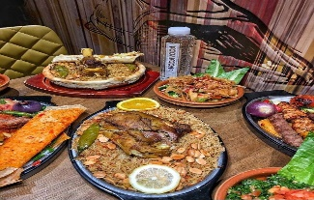
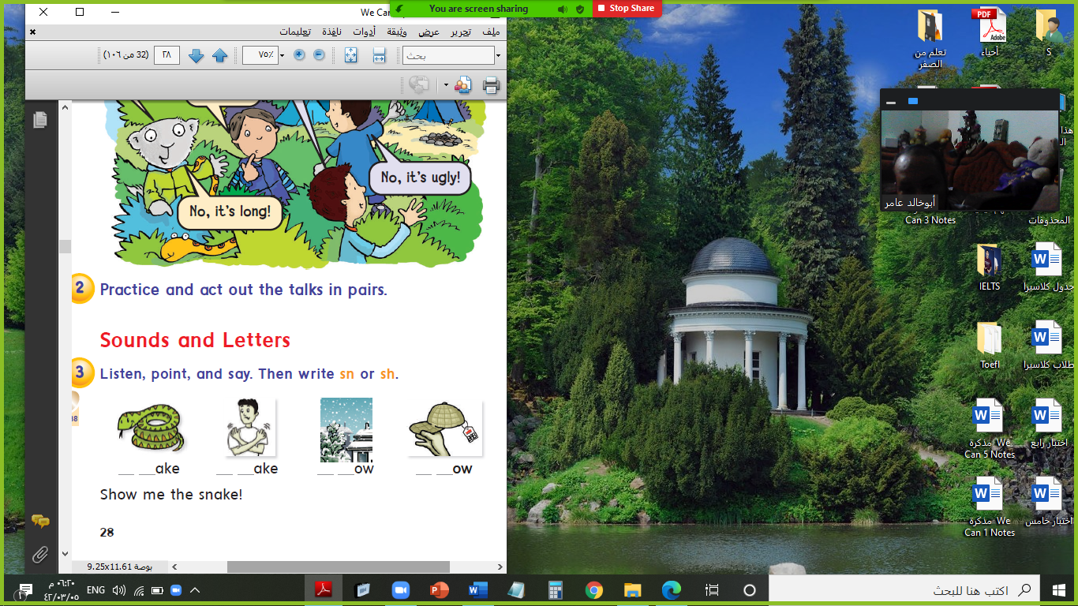

1.motorbike 2.lunch 3.snake 4.gorilla 5.night 6.class

( ) ( ) ( ) ( ) ( ) ( )
VI- Orthography:

4
Q6: Fill in the missing letters:
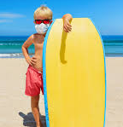
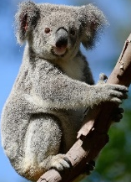


c / e / o / u / r / t / u / a
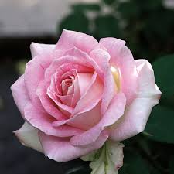
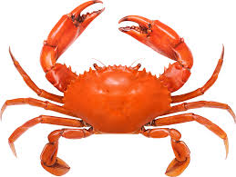

r__se b__s s__mmer ko__la s__rong m__at c__ab __ake
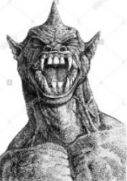
End of Questions
ABOKHALEDAMER
0557325813

المملكة العربية السعودية  وزارة التعليم  الإدارة العامة للتعليم بـن  مدرسة م ن الابتدائية | بسم الله الرحمن الرحيم  اختبار الفصل الدراسي الثاني  للعام الدراسي 1444 هـ | المادة | لغة انجليزية
 |  | الصف
 |  | الزمن | ساعة ونصف
 |  | الفصل | -----
اسم الطالب رباعيا: ............................................................................................................رقم الجلوس:....................
السؤال | 1 | 2 | 3 | 4 | 5 | 6 | المجموع
الدرجة
الدرجة | 6 | 5 | 4 | 5 | 6 | 4 | 30
المصحح

I- General Questions:
https://t.me/abokhaledamer

6
Q1: A- Choose the correct answer:
1. Look. It’s a flower.
( It’s ugly. – It’s beautiful. – It’s bad. )

2. What’s the weather like in winter?
( It’s cold. – It’s sunny. – It’s hot. )
3. Where is Ali?
( He’s at school. - He’s tall. – He’s eating. )
B- Match the questions in column (A) with the correct answers in column (B):
B | A
(2) by the tail.  (3) Walk straight then turn left.  (1) It’s over there. | 1. Where’s the lion? 2. I will catch a tiger 3. Where is the train station?

5
II- Controlled Writing:
Q2: Do as shown between brackets:
1. go– How– you– to– do– school? (Rearrange)> _How do you go to school?_.
2. have– Elephants– trunks– big (Rearrange)> _Elephants have big trunks._
3. Is he playing football? (Answer)> __Yes, he is._
4.January, _February_, March. (Complete)>
5. When you see red light, _Stop_. (Complete)
III- Reading Short Sentence:

4
Q3: Match the sentence with the pictures:
1. I love the mountains.

2. Let’s go to bed.

3. Look. It’s an elephant.

4. I go to the airport by taxi.
IV- Grammar:

5
Q4: Choose the correct answer:
1- Excuse me. (Why – When – Where) is the hospital?
2- Chimpanzees (am – is – are) smart.
3- That is (a – an – at) octopus.
4- I have breakfast (in – on – at) the morning.
5- The word “cats” is pronounced as ( Z – S – IZ )

6
V- Vocabulary:
Q5: Write the number under picture:
1.motorbike 2.lunch 3.snake 4.gorilla 5.night 6.class

( 3 ) ( 5 ) ( 4 ) ( 6 ) ( 1 ) ( 2 )
VI- Orthography:

4
Q6: Fill in the missing letters:
c / e / o / u / r / t / u / a

r_o_se b_u_s s_u_mmer ko_a_la s_t_rong m_e_at c_r_ab _c_ake
End of Questions
ABOKHALEDAMER
0557325813

المملكة العربية السعودية  وزارة التعليم  الإدارة العامة للتعليم بـن  مدرسة م ن الابتدائية |   بسم الله الرحمن الرحيم  اختبار الفصل الدراسي الثاني  للعام الدراسي 1444 هـ | المادة | لغة انجليزية
 |  | الصف
 |  | الزمن | ساعة ونصف
 |  | الفصل | -----
اسم الطالب رباعيا: ............................................................................................................رقم الجلوس:....................
السؤال | 1 | 2 | 3 | 4 | 5 | 6 | المجموع
الدرجة
الدرجة | 6 | 5 | 4 | 5 | 6 | 4 | 30
المصحح

I- General Questions:
https://t.me/abokhaledamer

6
Q1: A- Choose the correct answer:
1. Look. It’s a monster.
( It’s ugly. – It’s beautiful. – It’s bad. )

2. What’s the weather like in summer?
( It’s cold. – It’s sunny. – It’s hot. )

3. Where is Ali?
( He’s at home. - He’s tall. – He’s eating. )
B- Match the questions in column (A) with the correct answers in column (B):
B | A
( ) by the toes.  ( )Walk straight then turn right.  ( ) It’s over there. | 1. Where’s the snake? 2. I will catch a monkey 3. Where is the space station?

5
II- Controlled Writing:
Q2: Do as shown between brackets:
1. go – How – you – to – do – the park? (Rearrange)> _____________.
2. have – Hippos – mouths – big (Rearrange)> _______________.
3. Are they watching TV? (Answer)>_______________________.
4.January, February, ___________, April. (Complete)>
5. When you see yellow light, _____________. (Complete)

III- Reading Short Sentence:

4
Q3: Match the sentence with the pictures:
1. I love the daffodils.

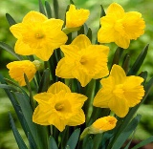
2. Let’s have lunch.

3. Look. It’s a monkey.

4. I go to the school by bus.
IV- Grammar:

5
Q4: Choose the correct answer:
1- Excuse me. Where (am – is – are) the airport?
2- Chimpanzees (have – has – is) long arms.
3- This is (a – an – at) elephant.
4- I have dinner (in – on – at) night.
5- The word “pens” is pronounced as ( Z – S – IZ )

6
V- Vocabulary:
Q5: Write the number under picture:
1.turn left 2.ambulance 3. flower 4.snow 5.breakfast 6.giraffe
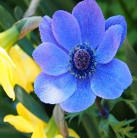
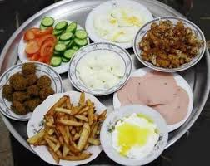
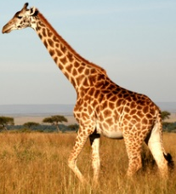
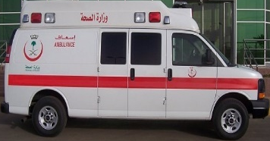


( ) ( ) ( ) ( ) ( ) ( )
VI- Orthography:

4
Q6: Fill in the missing letters:
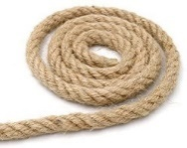
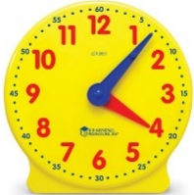


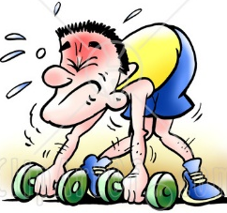
c / e / o / u / r / k / u / a / p

wea__ go__t so__r ro__e feathe__ bo__t s__eep clo__k
End of Questions
ABOKHALEDAMER
0557325813

المملكة العربية السعودية  وزارة التعليم  الإدارة العامة للتعليم بـن  مدرسة م ن الابتدائية |   بسم الله الرحمن الرحيم  اختبار الفصل الدراسي الثاني  للعام الدراسي 1444 هـ | المادة | لغة انجليزية
 |  | الصف
 |  | الزمن | ساعة ونصف
 |  | الفصل | -----
اسم الطالب رباعيا: ............................................................................................................رقم الجلوس:....................
السؤال | 1 | 2 | 3 | 4 | 5 | 6 | المجموع
الدرجة
الدرجة | 6 | 5 | 4 | 5 | 6 | 4 | 30
المصحح

I- General Questions:
https://t.me/abokhaledamer

6
Q1: A- Choose the correct answer:
1. Look. It’s a monster.
( It’s ugly. – It’s beautiful. – It’s bad. )

2. What’s the weather like in summer?
( It’s cold. – It’s sunny. – It’s hot. )
3. Where is Ali?
( He’s at home. - He’s tall. – He’s eating. )
B- Match the questions in column (A) with the correct answers in column (B):
B | A
(2) by the toes.  (3) Walk straight then turn right.  (1) It’s over there. | 1. Where’s the snake? 2. I will catch a monkey 3. Where is the space station?

5
II- Controlled Writing:
Q2: Do as shown between brackets:
1.go– How– you– to– do– the park?(Rearrange)>_How do you go to the park?_
2. have– Hippos– mouths– big (Rearrange)>_Hippos have big mouths_.
3. Are they watching TV? (Answer)>__Yes, they are._
4.January, February, _March_, April. (Complete)>
5. When you see yellow light, _Wait_. (Complete)
III- Reading Short Sentence:

4
Q3: Match the sentence with the pictures:
1. I love the daffodils.

2. Let’s have lunch.

3. Look. It’s a monkey.

4. I go to the school by bus.
IV- Grammar:

5
Q4: Choose the correct answer:
1- Excuse me. Where (am – is – are) the airport?
2- Chimpanzees (have – has – is) long arms.
3- This is (a – an – at) elephant.
4- I have dinner (in – on – at) night.
5- The word “pens” is pronounced as ( Z – S – IZ )

6
V- Vocabulary:
Q5: Write the number under picture:
1.turn left 2.ambulance 3. flower 4.snow 5.breakfast 6.giraffe

(3) (5) (6) (2) (4) (1)
VI- Orthography:

4
Q6: Fill in the missing letters:
c / e / o / u / r / k / u / a / p

wea_k_ go_a_t so_u_r ro_p_e feathe_r_ bo_o_t s_l_eep clo_c_k
End of Questions
ABOKHALEDAMER
0557325813


Q1. Answer :

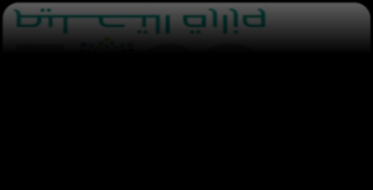
- Nice to meet you !
- How do you go to school ? 3- do you like lemon?
, ! I .
, I .

6


Q2. Do as shown between brackets:
1-August _ June _ July .
(arrange) > . .

5

2- how many balls ? (complete) >. I have .
3-How do you go to school? I go by the .


Q3. Match:

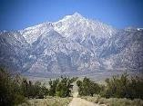
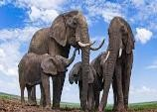
1-I love the mountains.

) (

) (
- My soup is hot. 3-Elephants are big. 4-Turn left.

) (

4

Q4. Choose the correct word :



  - He is ( playing – play ) football

5

) (
  - She has orange ( and– but) sandwich . 3- Hippos ( are – is ) fat.
4-I ( am – are ) at home
5-whose hat is that? It is (Noura – Noura's ).


Q5. Match:

6







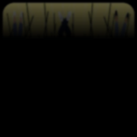

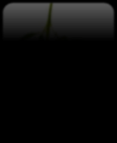

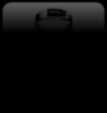


1-Winter 2- strong 3- sour 4- tiger 5- trunk 6-truck

 | 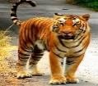 | 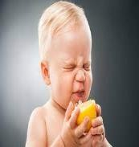 | 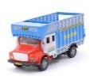 | 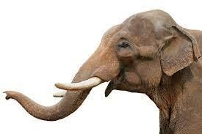 |  | 


Q6. Fill in the missing letters :

4

o_e / sh / ch / o / ea / cl / oo / gl

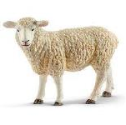 | 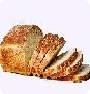 | 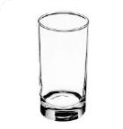 | 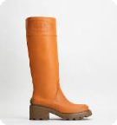 |  | 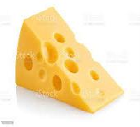 |  | 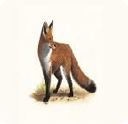
_ _eep | br_ _d | _ _ass | b_ _t | r_ s_ | _ _eese | _ _ass | f_ x

GOOD LUCK

Match the following :
6
- Where is Sara ? □ It’s ugly
- This is my friend Amal , □ She can't come.
- Do you like apples ? □ Nice to meet you
- Look it’s a plastic bag ! □ Yes, I do
Answer the following questions:
1-Do you have apples?.............................................
A-Choose the correct words to fill in the gap :-
5
1- It’s ………………..…… let’s watch TV ( evening , night , afternoon )
2- The opposite of long x……………… ( short , big , ugly)
3- It’s yellow and sour………..…… ( apple , ships , lemon )
B-Match the following:
Car | 
glass | 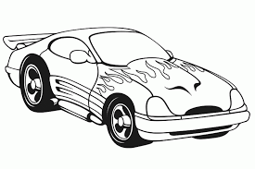

Read the sentences and put ()Or ( x )
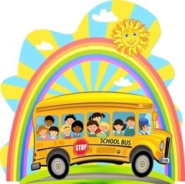
4
- It’s morning, let’s go to school. ( )

- The apple is small and long. ( )
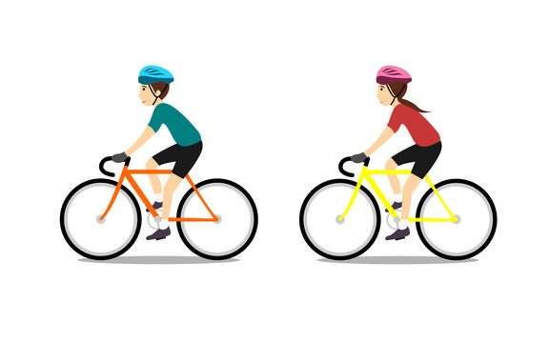
- She is cyclying . ( )

- Lemons are sweet. ( )
___________________________________________________________
Choose the correct answer:-
5
1- He ( am - is - are ) playing.
2- I ( am - is - are ) laughing.
3- They ( am - is - are ) talking.
4- Whose book is this ? It’s ( Amal - Amal’s )
5- is she playing?............................................

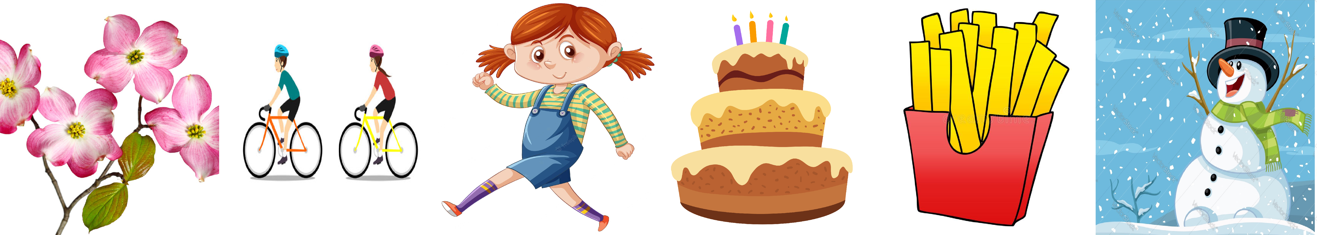
Cycling | cake | flowers | chips | winter | walking
Write the correct word under each picture :-
6

4
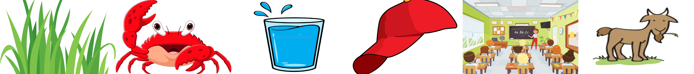
Choose and write (g ,c, cl ,gl , cr , gr )

_ _ass | _ _ab | _ _ass | _ap | _ _ass | _oat

Choose the correct letter:

1-C_ke ( a – I – u)
2-Bu_ ( z – s – c

https://t.me/madty5/4048

