Quiz 1
Name:……………………………………class:…………………………………
Recognize short and long a-i-o-e-oo-u :
Match
Sound | words
a | rice
i | date
o | food
oo | rose
u | duck

Recognize some English digraphs ch-sh-ph-wh ; match
wh | photo
ph | white
sh | chair
ch | sheep

Recognize and differentiate between the ending of plural nouns s – es
Change to plural;
Book \ ……………. Pen\.................... ruler\.....................

Class\.................. dress\...................... fox\........................

Quiz 2
Name …………………………………………………………… class…………………………………………
Answer the questions
What is your name ?
My name is ………………………………..
Where are you from ?
I am from ……………………………………

Complete the answer with correct proposition in box :

Under - between - on

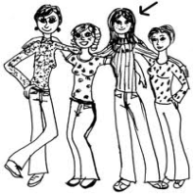
1- Manar is ………………………………. her friends Soha and Heba .
2- The lamp is……………………………………TV.

Quiz 3

Name;……………………………………………class…………………………………………………….
Match;
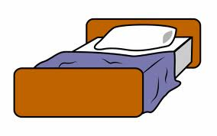
- Window

- Tv

- Sofa

- Lamp

- Book

- Wardrobe

- bed

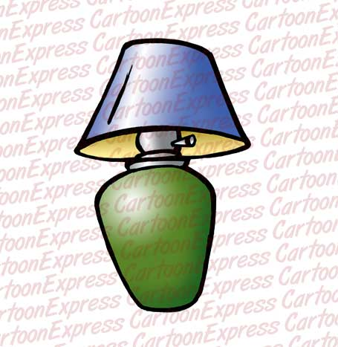
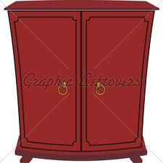
Quiz 4

Name; …………………………………………………………………… class……………………………………………………
Describe physical appearance
Match every animal with its body part
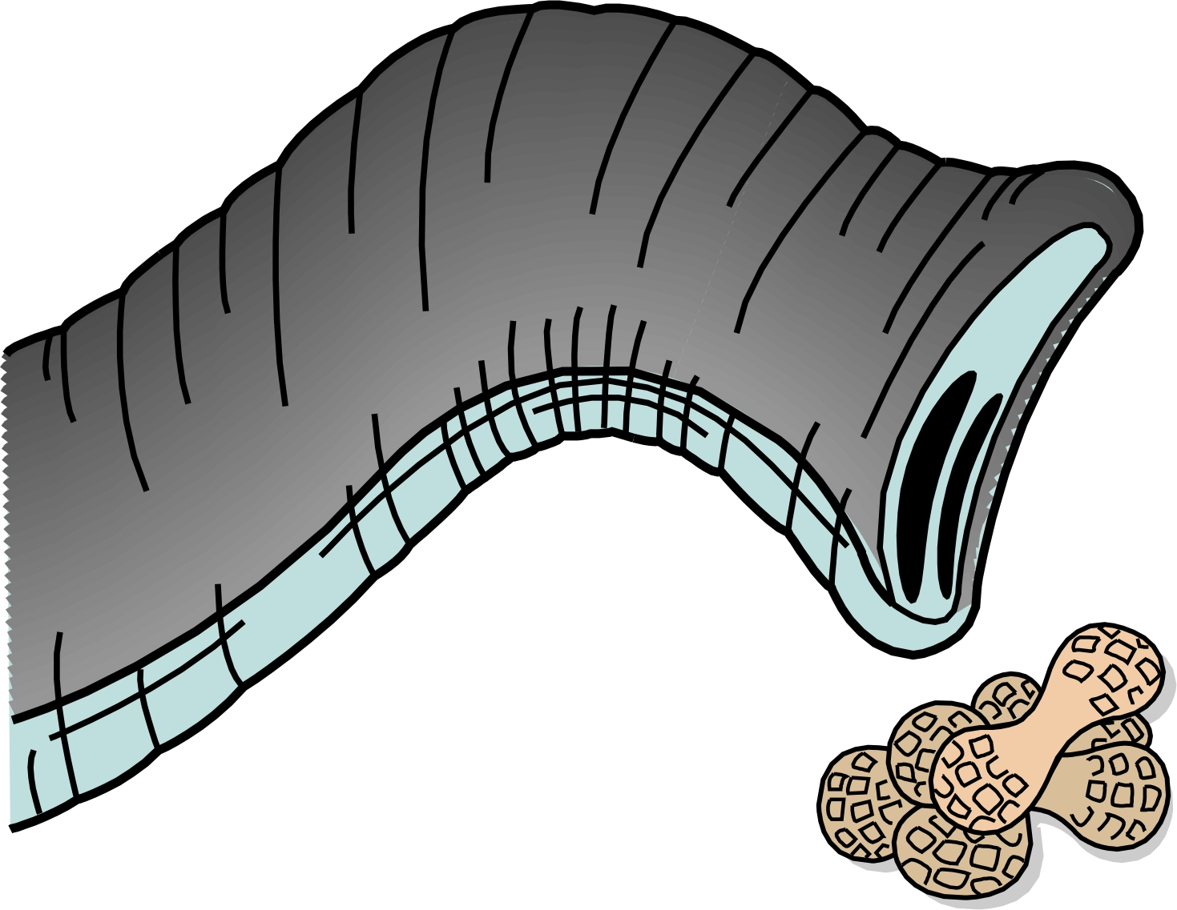

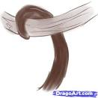

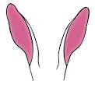

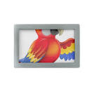
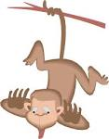

Parrot wings
Rabbit ears
Monkey tail
Elephant trunk

Quiz 5
Name……………………………………………………………………….class…………………………………..
Identify toys, games and classroom object;

- Computer games

- Doll

- Puzzle

- Ruler

- Chair

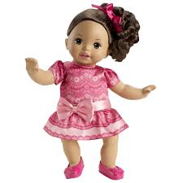
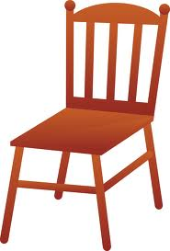
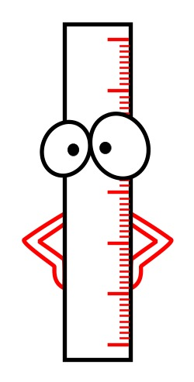

Quiz 6
Name ……………………………………………………………………… class………………………………………….
Identify irregular plural nouns;
Write the plural form;
Man……………...... women…………….…… Child ………………..
Recognize some consonant blends
Match every word with the suitable sound;

Pl | Plane
 | clam
cl | plan
 | clap

Quiz 7
Name;………………………………………………………………..class……………………………………………
Use the intensifier very
Use very in the following sentences;
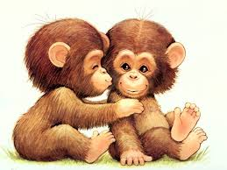 monkeys are cute.
……………………………………………………………

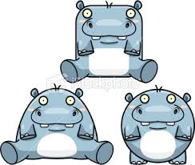 hippos are fat.
……………………………………………………………….
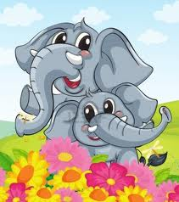 elephants are big.
……………………………………………………………………
Quiz 8
Name…………………………………………………………… class………………………………..
Ask about numbers using how many ….
How many toys do you have? 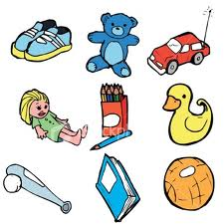
....................................................
identify the weather
Match :
Hot

Clod

Rainy

snowy

Quiz 9
Name;……………………………………………………………..class…………………………………………….
Using possessive adjective –its their

Its trunk …………..

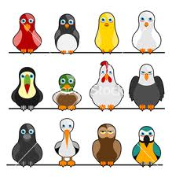

Their wings………

