|  |  |  |  |
| --- | --- | --- | --- |
| **المملكة العربية السعودية**  **وزارة التعليم**  **الإدارة العامة للتعليم بـن مدرسة م ن الابتدائية** | http://tabuk2day.com/wp-content/uploads/IMG_3362.jpgبسم الله الرحمن الرحيم **اختبار الفصل الدراسي الأول**  **للعام الدراسي 1444 هـ**  **https://t.me/abokhaledamer** | **المادة** | **لغة انجليزية** |
| **الصف** | **الرابع** |
| **الزمن** | **ساعة ونصف** |
| **الفصل** | **4 A** |
| **اسم الطالب رباعيا: ............................................................................................................رقم الجلوس:....................**   |  |  |  |  |  |  |  |  | | --- | --- | --- | --- | --- | --- | --- | --- | | **السؤال** | **1** | **2** | **3** | **4** | **5** | **6** | **المجموع** | | **الدرجة** |  |  |  |  |  |  |  | | **الدرجة** | 6 | 5 | 4 | 5 | 6 | 4 | 30 | | **المصحح** |  |  |  |  |  |  |  | | | | |

**I- General Questions:**

**6**

**Q1: A- Choose the correct answer:**

**1. How are you?**

(I’m hot. – I'm Ali. - I’m great.)

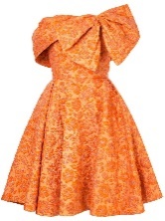

**2. Whose dress is this?**

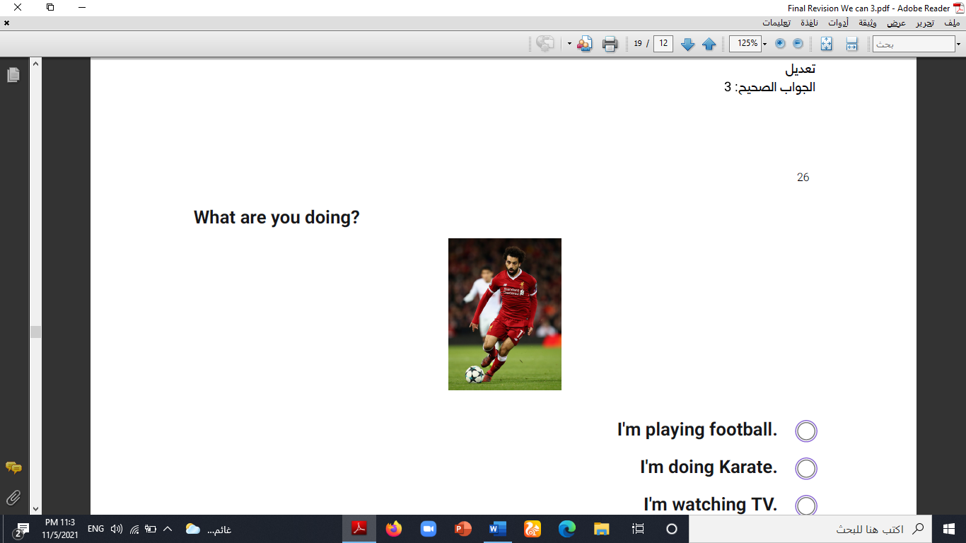(It’s mine. – It’s nine. – It’s fine.).

**3. What are you doing?**

(I’m watching TV. – I’m playing football. – I’m eating snacks.)

**B- Match the questions in column (A) with the correct answers in column (B):**

|  |  |
| --- | --- |
| **B** | **A** |
| **( ) Ali is the first.**  **( ) You’re welcome.**  **( ) Nice to meet you, too.** | **1. Nice to meet you. 2. Who is the first at school? 3. Thank you.** |

**5**

**II- Controlled Writing:**

**Q2: Do as shown between brackets:**

**1. eating – I’m – snacks. (Rearrange)>____ ______ _______.**

**2. like – I – hat. – your (Rearrange) > __ _____ ____ _____.**

**3. Can I speak to Nora? (Answer)> ____________________.**

**4. What’s the matter? (Answer)> ______________________.**

**5. Whose cap ____ it? (Complete)**

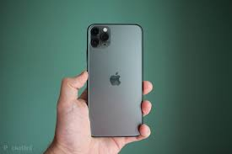**III- Reading Short Sentence:**

**4**

**Q3: Match the sentence with the pictures:**

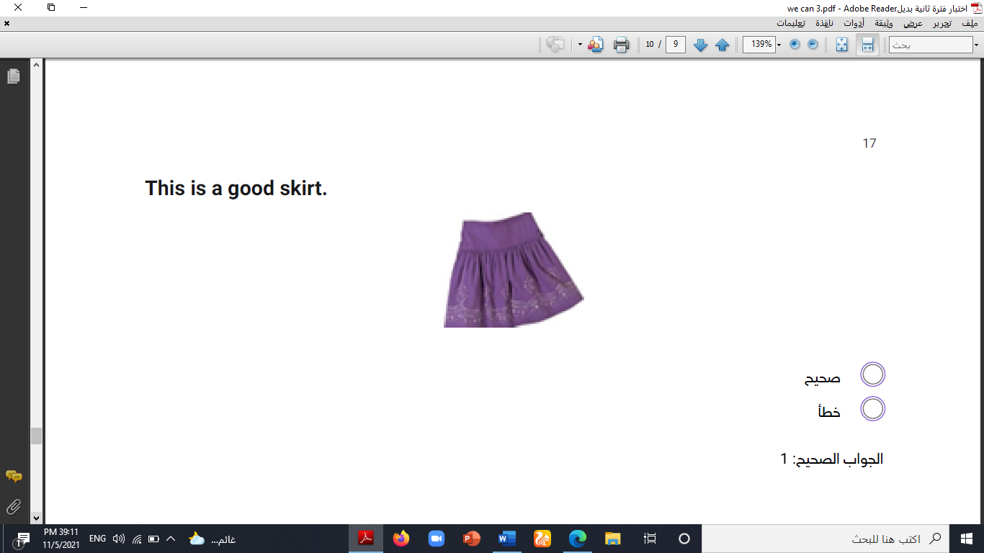**1. I’m wearing a skirt.**

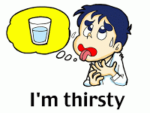**2. I’m doing my homework.**

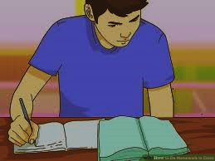**3. I have a new phone.**

**4. I’m thirsty.**

**5**

**IV- Grammar:**

**Q4: Choose the correct answer:**

**1- (**Why – How – What**) is the matter?**

**2- “B” is the (**first – second – third**) letter of the alphabet.**

**3- (**When – Where – Whose**) hat is this?**

**4- Can I speak (**on – to – of**) Ali?**

**5- I am (**watch – watching – watches**) TV.**

**6**

**V- Vocabulary:**

**Q5: Write the number under picture:**

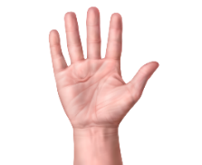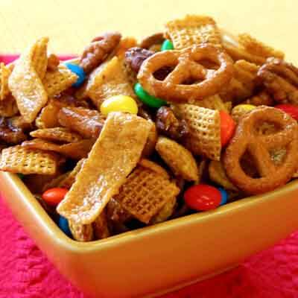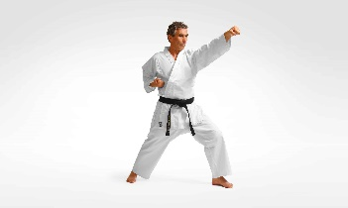**1. sunglasses 2. hand 3. cold 4. karate 5. shoes 6. snacks**

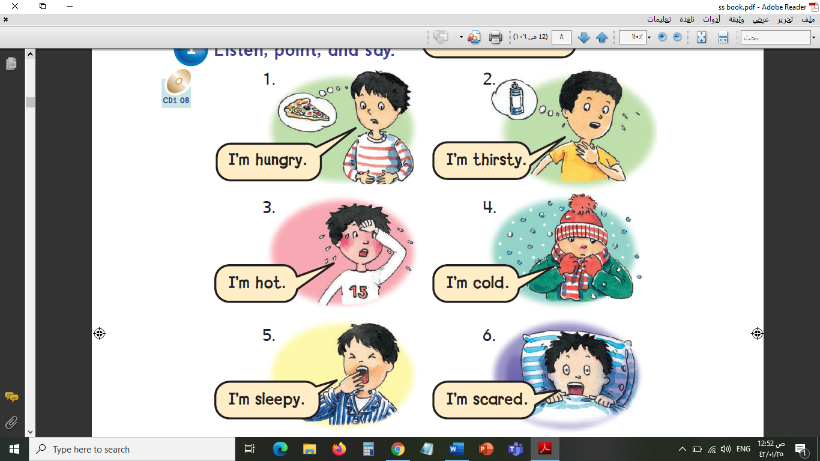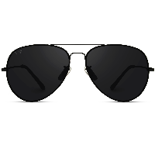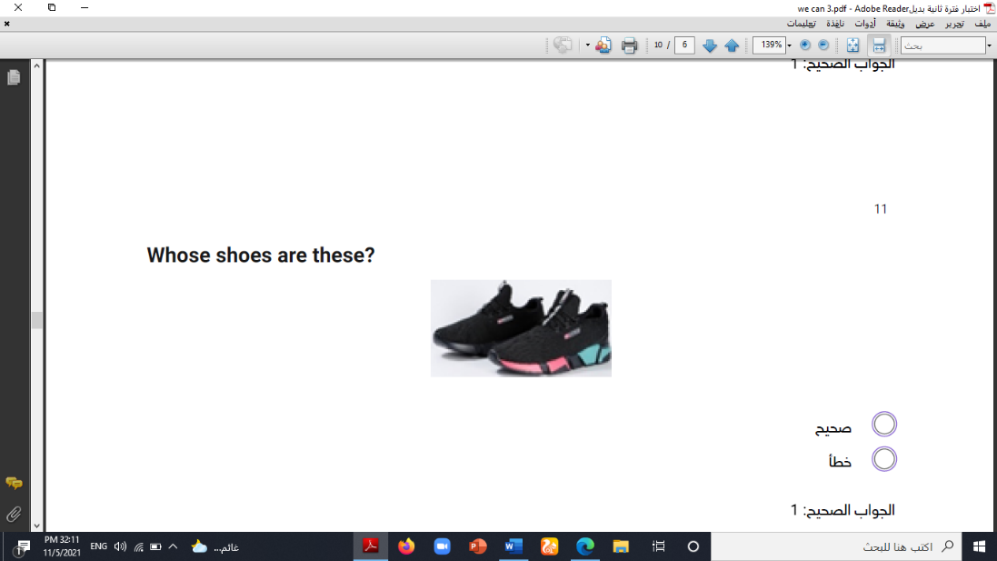

**( ) ( ) ( ) ( ) ( ) ( )**

**VI- Orthography:**

**4**

**Q6: Fill in the missing letters:**

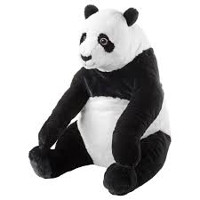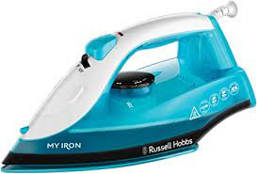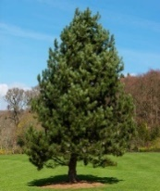**p / d / t / i-e / pl / a / b / i**

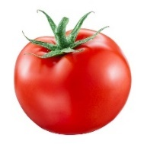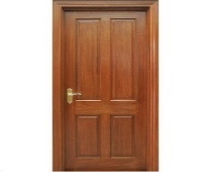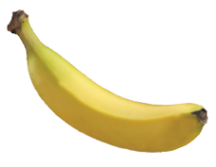NIKE Hat AEROBILL CAP
 Black 100% Polyester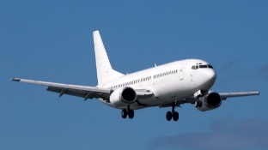

**c__p p__n_ __ron __anana __anda __oor _omato _lane**

**End of Questions**

**ABOKHALEDAMER**

**0557325813**