We Can! Book 4: Revision

1. Listen, and write the missing words. Then match with pictures.

1 | 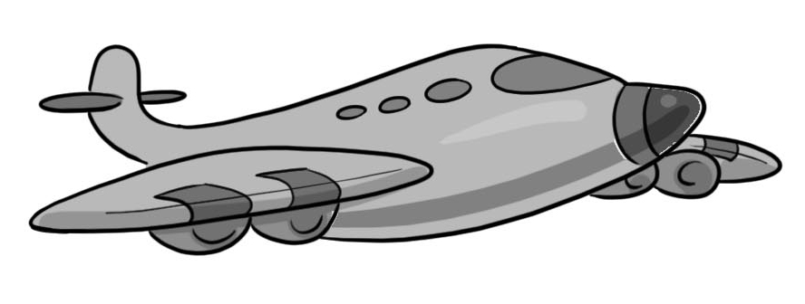  2 | 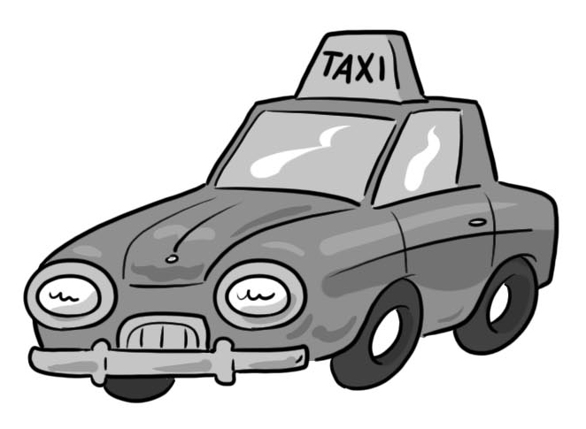  3 | 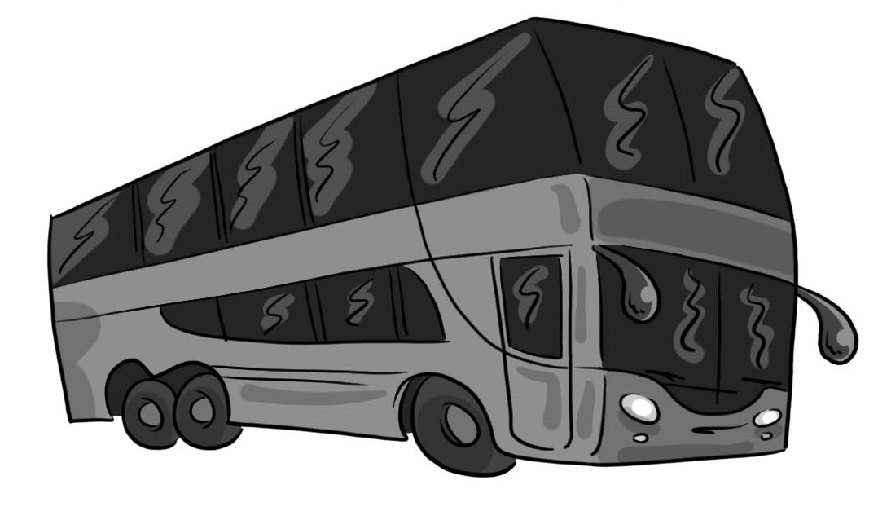  4 | 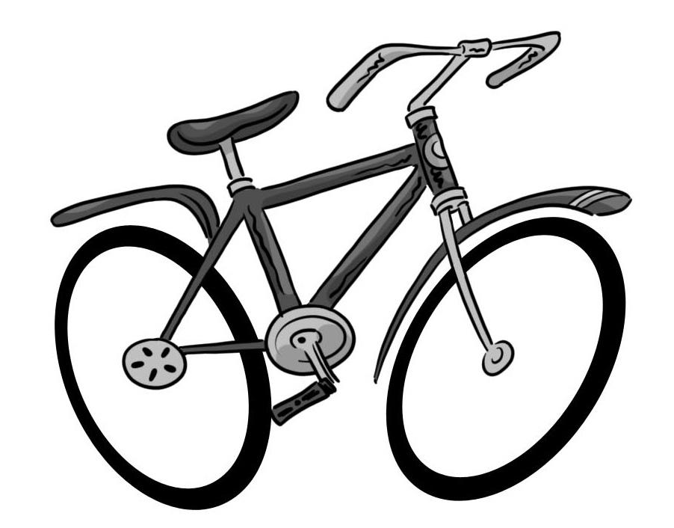  5
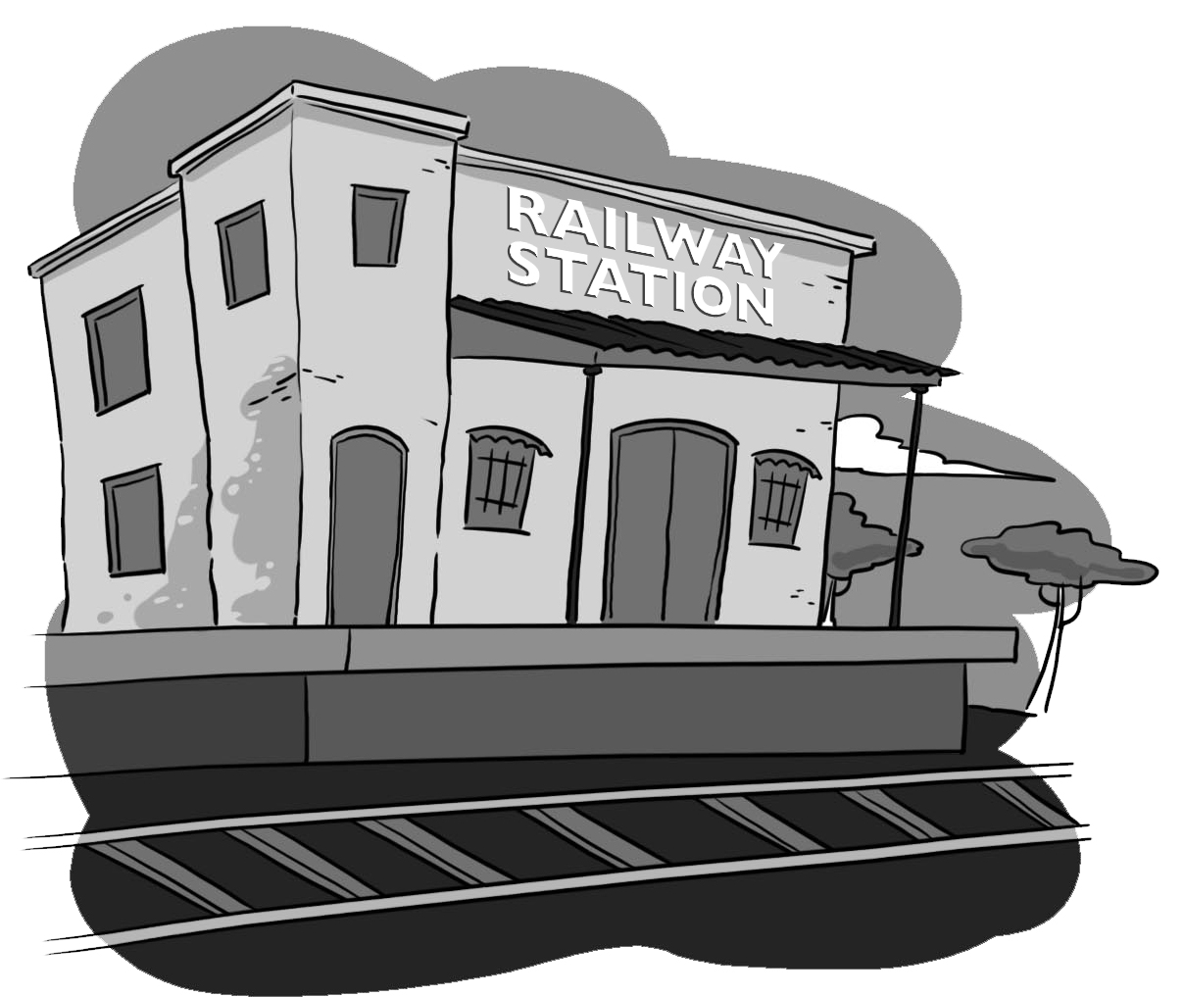  6 | 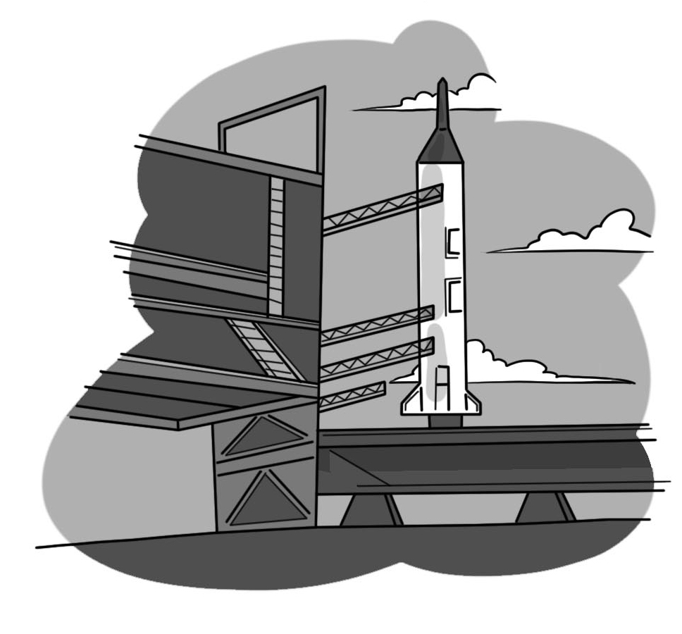  7 | 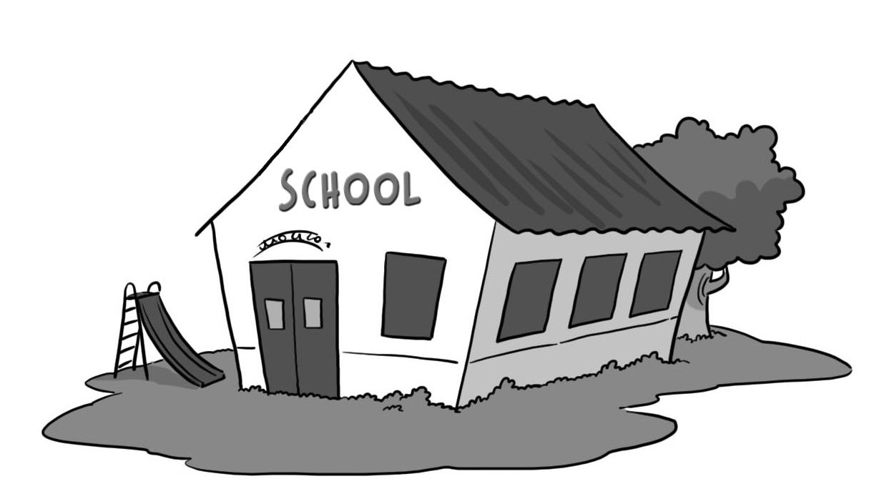  8 | 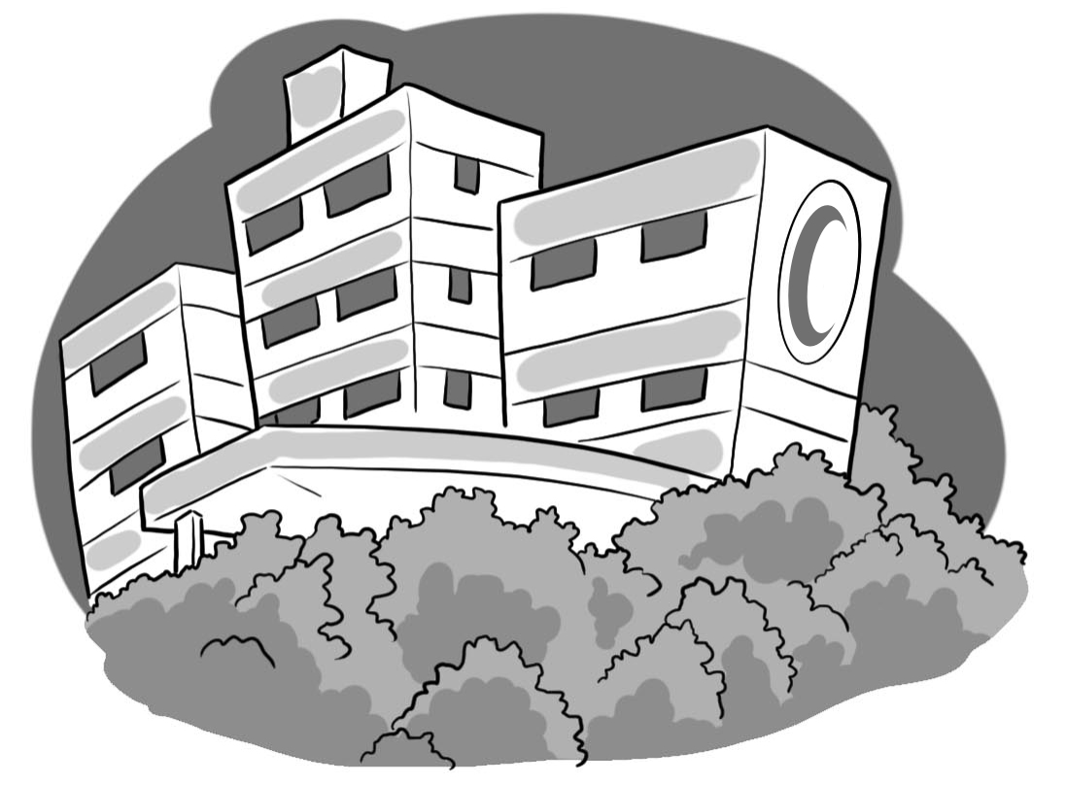  9 | 10

1. Take a ___________ and go to ___________.
2. Take a ___________ and go to the ___________.
3. Take an ___________ and go to the ___________.
4. Take a ___________ and go to the ___________.
5. Take a ___________ and go to the ___________.

2. Listen and write the missing letters.

 | b _______ |  | p _______
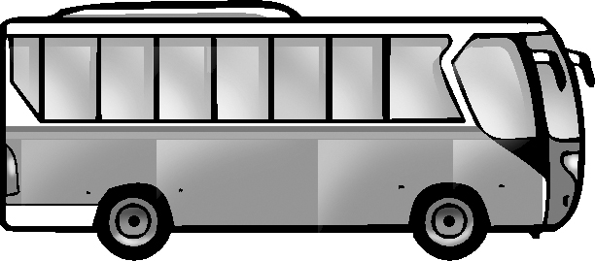 | b _______ |  | f _______
 | c _______ | 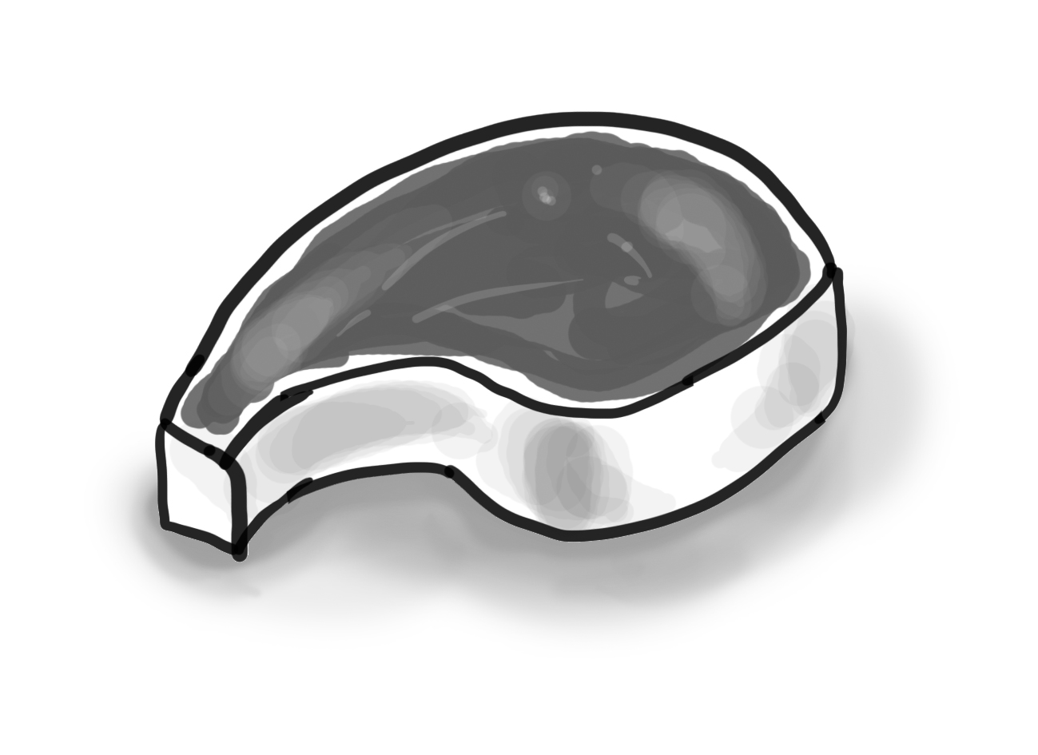 | m _______
 | c _______

3. Look at the map and write the missing word.

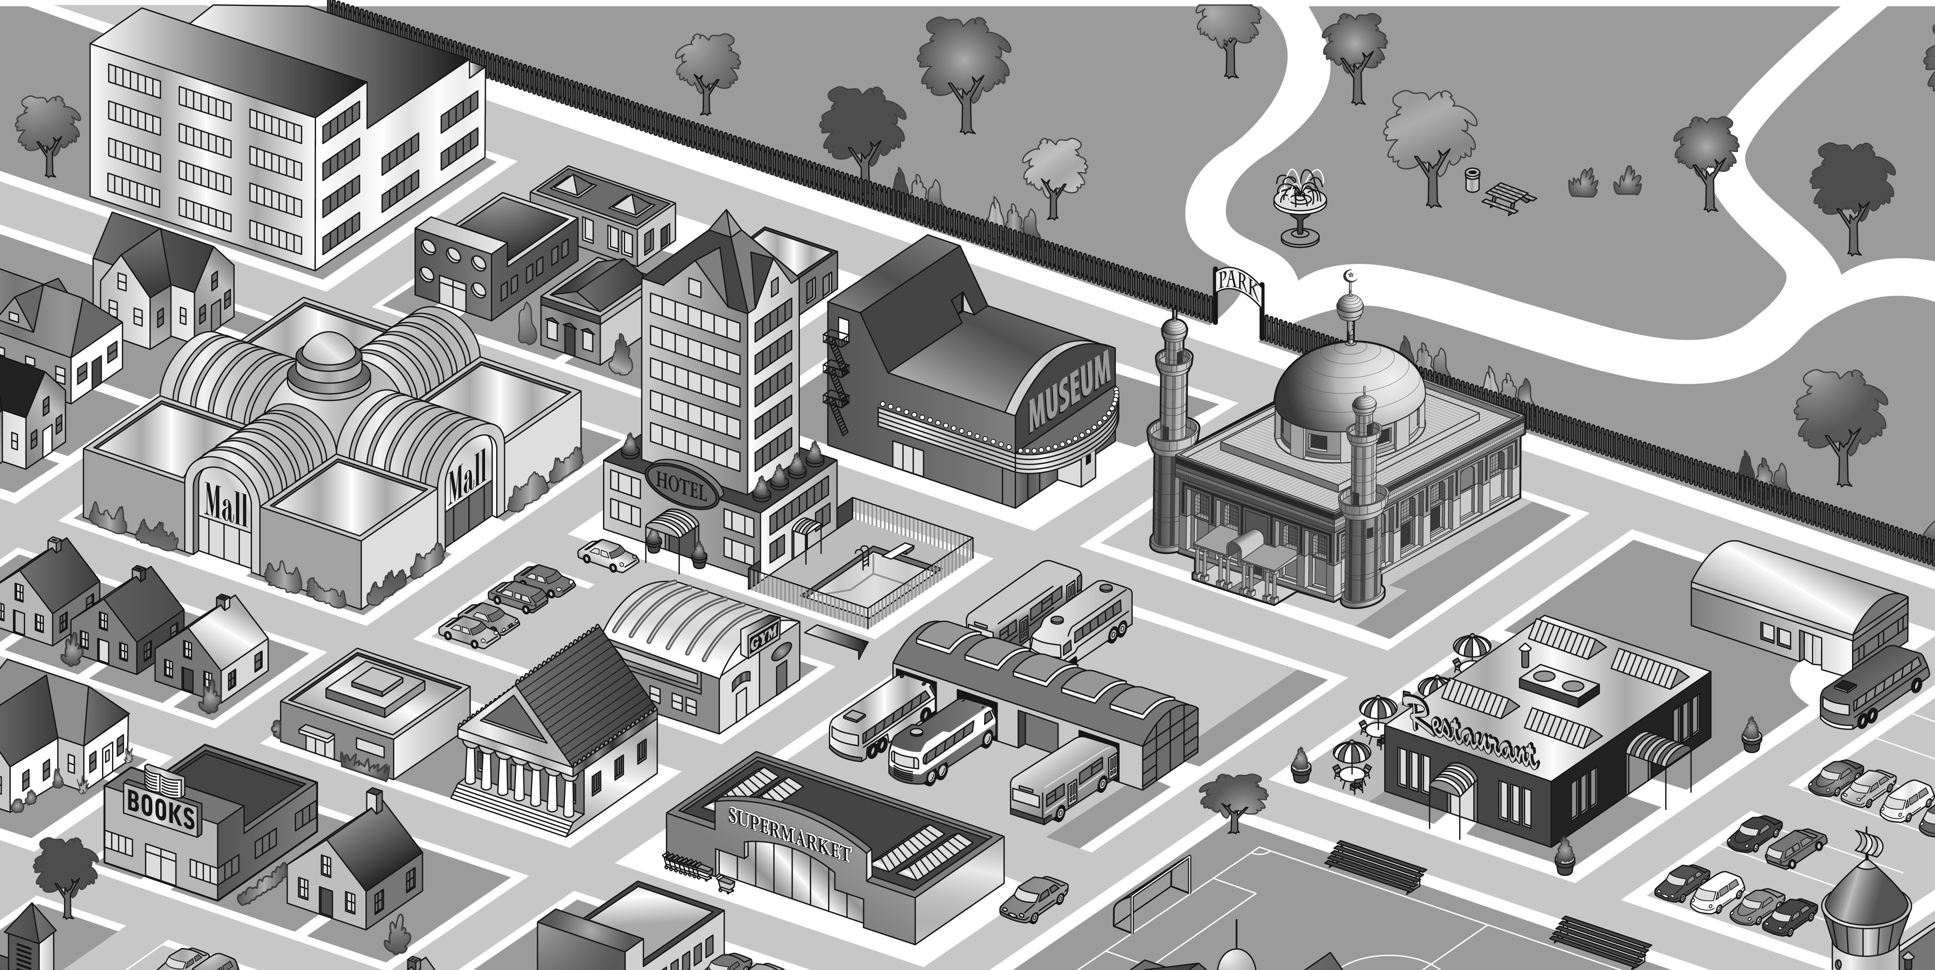

1. There’s a mosque ___________ the museum.
2. There’s a hotel ___________ the mall.
3. There’s a bus station ___________ the gym.
4. There’s a restaurant __________the supermarket.
5. There’s a football field _________the restaurant.
6. There’s a gym ___________ the hotel.
7. There’s a bus station ___________ the mosque.
8. There’s a bookstore __________the supermarket.

4. Listen and write the numbers in the correct order.

55 | 80 | 71 | 50 | 63 | 49
68 | 49 | 60 | 85 | 72
86 | 77 | 89 | 64 | 79
70 | 59 | 90 | 88 | 100 |  |  |  |  | 100

5. Listen, number and match dialogs and pictures. Then write/ copy.

Picture __  B: I’ll show you around ___  A: Hello ___  B: Welcome to our house.___  Would you like to come in?  Picture __  A: Thanks. ___  B: This is the living room ___  A: Yes, please. ___ | A: _________________  B: _________________  ___________________  A: _________________  B: _________________  A: _________________  B: _________________  _________________

.Picture 1 | Picture 2
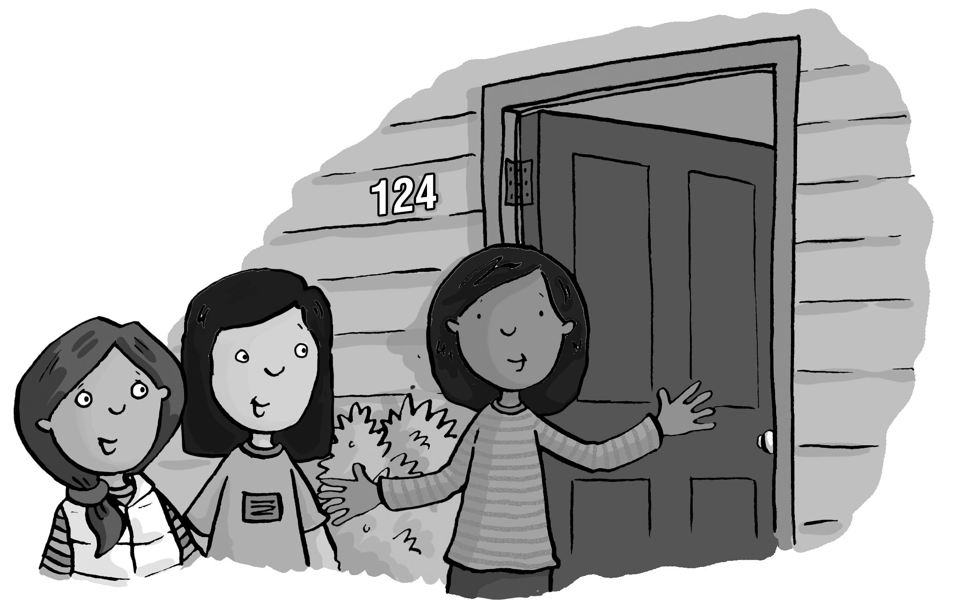 | 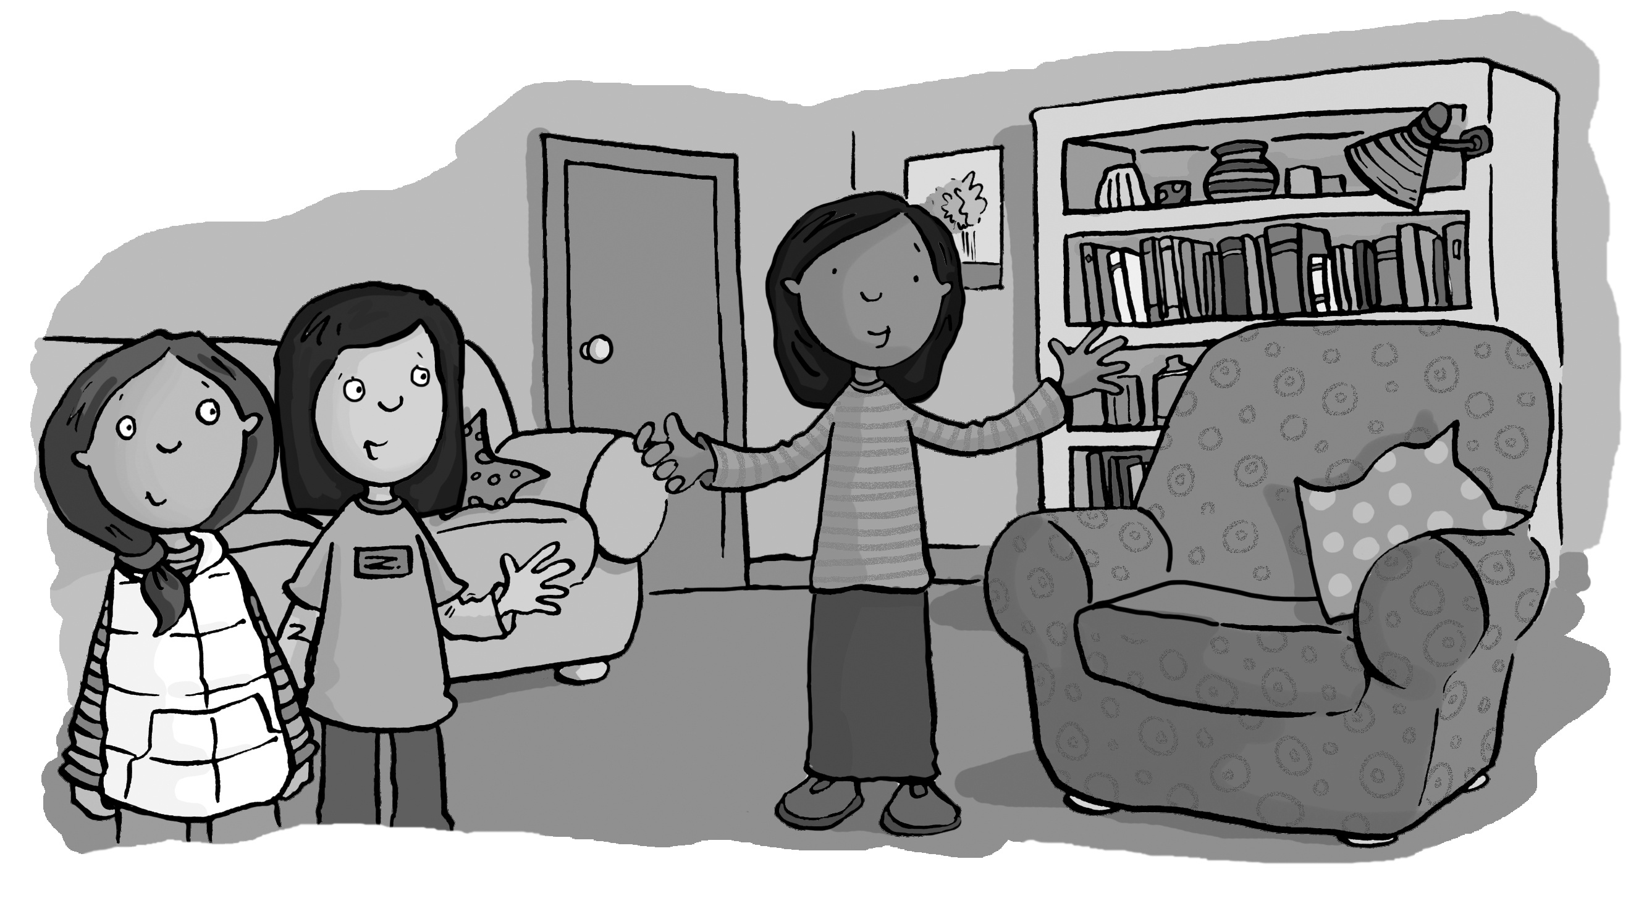

6. Answer the questions.
1. How do you go to school? ____________________
2. Is there a sofa in your bedroom? ______________
3. Where’s the refrigerator in your house?
_________________________________________
4. Do you have a pet? ________________________
5. How many pens are there in your bag?_____________

