

المملكة العربية السعودية المادة: لغة انجليزية
وزارة التعليم اختبار فتري للفصل الثالث 1446هـ
إدارة التعليم بمنطقة مدرسة :

المجموع: 20 / | الصف: | الاسم:

Choose the right answer:
______________________________________________________________________________
I have a headache. | I am going shopping. | 1- What is the matter?
It is asleep. | It is cat. | 2- What's your favorite animal?

Read then circle (✔) or (✖):

1- She has a toothache. | 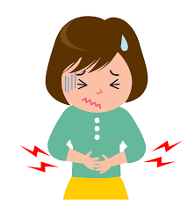 | ✔ | ✖
2- The bird is in the cage. | 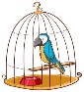 | ✔ | ✖
3- They are in the zoo. | 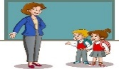 | ✔ | ✖
______________________________________________________________________________
Do as shown between brackets:
1- cats / the quietest / are / pets (Rearrange) ………………………………………………………………
interest | interesting | 2- Interest is (noun) ( Choose the adjective)
........................................ |  | 3- The tall giraffe lives in Africa. (Write the verb)
______________________________________________________________________________

Choose the right answer:
mustn't | should | 1- You______ drink a lot of water. It is good for your health.
strongest | stronger | 2- The lion is the ………………animal in the jungle.
whose | who | 3- The man ______ car is blue is my brother.
______________________________________________________________________________
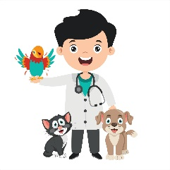 | 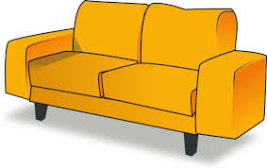 | 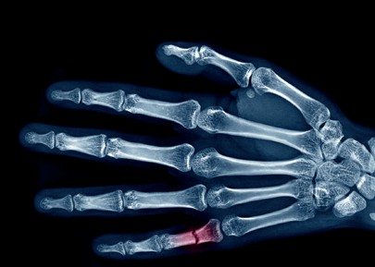 | 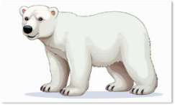 | 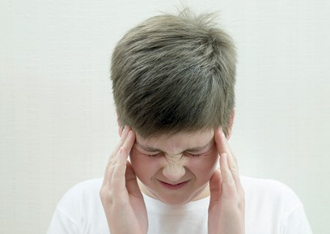
Shelter | couch | X-ray | Polar bear | headache
Vet | cough | back | Lion | stomachache
______________________________________________________________________________
Fill in the missing letters:
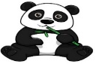 | 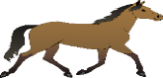 | 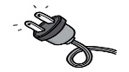 | 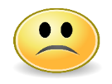
_anda | ho_se | Ca_le | __nhappy
b | r | b | O
p | n | f | U


Kingdom of Saudi Arabia 4th, 5th & 6th Elementary Grade
Ministry of Education Third Term

20
………….. Elementary School . . Mid-Term Exam 1446 AH
Name: ………………………………………………………….………………. Class: …………..
- General Questions:
- Choose the correct answer:
1- What’s the matter?
a- I have a stomachache. |  |  |  |  | b- I should go to the hospital.
2- What do you do?
a- I like rabbits. |  |  |  |  | b- I am a vet.
- Controlled Writing:
- Rearrange the words to form a sentence:
you eat – Wash – before – your hands
- Reading short sentence:
- Read the sentences then match them with the correct pictures:
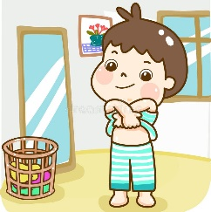 | a-_I put on my clothes.  b-_I take off my clothes.
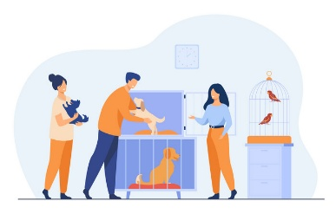  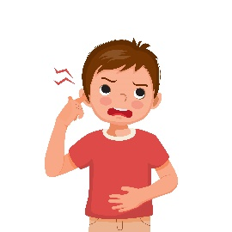 | a-_ They’re at the zoo.  b-_ They’re at the animal shelter.
a-_ He has an earache.
b-_ He has a cough.

- Grammar:
- Choose the correct answer:
- I want to ride my bike. You …………. wear a helmet.
- must |  |  |  | - mustn’t |  |  |  | - don’t have to
- Is there …………. to eat? I’m very hungry.
- someone |  |  |  | - nothing |  |  |  | - anything
- It was October …………… I visited Jeddah.
- where |  |  |  | - when |  |  |  | - whose
- The mouse is …………… than the frog.
- fast |  |  |  | - faster |  |  |  | - fastest
- Vocabulary:
- Choose the correct answer:
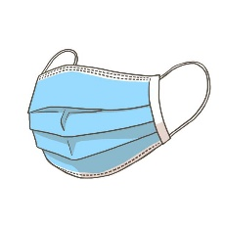 |  | 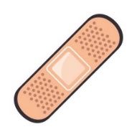 |  |  | 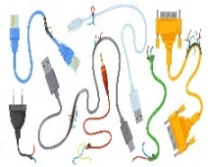 |  |  |  |  | 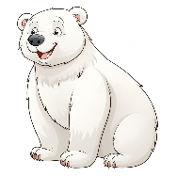
- towel  - mask |  | - band aid  - first aid |  |  | - cables  - toys |  | - pretty  - friendly |  |  | - polar bear  - lion
- Orthography:
- Choose the correct missing letters:
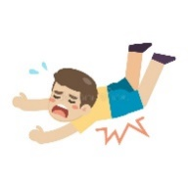  f__ll |  | 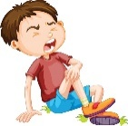  hu__t |  |  |   s__art |  |   bra__e |  |  | 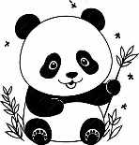  pan__a
a | o | r | n |  | t | m | v |  | f | b | d

BEST OF LUCK
Ms. Tahani Al-Ghamdi
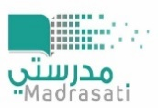

المملكة العربية السعودية
اختبار منتصف الفصل
مدرسة الابتدائية
وزارة التعليم
الفصل الدراسي الثالث 1446 هـ
الصف الابتدائي
الدرجة: 20 /
إسم الطالب :
الصف:
Choose the correct answer :
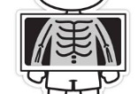
1. He needs to get an _____…..
a. x-ray | b. office | c. doctor
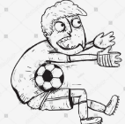
2. The ball hit his ______
a. finger | b. hand | c. stomach
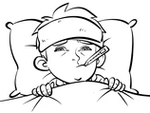
3. He feels______
a. good | b. sick | c. happy
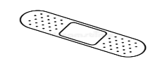
4. Choose the correct word :
a. band aid | b. cut | c. take off
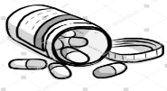
5. Choose the correct word :
a. food | b. medicine | c. hands
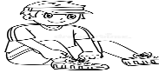
6. Choose the correct word :
a. put on | b. downstairs | c. play
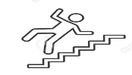
7. Choose the correct word
a. go | b. product | c. fall
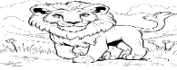
8. Choose the correct letter : ( li_n )
a. ( o ) | b. ( s ) | c. ( i )
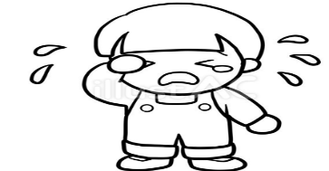
9. Choose the correct letter : ( cr__ )
a. ( n ) | b. ( a ) | c. ( y )
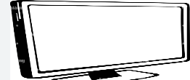
10. Choose the correct letter : ( scre__n )
a. ( w ) | b. ( e ) | c. ( s )
11. This is the school ______the students can learn.
a. who | b. where | c. when
12. She ______ shout in the hospital.
a. should | b. must | c. mustn't
13. He is coughing.
a. He has a headache | b. He has an earache | c. He has a cough
14. You should wear a mask in the ______
a. office | b. hospital | c. yard
15. I didn’t say ________
a. anything | b. nothing | c. something
16. Choose the correct halve : up___
a. body | b. stairs | c. ache
17. You should wear a _____ when you go cycling.
a. jacket | b. jeans | c. helmet
18. If the cut is on your head, you should see the ____ .
a. doctor | b. student | c. store
19. Which animal is black and white ?
a. The parrot | b. The panda | c. The tortoise
20. There’s _________ in my eye. I can’t see at all.
a. someone | b. something | c. somebody

اختبار منتصف الفصل الثالث
الاسم/................................................................................... الصف ..................
Match the questions to their answers:ضع أرقام الأسئلة أمام الإجابات الصحيحة

1- I have a stomachache. Hot drinks will help your throat.
2- I have a cough. Stop eating ice cream.
3- I have an earache. You should go to an ear doctor.
4- I have a headache. Stay in a dark room.

5- I have a toothache. Don’t eat sweets and chocolate.

Put ()or():ضع علامة (صح) أمام الجملة الصحيحة وعلامة (خطأ) أمام الجملة الخاطئة
- Be quiet in the hospital.
- Candy is good for teeth.
- Wash your hands before you eat.
- Kangaroos are fast.
- Parrots can talk.

must | mustn’t
should | shouldn’t
must | mustn’t
have to | don’t have to
Do | Don’t
Choose the correct words:ضع دائرة على الإجابة الصحيحة
- You ………… run in the hospital.
- I ……… drink 8 cups of water a day.
- You ……... take your medicine every day.
- I …...wear a helmet to ride a bike.
- …………touch cables with electricity
Circle the correct word: ضع دائرة على الكلمة الصحيحة
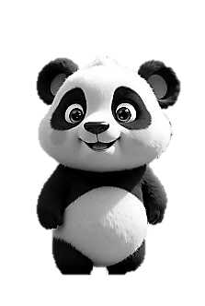  tiger  panda | 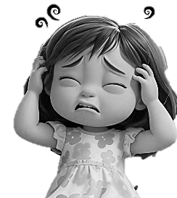  happy  headache | 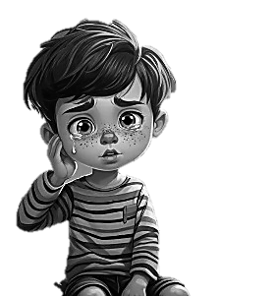  earache  parrot | 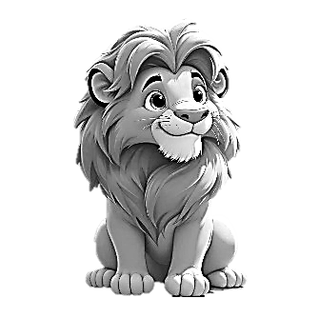  lion  dog | 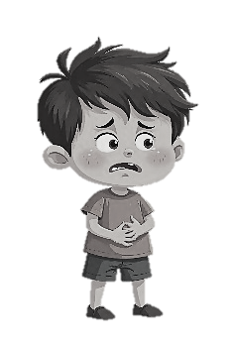  asleep  stomachache

