

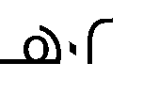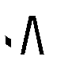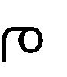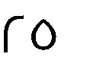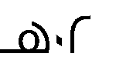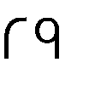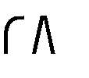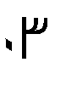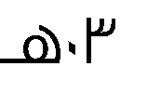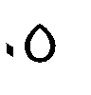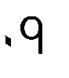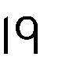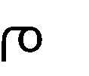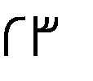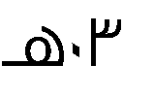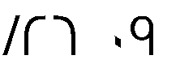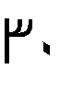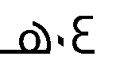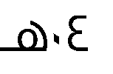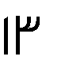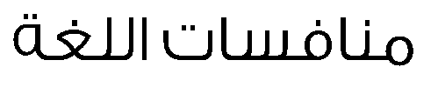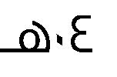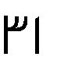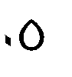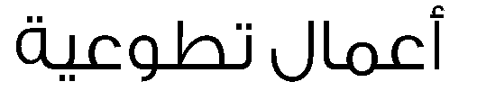





**–**

|  |  |  |  |  |  |  |  |  |  |  |
| --- | --- | --- | --- | --- | --- | --- | --- | --- | --- | --- |
|  | |  | |  | |  | |  | |  |
| – | – | – | – | – | – | – | – | – | – |  |
|  | |  | |  | |  | |  | |  |
|  | | – | | – | |  | |  | |  |
|  | |  | |  | | – | |  | |  |
|  | |  | |  | |  | |  | |  |
| – | – | – | – |  | – | – | – | – | – |  |
|  | |  | |  | |  | |  | |  |
|  | |  | |  | |  | |  | |  |
| – | | – | | – | |  | | – | |  |
|  | | | | | |  | |  | |  |
| – – – – | | | | | | – | – | – | – |  |
|  | | و | |  |
|  | |  | |  |
| – | | – | |  |









**–**

|  |  |  |  |  |  |  |  |  |  |  |
| --- | --- | --- | --- | --- | --- | --- | --- | --- | --- | --- |
|  | |  | |  | |  | |  | |  |
| – | – | – | – | – | – | – | – | – | – |  |
|  | |  | |  | |  | |  | |  |
|  | | – | | – | |  | |  | |  |
|  | |  | |  | | – | |  | |  |
|  | |  | |  | |  | |  | |  |
| – | – | – | – |  | – | – | – | – | – |  |
|  | |  | |  | |  | |  | |  |
|  | |  | |  | |  | |  | |  |
| – | | – | | – | |  | | – | |  |
|  | | | | | |  | |  | |  |
| – – – – | | | | | | – | – | – | – |  |
|  | | و | |  |
|  | |  | |  |
| – | | – | |  |









**–**

|  |  |  |  |  |  |  |  |  |  |  |
| --- | --- | --- | --- | --- | --- | --- | --- | --- | --- | --- |
|  | |  | |  | |  | |  | |  |
| – | – | – | – | – | – | – | – | – | – |  |
|  | |  | |  | |  | |  | |  |
|  | | – | | – | |  | |  | |  |
|  | |  | |  | | – | |  | |  |
|  | |  | |  | |  | |  | |  |
| – | – | – | – |  | – | – | – | – | – |  |
|  | |  | |  | |  | |  | |  |
|  | |  | |  | |  | |  | |  |
| – | | – | | – | |  | | – | |  |
|  | | | | | |  | |  | |  |
| – – – – | | | | | | – | – | – | – |  |
|  | | و | |  |
|  | |  | |  |
| – | | – | |  |