Lab 11: Sectional Views

1. Open a ‘New Part’ file and set the units to inches, decimal and three places.
See Figure 1.

Figure 1
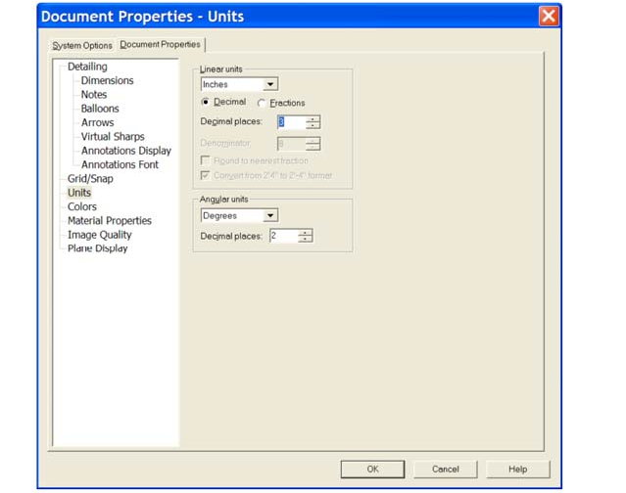

2. Open a Sketch on the Top Plane and sketch the profile shown in Figure 2.

Figure 2
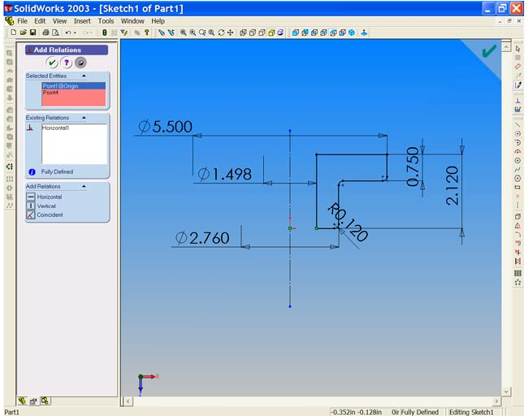

3. Select the ‘Revolved Boss/Base’ tool to create a revolved model from the sketch.
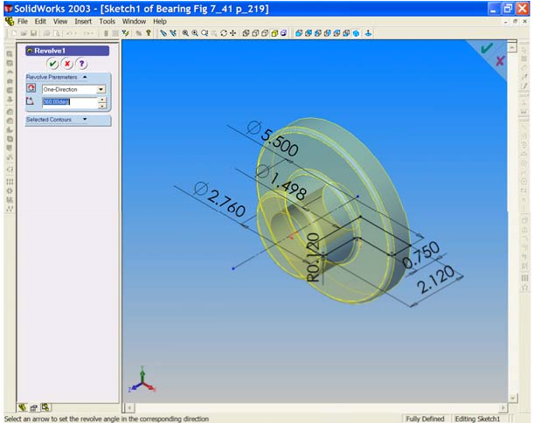
Figure 3

Accept the default revolve type and angle settings, click OK to generate the solid model.

4. Save as ‘Bearing Fig 7_41’.

5. We must now place the 4 bolt holes in the flange. Select the front face of the flange and open a sketch on this surface. Select ‘Normal To’ and draw a circle as shown in Figure 4.

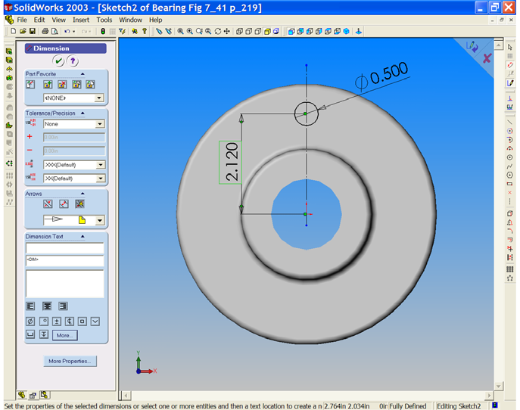
Figure 4

6. Select ‘Extruded Cut’ to form the bolt hole ‘Through All’.
7. Turn on ‘Temporary Axes’ from the ‘View’ dropdown menu. Select
‘Circular Pattern’, the Circular Pattern Properties Manager opens with
‘Cut-Extrude1 listed in the Features to Pattern field. The ‘Pattern Axis’ field is pink; select the temporary axis that passes through the flange bore. Axis
<1> is now listed and a preview of the patterned features is shown on screen. Increase the number of instances from 2 to 4 by using the ‘up arrow’. Notice
the preview changing as the value changes. Select OK  See Figure 5.

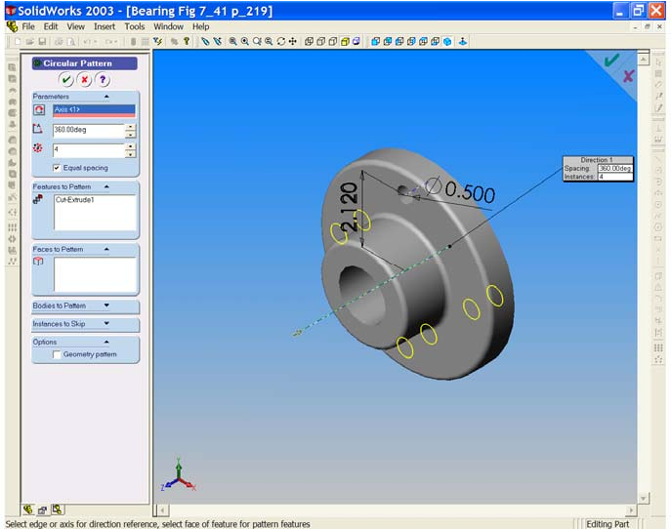
Figure 5

8. The model is complete and we may now turn off the temporary axes.

Save your work!!!

9. Now that the model is complete we must now prepare an Imperial drawing border. Using your previous instructions set up an imperial border using ‘C- Landscape’ as your base template. 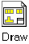

Ensure that:

• Units are set to inches and 3 decimal places.
• Scale is set to 1:1.
• Type of projection is ‘Third Angle’.
• Drawing Title is ‘Bearing’.
• Material is ‘Cast Iron’.
• Finish is ‘See Machine Symbols’
• ‘KFUPM Mech. Eng. Dept.’ is added.
• Your family name, ID No and section number are given
• The date is added.
10. Insert the three orthographic views with tangent edges removed. Position the views carefully within the border. You will have to modify the DWG. NO. (Use ‘Properties’). See Figure 6.

Figure 6
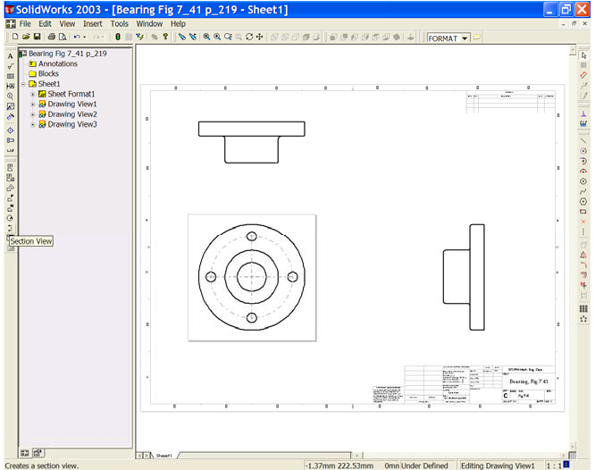

11. We will add a ‘Full Section’ to replace the Right End Elevation. Select the
‘Section View’ button from the ‘Drawing View’ toolbar. Place the cursor above the vertical centre line of ‘Elevation’ left click once and draw the section line (cutting plane) vertically down through the model to the bottom. Notice the cursor symbol change as it indicates what you are doing.

When you have drawn the line to the bottom of the model, left click once.

Notice that the cutting plane with viewing direction arrows is added to the Elevation and that the ‘Section View’ appears on screen. The ‘Section View Property Manager’ is open. The cutting plane arrows may be pointing in the wrong direction. If so, we can use the ‘Flip direction’ by checking the box in the property manager.

Left click to check the box and observe the result on screen. When you have the desired Section View left click once in the graphics area to place the view (with tangent edges removed). See Figure 7.
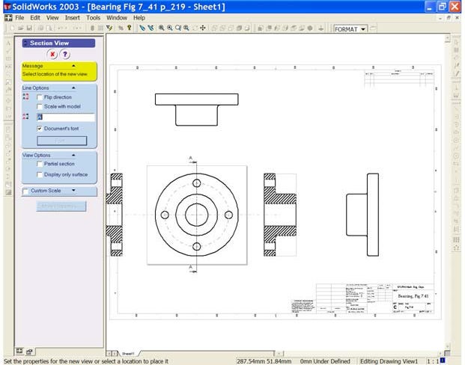
Figure 7

12. The Standard Right End Elevation is not required and may be hidden. Right click inside the border of this view and choose ‘Hide View’. See Figure 8.

Figure 8
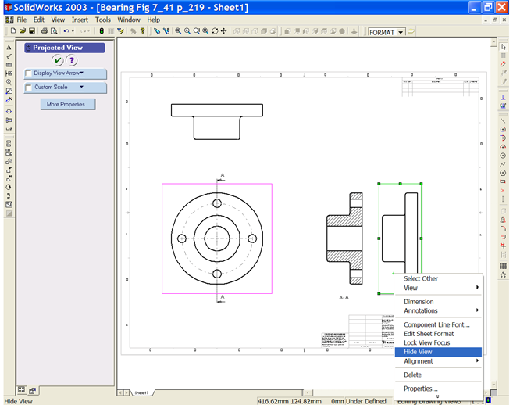

13. Now we need to add centre lines to the views. Activate the section view and select ‘Centreline’ from the ‘Annotations’ toolbar. Centrelines are placed through the cylindrical parts. Switch on ‘Hidden Edges’ for the Plan and repeat the procedure for the Plan. See Figure 9.
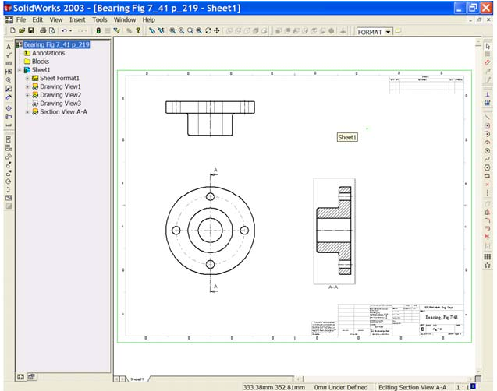
Figure 9

14. The Cutting Plane Line Font may need to be changed from the default. To do this select: Tools, Options, Document Properties and Line Font. Select
‘Section Line’ and choose ‘Chain’ from the ‘Style’ list and set ‘Thin’ for the
‘Thickness’.

Figure 10
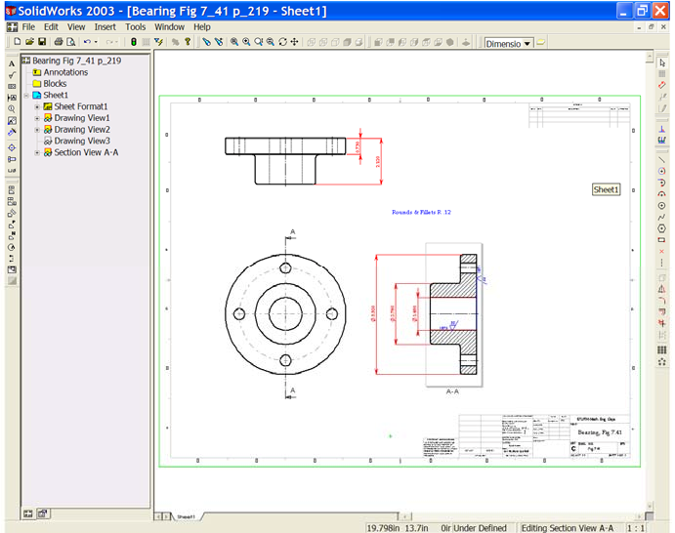

15. Create layers for Dimensions and for Machine Symbols. Set the machine symbols layer current and add the symbols as shown in Figure 10. The Ra value should be 32µ in. and Machine Allowance is to be 3/16” (.1875”). Use the ‘Font’ to control the size of the symbol.
16. We may add the data for Rounds & Fillets. Use the ‘Note’ button and add
‘Rounds & Fillets R .12’.

17. From ‘Insert’ Model Items, insert the dimensions on the dimensions layer.
Re-arrange the dimensions as shown in the Figure 10.

Figure 11
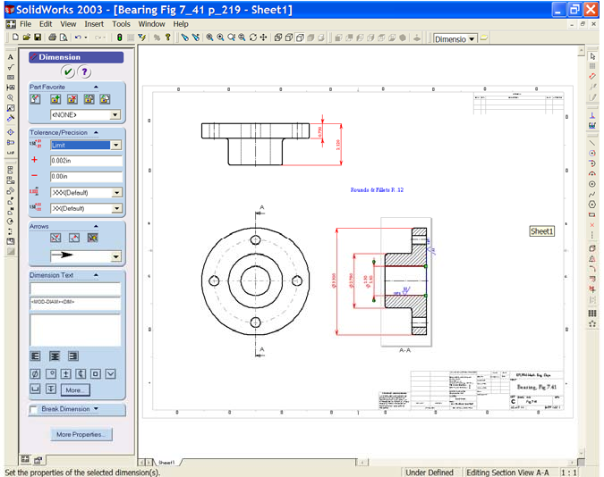

18. The bore dimension has a maximum and minimum limit. This may be added as follows; Select the bore diameter dimension. The Dimension Property Manager’ opens and we may select ‘Limit’ from the ‘Tolerance Type’ window.
The base sketch used the ‘Minimum Limit’ diameter for the model construction, therefore we do not need to change the ‘–ve’ value. The
‘Maximum Limit’ for the bore is Ø1.500 therefore we need to enter 0.002 in the ‘+ve’ field. Ensure that 3 decimal places are shown in the precision fields. See Figure 11.

Select OK to update the dimension. Save your work!!!

19. We need to dimension the four bolt holes. Select the ‘Dimension’ tool , choose the hole at the top of the Elevation and place the dimension. In the Property Manager edit the dimension to remove the brackets and add the data:

Ø0.500 Four holes
Equally spaced on Ø4.24
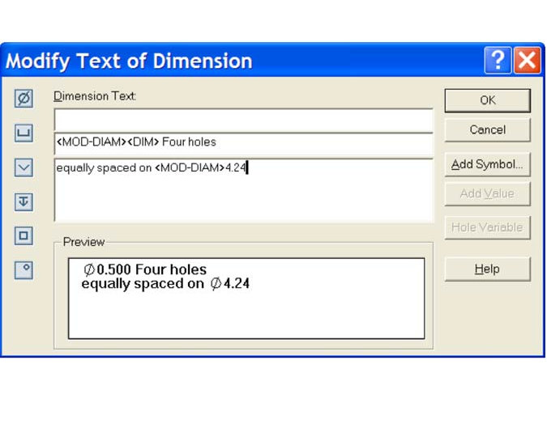
Figure 12

20. To complete the drawing add a pictorial view of the part showing tangent edges ‘with font’. See figure 13.

