المملكة العربية السعودية  وزارة التعليم  الإدارة العامة للتعليم ب.....  ابتدائية .... |   بسم الله الرحمن الرحيم  اختبار الفصل الدراسي الأول  للعام الدراسي 1444 هـ | المادة | لغة انجليزية
 |  | الصف | الخامس
 |  | الزمن | ساعة ونصف
 |  | الدور
الاسم: .............................................................................................................
Total | 6 | 5 | 4 | 3 | 2 | 1 | Question
 |  | Revised by: |  |  |  | Corrected by:

Q1General Questions:

6
A. Choose the suitable answer:
- Where do you live ?
- I live in Qassim. b- I’m eleven years old. c- My name’s Ali.

- Whose shoes are these?
- They’re Steve’s. b- My name’s Hashim. c- Thank you.

- How do you go to school?
- I have one brother. b- I live in Makkah. c- by school bus.

- How old are you?
a- I’m 13 years old. b- Thank you c- welcome

- What sport do you like?
a- I like tennis b- Yes, I do c- I like English
- What chores do you like?
a- No, I don’t b- I like washing dishes c- Nice to meet you
- Nice to meet you.
a- thank you b- nice to meet you too. c-. Yes, I do

- What do you think about sharks?
a- I think they’re scary b- yes, they are c- No, they aren’t
B. Answer
1- Do you like playing football? ……………………………………..
2- What do you think about seals? I think they’re ……………………..
Q2.Controlled writing:

5
A-Match:
feed |  | 1-I think dolphins are _________.
golf |  | 2-I’d like to try photography but I have no_______.
fast |  | 3I usually ______________ the fish
camera |  | 4- Does your brother play_______________.
B-Rearrange
- Riyadh – in – I – live . ……………………………………………………………
- Like - basketball – I. …………………………………..….……………………..
- is – think – I – seahorse – slow. ……………………………………………………

5

Q3-Grammar:
- Choose the correct answer:
- Seals are (cute – cuter – cutest) than starfish.
- (Who – What – How) do you go to school?
- Dolphins ( is – are - am ) cute.
- A whale ( is – are - am ) big.
- I ( have – has - is ) a bicycle.
- Whose skirt is this ? It is ( Nura – Nura's).
- My sister is a doctor. ( Her – His -My ) name is Nora.
- They are my sisters. ( My - Their – its ) names are Nora and Alia.
- She ( have – has – am) a doll.
- I think the whale is the ( big – biggest – bigger) sea animal.

6
Q4: Vocabulry:
Write the correct number under each picture:

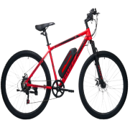
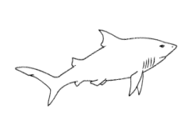
1.bicycle 2. Shark 3. Rain 4. Tie 5. Scuba diving 6.jellyfish


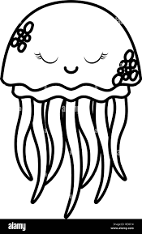
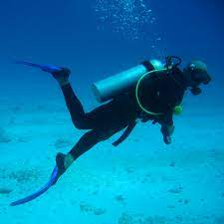

( ) ( ) ( ) ( ) ( ) ( )
Q5: Reading:

4
- Write the correct number under each picture:

- I am washing the dishes.
- I like playing tennis.
- I think whales are the biggest sea animals.
- Bungee jumping is a dangerous sport.
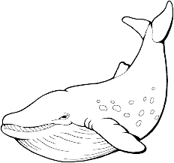
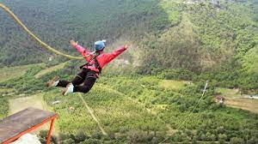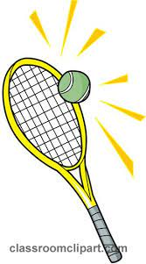
( ) ( ) ( ) ( )

4

Q6: Orthography
- Complete the missing letter :
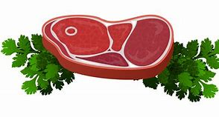

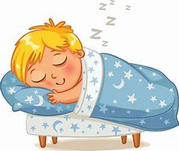
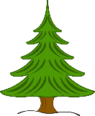
[ ee / ea / ie / i-e ]

1) m__ __ t 2) p __n __ 3) sl__ __ p 5) p__ __
- Fill in the missing letters with [ oi / oy ]
1. b____ 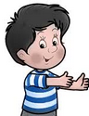 | 3. c____n 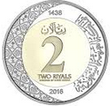

- Unscramble

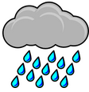
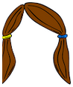
(nair) ……………… (aihr)………….

Best Of Luck

المملكة العربية السعودية |  | اسم الطالب/ه .........................
وزارة التعليم |  | رقم الجلوس : .........................
إدارة تعليم منطقة ..................... |  | المادة : انجليزي
مكتب التعليم ب........................ |  | الزمن : ساعة ونصف
مدرسة : .............................. |  | الصف : فصل ( )
اسم المصحح / ه: | التوقيع : | الدرجة رقما :
اسم المراجع / ه : | التوقيع : | الدرجة كتابة :
اختبار نهاية الفصل الدراسي الأول للعام الدراسي 1445 – لغة انجليزية –– للصف........... ابتدائي

1 : Choose the right answer:

6
General Questions

A. I like some juice. B. I live in Riyadh. | 1 – Where do you live?
A. I am 11 years old. B. I am fine. | 2 – How old are you?
A. It's a seahorse. B. It's a seal. | 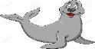  3- What is that?
A. I like painting. B . I like football. | 4 – What sport do you like?
A. I play football. B . I clean up my room. | 5- What chores do you do?
A. Yes, she does sometime. B.No, I don't . | 6- Does she vacuum the floor?

Q1 : Choose the right answer:

5
Controlled Writing

....................................................... |  |  | 1 – to - nice – you – meet . (Rearrange)
.......................................................... |  |  | 2 – horse - I – riding – like. (Rearrange)
 |  |  | 3- set - I – table – the . (Rearrange)
clean | set | feed | 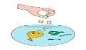  (choose) 4- I ____ the fish.
activities | sports | chores | 5- Football and volleyball are _______ (choose)

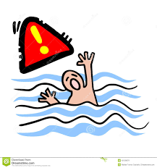
1. He can swim.

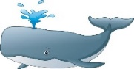
2. The whale is small.


3. I go shopping.

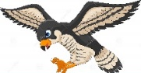
Falcons can see very far..4
Q3: Choose () or (×):
Reading

4

Q4: Choose
Grammar

5

your | my | his | 1 – I am a teacher, _____ name is Ali.
Noras' | Nora's | Nora | 2- Whose skirt is this? It's ______.
biggest | big | bigger | 3 – The whale is ______.
as | more | most | 4- Football is ___ exciting than jogging.
wash | washes | washs | 5- She ___ the dishes.

Q5: Write the right word under its picture:
Vocabulary

6

T-shirts – starfish – robot – fire - Scuba diving - computer games

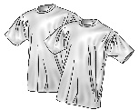 | 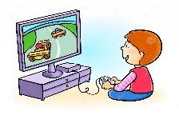 | 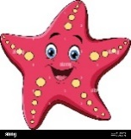 | 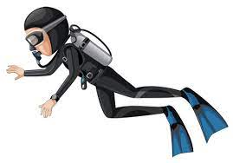 |  | 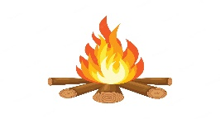
--------------- | ---------------------- | --------------- | -------------------------- | --------------- | ---------------

4
Q6:Fill in the missing letters:
Orthography

Choose the correct letter: ( ee , ai , ou , ow , ar , ear , air , or )

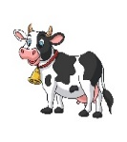 | 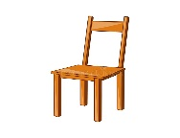 | 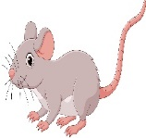 | 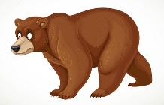 | 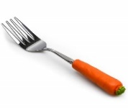 |  | 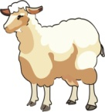 | 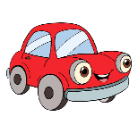
c_ _ | Ch_ _ _ | m_ _se | b_ _ _ | f_ _k | r_ _n | Sh_ _p | c_ _

GOOD LUCK
 | المملكة العربية السعودية  وزارة التعليم  الإدارة العامة للتعليم بتبوك  الابتدائية .................................. | الصف:
 |  | اليوم:
 |  | التاريخ: | / 4 / 1445هـ
 |  | الزمن: | ساعة ونصف
الاختبار النهائي لمادة اللغة الإنجليزية للفصل الدراسي الأول - الدور الأول للعام الدراسي 1445 هـ

اسم الطالبة : ..................................................................................................................... الصف: / رقم الجلوس: ( )
Total | 6 | 5 | 4 | 3 | 2 | 1 | Question
30 | 4 | 6 | 5 | 4 | 5 | 6 | Mark
 |  | Revised by: |  |  |  | Corrected by:

- Q1. General Questions
1. Where do you live? | ( ) He likes basketball.
2. How do you go to school? | ( ) I wash the dishes.
3. What sport does he like? | ( ) I think they're scary.
4. What chores do you do? | ( ) It's ours.
5. Whose books are these? | ( ) By car.
6. What do you think about sharks? | ( ) I live in Jeddah.

6

- Q.2 Controlled Writing: Rewrite
It’s nice to meet you.
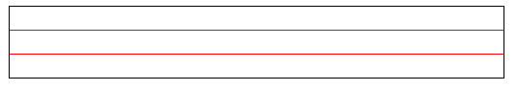
Rearrange
- live – I – Duba – in ……………………………………………
- ride – We – horses . ……………………………………………
Correct the mistake
- You folds the laundry.
………………………..…………………
- Omar and her friends are playing.
….……………..….……………………

5

- Q.3. Reading : Match the sentences with the correct picture
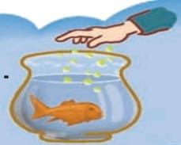 | 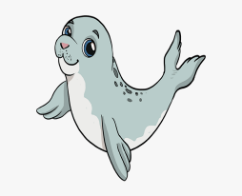 | 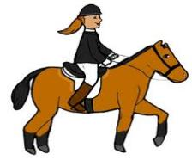 | 6  4
( ) | ( ) | ( ) | ( )
- She likes horse riding.
2. You feed the fish.
3. I think a baby seal is cute.
4. Annie washes the dishes.
- Q.4 Grammar: Choose the correct answer :
- She ( is – am ) a doctor.

5
- They (are – is ) playing football.
- This is my mother. ( Our – Her ) name is Fatmah.
- I think a walrus is ( big – bigger ) than a whale.
- You ( sets – set ) the table.
- She ( has – have ) a new computer.
- The polar bear is as (stronger – strong ) as a lion .
- I ( has – have ) a new class.
- ( Whose – How ) book is this?
- ( Do – Does ) she ski ?
- Q.5 Vocabulary: Match the word with its picture:

6
Q.2 Controlled Writing
. day ◌ . clown ◌ . meat ◌ . rice ◌ . mouse ◌ .goat

 | 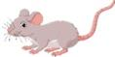 | 
……………… | ……………… | ……………… | ……………… | ……………… | ………………
- Q.6 Orthography: Complete the missing letters: ( ar ※ oa ※ ee ※ oi )
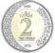 | 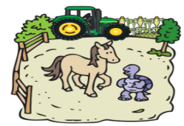 |  | 
c_ _n | f_ _m | sh_ _p | b_ _t

4

✨ End of Questions ✨
Tr: Nadia Ahmad Pr. Amal

I General Question

6
Choose:
a- My name is Amal  b –I'm fine, thank you | 1- What is your name ?
a- Whose  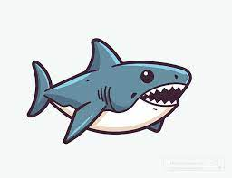  b- Where | 2-……………. book is this ?
a- It is a seal.  b- It is a shark. | 3- What is this?
  a- I clean up my room  b- I wash the dishes. | 4- What chores do you do?
a- I live in Jeddah.  b- I fold the laundry . | 5- Where do you live?
a- Yes, he does.  b- Yes, I do. | 6- Does he play football?

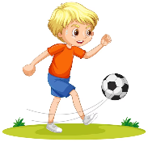
II Controlled Writing

5

Rearrange the words:
1- playing / She's / tennis
2- Nice / to / you / meet

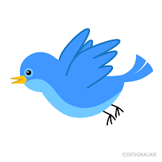
Complete:
( can / can't ) | 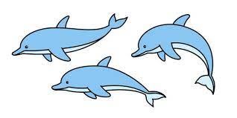  1- It …………… fly.
( slow / fast) | 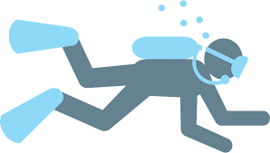  2- Dolphins are ……………
(scuba diving / basketball ) | 3- Dangerous sport is like ……………

III Reading short Sentences

4
Match:
 | 1- I set the table.
 | 2- I go shopping.
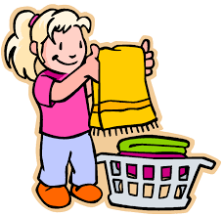  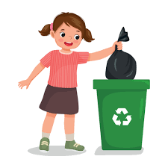 | 3- I take out the trash.
 | 4- I fold the laundry .
Grammar

5
Choose:

1- I'm …………………….golf .
play | playing | plays

2- She ……………..the fish.
feeds | feeding | feed

3- The whale is the……………
biggest | bigger | big

4- We …………… a cat .
has | have | does

5- ………………you vacuum the floor?
Do | Does | Did

Vocabulary

6

( starfish - seahorse - robot - horse riding – rock climbing - eel )

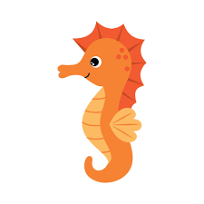 |  | 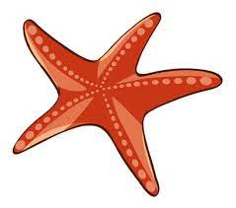 | 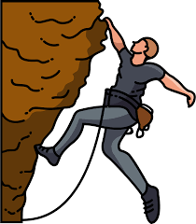 | 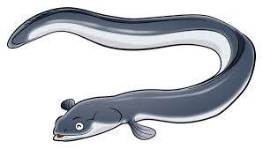 | 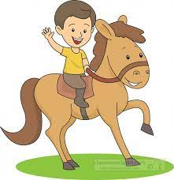

VI Orthography

4
Fill in the missing letters
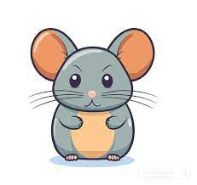
:
 | 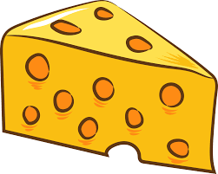 |  |  | 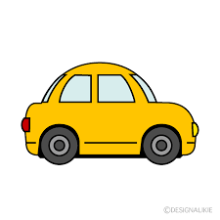  
m………se  (ou / ee) | Ch………se  (ow /ee) | c………t  (oa / ow) | c………n  (ay / oi) | doct………  (or / er) | c………  (er / ar)
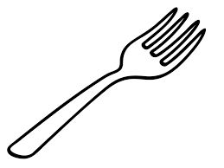 | 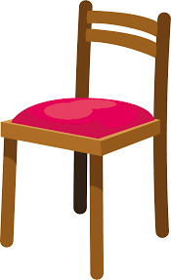
f………k  (or / er) | Ch………  ( ere /air )

With my best wishes / Tr.

