|  |  |  |  |
| --- | --- | --- | --- |
| المملكة العربية السعودية  وزارة التعليم  الإدارة العامة للتعليم  .......... | **http://tabuk2day.com/wp-content/uploads/IMG_3362.jpg** **اختبار الفصل الدراسي الأول**  **للعام الدراسي 1444 هـ**  **الدور الأول**  **الأسم :- _______________________** | **المادة** | **لغة انجليزية** |
| **الصف** | **الثالث متوسط** |
| **الزمن** | **ساعة ونصف** |

**30**

**1. Composition**

***Write a paragraph about (* yourself *) not less than 6 sentences using the following words .***

**6**

***( name – age – favorite sport – live –like )***

**…………………………………………………………………………………………………………………………………………………………………………….………………………………………………………………………………………………………………………………………………………………………………………………………………………………………………………………………………………………………………………………………………………………………………………………………………………………………………………………………………………………………………………………………………..………**

**6**

**2. Reading Comprehension**

**A-Read the following passage then answer the questions**

**Prophet Mohammad (PBUH) was born in Makkah in 571AD . He was an orphan . His father, Abdul Allah , dbefore he was born .His mother , Amana, died when he was a child of six . He live with his grandfather, Abdul Muttaleb . Prophet Mohammad died in AL_Madina in 11 Hijra ( 633AD) .**

**1.When was Prophet Mohammad born ? …………………………………………………………**

**2.Where was prophet Mohammad born ? ..........................................................**

**choose the right answer:**

**1.His mother died when he was a child of ( 8 - 6 - 3 ) .**

**2.Prophet Mohammad died in ( jeddah - Al-madina- Taif ) .**

**4.His grandfather was . ( Saad- Abdul Muttaleb - Abdul Allah)**

**5.he lives with his ( brother – grandfather – father )**

**3. GRAMMAR**

**7**

1. **Choose the correct words:**

**1- she always (drink - drank - drinks ) tea in the morning .**

**2- ( both - all - neither ). Of them is a teacher .**

**3-she used to (plays - played - play ) with toys .**

**4- it will (raining - rains - rain ) soon .**

**5-How ( is - much - many ) bananas do you have?**

**6- I eat ( much - little - few ) carrots.**

**7- Nawal cut ( her self - my self - ourselves) while she was peeling the potatoes.**

**4. Vocabulary**

**7**

**A- Match :**

|  |  |  |  |
| --- | --- | --- | --- |
| **1** | **Infant** |  | **gave to charity** |
| **2** | **encouraged** |  | **supported someone to succeed** |
| **3** | **donation** |  | **a baby** |

**B-Match the word with the suitable picture**:

**( baggage - pineapple - herbal - cheese )**

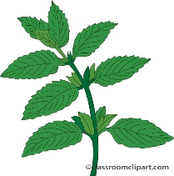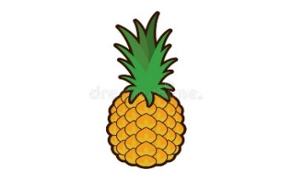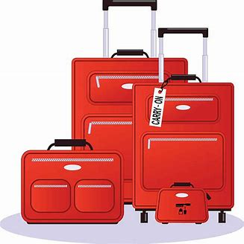

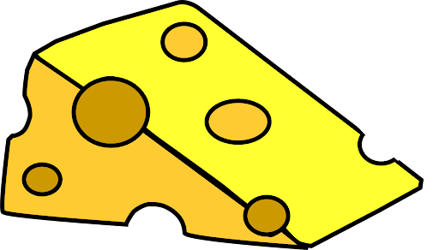

**………………..….. …………………………. …………………….. …………………….**

**5. orthography**

**A-Write the missing letters :**

**4**

**1- passp_rt ( e - o ) 2- fligh….. ( t - k )**

**3- chick_n. ( o - e ) 4- gr_ll ( b - i )**

**انتهت الأسئله**