
Kingdom of Saudi Arabia
Ministry of Education
……..Education Directorate
………………… School
English Language
elementary Grade …..
period Exam
…………….\20
Student's Name : class:

……\ 4 marks

General questions

A.Answer the questions

1-How many students are there in your school?
a-About 500 b- sorry c- Littlerock Elementary School.
2- What‘s the matter?
a-I like pizza. b-I have a stomachache. c-I'm 12 years old.
3-Which city do you live in?
a-I'm 11 years old b- I live in Najran c-We bring our own.
4-Did you drink milk this morning?
a-Yes, I can b- Yes, I do c-Yes, I drank milk this morning.
……\ 1 marks

Controlled Writing

A. Choose the correct answer

kitchen | bed room | library | 1-The best place in our school is …………
write | book | drink | 2- I should …………a lot of water.

Reading short sentence

……\ 4 marks
 | 1- I have a headache ( )
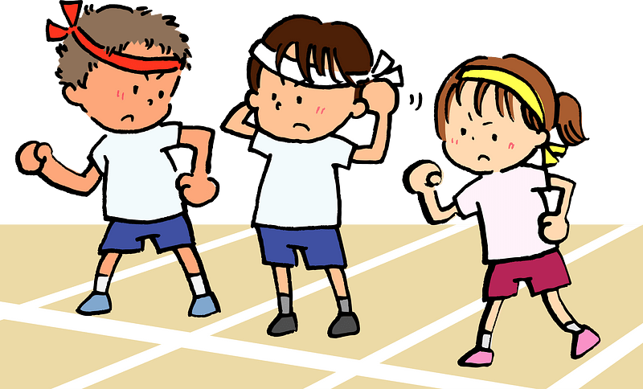 | 2- This year I like P.E ( )
A-Put ( ✔ ) or ( X )
B.Match

English in class! |  | 1- She has a toothache
because she never goes to the dentist. |  | 2-Use
……\ 4 marks

Grammar
A-Choose the correct answer.
1- You should ( do – did – does ) some exercise.
2- Last year we( go - went - goes ) to Riyadh.
3- I didn‘t (brush – brushes – brushed )my teeth this morning.
4-( Who – When - Which )subject do you like most this year?
……\ 5 marks

Vocabulary

A.write the correct word under each picture
( scan – sweater - lamb - science - soda )
)

 |  |  | 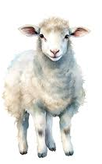 | 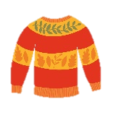
Orthography
……\ 2 marks

A. Fill in the missing letters
ir sq sk ur





g…..l
….uare
….ate
t….tle



Your teacher:

Your teacher …..:…………………………….

1- Choose the correct answer:
2

المملكة العربية السعودية |  | المادة: انجليزي
وزارة التعليم |  | المادة: انجليزي
إدارة التعليم بمنطقة |  | المادة: انجليزي
مكتب تعليم |  | الزمن : حصة دراسية
مدرسة : |  | الزمن : حصة دراسية
اسم المعلم / هـ: |  | 20  المجموع
اختبار فتري لغة انجليزية - الفصل الدراسي الثالث – الصف ابتدائي
اسم الطالب / هـ :
- How many students are there in your school?
- No, I am not . | - About 500 |  | - I should skip breakfast.
- What should you do to live a healthy life ?
- I should go to bed early. | - Yes, he is. |  | - I should skip breakfast.
__________________________________________________________________________________
3
2- Read the sentence then choose or :

Our school has a school bus . | I shouldn't do some exercise | Don't shout
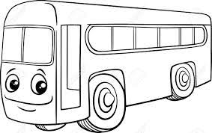 | 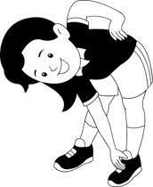 | 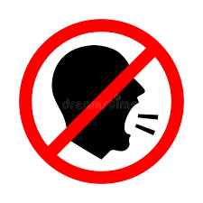
_________________________________________________________________________________
3- Do as shown between brackets:
2

 |  |  | 1- in – live – I - Riyadh . ( rearrange )
earache | toothache | headache | 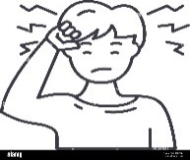  2– I have a _______. ( choose )
________________________________________________________________________________
4- Choose the correct word:
3

did | does | do | 1- Which subject ______ you like this year ?
got up | get up | do | 2- Did you ____ early this morning ?
plays | played | was | 3- The PAST of ( play ) is ____

5- Choose the right word under its picture:
5

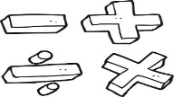 | 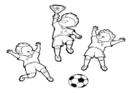 | 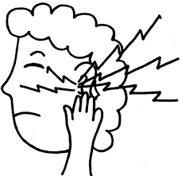 | 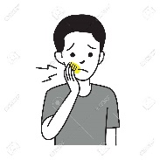 | 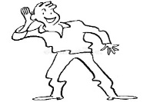  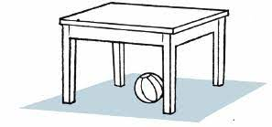
Math | Science | stomachache | Headache | Don't shout
English | PE | earache | toothache | Listen

_____________________________________________________________________________________________
6- Fill in the missing letters:
5

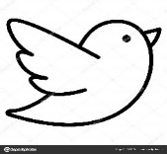  b_ _ d | 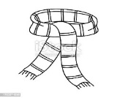  _ _arf | 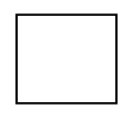  _ _uare | 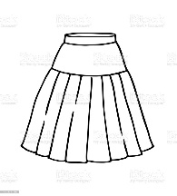  _ _ irt | 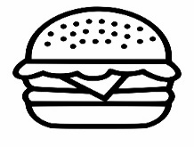  b_ _ger
ur | sk | sq | sk | ar
ir | sc | sk | sc | ur

_______________________________________________________________________________

Good luck

 The Grade
الاسم ثلاثي: |  | الفصل | / | الدرجة
Unit 1& 2 Exam

I. CHOOSE

- How many students are there in your school?
- No, I am not . | - About 500
- What should you do to live a healthy life ?
- I should go to bed early. | - I should skip breakfast.

222
II. CHOOSE OR

Our school has a school bus . | I shouldn't do some exercise . | Don't shout
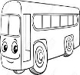

III. DO AS SHOWN BETWEEN BRACKETS

................................................................................................... |  |  | 1- in – live – I - Riyadh . ( rearrange )
earache | toothache | headache | 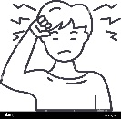  2– I have a _______. ( choose )

did | does | do | 1- Which subject ______ you like this year ?
got up | get up | do | 2- Did you ____ early this morning ?
plays | played | was | 3- The PAST of ( play ) is ____
IV. CHOOSE
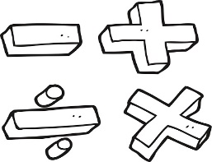 | 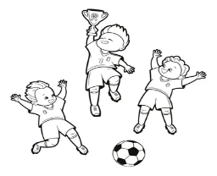 |  |  | 
Math | Science | stomachache | Headache | Don't shout
Engilsh | PE | earache | toothache | Listen
V. CHOOSE

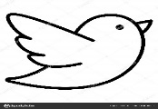  b_ _ d | 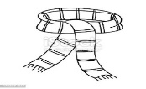  _ _arf |   _ _uare | 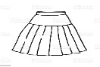  _ _ irt | 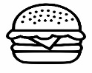  b_ _ger
ur | sk | sq | sk | ar
ir | sc | sk | sc | ur
VI. CHOOSE THE CORRECT LTTER

TEACHER :

The Grade
الاسم ثلاثي: |  | الفصل | / | الدرجة
Unit 1 Exam

I. CHOOSE

- How many students are there in your school?
- No, I am not . | - About 500
- What time does your school start?
- It starts at 6:30. | - Yes, he is.

222
II. CHOOSE OR

Our school has a school bus . | This year I like math . | Don't shout
 | 

III. DO AS SHOWN BETWEEN BRACKETS

................................................................................................... |  |  | 1- in – live – I - Riyadh . ( rearrange )
Listen | Speak | Do | 2– ____ English in class .( choose )

did | does | do | 1- Which subject ______ you like this year ?
went | goes | go | 2- Last year we ______ to Abha .
were | are | was | 3- The PAST of ( are ) is ____
IV. CHOOSE
 |  | 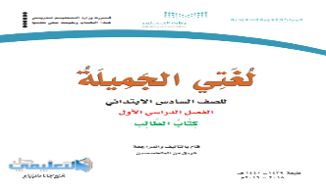 | 
Math | Science | History | Social studies | Don't shout
Engilsh | PE | Language | art | Listen
V. CHOOSE

  _ _ y | _ _arf | _ _uare | _ _ irt |   _ _an
sk | sk | sq | sk | sq
sc | sc | sk | sc | sc
VI. CHOOSE THE CORRECT LTTER

TEACHER :

