اسم الطالب/ة : ................................................ الفصل: .......................
6
I- General Questions:
A- Match the questions in column (A) with the correct answers in column (B):
B | A
( ) He is a doctor.  ( ) I cooked breakfast.  ( ) I made a rocket  ( ) 2 cups of flour  ( )I want to be a teacher  ( ) I usually go to bed at 9:00 | 1- What did you do over the weekend?  2- How much flour do we need ?  3-What good things happened to you last year ?  4- What does your dad do ?  5- What time do you go to bed ?  6- What do you want to be when you grow up ?

II- Controlled Writing:
5
A- Complete the sentences with the correct word:
sick
fires
thirty
1- Firefighter put out ______
2- Ten , twenty , ________ , forty.
3- Doctors help _________ people.

B- Rearrange the words to form a sentence:
1- game / We / a football / won
………………………………………………….
2- scary / How
………………………………………………….
III- Grammar:
5
A) Choose the correct word:
1- I usually ( take – took ) a bath in the morning.
2- Yesterday , I ( play – played ) computer games.
3- We don't have ( some – any ) oil.
B) Fill in the spaces with much or many :
1- How ________ oil do you need ?
2- How ________ apples do you eat ?

IV- Reading Short Sentence:
A- Read the sentences and match them with the correct pictures:
4

1- It's 10:30 2- a half past three 3- He is a baker
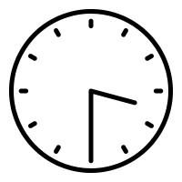
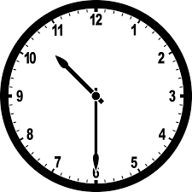


B- Read the question and choose the correct answer:
1- I broke my leg.
a) congratulations b) How nice c) sorry about that

6
V- Vocabulary:
A) Write the correct number under each picture:
1- pizza 2- teacher 3- boot 4- diver 5- bed 6- reporter

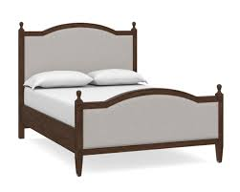
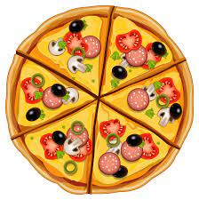


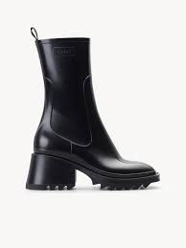


( ) ( ) ( ) ( ) ( ) ( )
VI- Orthography:
4
A) Choose the correct letter:

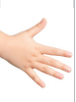
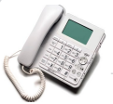
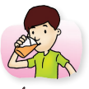

1- dri_ _ 2- _ _one 3- ha_ _ 4- lau_ _
( nk – sh – ch ) ( f – ph – kn ) ( gh – sh – nd ) ( gh – nt – nk )

I General Question

6
A-Choose the corret sentence:
I usually go to bed at 9:00. | ß | He is a pilot. | ą | What time do you go to bed? | 1
I want to be a teacher. | ß | I saw a rainbow | ą | What happened to you? | 2
She is fine. | ß | He is a scientist. | ą | What does your dad do? | 3
Yes, please. | ß | No, she doesn't | ą | Can I help you? | 4

Match :
B | A
( ) How nice. | 1-I won a football match 3 to 0
( ) congratulations. | 2-My friends were stuck in the train.
( ) That's scary.

II Controlled Writing

5
A- Rearrange the words to form sentences:
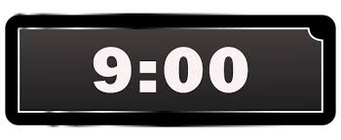
1- nine / It's /o'clock .
…………………………………………………………………………………………………………….

2-cleaned /my /I / room .
…………………………………………………………………………….
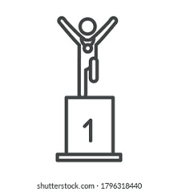
3- got /first place / I .
……………………………………………………………………………………………………………………

4- is /a reporter / she.
……………………………………………………………………………………
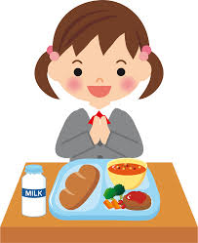
5- eat / my / I / lunch.
……………………………………………………………………………....

III Reading short Sentences

4
A- Match
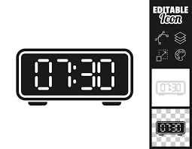 |  | 1- He kicked the ball.
 |  | 2- My dad is a firefighter.
 |  | 3- It's seven thirty.
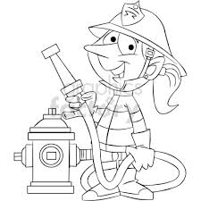 |  | 4- I want to be a baker.

IV Grammar

5
A – Choose:
1- ( How much – How many ) apples are there?
2- We have ( some – any ) milk in the house.
3- ( How much – How many) sugar do you want.
4- Yesterday, I ( watched – watch ) a DVD about animals.
_____________________________________________________________
B- Write the past form of the verb:
1- play :………………………………. 2- eat:………………………….
3- take: ……………………………… 4- cook :……………………….
________________________________________________________________
C- Choose a suitable comment:
1- I made a rocket. ( sorry for that – How a nice).
2- I won a basketball game. ( congratulations – How scary).
________________________________________________________
V Vocabulary

6
A-Write the suitable word:
(butter _ boots _ chocolate _ teeth _ businessman _ train station )

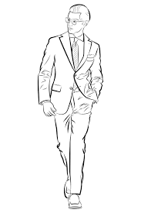 | 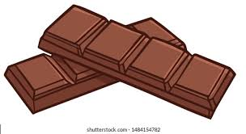 | 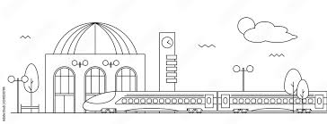 | 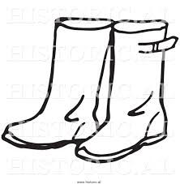 | 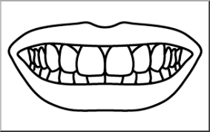 | 

B-Classify the words:
( mangoes – doctor – How nice – oranges – nurse – that's fantastic)
jobs | comments | fruits

________________________________________________________
VI Orthography
Choose the correct missing letter:
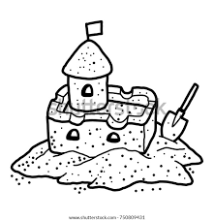 |  | 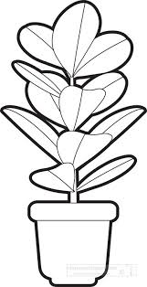 | 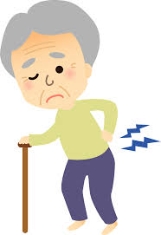 | 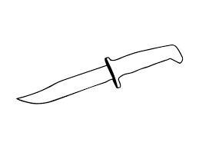 |  |  | 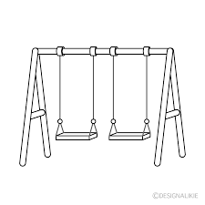  4
Sa_ _  nd - nt | _ _one  gh - ph | Pla_ _  nt - nd | ba_ _  ck - nk | _ _ ife  kn - gh | Lau- -  gh - ph | n_ _t  gh - kn | swi_ _  ng - nk
The End
With my best wishes / Tr. Abeer Nasser
السؤال | الدرجة | كتابةً | المصحح | التوقيع

س1

س2
س3
س4
س5
س6
المجموع :
المراجع : التوقيع :

 الــمـملكة الـعربية السـعوديـة بسم الله الرحمن الرحيم

وزارة التعليم

الإدارة العامة للتعليم -------

مكتب تعليم ------

مدرسة -------- الابتدائية

أسئلة اختبار نهاية الفصل الدراسي الثاني للعام الدراسي 1445هـ

( الدور الأول )

المادة: اللغة الإنجليزية الصف: الخامس الابتدائي الزمن: ساعة ونصف ( الفصل : / )

اسم الطالب / ................................................................. رقم الجلوس ( .........................)
1.General Questions: A. Match "A" with "B":
A
1- How much flour do we need ?
2- What does your dad do?
3- What time do you go to bed ?

B
I usually go to bed at 9:00 | ( )
He is a doctor . | ( )
2 cups of flour . | ( )

B. Choose the correct answer:

1 | What did you do over the weekend?
1 | a | I cooked breakfast. | b | She is a nurse. |  | c | Here you go.
2 | What good things happened to you last year?
2 | a | I lost a game. | b | I made a rocket. |  | c | I stayed home.
3 | What do you want to be when you grow up?
3 | a | I went to bed. | b | He is painting. |  | c | I want to be a teacher.

2.Reading Short Sentence: Choose ( ) or ( )
1. It's half past three.
2. He wants to be a player.
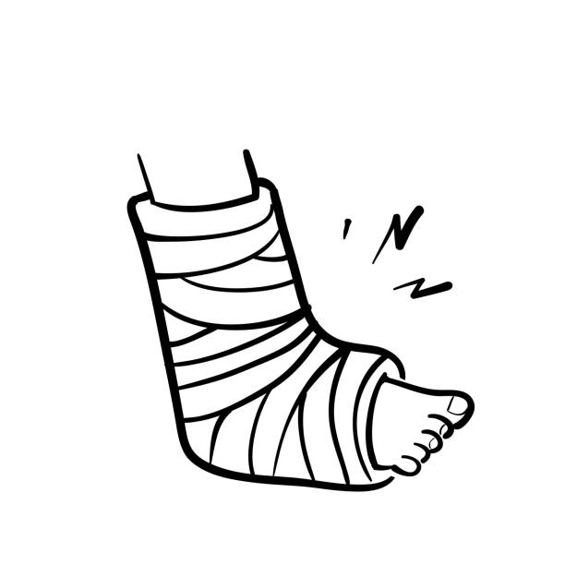 3. I broke my hand.
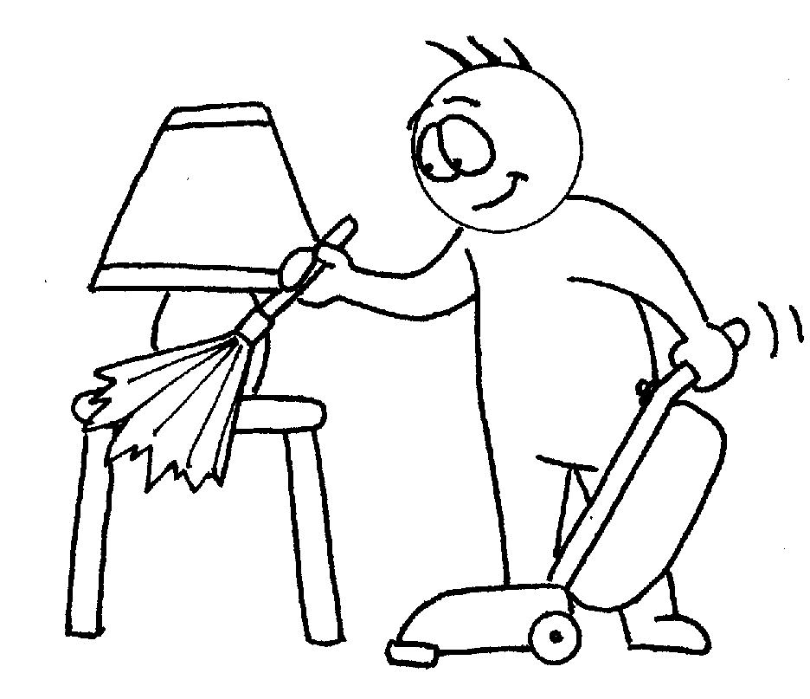 4. I cleaned my room.
3.Orthography: Choose the missing letters:

nk - ck | ph - fe | nt - nd | sh - gh
dri__ __ | __ __ one | ha __ __ | lau__ __

4.Grammar: Choose the correct answer:

1 | I usually …… a bath in the morning.
1 | a | take | b | took |  | c | takes
2 | Yesterday, I …… computer games.
2 | a | played | b | play |  | c | playing
3 | We don't have …… oil.
3 | a | some | b | any |  | c | more
4 | How …… apples do you eat?
4 | a | much | b | many |  | c | any
5 | I …… a cold.
5 | a | catching | b | Catched |  | c | caught

5.Vocabulary: Write the correct word under the correct picture:
1- pizza 2- teacher 3- boot 4- diver 5- bed 6- reporter
 |  | 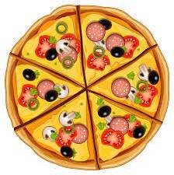 | 

6.Controlled Writing: A. Rearrange the words to make a correct sentence:

game / We / a football / won .

______________________________________________.

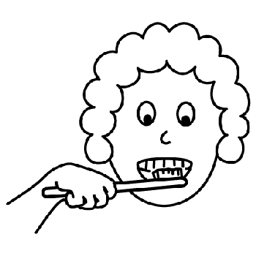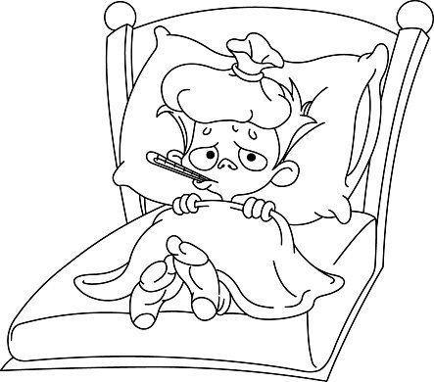B. Unscramble the words:

1. kcis = ____________ 2. burhs = ________

3. tyhrit = ___________ 30

C. Copy:

My dad had an operation.

_____________________________________________________________________________________

GOOD LUCK انتهت الأسئلة


المملكة العربية السعودية الصف السادس الابتدائي

وزارة التعليم الفصل الدراسي الثاني
الابتدائية .............. الزمن : ساعة ونصف ساعة

الاختبار النهائي لمادة اللغة الإنجليزية للصف السادس الابتدائي الفصل الدراسي الثاني للعام الدراسي 1445 هـ

_________________________________________________________________________________________________________________________________________________________________________
General Questions
6 /

Match the sentence with the correct picture: ( 6 marks )

1- I brush my teeth. 4 – I cleaned my room .
2 – You practiced on the trampoline. 5- I caught a cold .
3 – He watched a DVD about sharks. 6- I was a team captain

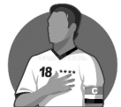 | 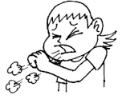 | 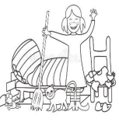 |  | 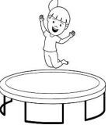 | 
_____________________________________________________________

Controlled Writing
5 /

Rearrange these sentences: ( 3 marks )

operation / dad / an / My / had

------------------------------------------------------------------------------------------------

stayed -Nora - home.

------------------------------------------------------------------------------------------------

ate – lunch – I

------------------------------------------------------------------------------------------------

B) Choose the correct answer: ( 2 marks )

1-What does he do? ( a- He is a cook. b- He’s Faisal )

2-Where does he work? ( a- He is a doctor . b- In a restaurant.)

(2)
____________________________________________________________________

Reading
4 /
Read the following sentences then Put (✓ T ) or ( x F ): ( 4 marks )

1- We were stuck in an elevator . | 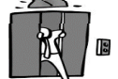 | ( )
2- This is a ring . | 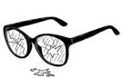 | ( )
3- I got first place in a race . |  | ( )
4- It's three o'clock . | 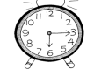 | ( )

Grammar
5 /

choose the correct answer : ( 5 marks )

- She ……………………. the breakfast
- cooked | - cleaned | - kicked
- How ………… flour do we need ?
- many | - much | - some
- 2- Yesterday I ……….up at five o'clock.
- get | - gotten | - got
- I usually ………. my homework at 4 o'clock .
- do | - did | - does
- I ……………… a big fish.
- were | - caught | - was
___________________________________________________________________

(3)

______________________________________________________________________

Vocabulary
6 /

Match the words to the correct picture : ( 6 marks )

hand– rock– knock – astronaut- firefighter – right

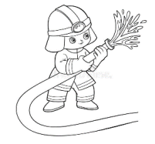 | 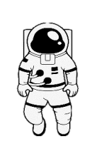 | 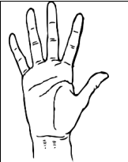 | 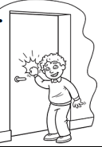 | 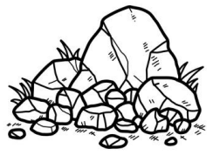 | 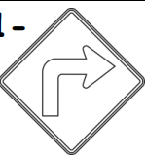

Orthography
4 /

Fill in the missing letters : ( 4 marks )

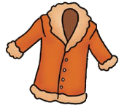 | 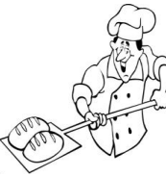 | 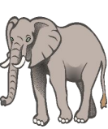 | 
C _ at | ba _ er | e_ephant | Rain_ow

Good luck

(4)

