

للصف الرابع الابتدائي

The Principle | Supervisor | Teacher
............................ | ............................ | ............................

Unit 1 The body
2 Reading and writing
a Guess what the abbreviations associated
with vacation advertisements mean.
Choose from the box.
S/C _______________________________ .
1 O/W _______________________________ .
2 R/O _______________________________ .
3 Rtn. _______________________________ .
4 B+B _______________________________ .
5 1 Nt. _______________________________ .
b Complete
Write parts of the body :
Copy the following words:

head | eye | nose | ear | mouth
……………………………………………………………………………………………………………………………………………………
…………………………………………………………………………………………………...............................................................
……………………………………………………………………………………………………………………………………………………
…………………………………………………………………………………………………...............................................................
……………………………………………………………………………………………………………………………………………………
…………………………………………………………………………………………………...............................................................
……………………………………………………………………………………………………………………………………………………
…………………………………………………………………………………………………...............................................................
finger | arm | toes | leg | hand
……………………………………………………………………………………………………………………………………………………
…………………………………………………………………………………………………...............................................................
……………………………………………………………………………………………………………………………………………………
…………………………………………………………………………………………………...............................................................
……………………………………………………………………………………………………………………………………………………
…………………………………………………………………………………………………...............................................................
……………………………………………………………………………………………………………………………………………………
…………………………………………………………………………………………………...............................................................

Draw and color:

a mouth a bag a head an eye

A pen a tree a hand a car

Write b , h , or p:

………ag …………ead

……..en …………oat

…….and ………..encil

aero…..lane ….……ook

Unit 2
My face
Write parts of the face :
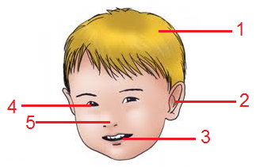
1- ……………………….
2-………………………..
3-………………………..
4-………………………..
5-………………………..

Color the following :

green black white blue

yellow red pink brown

Write m , n , and r:

1 -………..outh 2 - ……ose

3 - o…..ange 4 - ca……

5 -ha…….d 6- ar……..

7 -…osque 8- ……abbit

9- ea……. 10- s….all
robot | hair | red | green | blue
…………………………………………………………………………………………………………………………………………………
…………………………………………………………………………………………………...............................................................

…………………………………………………………………………………………………………………………………………………
…………………………………………………………………………………………………...............................................................

…………………………………………………………………………………………………………………………………………………
…………………………………………………………………………………………………...............................................................

…………………………………………………………………………………………………………………………………………………
…………………………………………………………………………………………………...............................................................
white | black | brown | pink | yellow
…………………………………………………………………………………………………………………………………………………
…………………………………………………………………………………………………...............................................................

…………………………………………………………………………………………………………………………………………………
…………………………………………………………………………………………………...............................................................

…………………………………………………………………………………………………………………………………………………
…………………………………………………………………………………………………...............................................................

…………………………………………………………………………………………………………………………………………………
…………………………………………………………………………………………………...............................................................
Copy the following words

Unit 3
My house
Look at the pictures, then write :

……………………………… ……………………………… ………………………………

……………………………… ………………………………

Circle I , u , and y :

1 – juice 7 -living

2 – umbrella 8 –rice

3 – mouth 9 -chair

4 – yoyo 10 - yellow

5 –key 11 -mug

6 – kitchen 12 –say

Copy the following sentences :

There`s the living room .
…………………………………………………………………………

…………………………………………………………………………

…………………………………………………………………………

Look ! There `s a garden.

…………………………………………………….......................

……………………………………………………………………..

……………………………………………………………………..

Look ! There`s a key.

……………………………………………………………………...
……………………………………………………………………..

……………………………………………………………………..

Where is the book ?

……………………………………………………………………..

……………………………………………………………………..

……………………………………………………………………

Unit 4
Food
Look, read and number :

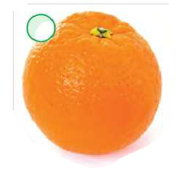
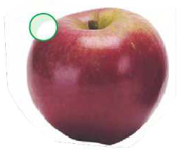
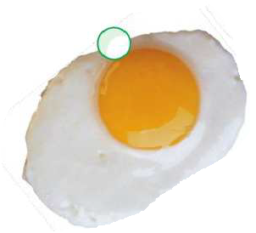
- an apple

- an egg

- an orange
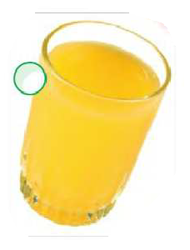
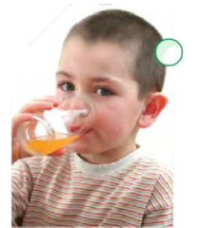
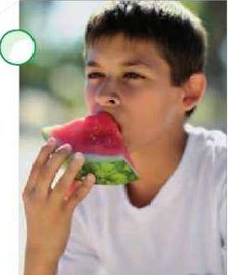
- juice

- eat

- drink

Match and make words :

1 – x- lla

2 - living dow

3 - vi ray

4 - yo room

5 – win yo

Choose the right letter:

1 - ……illa ( v - w - x )

2 - …ray ( v - w - x )

3 - ….indow ( v - w - x )

4 - …….hite ( v - w - x )

5 – bo…. ( v - w - x )

6 - ….here ( v - w - x )

Revision

Read , draw , and color :

a yellow yoyo a red rabbit a black hen

Orange juice a blue bag a green pencil

Unit 6
In the street
Read and match :
- taxi

- bus

- Shop

- traffic lights

- mosque

- street

Choose the right letter :

1 - ……..ye ( f - k - s - z )

2 - …….oot ( f - k - s - z )

3 -…… ish ( f - k - s - z )

4 – no…..e ( f - k - s - z )

5 – mo…..que ( f - k - s - z )

6 - ………..oo ( f - k - s - z )

Trace and copy the following sentences :

There`s a mosque on yellow street.

……………………………………………………………………………………….

………………………………………………………………………………………..

………………………………………………………………………………………..

There`s a shop on green street .

…………………………………………………………………………………………

…………………………………………………………………………………………

…………………………………………………………………………………………

copy the following sentences

taxi | bus | shop | street | mosque
…………………………………………………………………………………………………………………………………………………
…………………………………………………………………………………………………...............................................................

…………………………………………………………………………………………………………………………………………………
…………………………………………………………………………………………………...............................................................

…………………………………………………………………………………………………………………………………………………
…………………………………………………………………………………………………...............................................................

…………………………………………………………………………………………………………………………………………………
…………………………………………………………………………………………………...............................................................

traffic lights | key | zoo | fish | shirt
…………………………………………………………………………………………………………………………………………………
…………………………………………………………………………………………………...............................................................

…………………………………………………………………………………………………………………………………………………
…………………………………………………………………………………………………...............................................................

…………………………………………………………………………………………………………………………………………………
…………………………………………………………………………………………………...............................................................

…………………………………………………………………………………………………………………………………………………
…………………………………………………………………………………………………...............................................................
Unit 7
Day and weather
Look at the pictures and write :
………………………………………………………………………………………….
……………………………………………………………………..
Choose the right letter:
1 - …. …. Obe ( th - ch - wh )

2 - …. ….air ( th - ch - wh )

3 - ….. ….ite ( th - ch - wh )

4 – bro…. … er ( th - ch - wh )

5 – mou…. …. ( th - ch - wh )

6 - ….. …… icken ( th - ch - wh )

7 - …. …. ere ( th - ch - wh )

8 - ….. ….at ( th - ch - wh )
Unscramble the following to make meaningful sentences:
1 – and – cold – It – cloudy – is – today .

………………………………………………………. .
2 - is – It – today – rainy – cold – and .

………………………………………………………. .
3- the weather – What`s – today – like ?

…………………………………………………………
4 – morning – good .

…………………………………………………………. .
Draw and color

black stars red sun yellow moon

A red chair white clouds a blue umbrella

Trace and copy the following sentence:

Put on the thobe .
………………………………………………………………………………..

…………………………………………………………………………………..

……………………………………………………………………………………

Unit 8
My school
Look at the pictures and write :
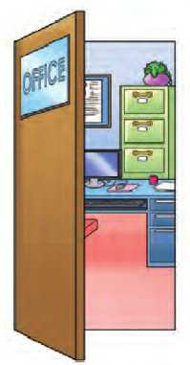
………………………………………………………………………………………….

Pronounce the following words :
1 – office 7 – gate

2 – shoes 8 - library

3 – elephant 9 - classroom

4 – fish 10 - whiteboard

5 – shirt 11 - school

6 – phone 12 –brother

Trace and copy the following sentences :

What are these ?

…………………………………………………………………………………………

………………………………………………………………………………………….

………………………………………………………………………………………….

These are pens

………………………………………………………………………………………….

………………………………………………………………………………………….

…………………………………………………………………………………………
Choose the right letters :

1 - …. … one ( sh - ph - ch )

2 - …… ….oes ( sh - ph - ch )

3 - …. ….irt ( sh - ph - ch )

4 – fi…. ….. ( sh - ph - ch )

5 – ele …. …. ant ( sh - ph - ch )

Trace and copy

Phone …………………………………………………………………………………
………………………………………………………………………………….
…………………………………………………………………………………..

Shoe …………………………………………………………………………………
………………………………………………………………………………….
…………………………………………………………………………………

fish …………………………………………………………………………………
…………………………………………………………………………………
…………………………………………………………………………………

White ………………………………………………………………………………….
…………………………………………………………………………………
………………………………………………………………………………….

Chair …………………………………………………………………………………
…………………………………………………………………………………
………………………………………………………………………………….

Unit 9
My country
Look at the pictures and write :
………………………………………………………………………………………….
Find ph - sh – th – ch - and wh . Circle

1 – phone 2 – elephant

3 - fish 4- shop

5 – thobe 6- brother

7 – white 8 – shirt

Read the following sentences :

- There`s a map of Qatar .

2 – There`s the Holy Qura`n.

3 – The flag of Saudi Arabia is green.

4 – I am from Egypt.
Choose the right letters :

1 – bro….. …. er ( th - wh - sh - ph )

2 - …. …. Icken ( th - wh - sh - ph )

3 - …. ….oes ( th - wh - sh - ph )

4 - ….. …..ite ( th - wh - sh - ph )

5 – ele … …ant ( th - wh - sh - ph )

6- … … op ( th - wh - sh - ph )
Trace and write in order

3 5 7 9 0 1 6 8 4 2

----- ------- ------- ------- ------ ------ ------ ------ -------- ----

Complete the alphabets :

a ………. C …….e ………. ……. h……
j ….. …… m …… o p ……..
r ….. .. …. ….. v w ……..
……. z
Draw and color three hens

