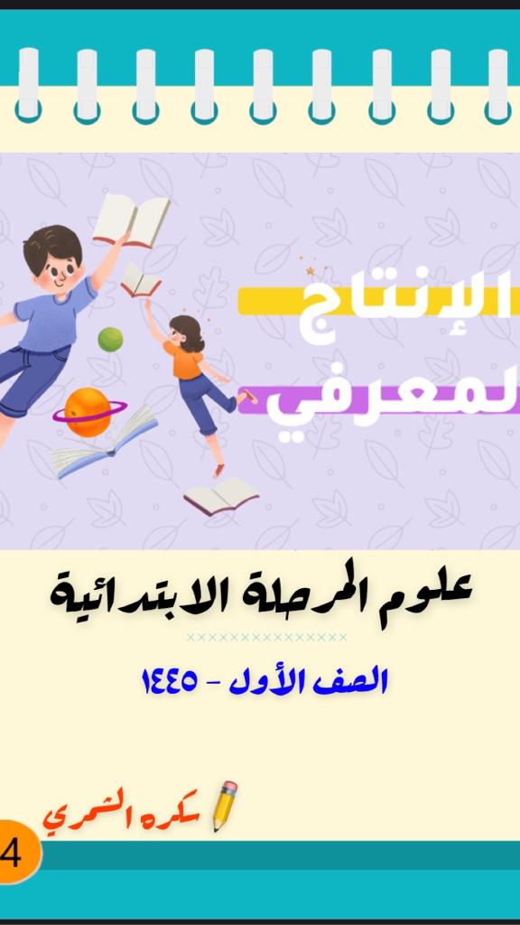

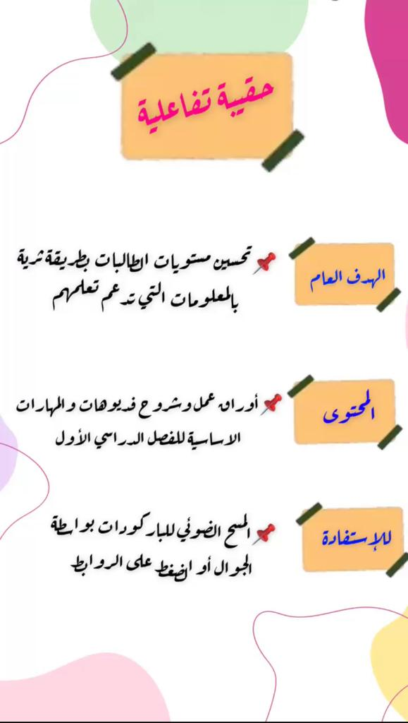



**علوم الصف الأول الفصل الدراسي الأول**

[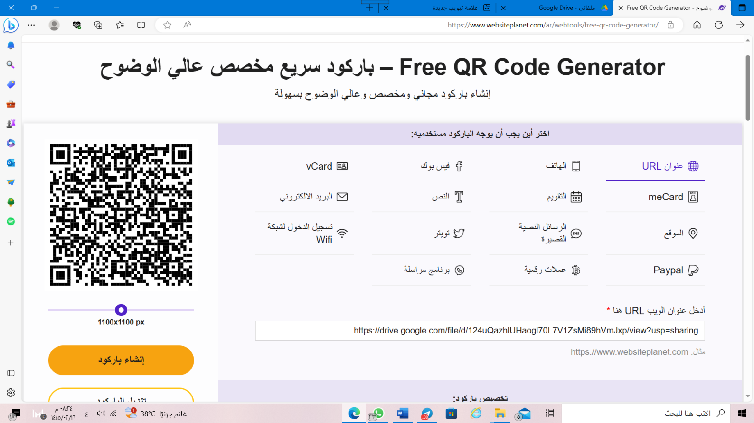](https://drive.google.com/file/d/124uQazhlUHaogl70L7V1ZsMi89hVmJxp/view?usp=sharing)[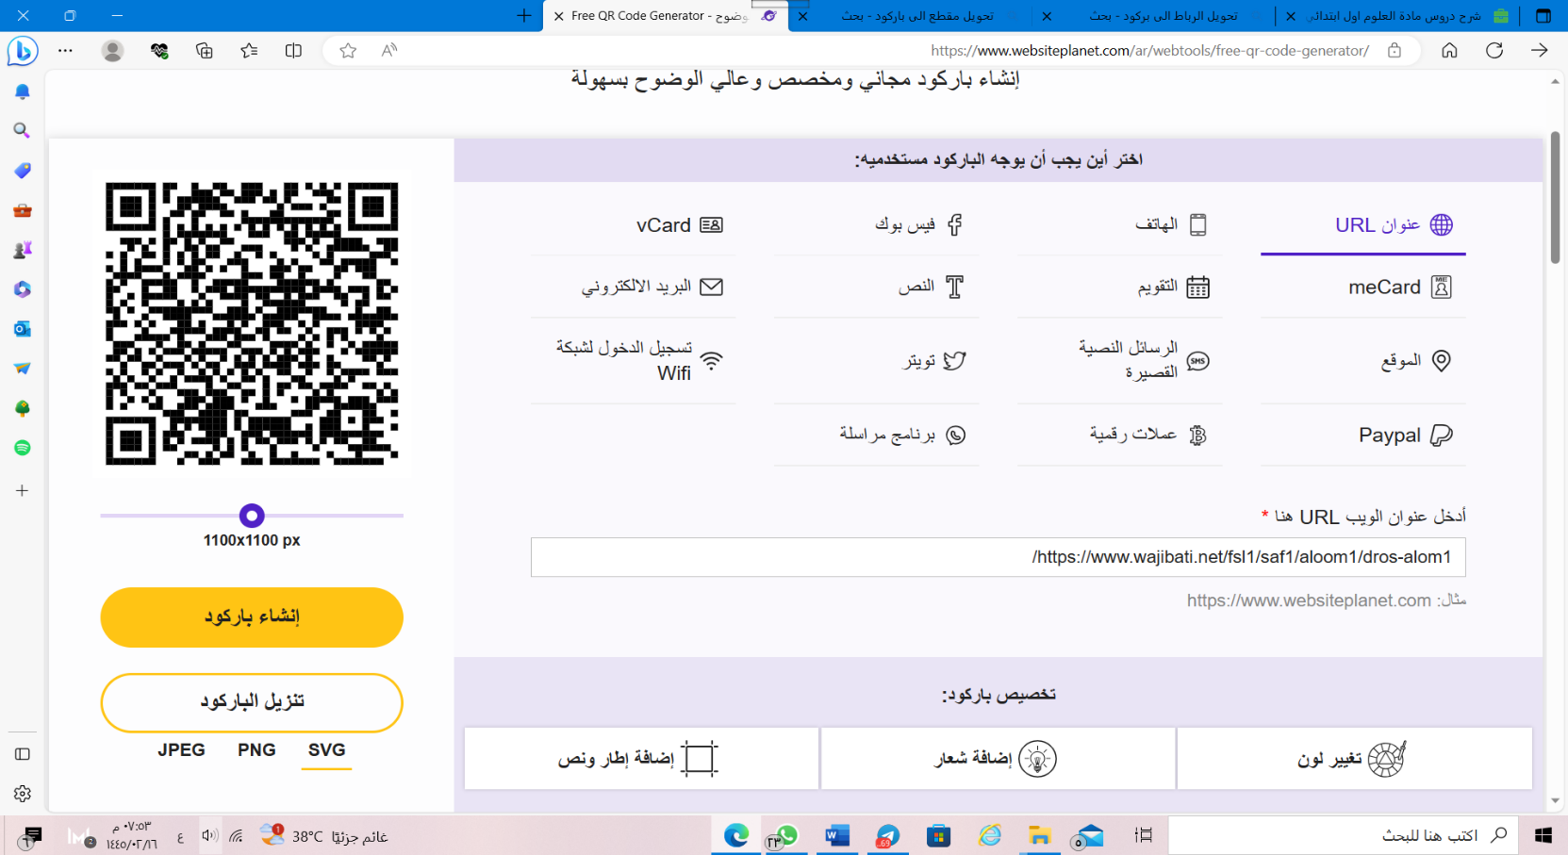](https://www.wajibati.net/fsl1/saf1/aloom1/dros-alom1/)[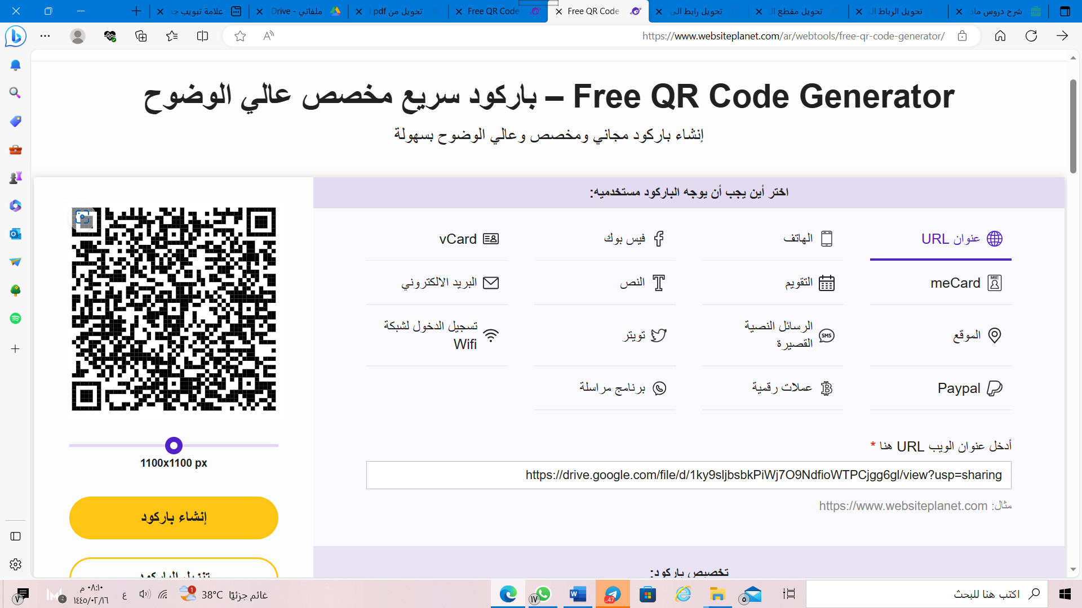](https://drive.google.com/file/d/1ky9sljbsbkPiWj7O9NdfioWTPCjgg6gl/view)[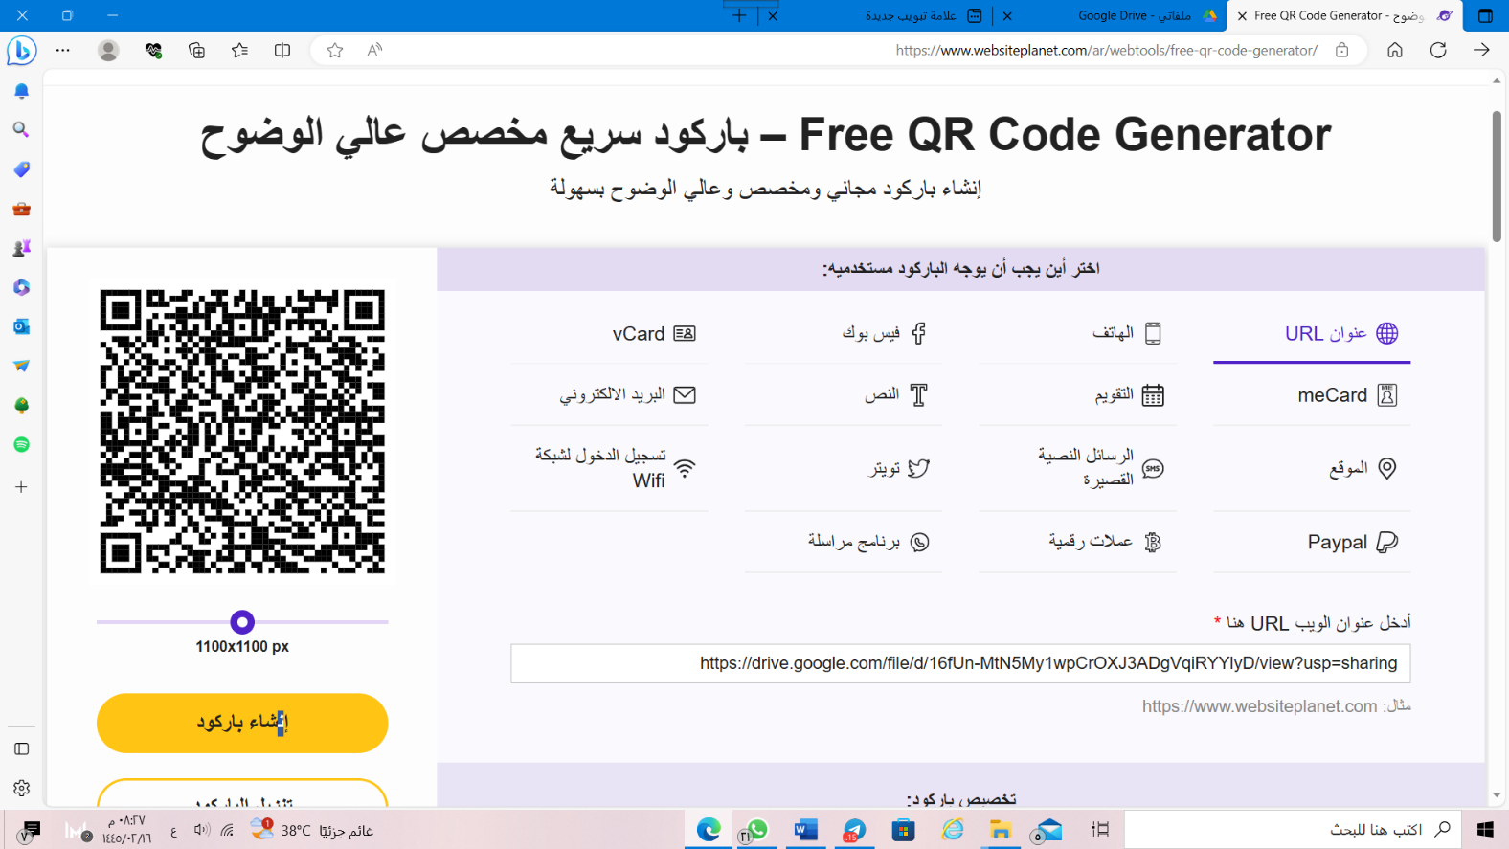](https://drive.google.com/file/d/16fUn-MtN5My1wpCrOXJ3ADgVqiRYYlyD/view?usp=sharing)