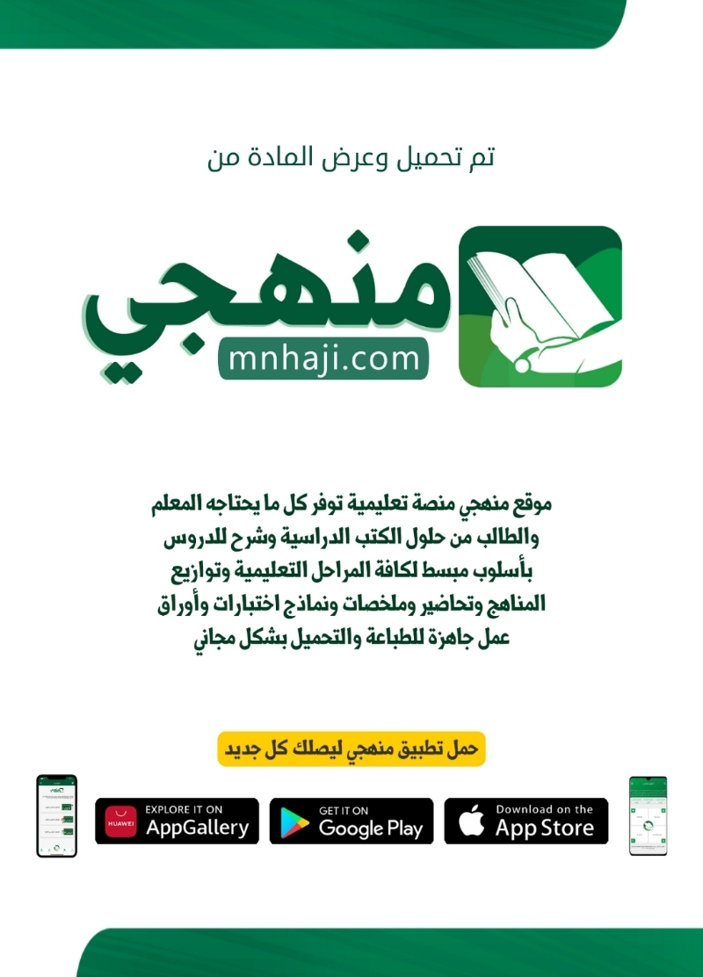

English language
Level 3.2 /Second term /1445 H
Oral Test
Time :25 minuets
K.S.A
The Ministry of Education
The General Administration of Education
For Girls in ……….
…………………secondary school \ girls

First Session
Student`s name :………………………….…………………… Seat no: (……..).

السؤال | الدرجة رقما | الدرجة كتابة | المصححة | المراجعة | المدققة
Q 1

ــــــــ5
Listen carefully then Put ( T ) Or ( F ) :

1. Both Jenna and Alicia are studying pre-law ( F ) .
.
( F ). They have different accents and mannerisms.2

( T ). They have been painting since they were fives .3

4. They planned to study teaching ( T ).

( T ). They have the same recurring dream.5

>>>>>>>>>>>>>>>>>>>>>>>>>>>>>>>>>>>>>>>>>>>>>>>>>>>>>>>>>>>>>>



The End
your teacher : ……………………….. ♥

Audioscript
Alicia Smith and Jenna Greer are identical twins who, at birth, were
orphaned and adopted by different families. Incredibly, they grew
up just 25 kilometers apart from one another, with each believing
that she was an only child.
Some would say that the story of their recent accidental reunion
was coincidence. Some would say it was meant to be. Upon
graduating from high school, each of the girls chose to study
psychology at universities only 2 kilometers apart. While attending
university, Jenna kept noticing that strangers would wave and
say hello to her. Meanwhile, Alicia’s friends complained that she
sometimes didn’t wave back at them when they saw her on the
street. Listen to the young women tell the story of how they
discovered one another.
Alicia: A friend of Jenna’s came to a study meeting at our dorm
when I was twenty. She was shocked by how much I looked like
a friend of hers. Of course, that friend was Jenna. She kept telling
me that I had to meet this friend. She showed me a picture of
Jenna and gave me her email address.
Jenna: After exchanging a couple of emails and talking to our
parents, we discovered that we were sisters. So we made plans
to meet.
Alicia: The first meeting was really emotional. I thought my heart
was going to thump out of my chest. It was strange seeing my
face on someone else’s body. And as soon as we started talking,
we both noticed how similar our accents and mannerisms were.
Jenna: As we got to know each other, we found out that we’d
lived lives that were, in many ways, incredibly similar. It’s uncanny
how much we have in common. Both of us have been painting
since we were five, we both liked horses, we both planned to
study teaching, and we had both volunteered at the community
support center.
Alicia: But I think the strangest thing of all is that we even have
the same recurring dream. One time when Jenna and I were
talking, she described the same dream that I’ve had since I was a
child. I was so freaked out that I just dropped the phone.
Jenna: I really believe that we are meant to be together. I think it
was supposed to happen now. Not when we’re older, or when we
were younger and wouldn’t have understood. This way we can
enjoy each other for the rest of our lives.


Final Listening Exam The Secondary School
Third Secondary Grade First Semester 1445 H

Name/ ……………………………………………………….. class/ …………………

Listen to the dialogue about Dinner carefully, then answer the questions below:

A. Circle True or False for these sentences.

The sentence | ( T ) | ( F )
1. The mother made a fish, rice and carrot for dinner. | True √ | False X
2. She also made a salad with a chicken. | True √ | False X
3. She is going to serve ice cream for a dessert. | True √ | False X
4. The boy wasn't hungry because he ate burger before. | True √ | False X
5. She made a delicious soup with a shrimp. | True √ | False X
6. The boy wanted to eat pizza. | True √ | False X

B. Choose the correct answers:

1- The mother prepared a delicious seafood salad with a ------------------.
a) pasta | b) shrimp | c) tomato
2- She baked an apple ------------------ for dessert.
a) cake | b) pie | c) waffle
3- She has cooked for ------------------ hours.
a) 2 | b) 6 | c) 3
4- The boy had a chocolate ------------------.
a) pancake | b) ice cream | c) shake
5- The mother told her son that she was making something nice that ------------------
a) morning | b) evening | c) night
6- The boy ate burger and ------------------
a) cheesecake | b) fries | c) pizza

C. Write the correct words given under the pictures:
Fries salad seafood

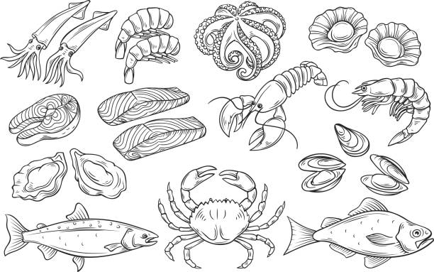
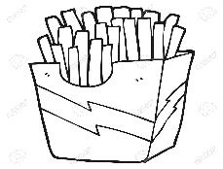

…………………………… ………………………..
Best of luck

Final Listening Exam The Secondary School
Third Secondary Grade First Semester 1445 H

Name/ ……………………………………………………….. class/ …………………

Listen to the dialogue about Dinner carefully, then answer the questions below:

A. Circle True or False for these sentences.
A. Circle True or False for these sentences.

The sentence | ( T ) | ( F )
1. The mother made a fish, rice and carrot for dinner. | T | F
2. She also made a salad with a chicken. | T | F
3. She is going to serve ice cream for a dessert. | T | F
4. The boy wasn't hungry because he ate burger before. | T | F
5. She made a delicious soup with a shrimp. | T | F
6. The boy wanted to eat pizza. | T | F

B. Choose the correct answers:

1- The mother prepared a delicious seafood salad with a ------------------.
a) pasta | b) shrimp | c) tomato
2- She baked an apple ------------------ for dessert.
a) cake | b) pie | c) waffle
3- She has cooked for ------------------ hours.
a) 2 | b) 6 | c) 3
4- The boy had a chocolate ------------------.
a) pancake | b) ice cream | c) shake
5- The mother told her son that she was making something nice that ------------------
a) morning | b) evening | c) night
6- The boy ate burger and ------------------
a) cheesecake | b) fries | c) pizza
C. Write the correct words given under the pictures:
Fries salad seafood

seafood Fries
Best of luck

Transcript for Online safety conversation
Man: I'm home!
Woman: Hi sweetie. Welcome home. Are you ready to eat?

Man: Well, . . . uh . . .

Woman: Uh, we're having fish and seasoned rice and carrots for the main course.

Man: Really? Um . . Yeah.

Woman: What? What?

Man: Oh, that sounds great.

Woman: Are you sure?

Man: Sure.

Woman: Hm. Well, before that, I have a delicious seafood salad with shrimp.

Man: Oh.

Woman: And, for desert, I made apple pie.

Man: Oooh.

Woman: Honey. It took me three hours to make.

Man: Oh . . . well . . . yeah . . . um . . . yeah.

Woman: Hmm. What's wrong? Don't you like . . . don't you like what I made?

Man: Well, to be honest, I just had a hamburger, fries, and a chocolate shake.

Woman: You're kidding. Really?

Man: Yeah. I'm sorry. I didn't know that you were making . . .

Woman: Honey. I told you this morning that I was making you something nice.

Man: Yeah, but I forgot. You . . . you know how work is. Wait, wow, WAIT!! What are you doing? Why are you putting the food in my shoes?

Woman: So you can enjoy it as you walk to work tomorrow.

Man: Ah

Final Listening Exam The Secondary School
Third Secondary Grade First Semester 1445 H

Name/ ……………………………………………………….. class/ …………………

Listen to the dialogue about Dinner carefully, then answer the questions below:

A. Circle True or False for these sentences.

The sentence | ( T ) | ( F )
1. The mother made a steak, rice and carrot for dinner. | True √ | False X
2-The boy wasn't hungry because he ate burger before. | True √ | False X
3. She is going to serve pancake for a dessert. | True √ | False X
4-She also made a salad with a shrimp. | True √ | False X
5. She made a delicious banana cake. | True √ | False X
6. The boy doesn't want to eat. | True √ | False X

B. Choose the correct answers:

1- The mother prepared a delicious ------------------ salad with a shrimp.
a) pasta | b) seafood | c) tomato
2- She baked an ------------------ pie for dessert.
a) apple | b) banana | c) lemon
3- She has cooked for ------------------ hours.
a) 2 | b) 6 | c) 3
4- The boy had a ------------------ shake.
a) milk | b) chocolate | c) avocado
5- The mother told her son that she was making something nice that ------------------
a) morning | b) evening | c) night
6- The boy ate ------------------ and fries.
a) pasta | b) pizza | c) burger

C. Write the correct words given under the pictures:
Fries salad seafood

…………………………… ………………………..
Best of luck

Final Listening Exam The Secondary School
Third Secondary Grade First Semester 1445 H

Name/ ……………………………………………………….. class/ …………………

Listen to the dialogue about Dinner carefully, then answer the questions below:

A. Circle True or False for these sentences.

The sentence | ( T ) | ( F )
1. The mother made a steak, rice and carrot for dinner. | T | F
2-The boy wasn't hungry because he ate burger before. | T | F
3. She is going to serve pancake for a dessert. | T | F
4-She also made a salad with a shrimp | T | F
5. She made a delicious banana cake. | T | F
6. The boy doesn't want to eat. | T | F

B. Choose the correct answers:

1- The mother prepared a delicious ------------------ salad with a shrimp.
a) pasta | b) seafood | c) tomato
2- She baked an ------------------ pie for dessert.
a) apple | b) banana | c) lemon
3- She has cooked for ------------------ hours.
a) 2 | b) 6 | c) 3
4- The boy had a ------------------ shake.
a) milk | b) chocolate | c) avocado
5- The mother told her son that she was making something nice that ------------------
a) morning | b) evening | c) night
6- The boy ate ------------------ and fries.
a) pasta | b) pizza | c) burger

C. Write the correct words given under the pictures:
Fries salad seafood

…………………………… ………………………..
Best of luck

Final Listening Exam The Secondary School
Third Secondary Grade First Semester 1445 H

Name/ ……………………………………………………….. class/ …………………

Listen to the dialogue about Dinner carefully, then answer the questions below:

A. Circle True or False for these sentences.

The sentence | ( T ) | ( F )
1. The mother made pasta, rice and carrot for dinner. | True √ | False X
2. She also made a caramel cake. | True √ | False X
3. She is going to serve an apple pie for a dessert. | True √ | False X
4. The boy wasn't hungry because he ate burger before. | True √ | False X
5. She made a delicious seafood salad with a shrimp. | True √ | False X
6. The boy wanted to eat noodles. | True √ | False X

B. Choose the correct answers:

1- The mother prepared a delicious seafood salad with a ------------------.
a) pasta | b) shrimp | c) tomato
2- She baked an apple ------------------ for dessert.
a) cake | b) pie | c) waffle
3- She has cooked for ------------------ hours.
a) 2 | b) 6 | c) 3
4- The boy had a chocolate ------------------.
a) shake | b) ice cream | c) pancake
5- The mother told her son that she was making something nice that ------------------
a) evening | b) morning | c) night
6- The boy ate burger and ------------------
a) cheesecake | b) fries | c) pizza

C. Write the correct words given under the pictures:
Fries salad seafood

…………………………… ………………………..
Best of luck

Final Listening Exam The Secondary School
Third Secondary Grade First Semester 1445 H

Name/ ……………………………………………………….. class/ …………………

Listen to the dialogue about Dinner carefully, then answer the questions below:

A. Circle True or False for these sentences.

The sentence | ( T ) | ( F )
1. The mother made pasta, rice and carrot for dinner. | True √ | False X
2. She also made a cake with a caramel. | True √ | False X
3. She is going to serve an apple pie for a dessert. | True √ | False X
4. The boy wasn't hungry because he ate burger before. | True √ | False X
5. She made a delicious seafood salad with a shrimp. | True √ | False X
6. The boy wanted to eat noodles. | True √ | False X

B. Choose the correct answers:

1- The mother prepared a delicious seafood salad with a ------------------.
a) pasta | b) shrimp | c) tomato
2- She baked an apple ------------------ for dessert.
a) cake | b) pie | c) waffle
3- She has cooked for ------------------ hours.
a) 2 | b) 6 | c) 3
4- The boy had a chocolate ------------------.
a) pancake | b) ice cream | c) shake
5- The mother told her son that she was making something nice that ------------------
a) morning | b) evening | c) night
6- The boy ate burger and ------------------
a) cheesecake | b) fries | c) pizza

C. Write the correct words given under the pictures:
Fries salad seafood

…………………………… ………………………..
Best of luck

Final Listening Exam The Secondary School
Third Secondary Grade The 2nd Semester 1445 H

Name/ ……………………………………………………….. class/ …………………

Listen to the dialogue about shopping carefully, then answer the questions below:

A. Circle True or False for these sentences.

The sentence | ( T ) | ( F )
1. I think you can buy some cough medicine at that store. | True √ | False X
2. He is going to drop by and buy a rose for his mother. | True √ | False X
3. She is washing her clothes for the year. | True √ | False X
4. Hey.Tell me where you got your hair cut. | True √ | False X
5. We should pick up some paper, pencils and pens for new school year. | True √ | False X
6. That's a nice jacket. Where did you buy it? | True √ | False X

B. Choose the correct answers:

7- I'd like to order a ------------------ . I'm trying to eat good diet.
a) soup | b) salad | c) pasta
8- Why don't you grab some bread while I look for ------------------ in the frozen food section?
a) juice | b) cake | c) a pizza
9- I think we should buy a new ------------------ table.
a) kitchen | b) bedroom | c) living room
10- I bought a beautiful ------------------for my sister's birthday ..
a) bag | b) earrings | c) necklace

Best of luck
E.Teacher; Najmh

Final Listening Exam The Secondary School
Third Secondary Grade The 2nd Semester 1445 H

Name/ ……………………………………………………….. class/ …………………

Listen to the dialogue about shopping carefully, then answer the questions below:

A. Circle True or False for these sentences.

The sentence | ( T ) | ( F )
1. I think you can buy some headache medicine at that store. | True √ | False X
2. He is going to drop by and buy a rose for his wife. | True √ | False X
3. She is washing her clothes for the week. | True √ | False X
4. Hey.Tell me where you got your hair cut. | True √ | False X
5. We should pick up some paper, pencils and pens for old school year. | True √ | False X
6. That's a nice tie. Where did you buy it? | True √ | False X

B. Choose the correct answers:

7- I'd like to order a ------------------ . I'm trying to eat good diet.
a) soup | b) salad | c) pasta
8- Why don't you grab some bread while I look for pizza in the ------------------ food section?
a) fruit | b) frozen | c) hot
9- I think we should buy a new kitchen ------------------.
a) mirror | b) table | c) chair
10- I bought a beautiful necklace for my ------------------ birthday .
a) mother | b) sister's | c) wife

Best of luck
E.Teacher; Najmh

Final Listening Exam The Secondary School
Third Secondary Grade The 2nd Semester 1445 H

Name/ ……………………………………………………….. class/ …………………

Listen to the dialogue about shopping carefully, then answer the questions below:

A. Circle True or False for these sentences.

The sentence | ( T ) | ( F )
1. I think you can buy some cough medicine at that street. | True √ | False X
2. He is going to drop by and buy an ice cream for his wife. | True √ | False X
3. She is washing her house for the week. | True √ | False X
4. Hey.Tell me where you got your hair washed. | True √ | False X
5. We should pick up some paper, pencils and pens for new school year. | True √ | False X
6. That's a nice tie. Where did you buy it? | True √ | False X

B. Choose the correct answers:

7- I'd like to order a salad. I'm trying to eat a -------------- diet.
a) good | b) little | c) small
8- Why don't you grab some bread while I look for pizza in the frozen ------------ section?
a) drink | b) food | c) fish
9- I think we should buy a new ------------------ table.
a) kitchen | b) bedroom | c) living room
10- I bought a ------------------ necklace for my sister's birthday ..
a) wonderful | b) beautiful | c) cheep

Best of luck
E.Teacher; Najmh Al-zahrani

Final Listening Exam The Secondary School
Third Secondary Grade The 2nd Semester 1445 H

Name/ ……………………………………………………….. class/ …………………

Listen to the dialogue about shopping carefully, then answer the questions below:

A. Circle True or False for these sentences.

The sentence | ( T ) | ( F )
1. I think you can buy some headache medicine at that store. | True √ | False X
2. He is going to drop by and buy a rose for his wife. | True √ | False X
3. She is washing her clothes for the month. | True √ | False X
4. Hey.Tell me where you got your hair cut. | True √ | False X
5. We should pick up some paper, books and pens for old school year. | True √ | False X
6. That's a nice tie. Where did you buy it? | True √ | False X

B. Choose the correct answers:

7- I'd like to order a salad. I'm trying to ------------ good diet.
a) eat | b) drink | c) cook
8- Why don't you grab some ------------------ while I look for pizza in the food section?
a) chocolate | b) apples | c) bread
9- I think we should buy a new kitchen ------------------.
a) mirror | b) table | c) chair
10- I bought a beautiful necklace for ------------------sister's birthday .
a) her | b) his | c) my

Best of luck
E.Teacher; Najmh

