We Can! Book 4: Revision

1. Listen, and write the missing words. Then match with pictures. [Play CD2 15 or read.]

1 | 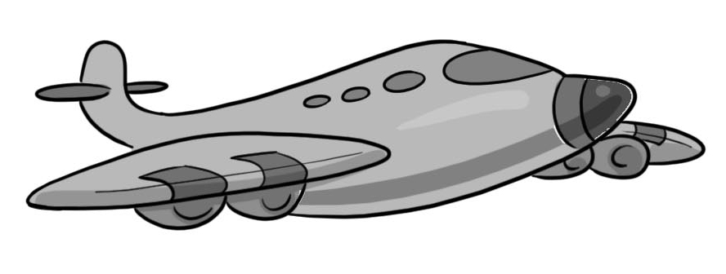  2 | 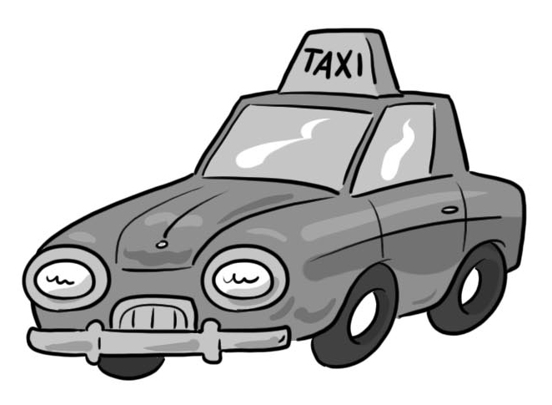  3 | 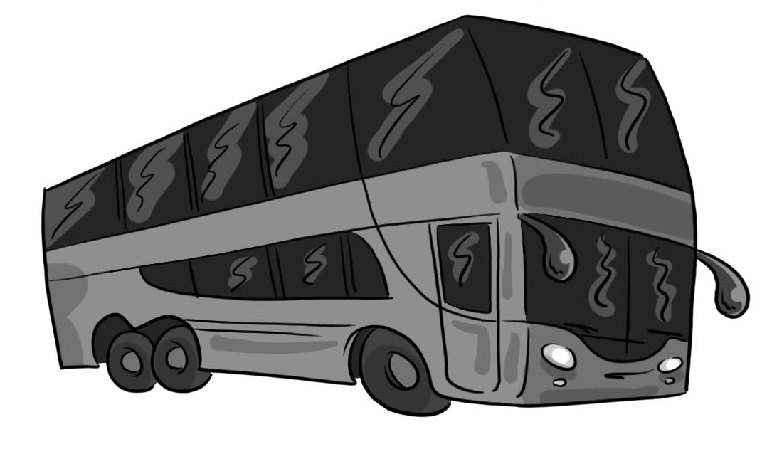  4 | 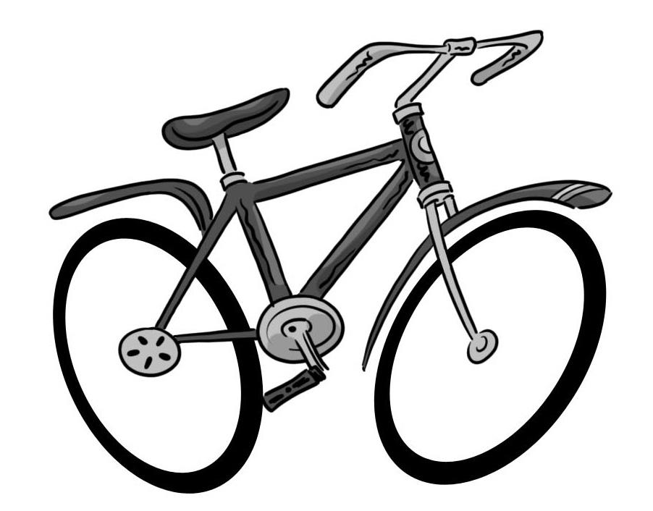  5
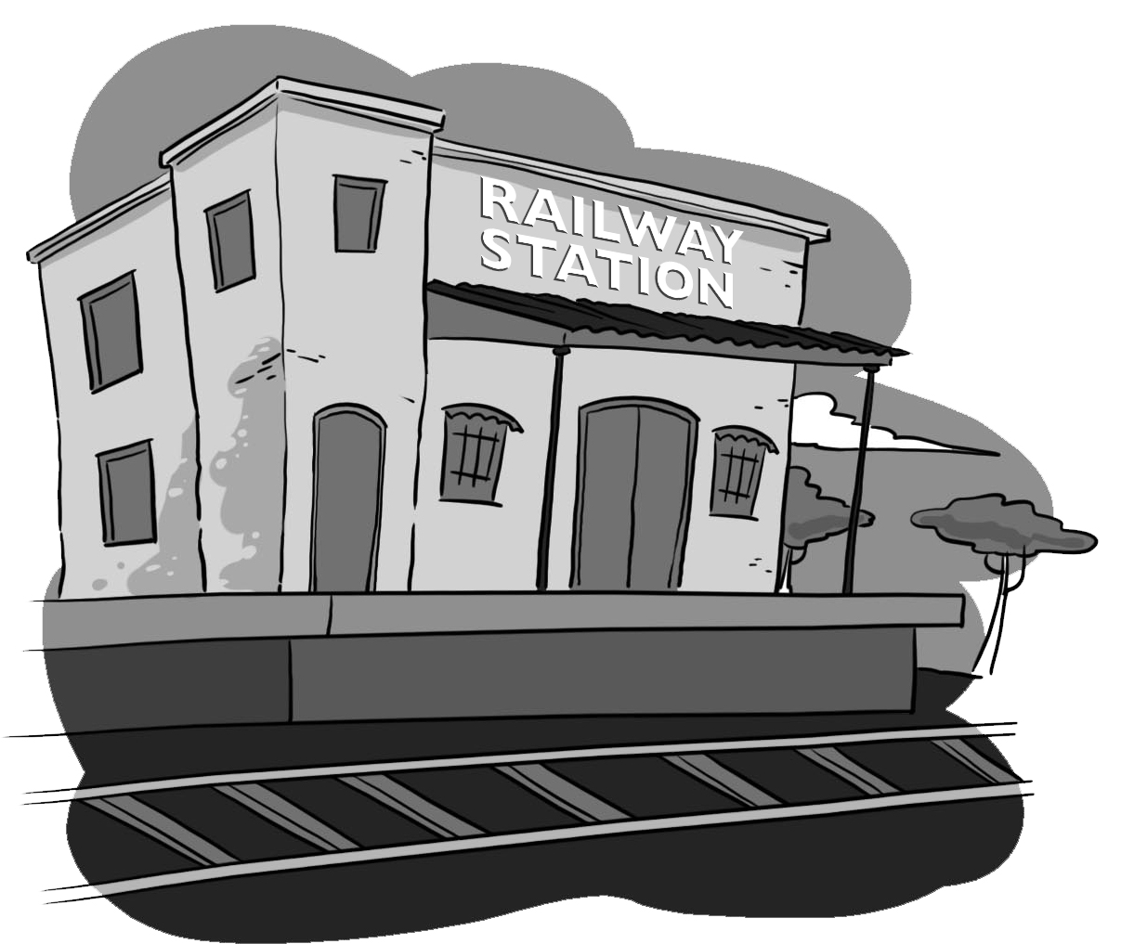  6 | 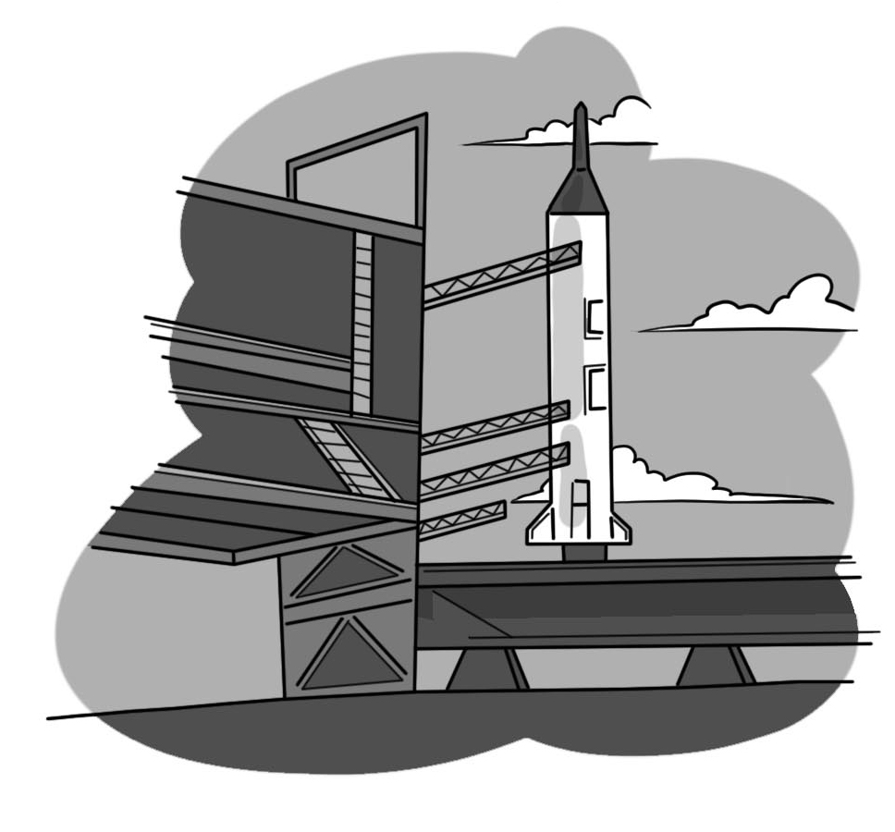  7 | 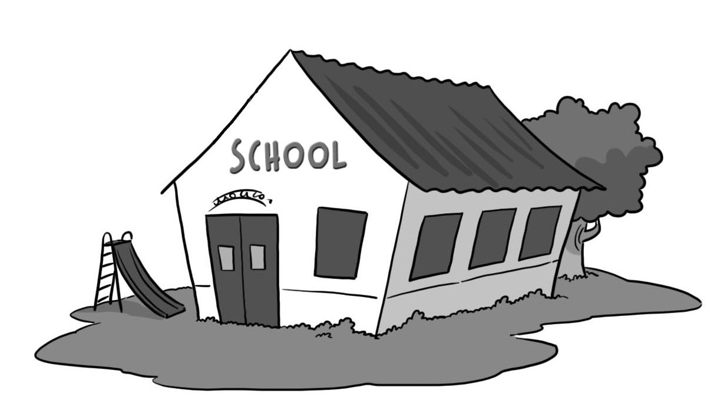  8 | 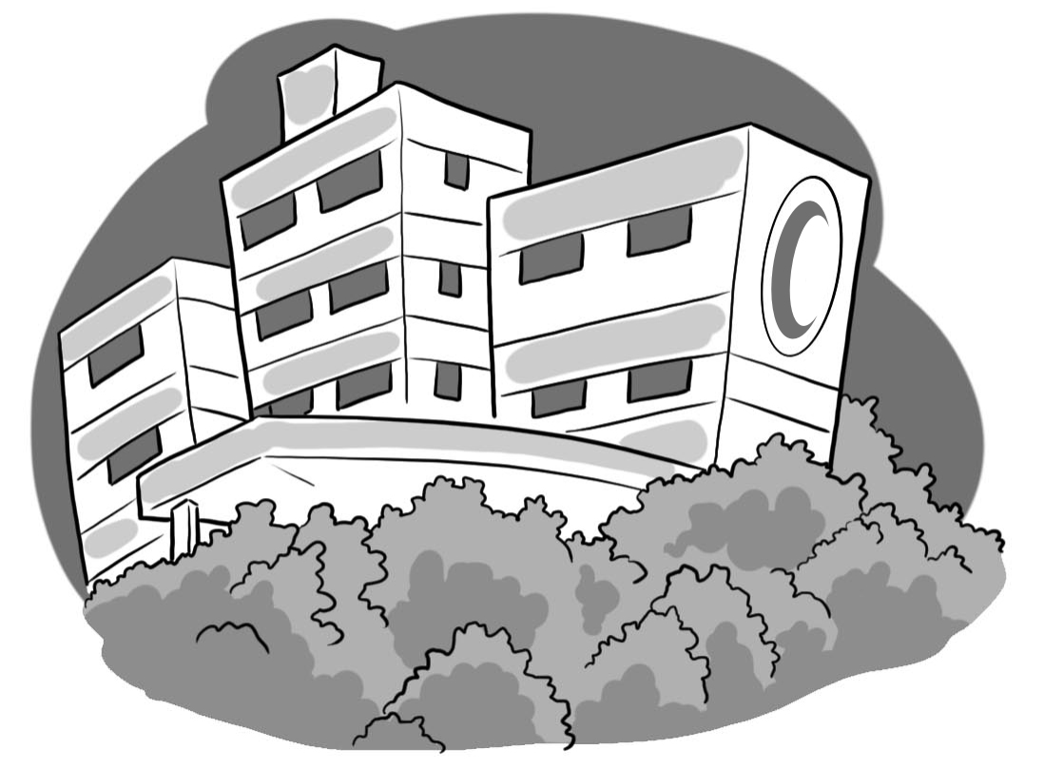  9 | 10

1. Take a bus and go to school.
2. Take a taxi and go to the train station.
3. Take an airplane and go to the space station.
4. Take a rocket and go to the moon.
5. Take a bicycle and go to the hospital.

2. Listen and write the missing letters. CD2 08

 | b read |  | p each
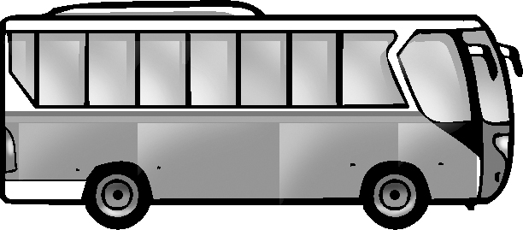 | b us |  | f eather
 | c up | 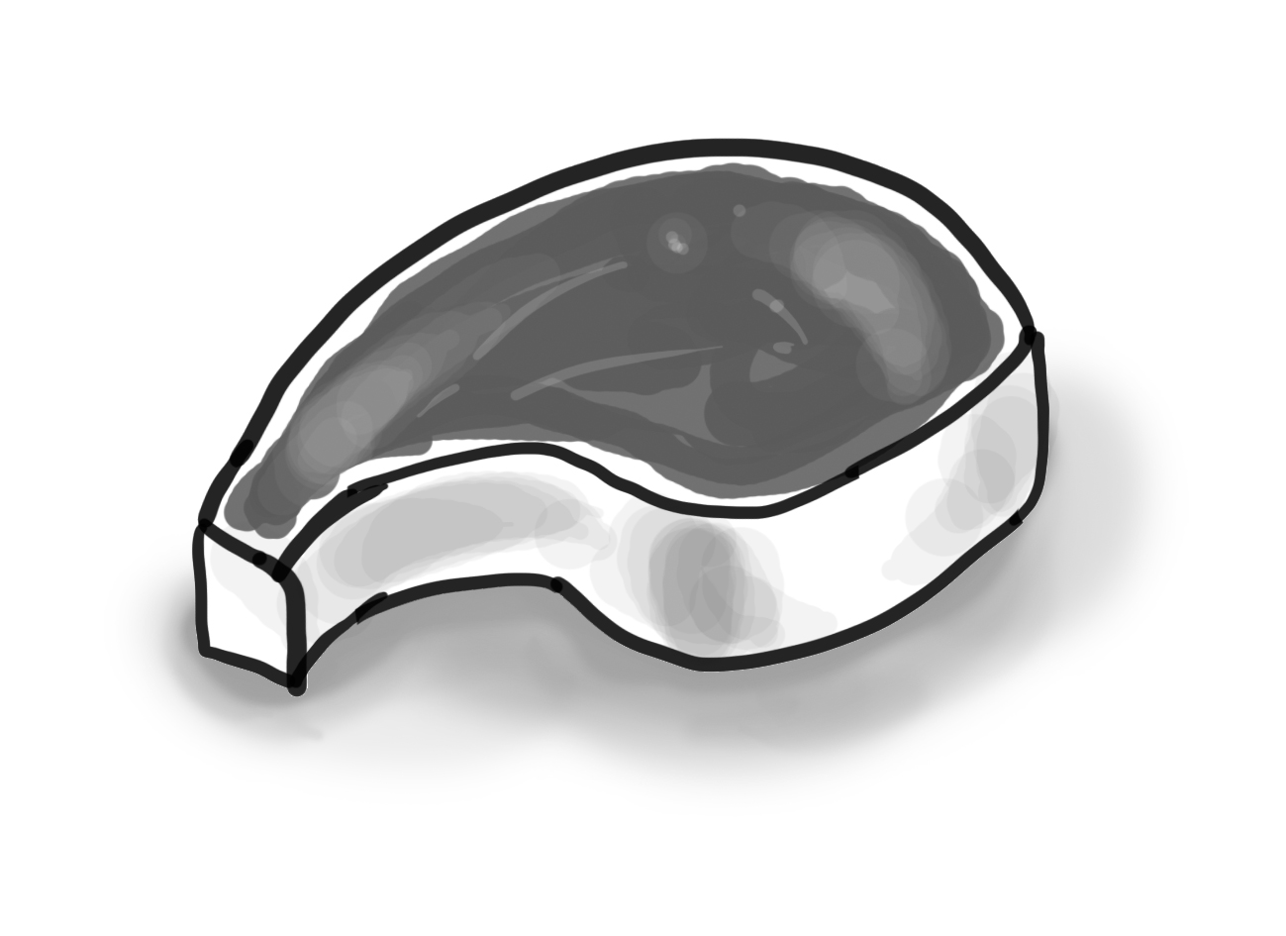 | m eat
 | c ube

3. Look at the map and write the missing word.

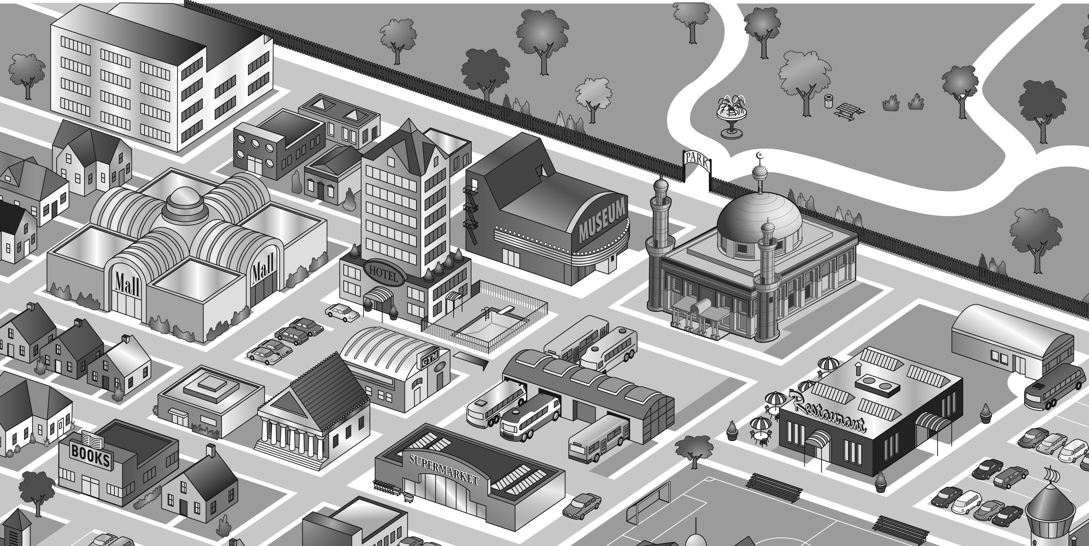

1. There’s a mosque next to/ opposite the museum.
2. There’s a hotel opposite the mall.
3. There’s a bus station opposite the gym.
4. There’s a restaurant near the supermarket.
5. There’s a football field opposite the restaurant.
6. There’s a gym next to the hotel.
7. There’s a bus station opposite the mosque.
8. There’s a bookstore near the supermarket.

4. Listen and write the numbers in the correct order. [Play CD2 33 or read.]
55 | 80 | 71 | 50 | 63 | 49 | 50 | 55 | 59 | 60
68 | 49 | 60 | 85 | 72 | 63 | 64 | 68 | 70 | 71
86 | 77 | 89 | 64 | 79 | 72 | 77 | 79 | 80 | 85
70 | 59 | 90 | 88 | 100 | 86 | 88 | 89 | 90 | 100

5. Listen, number and match dialogs and pictures. Then write/ copy. [Play CD2 16 or read.]

Picture __  B: I’ll show you around ___  A: Hello ___  B: Welcome to our house.___  Would you like to come in?  Picture __  A: Thanks. ___  B: This is the living room ___  A: Yes, please. ___ | A: _________________  B: _________________  ___________________  A: _________________  B: _________________  A: _________________  B: _________________  _________________

.Picture 1 | Picture 2
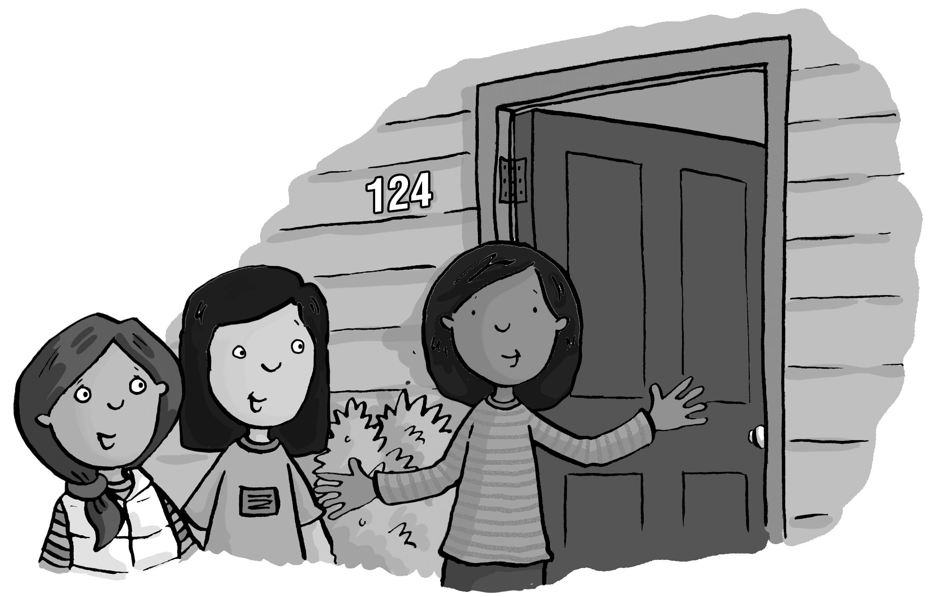 | 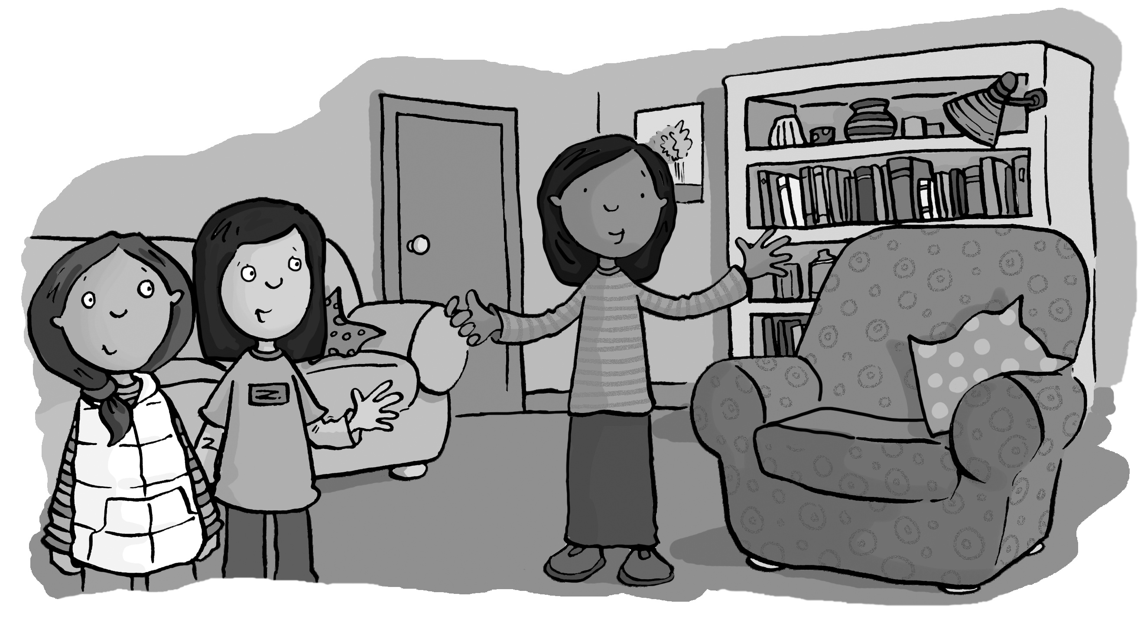

6. Answer the questions.
1. How do you go to school? ____[Answers will vary.]_____
2. Is there a sofa in your bedroom? ______________
3. Where’s the refrigerator in your house?
_________________________________________
4. Do you have a pet? ________________________
5. How many pens are there in your bag?_____________

