( Mega 2.1 )
U 3 , Conversation & Vocabulary building

A- Match the words to their suitable pictures ?
- Passenger ( )
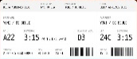
- isle ( )
- Attendant ( )
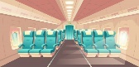
- Boarding pass ( )

- B- Fill in the spaces with the suitable words:

crummy - drag - red-eye - I don’t get it

1 – He was running to catch ………………………………… to New York.

2 – Our holiday was a bit of a …………………………………………… .

3- I had a …………………………………… flat when I first came here.

- Why don’t you allow to change my seat ? ………………………………………………… .

- c- Match the words to their meanings :

- pristine ( ) the action of cutting down trees to clear forests .

- conservation ( ) abundantly green, fertile .

- deforestation ( ) not spoiled .

- lush ( ) careful protection of something .

