
Kingdom of Saudi Arabia Third Elementary Grade
Ministry of Education Second Term

20
……………… Elementary School . . Mid-Term Exam 1446 AH
Name: ………………………………………………………….………………. Class : …………..
- General Questions:
- Choose the correct answer:
1- What time did you take a bath yesterday?
a- I usually take a bath at 9 o’clock. |  |  |  |  |  |  | b- Yesterday, I took a bath at 9 o’clock.
2- Do you like cheese?
a- No, it isn’t. |  |  |  |  |  |  | b- Yes, I do.
3- Where do they work?
a- They are doctors. |  |  |  |  |  |  | b- In the hospital.
4- What does your uncle do?
a- reporter |  |  |  |  |  |  | b- Ali
- Controlled Writing:
- Rearrange the words to form a sentence:
put |  |  | Firefighters |  |  |  | fires |  |  |  |  |  | out
- Reading short sentence:
- Read the sentences then choose the correct sentence for each picture:
 |  |  | 
a. He played football.  b. He got up. | a. He is a businessman.  b. He is a cook. | a. I ride the bus home.  b. I jump into bed. | a. I design buildings.  b. I teach English.

- Grammar:
- Choose the correct answer:
- A: ……….. is he? B: He is my father.
- Where |  |  |  |  | - What |  |  |  |  |  | - Who
- Yesterday, I ………… my homework at 5 o’clock.
- did |  |  |  |  | - do |  |  |  |  |  | - does
- Vocabulary:
- Choose the correct answer:
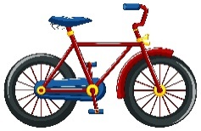 |  |  |  |  |  |  |  |  |  |  |  |  | 
- fire  - bike |  |  | - thousand  - hundred |  |  |  |  | - cook  - dream |  |  |  |  | - waiter  - engineer
- Orthography:
- Choose the correct missing letters:
  li__ __t |  | 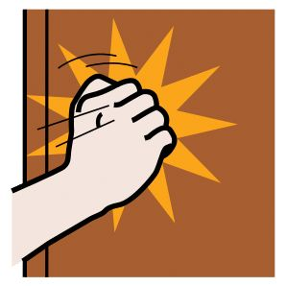  __ __ ock |  |  |  |   spri __ __ |  |  |  |   __ __ erry |  |  |  |   __ __ one
kn | gh | kn |  | gh |  | ng |  |  | ck | sh |  | ch |  | wh | ph

BEST OF LUCK
Ms. Tahani Al-Ghamdi

__________________________________________________________________________________
General Questions

/ 3

Choose the correct answer:

1 – What does your dad do ?
A . I am playing. B . He is a doctor.
2 – What does the firefighter do?
A. He puts out fires . B. He flies plane .
3 – What is the time? 10:30
A . It is ten o'clock. B. It is ten thirty.

________________________________________________________________________________________________________________________________________________________________________________________________________
/ 3
Reading short sentences
Read the sentence then choose or :

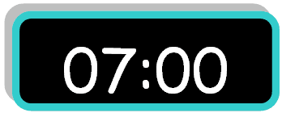
1. It is seven o'clock.

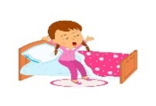
2. I eat my lunch.


3. He is a pilot.

______________________________________________________________________________________________________________________________________________________________________________________________________
/ 3
Grammar
C. got | B. get | A. go | 1 – I usually ____ up at 5:00 .
C. go | B. came | A. come | 2- yesterday, I ____ home at 1:00 .
C. where | B. what | A. who | 3- ____ does she do ? She is a nurse .

Choose the correct answer:

Do as shown between brackets:
/ 2
Controlled writing

Thirty | Thousand | hundred |   2- One _______. ( choose )
..................................................... |  |  | 3– she - a – teacher – is. ( rearrange )

/ 5
Vocabulary

Put the right word under its picture:
clock – doctor – firefighter – baker - get up

 |  | 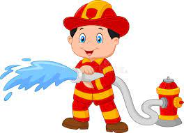 | 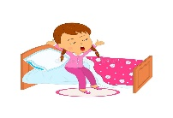 | 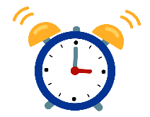

Orthography
/ 4

Fill in the missing letters:
ng – kn – gh -nk

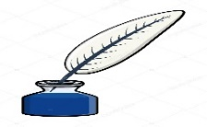 |  | 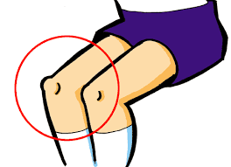 | 
i_ _ | ri_ _ t | _ _ ee | ri_ _

Good luck T.

اختبار فتري – الصف ..........
الاسم ثلاثي: |  | الفصل | / | الدرجة | / 20
Midterm Exam

2
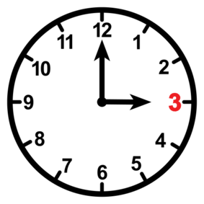

20
- What is the time ?
- It is one o'clock. | - It is three o'clock.

- What does the firefighter do?
- He puts out fires . | - He flies plane .

3
222
General Questions

It is seven o'clock. | He is a doctor. | I eat my lunch.
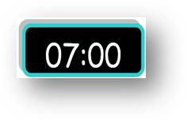 |  | 

2

/ 3

thirty | thousand | hundred | 1-one _______ . ( Choose )
ززززززززززززززززززززززززززززززززززززززززززززززززززززززززززززززززززززززززززززززززززززززززززززززززززززززززززززززززززززززززززززززززززززززززززززززززززززززززز |  |  | 2. is – a – she – teacher ( rearrange)

C. go | B. get | A. got | 1 – I usually ____ up at 5:00 .
C. Where | B. Who | A. What | 2. ____ does she do ? She is a nurse .
Choose the correct answer:
2

/ 3

6

 |  |  |  | 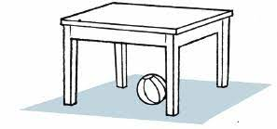
Eat | Take a bath | Engineer | Baker | Teacher | Clock
Brush | Get up | Firefighter | Nurse | Doctor | Ring

  _ ilot |   dri_ _ | ri_ _t | _ _ee | ri_ _
b | nk | ph | gh | ng
p | kn | gh | kn | nk
Reading short sentences
5

TEACHER :

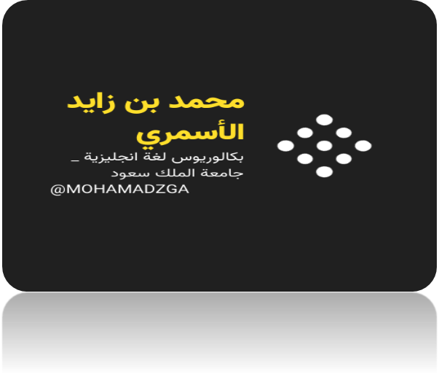

لا تنسوني من صالح دعائكم




M_zaid0

