**Test 2**

**20**

TOTAL

# Name .

****

**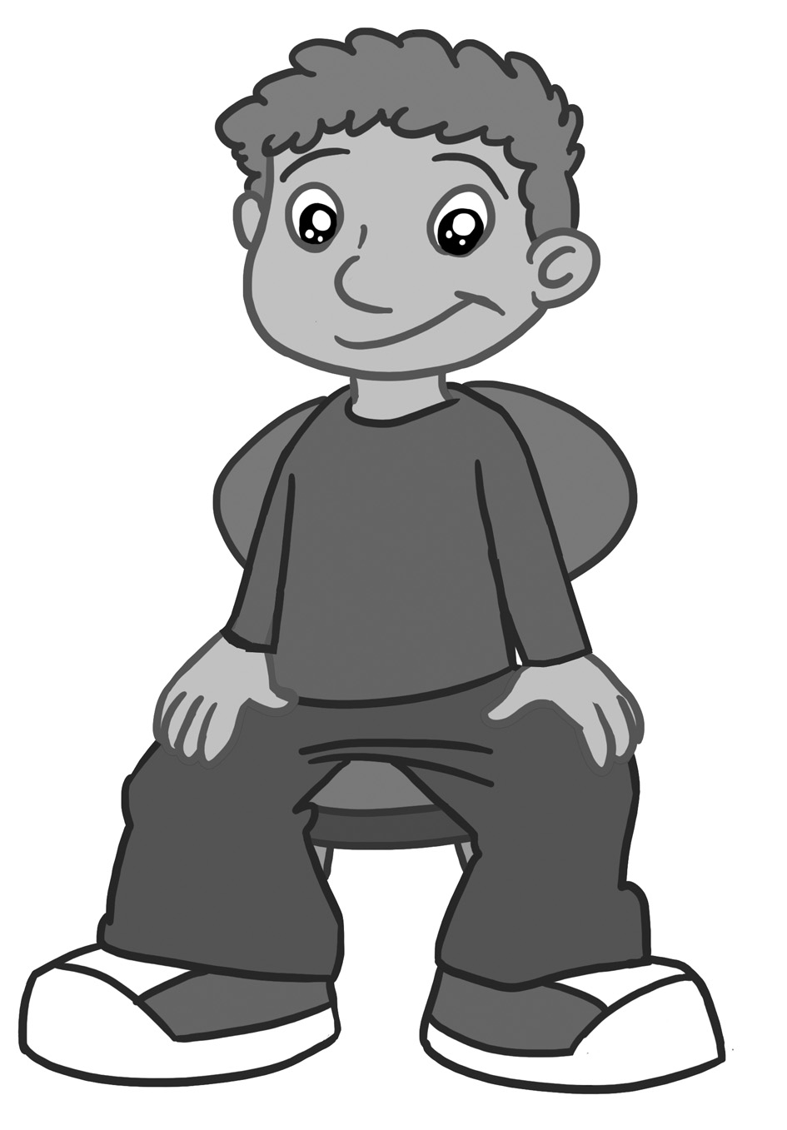1. Listen and number (1-4).**

**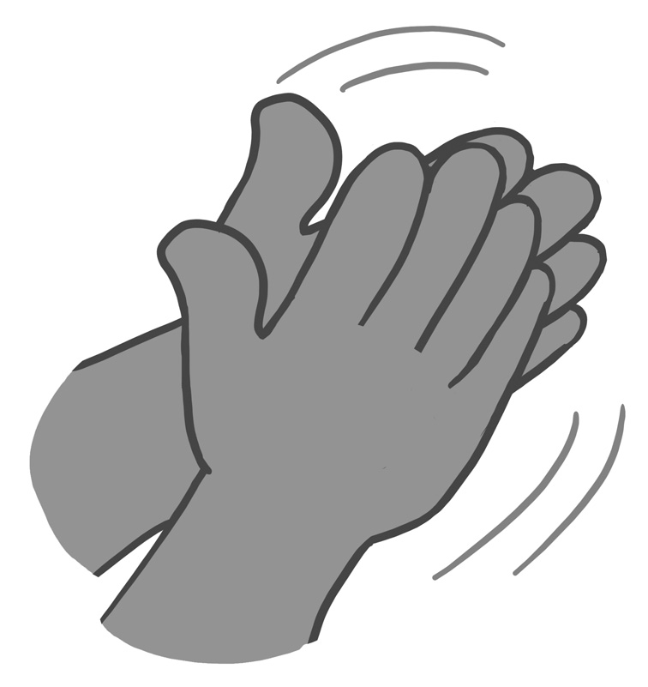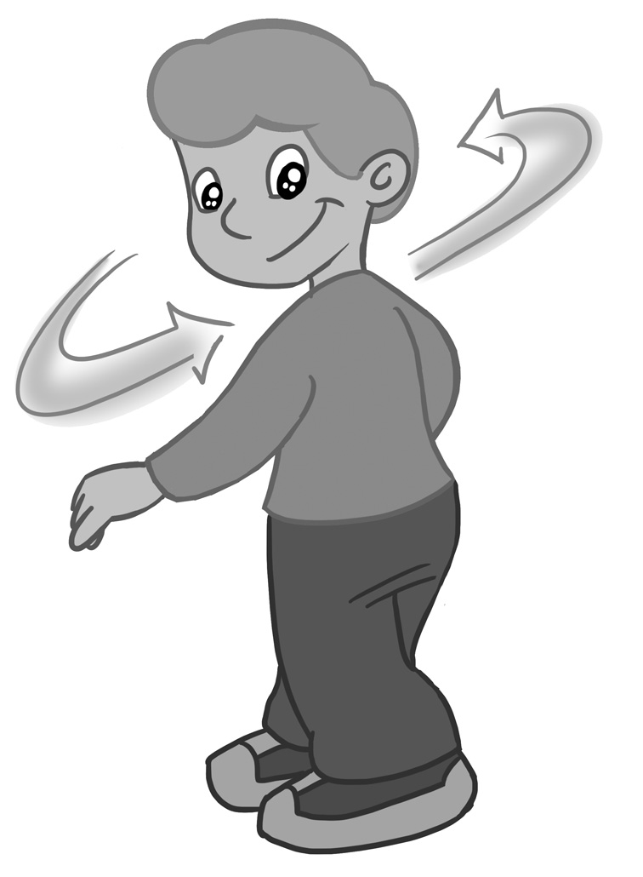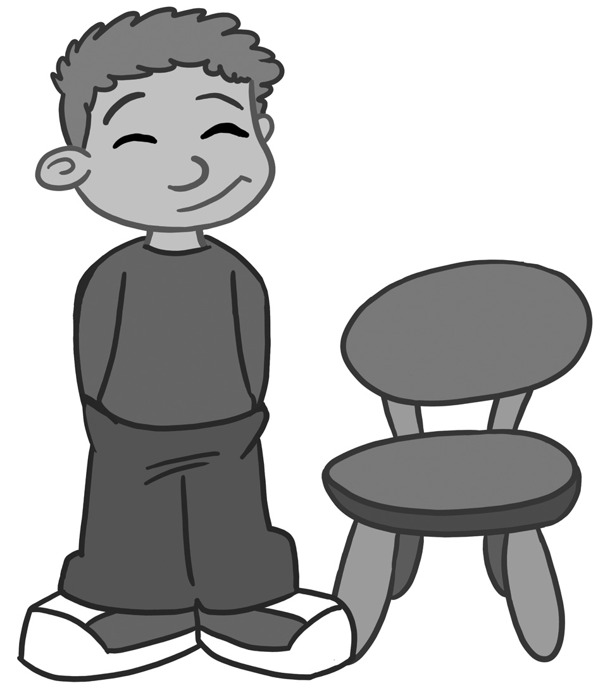**

b

d

c

a

**8**

score

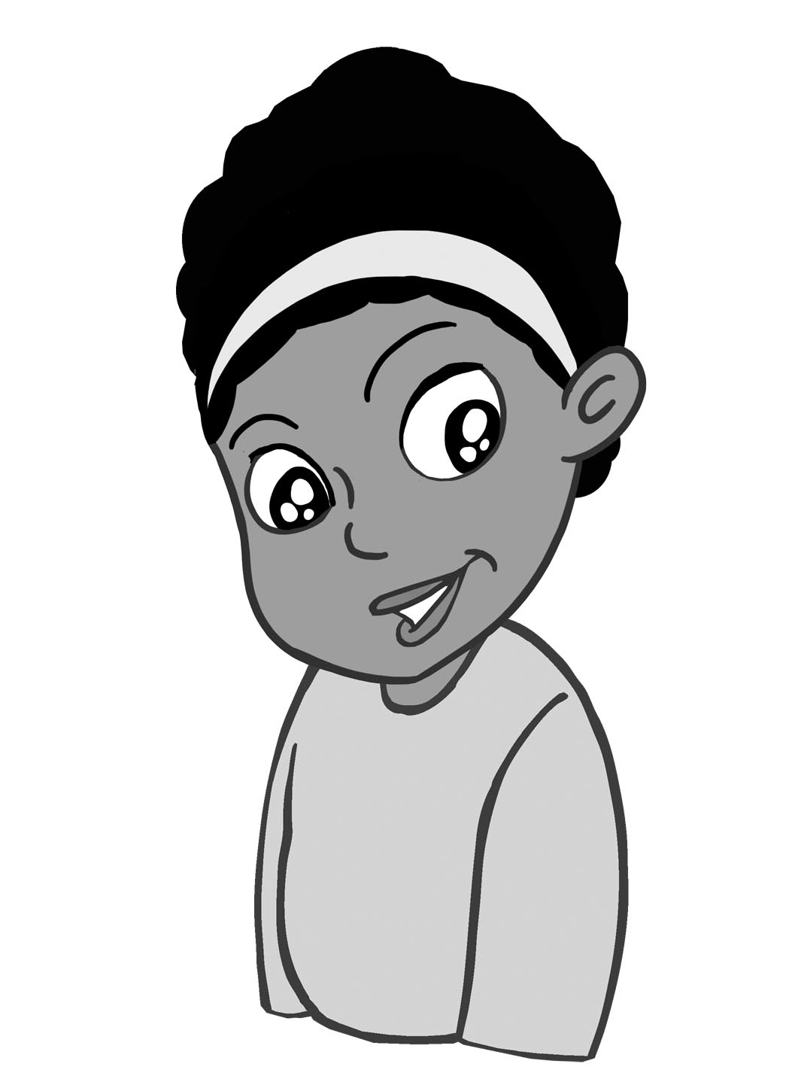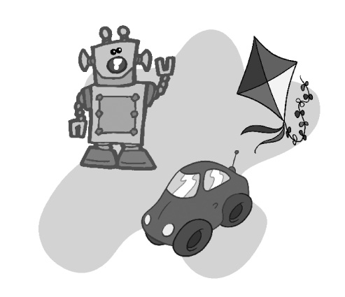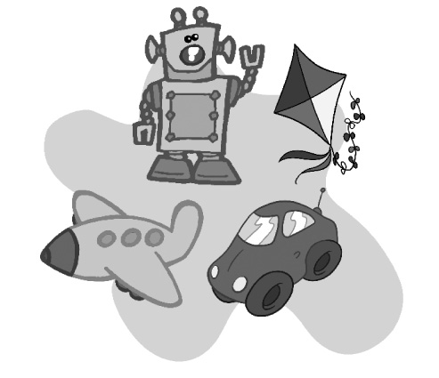**2. Read, look and tick (**✓**).**

I have got a robot and a kite.

I haven’t got a teddy bear.

I have got a car and a plane.

b

a

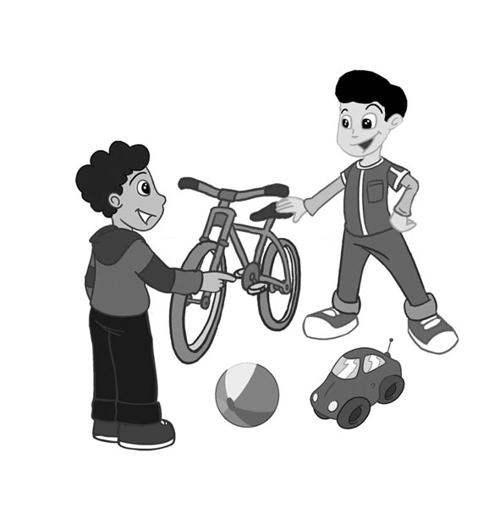

**4**

score

Yes, I have. No, I haven’t.

**3. Listen and write.**

1. Have you got a bike?

.

2. Have you got a kite?

.

3. Have you got a ball?

.

4. Have you got a robot?

.

**4**

score

on in

open bag.tifOn_grey.tif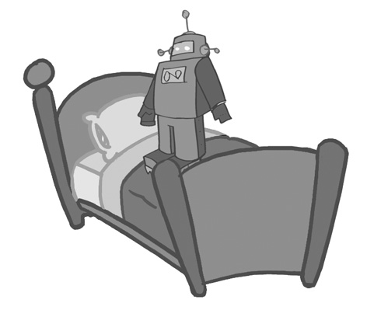In_grey.tif**4. Look and write.**

**4**

score

The ball is

the box.

The plane is

the bag.

The robot is

the box.

The ball is

the box.

4.

2.1.

3.

1.