**General Review of math course**

1) The value of  for  and is:

1. 18 b) 54 c) 216 d) 108

2)The simplification of of  is:

1.  b)  c)  d) 

3)The simplification of  is:

1.  b)  c)  d) 

4)The solution of  is:

1.  b)  c)  d) 

5)The solution of  is:

1.  b)  c)  d) 

6)The solution of  is:

1.  b)  c)  d) 

7)The simplification of the expression  is:

1.  b) 0 c) 1 d) 

8)The simplification of  is:

1.  b)  c)  d) 

9)The scientific notation of  is equal to:

1.  b)  c)  d) 

10)The value of the expression  is equal to:

1.  b)  c)  d) 

11)The decimal notation of  is equal to:

1.  b)  c)  d) 

12)The quadrant for which the first coordinate is positive and second coordinate is negative is:

1. I b) II c) III d) IV

13)The y-intercept of the line is:

1. (0,4) b) (0,-4) c) (2,-4) d) (2,0)

14)The factorization of the polynomial  is:

1.  b)  c)  d) 

15)The factorization of  is:

1.  b)  c)  d) 

16)The rational expression  is not defined at:

1. {-1,2} b) {1,5} c){ 5,-5} d){ 5,2}

17)One of the following correspondence is not a function:

1. 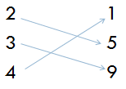 b) 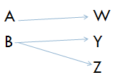 c) 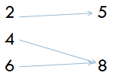

18)The domain of the function  is:

1. {x|x>2} b) {x|x is real number} c) {x|x <2} d) {x|x=0}

19)Two nonvertical lines are perpendicular if the product of their slopes is:

1. 1 b) -1 c) 0 d) 

20)The interval notation for the set {x|-3<x≤6} is:

1. (-3,6) b) [-3,6) c) [-3,6] d) (-3,6]

21)The solution of the inequality  is:

1. x<-2 b) x>-2 c) x≥2 d) x≤-2

22)The solution of the equation  is:

1. {-1,3} b) {-1,-3} c) {1,-3} d) {1}

23)The simplification of  is:

1. 3 b) 9 c) 12 d) 27

24)The value of is equal to:

1. -4 b) 4 c) 16 d) -16

25)The solution of the system in the graph is:

1. (2,1) b) (0,3) c) (1,2) d) (3,0)

Question2: Solve the equations

1. 
2. 
3. 
4. 
5. 

Question3: Solve the following inequalities







Question 4: Graph the following

1. 
2. 

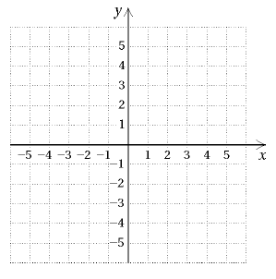

Question 5: Perform and simplify the following:











Question 6: Factor by grouping.



Question 7: Find the domain of the function

1. 
2. 
3. 
4. 

Question 8: Solve the system

