التاريخ : / / 1445هـ
الصف: السادس الابتدائي
المادة : اللغة الإنجليزية

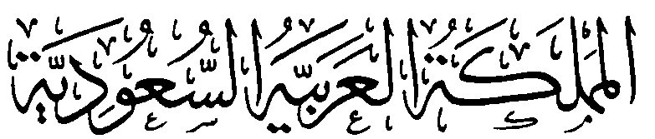
وزارة التعليم
الإدارة العامة للتعليم بمنطقة ........
مكتب ............
مدرسة .....................

اختبار اللغة الإنجليزية نهائي – الدور الأول – للصف السادس – الفصل الدراسي الثالث 1445ه
اسم الطالب: ..................................................... الفصل: .........
6
I- General Questions:
A- Match the questions in column (A) with the correct answers in column (B):
B | A
( 3 ) I'm going to Jeddah.  ( 1 ) Yes, I got up early this morning.  ( 5 ) I'm going diving.  ( 6 ) I should drink a lot of water.  ( 2 ) I have a headache .  ( 4 ) Go straight and you'll find it. | 1- Did you get up early this morning?  2- What's the matter?  3- Where are you going at weekend?  4- Where's the post office?  5- What are you going to do there?  6- What should you do to live in a healthy life?

II- Controlled Writing:
5
A- Complete the sentences with the correct word:
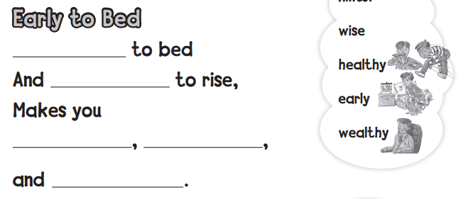

Early to bed, and early to rise, makes you.
Healthy, wealthy, and wise.
III- Reading Short Sentence:
4
A- Read the sentences and match them with the correct pictures:

1- I should brush my teeth. 2- No bicycles 3- I have an earache 4- I shouldn't eat junk food.
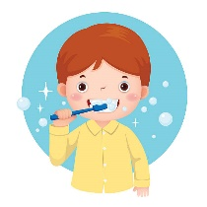
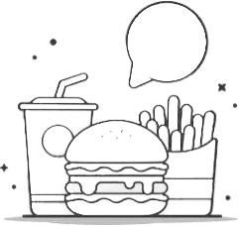
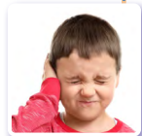
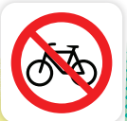

1
4
3
2

IV- Grammar:
5
A) Choose the correct word:
1- Yesterday, I ( play - played ) computer games.
2- He ( am - is ) going to the book store.
3- We are going to ( visit - visited ) Abha.
4- You should ( drink - drank ) milk.
5- What are ( she - they ) doing?

6
V- Vocabulary:

A) Write the correct number under each picture:
1- butcher shop 2- shower 3- stomachache 4- burger 5- candy store 6- flower store

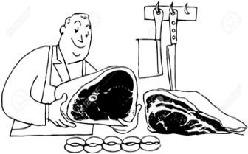
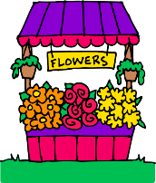
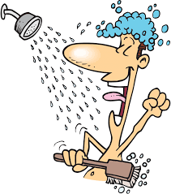
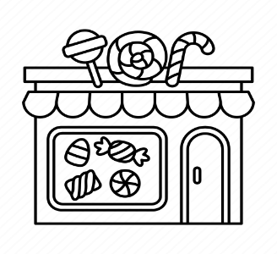

( 4 ) ( 3 ) ( 1 ) ( 6 ) ( 2 ) ( 5 )

VI- Orthography:
4
A) Choose the correct letter:
ir u e tl ur

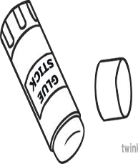
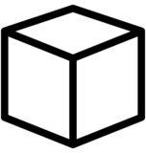
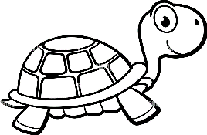
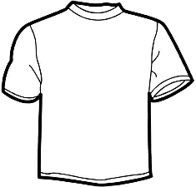

4- shirt 1- turtle 2- c ube 3- glue

