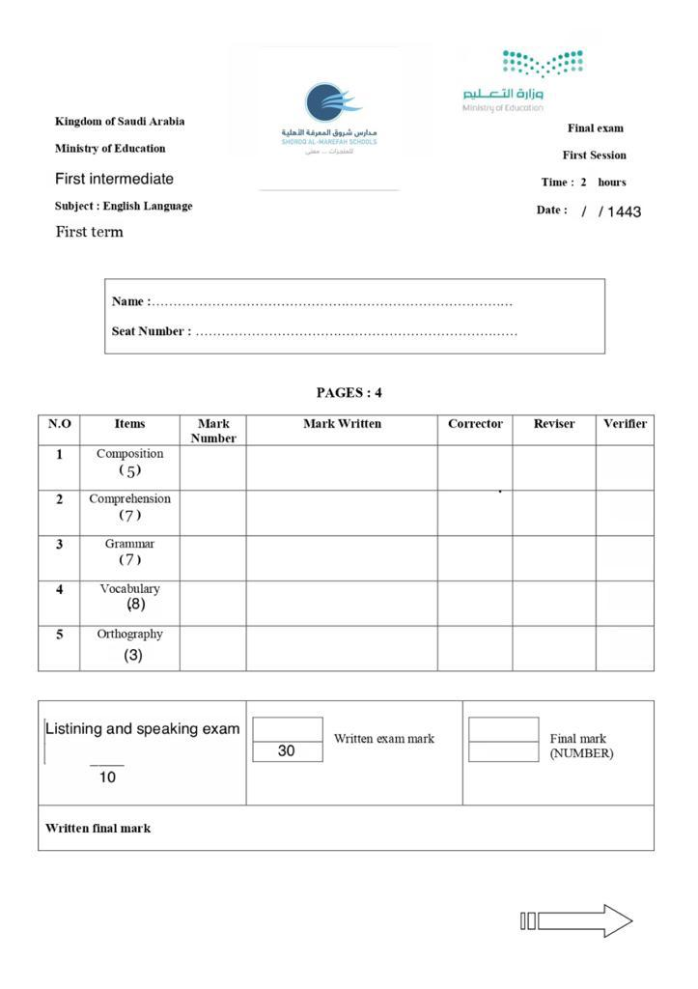
اسم الطالبة: .............................. الفصل: ........ رقم الجلوس: ........ رقم اللجنة: ...... ===================================================================
Composition:

5
Q1) Write about your dream job using the words bank below:
(Name - Want - Future- teacher – be- doctor - like – fun – difficult – interesting)

My Dream Job
________________________________________________________________________________________________________________________________________________________________________________________________________________________________________________________________________________________________________________________________________________________________________________________________________________________________________________________________________________________________________________________________________________________
===================================================================
Q2) Read the following passages then answer the questions: Comprehension

7
Jack has three new friends. Maria has short brown hair and she is nine years old. Hi Maria’s school bag is purple and her shoes are pink. Jeremy is eight years old and has small eyes and a big head. Jeremy’s school bag is blue and his pants are blue too. Peter is nine years old and has curly black hair. Peter has got a basketball, green shorts and a gray shirt. Maria can swim, can dance and can sing but she can’t ride a bike. Jeremy can play football but he can't play the piano. Peter can run fast, can draw, can do karate but he can’t drive a car.

A) Put ( √ ) or ( × ) :
__1
1- Maria is 9 years old. ( )
2- Jeremy can play the piano ( )
B) Give the opposites of these words from the passage:
___2
Big x __________ Fast x __________

C) Choose the correct answer:_
1_ Peter has curly ( brown – black – blond – gray ) hair .
___4
2_ Maria’s ( bag – shoes – pants – hair ) are pink .
3_Jeremy is ( 6 – 7 – 8 – 9 ) years old .
4_Peter can (run -draw – drive – do karate) fast

Grammar:

7
Q3) A) Choose the correct answer:
- He ( work – works – working – worked) for an airline
- He is tired, (so – because – or – and) he’s taking a nap.
___4
- (Do – Does – Is – Doesn’t ) they speak English?
- We read ( or – on – at – and ) write in class
- I live ( in – on – at – or ) Jeddah
- The hotel is ( taller than – taller – the tallest – tallest ) building in the city
- We are ( study – studying – studies – studied ) now
- I would like ( read – to read – to reading – reads) a magazine

B) Do as Shown between brackets :
1-Is there a table in the kitchen ? ( Answer )
Yes, _____________________
___2
2- I do my homework (use always)
______________________________
B) Correct the verb in each sentence:
___1
1- She cook dinner every night _______
2- They are play football _______
Vocabulary :

8 5
Q4: A) Choose the correct answer:
1- Hard means ( difficult – athletic – not boring - intelligent)
__1
2- smart means ( difficult – athletic – not boring - intelligent)

B) Match the word with its picture:
1-driver 2- doctor 3- mirror 4- hospital 5- stove 6-school
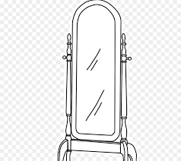
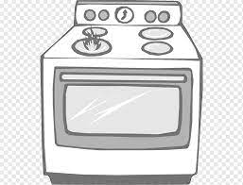
__5
_____ _____ _____ _____ ______
___2
C)Match
1- Teacher |  | Works in a hospital
2- Tennis player |  | Designs new gadgets
3- Nurse |  | Teaches at a school
4-High-tech designer |  | Drives a car
 |  | Plays tennis
Orthography:
Q5) A) Fill in the missing letters:

3
F__n (r– u –y –d ) sho__t (r– u –y –d) eas__ (r – u –y –d )
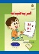
B) Unscramble :
lapm ____ sfao maht _____

انتهت الأسئلة (Good luck)

