

المملكة العربية السعودية
Kingdom of Saudi Arabia
Ministry of Education
------- Educational Directorate
------- Future Educational Schools
2nd Grade High School 2022
2nd Term – Final Exam

وزارة التعليم
الإدارة العامة للتعليم بن
مدارس م ن التعليمية
الصف الثاني الثانوي
الاختبار النهائي للفصل الدراسي الثاني1444هـ
Total  written | 5  Vocabulary | 4  Grammar | 3  Free Composition | 2  Guided Composition |  | 1 Comprehension | Q. NO.
 |  |  |  |  |  |  | Mark Given
30 | 6 | 6 | 6 | 6 |  | 6 | Mark
6 |  |  | Reviser |  |  |  | Corrector
زمن الاختبار: 3 ساعات
اسم الطالب: ------------------------------------ رقم الجلوس: ------------- الصف الثاني الثانوي

1.Comprehension
Read the following passage then answer the questions
The Benefits of Exercise
Getting regular exercise is good for you. Everyone knows that. But, then why doesn't everyone exercise? Some people say they don't have enough time because they are busy with work, school, and family obligations. However, making time for some exercise should be a priority for everyone. The following are just a few of the reasons why:
1) Exercising makes you feel good. When you have a bad day, or you feel stressed or angry about something, a little exercise can help you relax and improve your mood. Also, getting regular exercise can help prevent depression.
2) Physical exercise helps prevent some diseases such as high blood pressure, diabetes, and certain types of cancer. A walk a day can help keep you healthy!
3) Exercising helps you maintain a healthy weight and keeps you strong.
4) Exercising gives you more energy. You will feel less tired during the day if you are physically stronger and more active.
5) Exercising helps you sleep better. If you have been active during the day, you sleep better. And when you have slept better at night, you feel better during the day.
6) Find an activity that you enjoy. You don't have to go to the gym. You can go for a walk or a hike. Whenever you are active, you are doing something good for both your physical and mental health.

A) Answer the following questions:
1. What is the passage about? ----------------------------------------------------------------------------.
2. Does exercising help you sleep better? -------------------------------------------------------------.
3. Why do some people say they don't have enough time? -------------------------------------------.
4. What can you do if you don’t go to the gym? -------------------------------------------------------.
B) Put ( √ ) or ( X ):
5. Exercising helps you to keep strong. ( )
6. Exercising is good for both your physical and mental health. ( )

7. Cancer is a kind of disease. ( )
8. Exercising doesn't make you feel good. ( )
C) Complete:
9. Exercising gives you more -------------------------.
10. Physical exercise helps prevent some ------------------------------.
D) Choose the correct answer:
11. Getting regular exercise can help prevent (happiness – depression – devasted – drown)
12. The underlined word “they" refers to: ( school – exercise – work – people )

2) Guided Composition

6

Playing sports is a must to keep fit.
Write a paragraph about “ Your Favorite Sport”:
You many use the guiding words:
Favorite – club – gym – friends – free time – build muscles – keep fit – feel happy

-------------------------------------------------------
-------------------------------------------------------------------------------------------------------------------------------------------------------------------------------------------------------------------------------------------------------------------------------------------------------------------------------------------------------------------------------------------------------------------------------------------------------------------------------------------------------------------------------------------------------------------------------------------------------------------------------------------------------------------------------------------------------------------------------------------------------------------------------------------------------------------------------------------------------------------------------------------------------------------------------------------------------------------------------------------------------------------------------------------------------------------------------------------------------------------------------------------------------------------------------------------------------------------------------------------------------------------------------------------

3) Free Composition

6

Choose one topic from the following to write about.
1. Recycling is a must to keep our environment clean
2. Write a paragraph about "Your Dream House" in which you describe which kind of you want to live in, where, who live with, …

-------------------------------------------------------
---------------------------------------------------------------------------------------------------------------------------------------------------------------------------------------------------------------------------------------------------------------------------------------------------------------------------------------------------------------------------------------------------------------------------------------------------------------------------------------------------------------------------------------------------------------------------------------------------------------------------------------------------------------------------------------------------------------------------------------------------------------------------------------------------------------------------------------------------------------------------------------------------------------------------------------------------------------------------------------------------------------------------------------------------------------------------------------------------------------------------------------------------------------------------------------------------------------------------------------------------------------------------------------------
4) Grammar

6

A: Choose the correct answer:
1. The manager insisted that he ( worked – works – work – working ) late.
2. Quit ( using – to use – used – use ) disposable batteries.
3. She is not ( enough tall – tall enough – tall too – tall so ) to reach the shelf.
4. ( Not Warming – Not warm – Not warms – Not warmed ) up is bad.
5. This is the ( most – more – less – many ) exciting sporting event.
6. I want you ( opened – opening – open – to open ) the window.
B- Do as shown between brackets:
1. you / applying for the job / to consider / I’d like (Unscramble)
-------------------------------------------------------------------------------.
2. to buy – a hybrid – Do they – car? – intend (Unscramble)
----------------------------------------------------------------------------.
3. I bought (yellow – big – Japanese – expensive) car. (Reorder the adjectives)
-------------------------------------------------------------------.
4. She is short to play basketball. (Use: too)
---------------------------------------------------------------------------.
5. Ali is the nicest boy I (see). (Correct in present perfect)
--------------------------------------------------------------------------------.
6. (Swim) uses more muscles of the body. (Correct)
---------------------------------------------------------------------------.
5) vocabulary:

6

A- Match the words with the pictures:

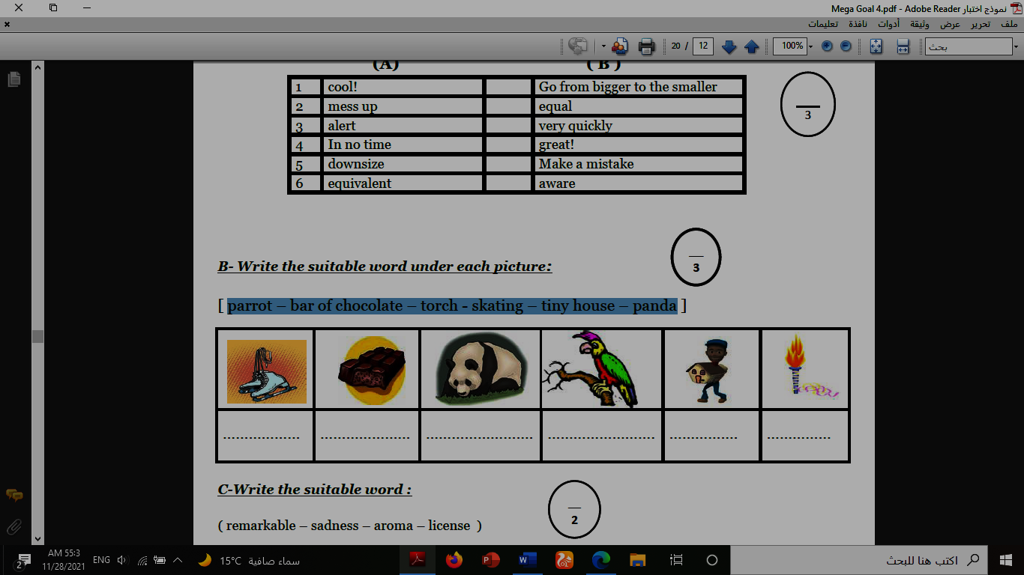
1.recycle 2.torch 3.zoologist 4.medal 5.canyon 6.windmill
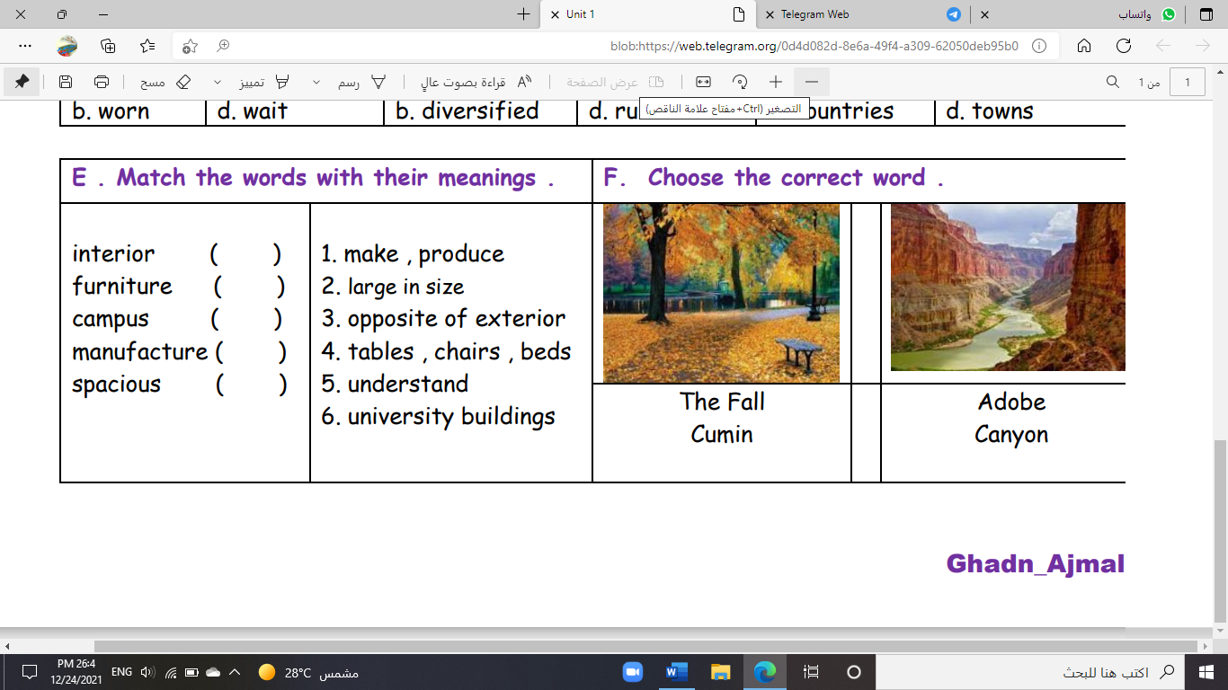
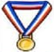


( ) ( ) ( ) ( ) ( ) ( )
B- Match to form new words or expressions:
1. satisfaction ------ a. take one’s place, often in work
2. cover ------ b. feeling of contentment
3. a piece of cake ------ c. without a soul
4. cool ------ d. ready for
5. soulless ------ e. very easy
6. up for ------ f. great

End of Questions
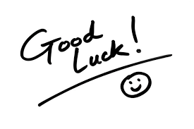
Best of Luck https://t.me/abokhaledamer

