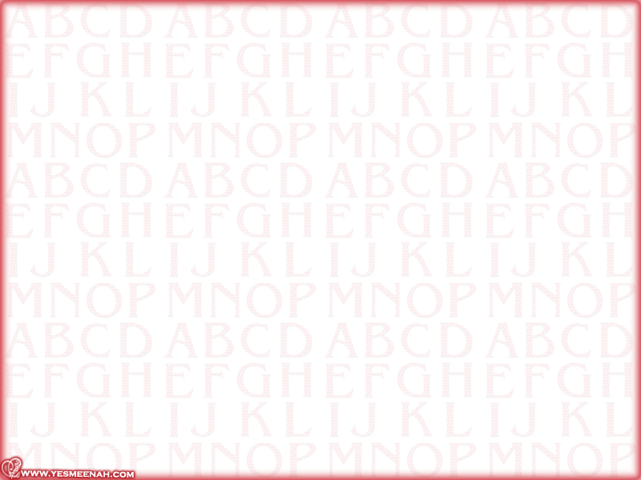



1st Week | 2nd Week |  | 3rd Week | 4th Week
17/12th - 20/12th | 24/12th - 28/12th |  | 1/1st - 5/1st | 8/1st - 12/1st
Introduction  Warming up | Books are not available |  | Unit 1  New friends  Lesson 1 | Unit 1  New friends  Lesson 2+3
5th Week | 6th Week |  | 7th Week | 8th Week
15/1st - 19/1st | 22/1st - 26/1st |  | 29/1st - 3/2nd | 6/2nd - 10/2nd
Unit 2  My things  Lesson 1+ 2 | Unit 2  My things L 3  Unit 3  Around school L1 |  | Unit 3  Around school L 2+3 | Unit 4  When is it? L 1+2
9th Week ( Mid Term Holiday) 13/2nd - 17/2nd
10th Week |  | 11th Week | 12th Week | 13th Week
20/2nd 24/2nd |  | 27/2nd 2/3rd | 5/3rd 9/3rd | 12/3rd 16/3rd
Unit 4  When is it? L 3  Unit 5  Food and meals L 1 |  | Unit 5  Food and meals L 2 +3 | Unit 6  Hot and cold L 1+2 | Unit 6  Hot and cold L 3  Unit 7  Going to the mall L 1
14th Week |  | 15th Week | 16th Week | 17th Week
19/ 3rd 23/3rd |  | 26/3rd 30/3rd | 3/4th 7/4th | 10/4th 14/4^{h}
Unit 7  Going to the mall L 2 +3 |  | Unit 8  I’m sorry I’m late L 1+2 | Unit 8  I’m sorry I’m late L 3 | Unit 9  Bad times, good times L1+2
18th Week |  | 19th Week
17/4th 21/4 th |  | 24/4th 28/4th
Final Exams

Headmaster's Signature……….…….……….……… Supervisor's signature……………………..…………..….…..

