A.Match | 1-How are you ? |  |  | Nice to meet you too.
 | 2-What's the matter ? |  |  | I'm fine, thank you.
 | 3-Nice to meet you |  |  | I'm scared.  3
B.Choose | - I (am - is - are ) hungry .  - He ( am - is - are ) cold.  3  - (Who - What - Where) is wearing green today ?
C. Match words with pictures:
1-cap | 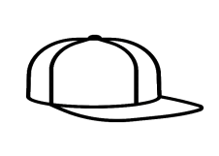  2- clap | 3- blouse | 4- sunglasses
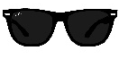
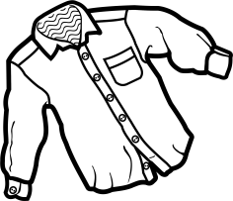
2
- Match Numbers correctly with words:

Second (1- 2 - 3- 4 - 5) | Third (1- 2 - 3- 4 - 5) | Fifth (1- 2 - 3- 4 - 5)
First (1- 2 - 3- 4 - 5) | Fourth (1- 2 - 3- 4 - 5) | 5
He is hungry.

He is thirsty.

She is sleepy.

She is scared
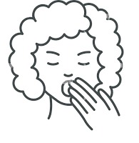
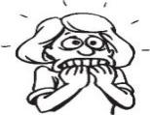
- Choose the right picture:

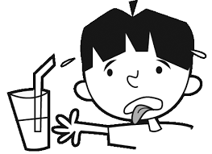
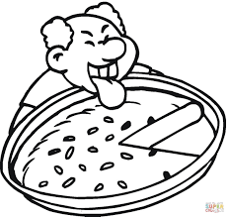

4

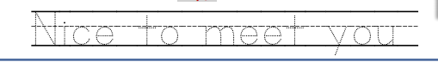
- Copy
4

G . Fill in :
V__s__ | T_ m _ | T _ p | 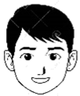  F__c__
(a / a–e / i-e) | (a / a–e / i-e) | (a / a–e / i-e) | (a / a–e / i-e)  4

