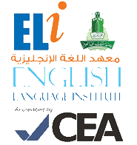

**Grammar and**

**Vocabulary Practice**

**102**

**رؤية جامعة الملك عبد العزيز**

**منارة في المعرفة**

**تكامل في التكوين**

**ريادة في التنمية**

**رسالة جامعة الملك عبدالعزيز**

**الرقي بالمجتمع عبر تميز ثقافي و علمي و بحثي رائد**

**Student’s Name:** __________________ **Level:** 102 **Section:** ____________

1. **Grammar Section (Unit 7)**

**Choose the correct answer:**

1. Adnan is _______________ on his science project these days.

a. work b. working c. worked d. works

1. **Vocabulary Section (Unit 7)**

**Choose the correct answer:**

1. Amal is a student and she has a _______________ job.

a. full-time b. self-employed c. part-time d. work