

اسم الطالب ……………………………………………………………………….……………………………….…………الصف……………………………….

Choose the correct answer:ضع دائرة على الإجابة الصحيحة


- I ( play – played) tennis yesterday.
- She didn’t ( drop – dropped ) the glass.
- Did he ( call – called ) you last night?
4-I ( go – went ) to Makkah last week.
5- Did you ( win – won ) the game?

Circle the correct word:ضع دائرة على الكلمة المناسبة

  eat  laugh | 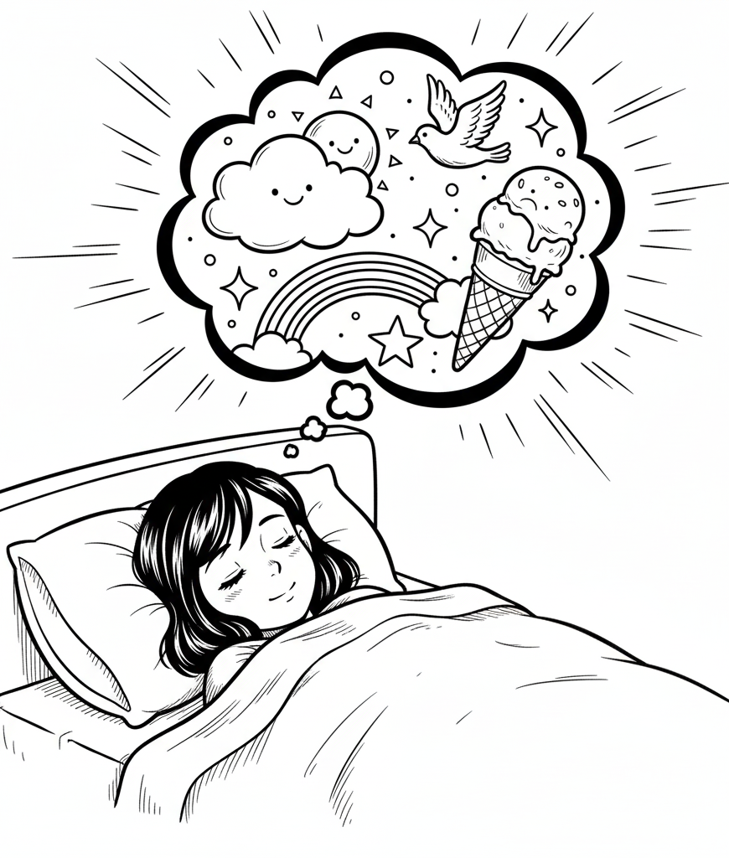  play  dreamed | 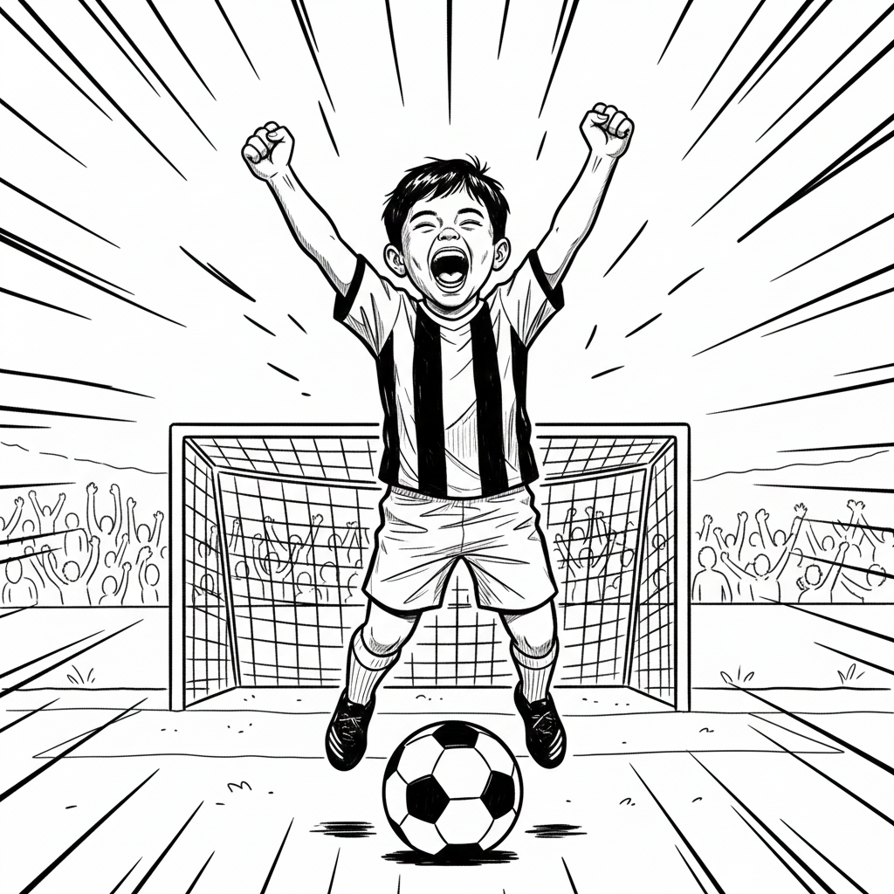  sleep  score | 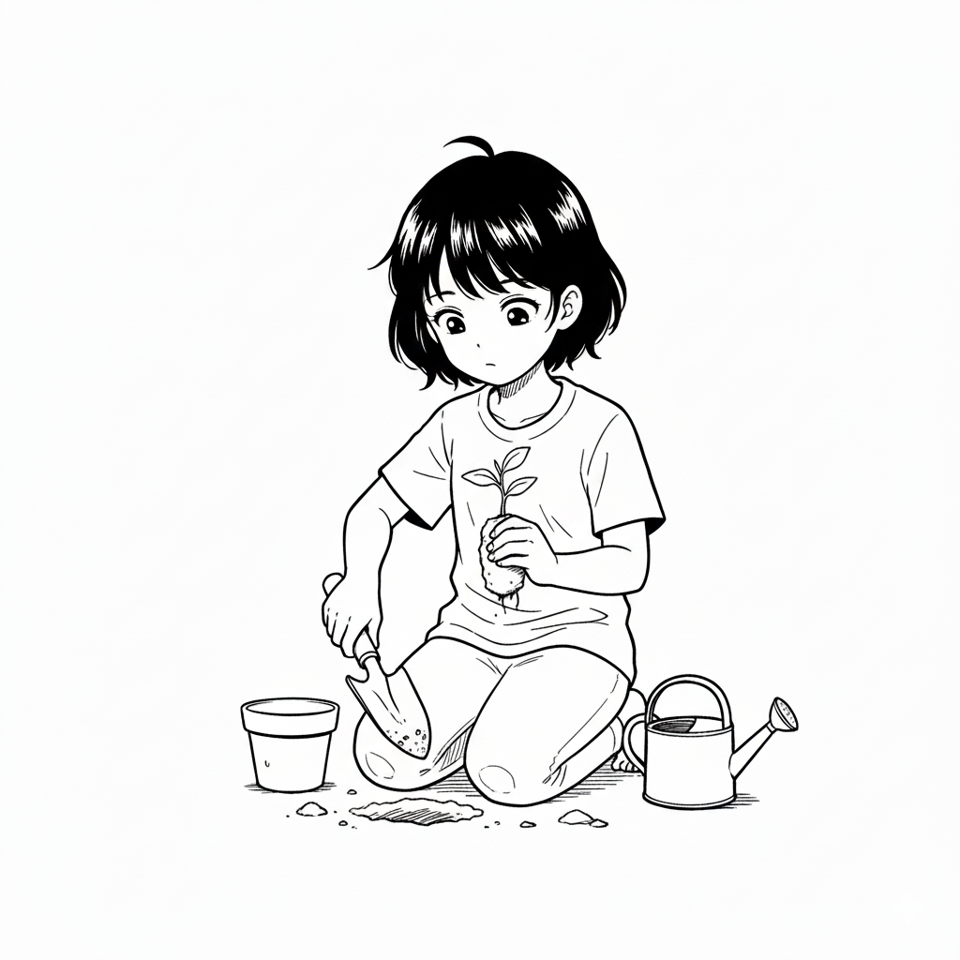  plant  cook |   a  vlogging  hide

