[](https://t.me/Techni456_group)

**قروب كل ما يتعلق بالمهارات الرقمية**

**المملكة العربية السعودية**

**وزارة التعليـم**

**إدارة التعليم بـ ..................**

**مدرسة ...................................**

**معلم المادة ..............................**

**الفصل الدراسي ........................**

|  |  |  |  |  |  |  |  |  |  |  |  |  |  |  |  |  |  |  |  |  |  |  |  |  |  |  |  |  |  |  |  |
| --- | --- | --- | --- | --- | --- | --- | --- | --- | --- | --- | --- | --- | --- | --- | --- | --- | --- | --- | --- | --- | --- | --- | --- | --- | --- | --- | --- | --- | --- | --- | --- |
| **سجــــل متابعة المهارات الرقمية للصف .............................................................. الفصل .................... للعــــــام الدراسي 144 / 144هـ** | | | | | | | | | | | | | | | | | | | | | | | | | | | | | | | |
| **م** | **اســم الطـــالـــب :** | **الـــمــهــــــــــــام الأدائــــيـــــــــة** | | | | | | | | | | | | | **المشاركة والتفاعل** | | | | | **تطبيقات عملية** | | | | | | **اختبار تحريري قصير** | | | | | **المجموع النهائي** |
| **واجــبــــــــــــــــات** | | | | | | | | **بحوث/ مشروعات/ تقارير** | | | | | **أنشطة و مشاركة** | | | | |
| **10** | | | | | | | | **10** | | | | | **20** | | | | | **40** | | | | | | **20** | | | | | **100** |
| **1** |  |  |  |  |  |  |  |  |  |  |  |  |  |  |  |  |  |  |  |  |  |  |  |  |  |  |  |  |  |  |  |
| **2** |  |  |  |  |  |  |  |  |  |  |  |  |  |  |  |  |  |  |  |  |  |  |  |  |  |  |  |  |  |  |  |
| **3** |  |  |  |  |  |  |  |  |  |  |  |  |  |  |  |  |  |  |  |  |  |  |  |  |  |  |  |  |  |  |  |
| **4** |  |  |  |  |  |  |  |  |  |  |  |  |  |  |  |  |  |  |  |  |  |  |  |  |  |  |  |  |  |  |  |
| **5** |  |  |  |  |  |  |  |  |  |  |  |  |  |  |  |  |  |  |  |  |  |  |  |  |  |  |  |  |  |  |  |
| **6** |  |  |  |  |  |  |  |  |  |  |  |  |  |  |  |  |  |  |  |  |  |  |  |  |  |  |  |  |  |  |  |
| **7** |  |  |  |  |  |  |  |  |  |  |  |  |  |  |  |  |  |  |  |  |  |  |  |  |  |  |  |  |  |  |  |
| **8** |  |  |  |  |  |  |  |  |  |  |  |  |  |  |  |  |  |  |  |  |  |  |  |  |  |  |  |  |  |  |  |
| **9** |  |  |  |  |  |  |  |  |  |  |  |  |  |  |  |  |  |  |  |  |  |  |  |  |  |  |  |  |  |  |  |
| **10** |  |  |  |  |  |  |  |  |  |  |  |  |  |  |  |  |  |  |  |  |  |  |  |  |  |  |  |  |  |  |  |
| **11** |  |  |  |  |  |  |  |  |  |  |  |  |  |  |  |  |  |  |  |  |  |  |  |  |  |  |  |  |  |  |  |
| **12** |  |  |  |  |  |  |  |  |  |  |  |  |  |  |  |  |  |  |  |  |  |  |  |  |  |  |  |  |  |  |  |
| **13** |  |  |  |  |  |  |  |  |  |  |  |  |  |  |  |  |  |  |  |  |  |  |  |  |  |  |  |  |  |  |  |
| **14** |  |  |  |  |  |  |  |  |  |  |  |  |  |  |  |  |  |  |  |  |  |  |  |  |  |  |  |  |  |  |  |
| **15** |  |  |  |  |  |  |  |  |  |  |  |  |  |  |  |  |  |  |  |  |  |  |  |  |  |  |  |  |  |  |  |
| **16** |  |  |  |  |  |  |  |  |  |  |  |  |  |  |  |  |  |  |  |  |  |  |  |  |  |  |  |  |  |  |  |
| **17** |  |  |  |  |  |  |  |  |  |  |  |  |  |  |  |  |  |  |  |  |  |  |  |  |  |  |  |  |  |  |  |
| **18** |  |  |  |  |  |  |  |  |  |  |  |  |  |  |  |  |  |  |  |  |  |  |  |  |  |  |  |  |  |  |  |
| **19** |  |  |  |  |  |  |  |  |  |  |  |  |  |  |  |  |  |  |  |  |  |  |  |  |  |  |  |  |  |  |  |
| **20** |  |  |  |  |  |  |  |  |  |  |  |  |  |  |  |  |  |  |  |  |  |  |  |  |  |  |  |  |  |  |  |
| **21** |  |  |  |  |  |  |  |  |  |  |  |  |  |  |  |  |  |  |  |  |  |  |  |  |  |  |  |  |  |  |  |



**قروب كل ما يتعلق بالمهارات الرقمية**

**مدرسة ...................................**

**معلم المادة ..............................**

**الفصل الدراسي ........................**

**المملكة العربية السعودية**

**وزارة التعليـم**

**إدارة التعليم بـ ..................**

[](https://t.me/Techni456_group)

|  |  |  |  |  |  |  |  |  |  |  |  |  |  |  |  |  |  |  |  |  |  |  |  |  |  |  |  |  |  |  |  |
| --- | --- | --- | --- | --- | --- | --- | --- | --- | --- | --- | --- | --- | --- | --- | --- | --- | --- | --- | --- | --- | --- | --- | --- | --- | --- | --- | --- | --- | --- | --- | --- |
| **سجــــل متابعة المهارات الرقمية للصف .............................................................. الفصل .................... للعــــــام الدراسي 144 / 144هـ** | | | | | | | | | | | | | | | | | | | | | | | | | | | | | | | |
| **م** | **اســم الطـــالـــب :** | **الـــمــهــــــــــــام الأدائــــيـــــــــة** | | | | | | | | | | | | | **المشاركة والتفاعل** | | | | | **تطبيقات عملية** | | | | | | **اختبار تحريري قصير** | | | | | **المجموع النهائي** |
| **واجــبــــــــــــــــات** | | | | | | | | **بحوث/ مشروعات/ تقارير** | | | | | **أنشطة و مشاركة** | | | | |
| **10** | | | | | | | | **10** | | | | | **20** | | | | | **40** | | | | | | **20** | | | | | **100** |
| **22** |  |  |  |  |  |  |  |  |  |  |  |  |  |  |  |  |  |  |  |  |  |  |  |  |  |  |  |  |  |  |  |
| **23** |  |  |  |  |  |  |  |  |  |  |  |  |  |  |  |  |  |  |  |  |  |  |  |  |  |  |  |  |  |  |  |
| **24** |  |  |  |  |  |  |  |  |  |  |  |  |  |  |  |  |  |  |  |  |  |  |  |  |  |  |  |  |  |  |  |
| **25** |  |  |  |  |  |  |  |  |  |  |  |  |  |  |  |  |  |  |  |  |  |  |  |  |  |  |  |  |  |  |  |
| **26** |  |  |  |  |  |  |  |  |  |  |  |  |  |  |  |  |  |  |  |  |  |  |  |  |  |  |  |  |  |  |  |
| **27** |  |  |  |  |  |  |  |  |  |  |  |  |  |  |  |  |  |  |  |  |  |  |  |  |  |  |  |  |  |  |  |
| **28** |  |  |  |  |  |  |  |  |  |  |  |  |  |  |  |  |  |  |  |  |  |  |  |  |  |  |  |  |  |  |  |
| **29** |  |  |  |  |  |  |  |  |  |  |  |  |  |  |  |  |  |  |  |  |  |  |  |  |  |  |  |  |  |  |  |
| **30** |  |  |  |  |  |  |  |  |  |  |  |  |  |  |  |  |  |  |  |  |  |  |  |  |  |  |  |  |  |  |  |
| **31** |  |  |  |  |  |  |  |  |  |  |  |  |  |  |  |  |  |  |  |  |  |  |  |  |  |  |  |  |  |  |  |
| **32** |  |  |  |  |  |  |  |  |  |  |  |  |  |  |  |  |  |  |  |  |  |  |  |  |  |  |  |  |  |  |  |
| **33** |  |  |  |  |  |  |  |  |  |  |  |  |  |  |  |  |  |  |  |  |  |  |  |  |  |  |  |  |  |  |  |
| **34** |  |  |  |  |  |  |  |  |  |  |  |  |  |  |  |  |  |  |  |  |  |  |  |  |  |  |  |  |  |  |  |
| **35** |  |  |  |  |  |  |  |  |  |  |  |  |  |  |  |  |  |  |  |  |  |  |  |  |  |  |  |  |  |  |  |
| **36** |  |  |  |  |  |  |  |  |  |  |  |  |  |  |  |  |  |  |  |  |  |  |  |  |  |  |  |  |  |  |  |
| **37** |  |  |  |  |  |  |  |  |  |  |  |  |  |  |  |  |  |  |  |  |  |  |  |  |  |  |  |  |  |  |  |
| **38** |  |  |  |  |  |  |  |  |  |  |  |  |  |  |  |  |  |  |  |  |  |  |  |  |  |  |  |  |  |  |  |
| **39** |  |  |  |  |  |  |  |  |  |  |  |  |  |  |  |  |  |  |  |  |  |  |  |  |  |  |  |  |  |  |  |
| **40** |  |  |  |  |  |  |  |  |  |  |  |  |  |  |  |  |  |  |  |  |  |  |  |  |  |  |  |  |  |  |  |
| **41** |  |  |  |  |  |  |  |  |  |  |  |  |  |  |  |  |  |  |  |  |  |  |  |  |  |  |  |  |  |  |  |
| **42** |  |  |  |  |  |  |  |  |  |  |  |  |  |  |  |  |  |  |  |  |  |  |  |  |  |  |  |  |  |  |  |

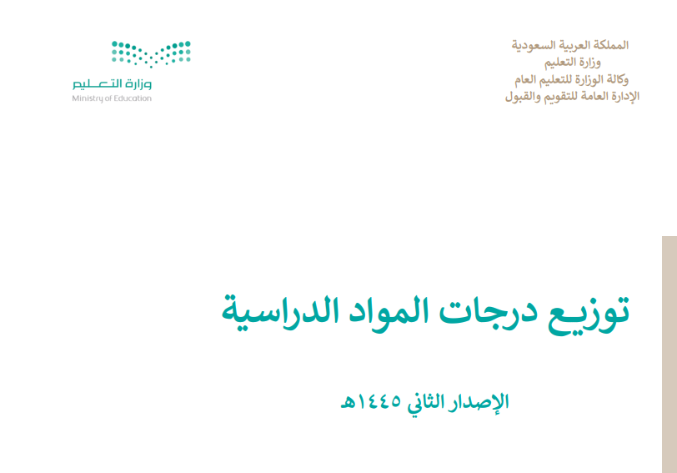



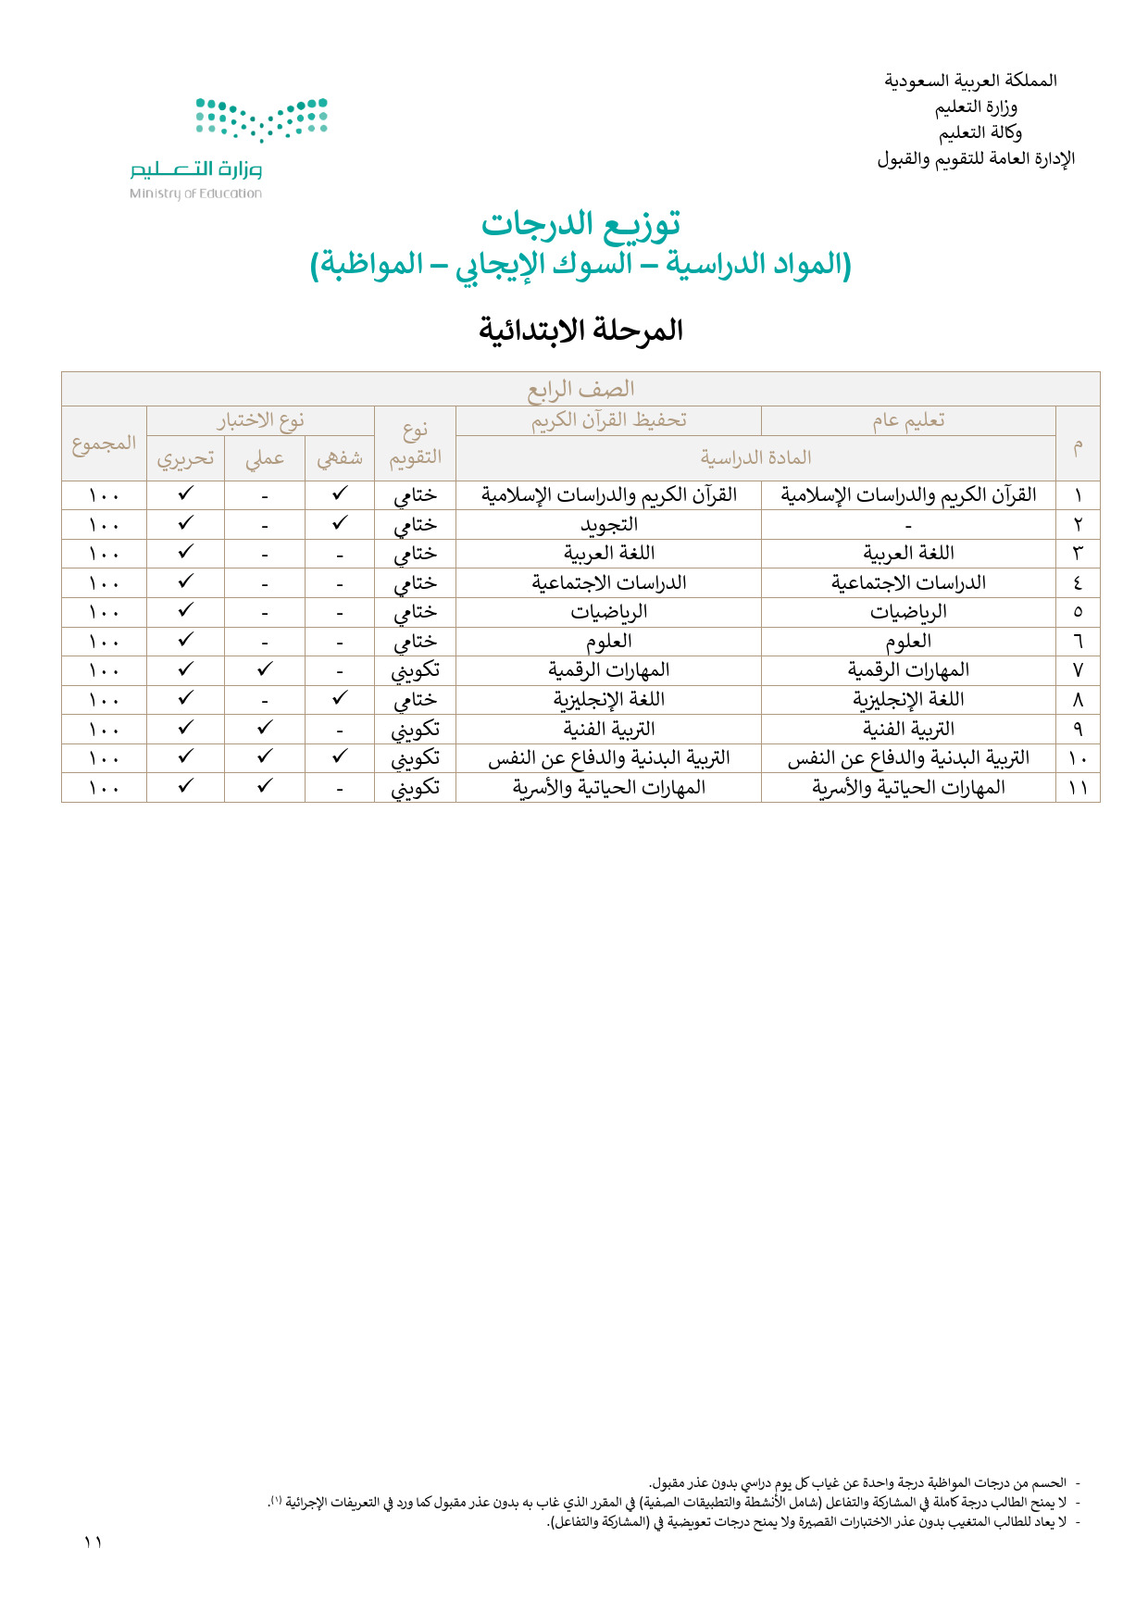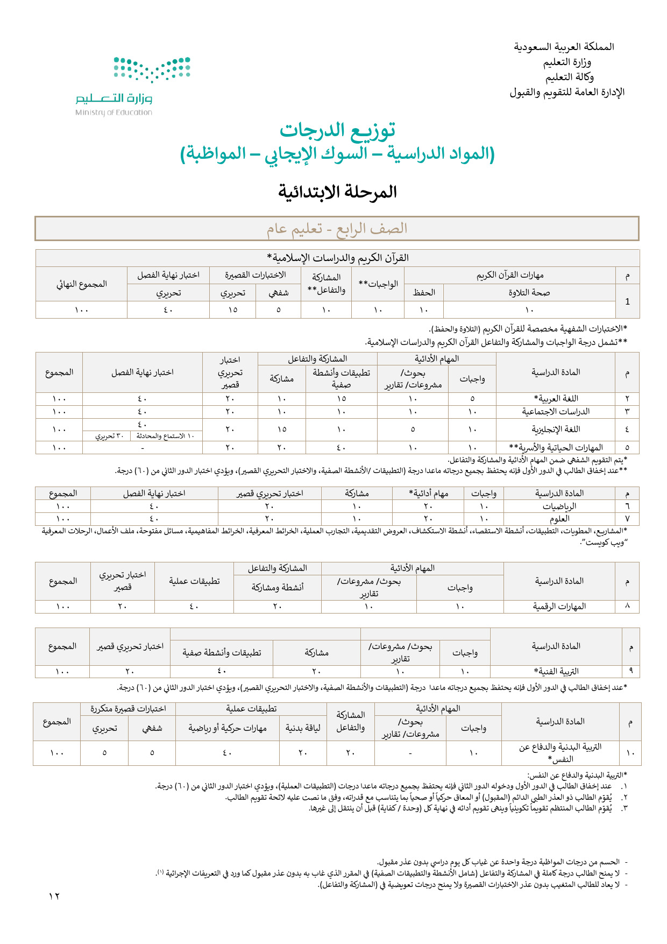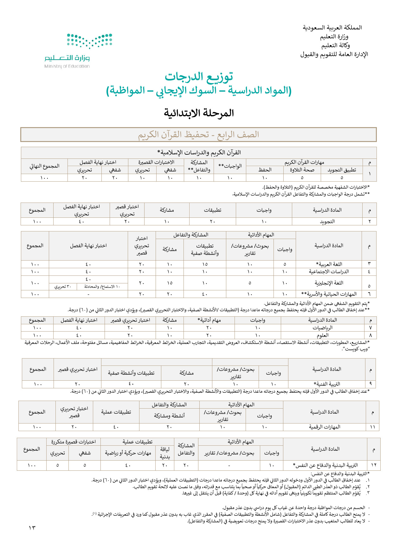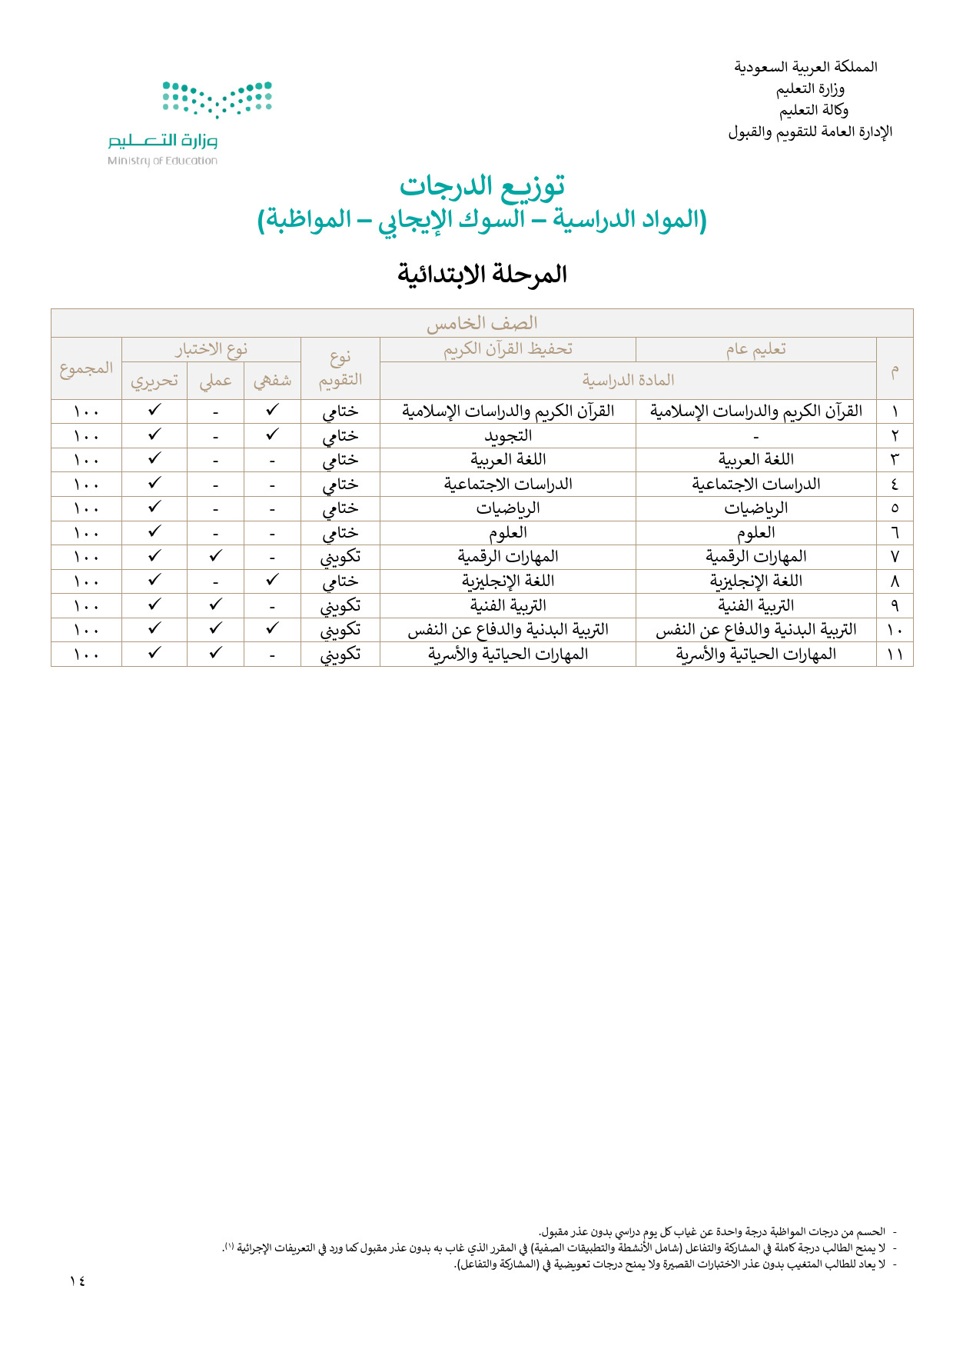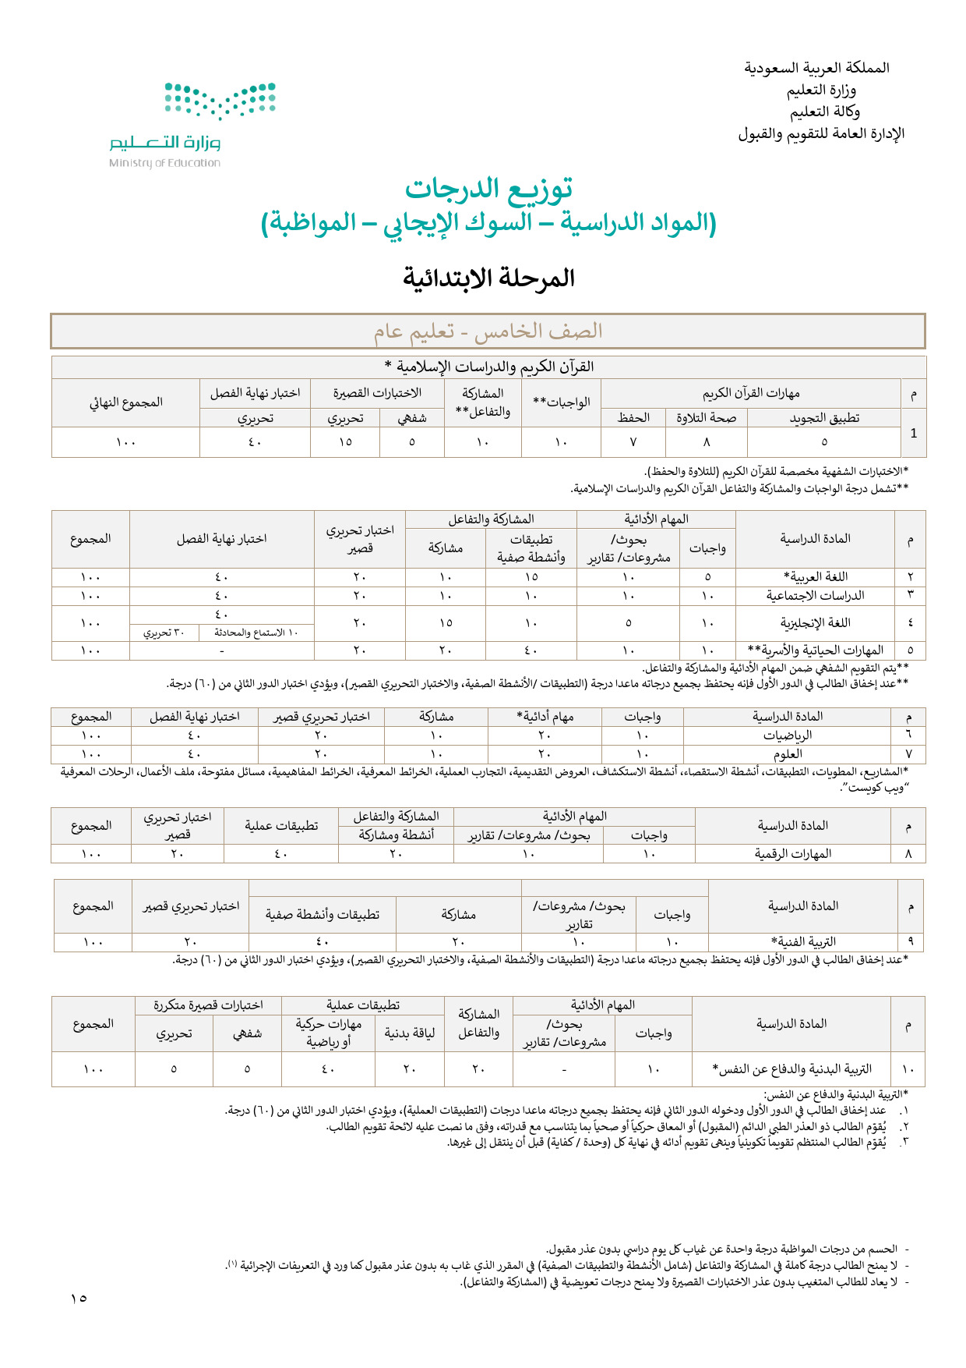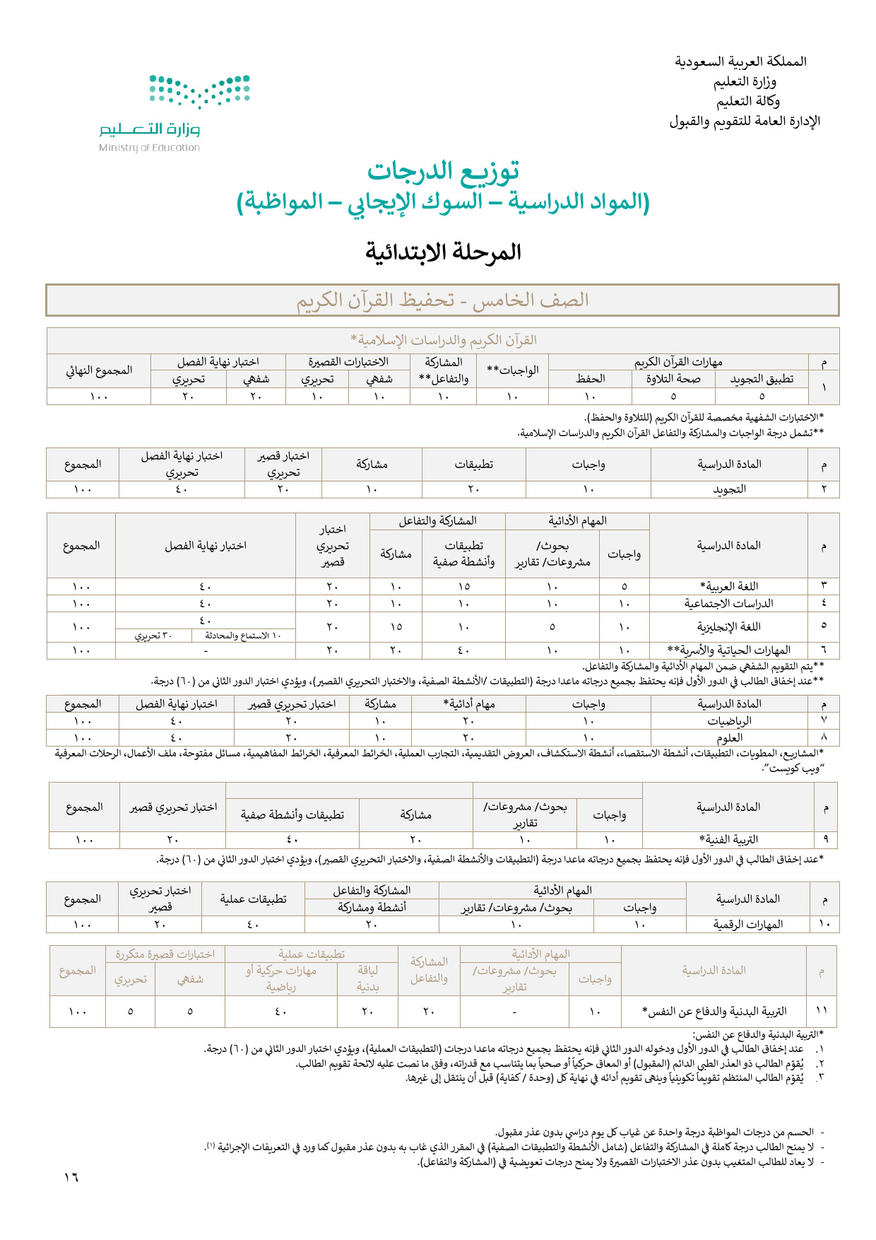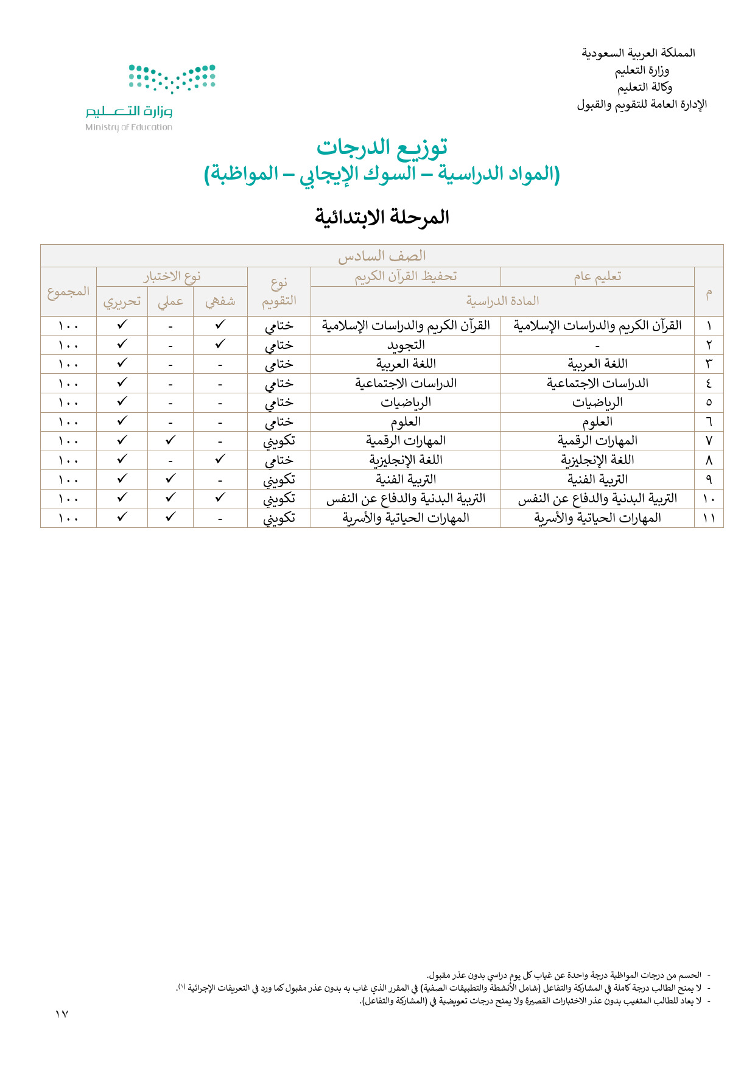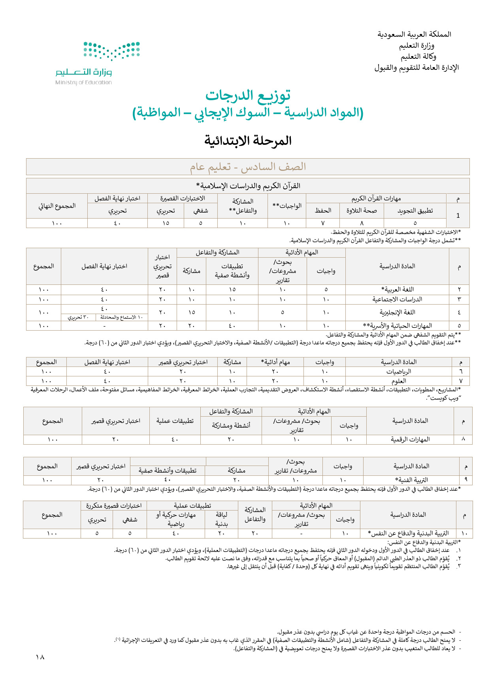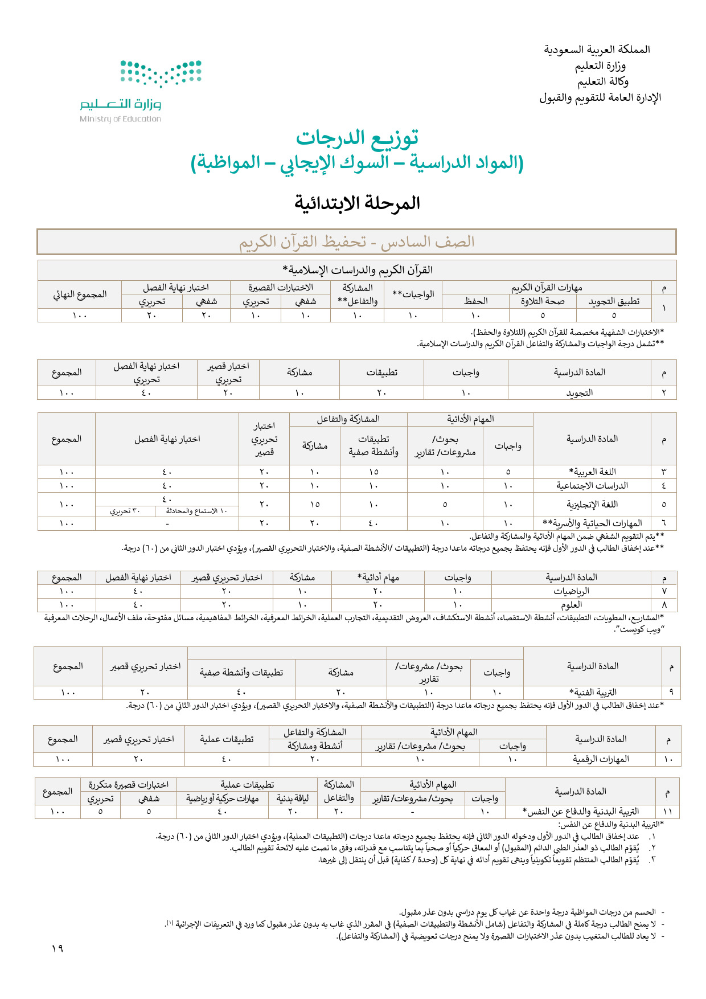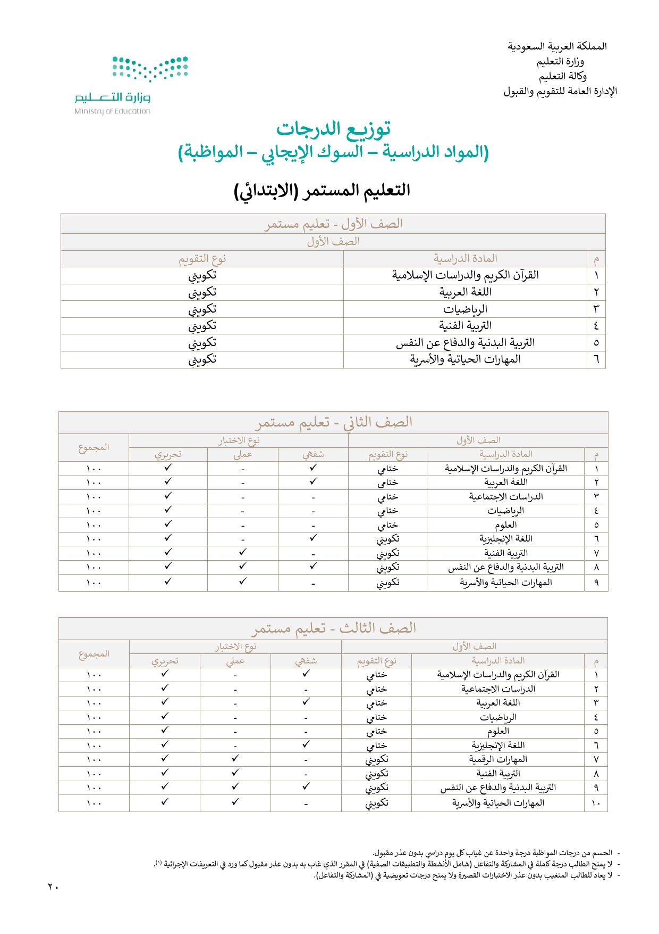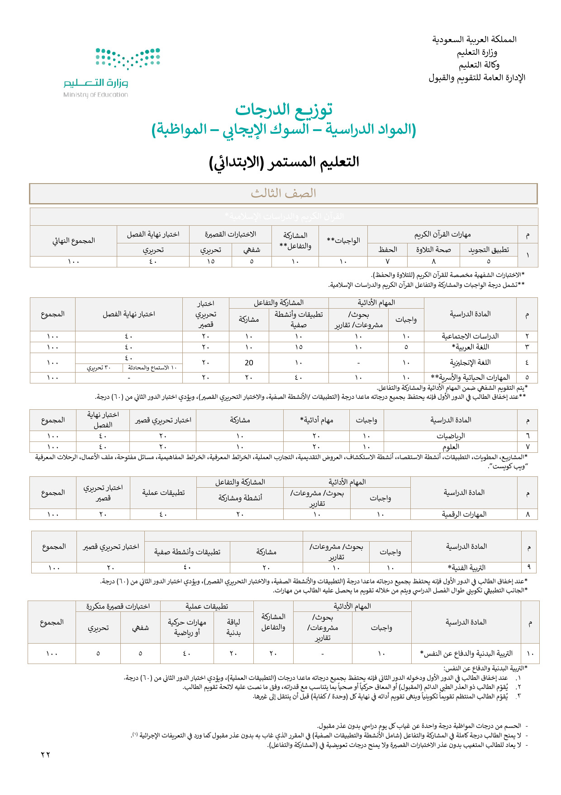

**[](https://t.me/Techni456_group)[](mailto:alghazee@hotmail.com)**

**إعداد المعلم /**

**غزي بن مساعد الغزي**

