اختبار الصف الخامس منتصف الفصل الدراسي الثالث 1444

/20 | الدرجة | / 5 | الفصل |  | األسم ثالثي:

- Choose : 3 /
- Rearrange :
mouse / on / The / is / the / chair/.
………………………………………………………………………………………………………
3 /
controlled Writing
Grammar
1- What are ? | these | this | that
2 – ………………….. is Ali ? | Who | What | Where
3- She …………….. in the bedroom . | am | are | is
- Circle :
Reading
1-A sofa in the living room . 2 /
2-The mouse is next to the fridge.
#.Write :
Vocabulary
1-This is the …………………………………….. 2 /
2-This is the ……………………………………

#. Match :

Fill in :

Vocabulary
house 4 /
tree candy ox
Orthography
3 /

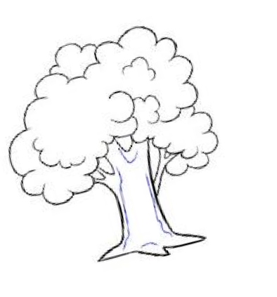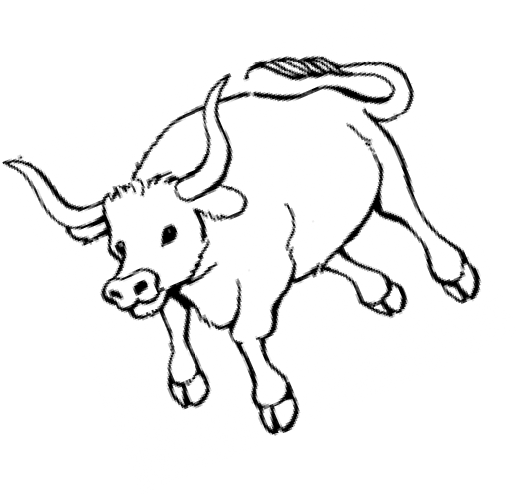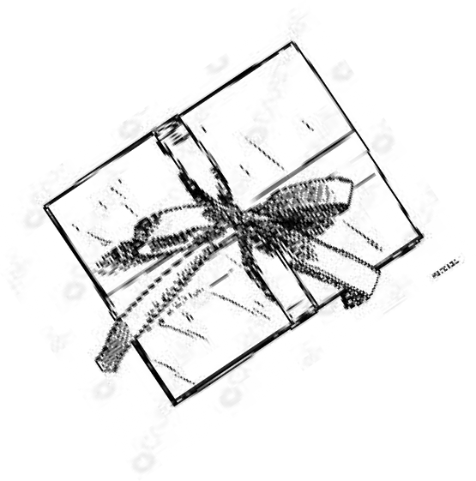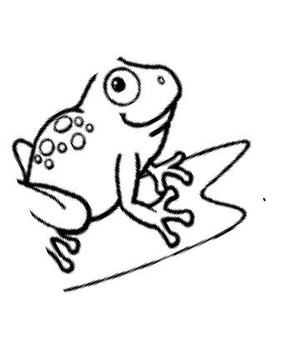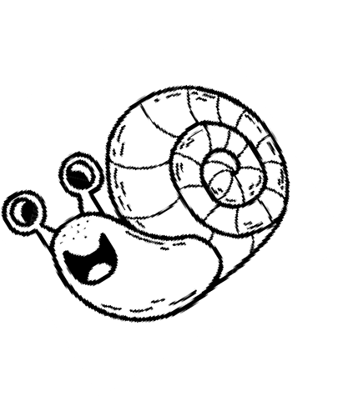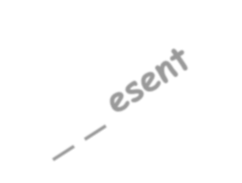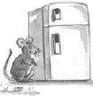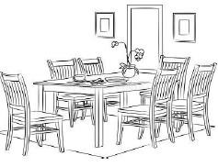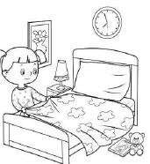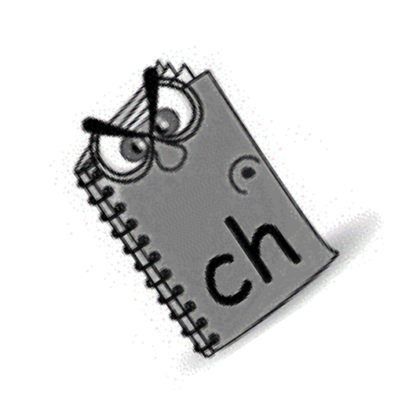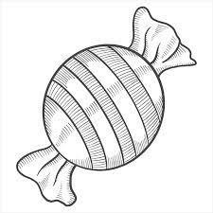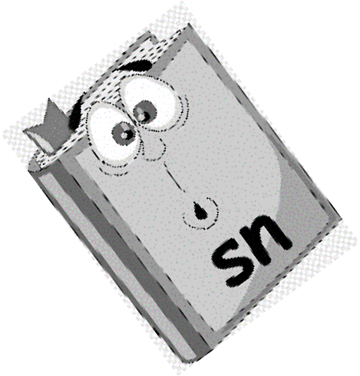
- Match :
1 – Where’s Hashim?
2- Can I have some candy ? 3- How do you spell box?
3 /
b-o-x .
He’s in the bathroom. Sure. Here you go.
General Questions

Good luck… Fekry Bosubaih

.....................................الطالبة اسم |  | المملكة العربية السعودية
 |  | مكتب التعليم صبيا
الصف: الخامس |  | مدرسة االبتدائية الثامنة واالسكان

The 5th Grade Exam first period (U3 My House)

Q1 Match

1- on
2- in
3- under
4- next to
5- behind

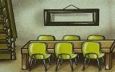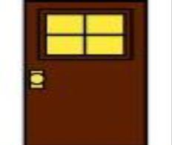Q2 write the words

..........
…………………………
....................... ..............

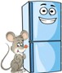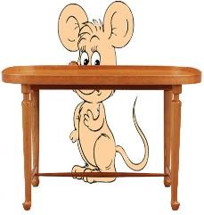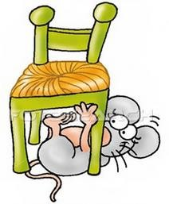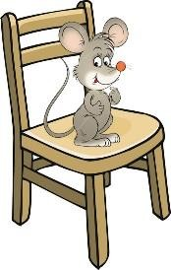
1-front door 2- Dining room 3-kichen 4- living room

Q3 Write the missing letters: (pr -fr – ou)
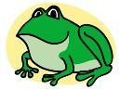

---og ----esent cl----d h se
Chair – fridge - table

Q4- unscramble the word
d i r e g f………………….
r a i ch………………
e a l b t………………

اختبار مادة اللغة اإلنجليزية الفترة الثانية للصف الخامس الفصل الدراسي الثالث

20
...................... : الصف
.............................. :االسم

A)- Match:
Q1. General Questions:

3
B

- What are these ?
A
- Can I have some candy ? 3- How many MP3 players ?

Q2. Controlled Writing:
A)- Rearrange:
2

They are wallets. Here you go .

2

comic book . / a / is / It

A)- Choose :

4

Q3. Grammar:

It is ( a – an ) wallet .
- How many candy are there ( ? - ! ) .

What ( are – is ) this ?.

They are ( pencil – pencils ) .

Q4. Reading short sentences:
A)- Read then put
or
:
They are watches . (
)

2

A)-Circle the odd word:
Q5. Vocabulary:

5

1- pen - cat - pencile – paper. 2- cow – wallet – watch.
B)- Read and write the matching number:
1-paper/2-glue/3-scissors /4-erasers/5-Pens

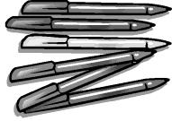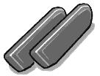

A)-Fill in the missing letters with:
Q6. Orthography:

4
{ sw/sp/sn/sm }
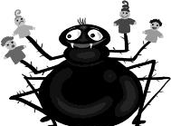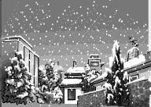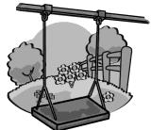
….. ider
……ile
…owy
…ing

اختبار اللغة اإلنجليزية للصف ◊الرابع ◊الخامس االبتدائي – الفصل الدراسي الثالث– 1444 هـ

Name: .......................................................................... Class: /
20

1-Circle the correct answer :
1 –Welcome to my house. Would you like to come in ?
A-You're welcome. |  | B- Yes, please . | C- It's mine .
2- Where is my mom?
 | A good bye . | B- She's in the kitchen. | C- That's Ok .
3- Can I have some candy ?
 | A- Sure .Here you go | B- thank you . | C- I'm here.
4 – Let's count the candy .
 | A-1, 2, 3, 4, 5 | B- a , b , c , d . | C- In the bag .
2- Read the sentences then put (T✓)or(F ×):

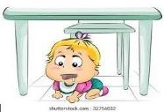
3 –Tick ✓beside the correct word:

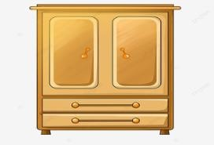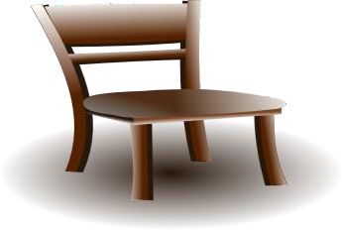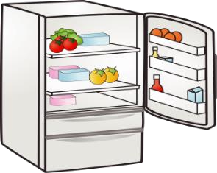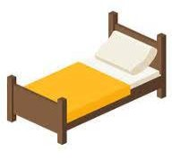

1-The mouse is on the box. ( )
2- The baby is next to the table.( )

- bed  - cupboard | - chair  - table | - table  - fridge | - bed  - chair

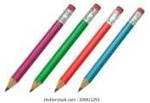
(4) – Choose the correct picture :

1-There are 4 pencils . | ◊ | ◊
2- There are 11 papers . | ◊ | ◊
3- There are 16 erasers . | ◊ | ◊
4- There are 30 candies . | ◊ | ◊

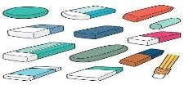
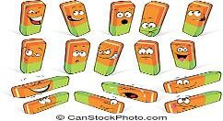
( 5 ) –Write the correct word under each picture:

1-bedroom | 2-living room | 3-bath room | 4-kitchen

……………………………………

……………………………………

……………………………………

……………………………………

( 6 ) –Fill in the missing letters :
sn - sm - fr - pr

 |  |  | 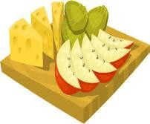
--ies. | --ize . | --ile . | --ack
good luck

