Kingdom of Saudi Arabia English Final Exam
Ministry of Education Grade: 1st Intermediate
…….. Intermediate school Term: Second Term
الصف الأول متوسط
الفصل الدراسي الثاني - الدور الأول
Year: 1443 H
Time: 2 hours
Pages: 3 pages
1) Writing

6
- Write an email to a friend about "your school "
by using the following questions:
1- What subject do you take?
2- What is your favorite class?
3-Who are your teachers?
4- Does your school have sports or clubs?
5- What sports or clubs are you in ?

…………………………………………………………………………………………………………………………………………………………………………
………………………………………………………......................................................................................................................
....................................................................................................................................................................................................................................................................................................................................................................................................................................................................................................................................................................................................................................................................................................................................................................................................................................................................................................................

6
2) Reading Comprehension
- Read the following passage, then answer the questions below:
Mr. and Mrs. Smith have one son and one daughter. The son's name is John. The daughter's name is Sarah. The Smiths live in a house. They have a living room. They watch TV in the living room. The father cooks food in the kitchen. They eat in the dining room. The house has two bedrooms. They sleep in the bedrooms. They keep their clothes in the closet. There is one bathroom. They brush their teeth in the bathroom.
The house has a garden. John and Sarah play in the garden. They have a dog. John and Sarah like to play with the dog.

A) Choose the correct answer:
1- Mr. and Mrs. Smith have [ a) One son b) One son and one daughter c) No children ]
2- The family watch TV in the [ a) living room b) bedroom c) dining room ]
3- The house has [ a) one b) two c) three ] bedrooms.
B) Put ( ) or ( x ):
1- The father cooks food in the kitchen [ ]
2- The house has a garden [ ]
3- John and Sarah play in the bedroom [ ]
(1)
3) Grammar

7
A) Choose the correct word:

1- ( There is – There is not – There are ) four people at the table .

2- The cat is ( in – behind – under ) the mouse .
3- I can speak English, ( and - but - or ) I can not speak French .
4- I live ( in – on – at ) Skaka .
5- The bank is ( between – near – far from ) hospital .
6- Jack and his friends are ( eat – ate – eating ) pizza at his house .
7- He usually does his homework ( before – after – then ) dinner .
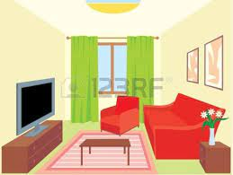
8- What does Fred do? He ( cook - cooks - cooking ) Food .
B) Do as shown between the brackets:

1- Is there a TV in the living room ? (answer)

.................................................................................

2- Trains are ( fast ) buses . (make comparative sentence)

................................................................................................

3- What would you like ? Coffee (answer)

................................................................................................

4- Football / very / exciting / sport (Use the words to write sentence)

...............................................................................................

5- opens / at nine / usually / The bank (Write the words in the correct order)

..................................................................................
4) Vocabulary

7
A) Write the correct word under each picture:
( Smartphone – Turn right – Cyclist – Hospital – Time – Kitchen )
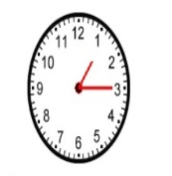
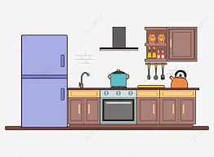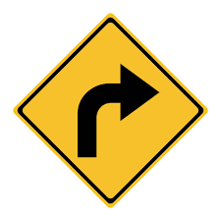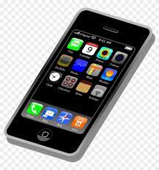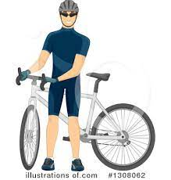
…………………… ……………………… ………….... ……………… ……………… ……………

B) Match:
a- not boring
b- a place to eat
c- believe me
d- absolutely not
e- a place to buy books
f- athletic
- active ………
- restaurant ………
- interesting ………
- bookstore ………
- trust me ………
- No way ………
(2)
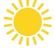
C) What time is it ?
.......................................................................................

5) Spelling
A) Fill in with the correct letter:

4
- Ta………le ( b - p - m )
- Flowe………s ( r - s - t )
- Phar……...acy ( n - m - o )
- Mal………. ( c - l - z )
- La……...top ( d - k - p )
- Hi………tory ( j - l - s )

انتهت الأسئلة , مع تمنياتي لكن بالتوفيق
(3)

