1
I. CHOOSE
المملكة العربية السعودية |  |  | اسم الطالب/ه ......................................
وزارة التعليم
إدارة التعليم بمنطقة |  |  | المادة : انجليزي
مدرسة : |  |  | الزمن :
 |  |  | الصف : فصل ( )
شفهي | تحريري |  |  | المجموع
10 / | 10 / |  |  | 20 /
اختبار الفترة الأولى للفصل الثاني - للعام الدراسي 1447– لغة انجليزية –– للصف الثالث ابتدائي
نموذج الاجابة

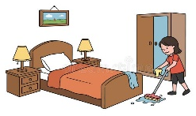
1 – What did you do over the weekend?

A . I am 10 years. B . I cleaned my room .
2 – I won a table tennis game 21 to 3 .
A. Congratulations. B. Sorry about that .

2. CHOOSE OR
1.5

1. He kicked the ball.

She watched TV. .2
3. I caught a big fish.






3. DO AS SHOWN BETWEEN BRACKETS
1.5

She cooked breakfast. |  |  | 1– breakfast – cooked – she . ( rearrange )
grocer's | park | bank | 2– I went to the ____ to buy some milk. ( choose )

4. CHOOSE
1
4. CHOOSE
some | many | much | 1 – How____ oil do you need ?
wining | won | win | 1- The PAST TENSE of win is ______ .

________________________________________________________________________________________________________________________________________________________________________________________________________________________________

French fries - Trampoline - carrots

3
5. CHOOSE
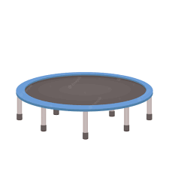     |  | 
Trampoline | French fries | carrots

\

6. CHOOSE THE RIGHT LETTERS:
2

Choose the correct letter:

  ele_ _ant | 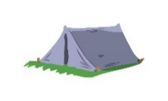  te_ _ | 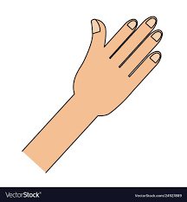  ha_ _ |   _rog
gh | nd | nd | f
ph | nt | nt | d

Controlled writing

4

______________________________________________________________________________________

Good luck

