**Test 1**

**20**

TOTAL

# Name .

**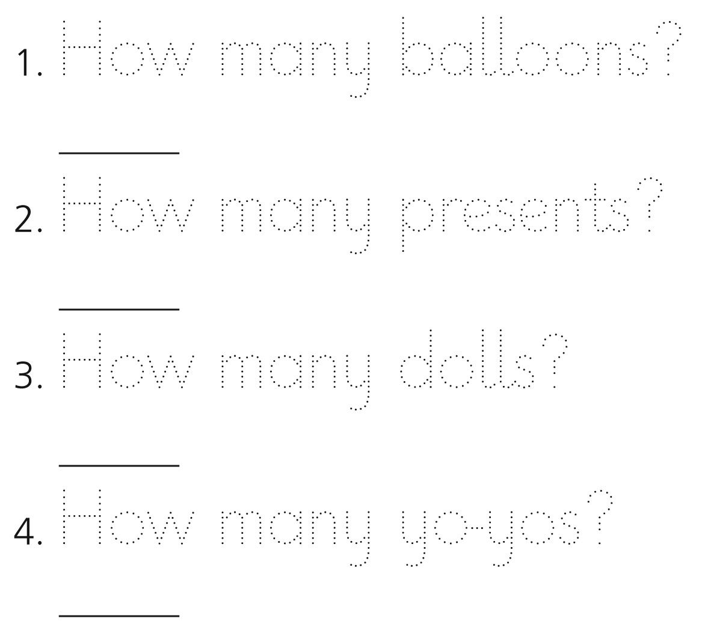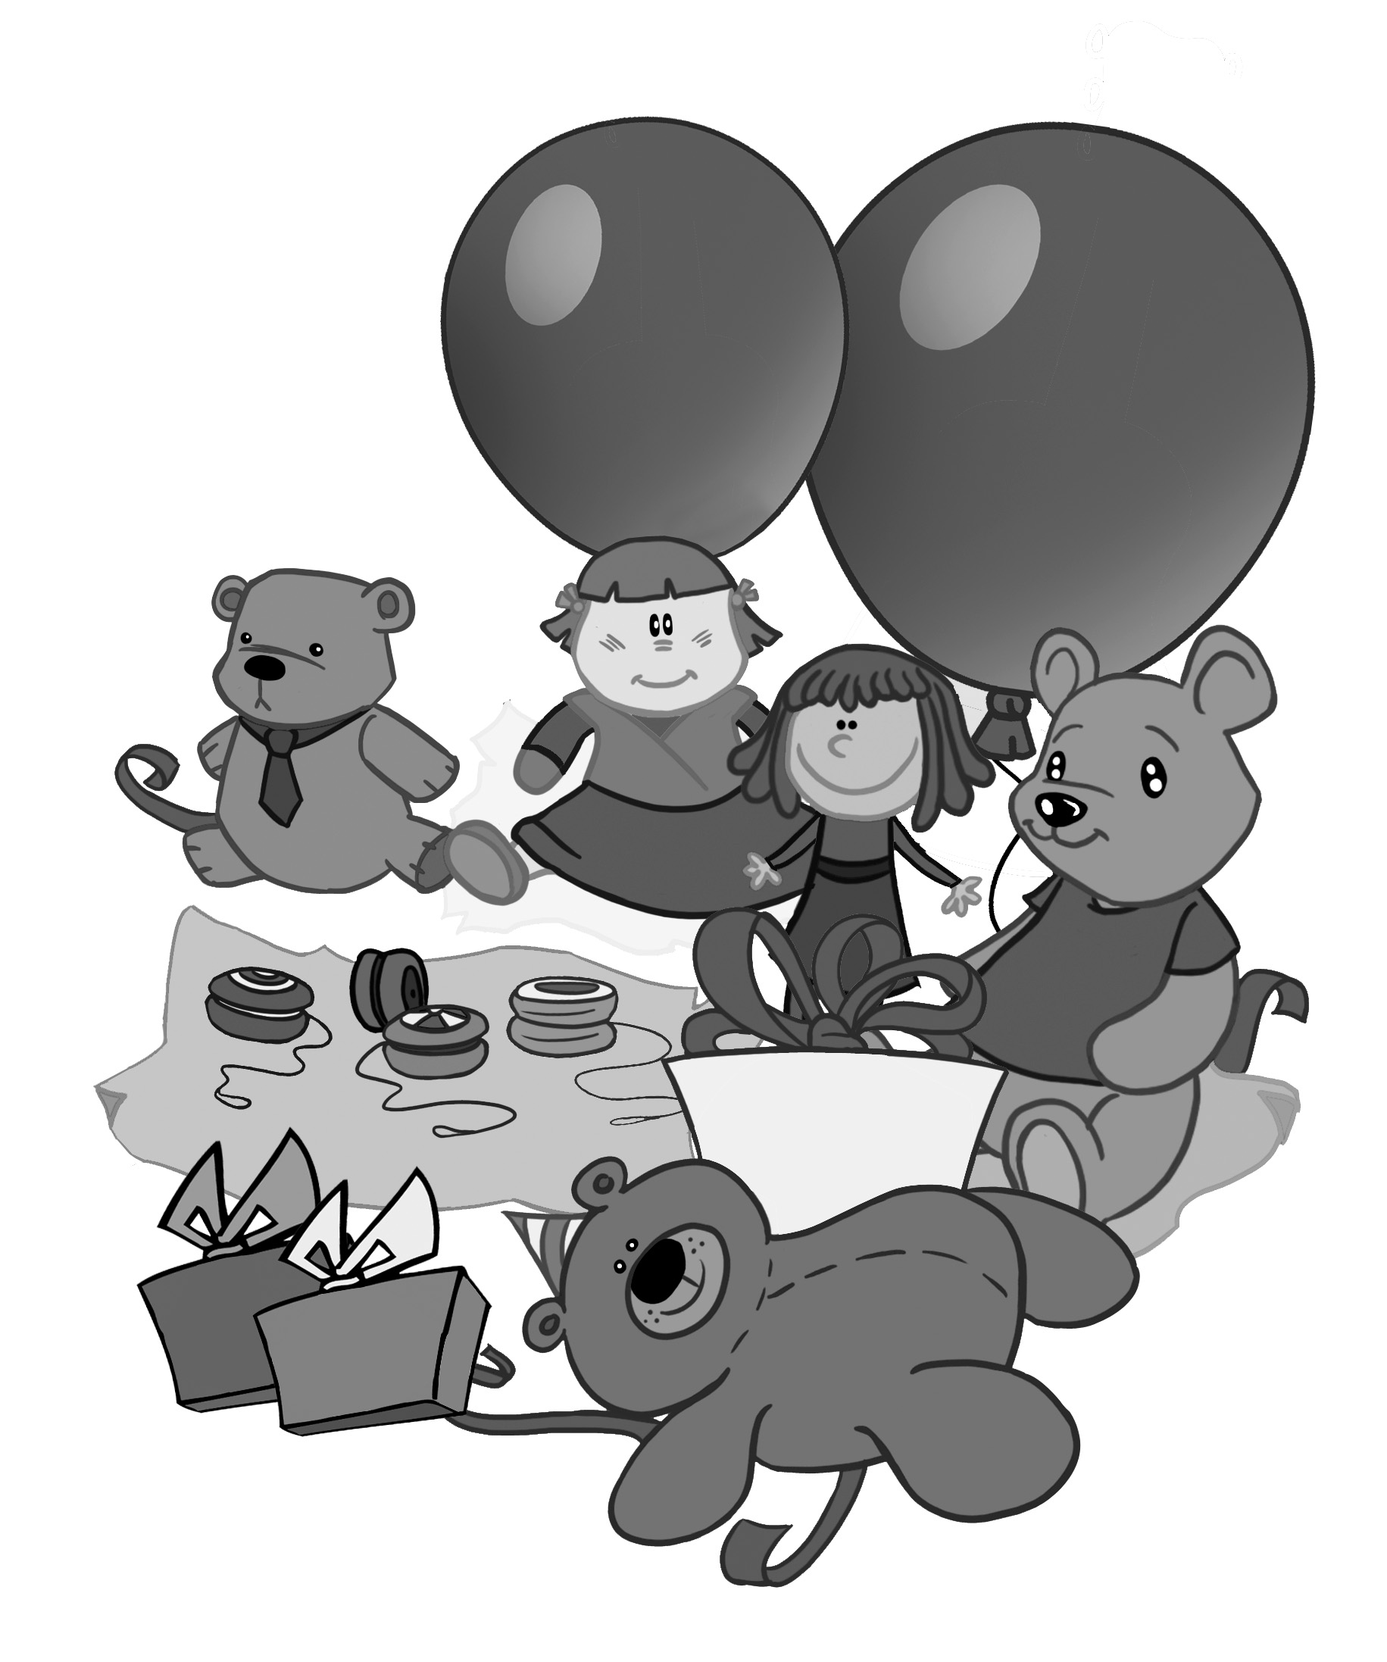1. Trace. Then count and write the number.**

**8**

score



**2. Listen and number (1-4).**

c

a





d

b

**6**

score



**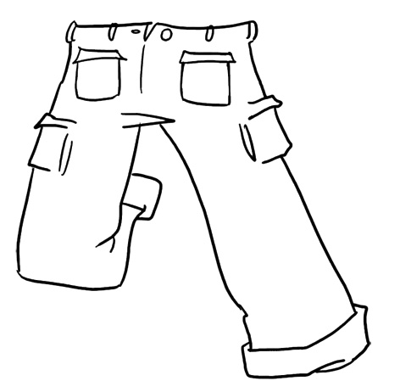3. Listen and colour.**

jumper_outline.tifjumper_outline.tifdress_outline.tifdress_outline.tif

**6**

score

3.

2.

1.