


اختبار الفاقد التعليمي – الصف .......
الاسم : |  | الفصل | / | الدرجة | / 20

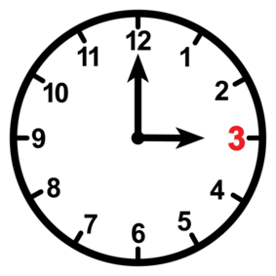
I. Choose the right answer :
2
- What is the time ?
- It is one o'clock. | - It is three o'clock.

- What did you do over the weekend?
- I usually get up at 6:00 | - I cooked a big breakfast.

222
II. Choose  OR 
3

He kicked a ball . | He is a doctor. | I watch TV.
 |  | 
  |   |  
2
III. Do as shown between brackets:

thirty | thousand | hundred |  1-one _______ . ( Choose )
ززززززززززززززززززززززززززززززززززززززززززززززززززززززززززززززززززززززززززززززززززززززززززززززززززززززززززززززززززززززززززززززززززززززززززززززززززززززززز |  |  | 2. was – I – sick ( rearrange)
C. go | B. get | A. got | 1 – I usually ____ up at 5:00 .
C. some | B. much | A. many | 2. How____ oil do you need?
2

V. Choose the correct word:

6

 |  | 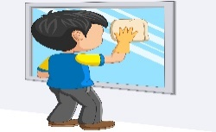 | 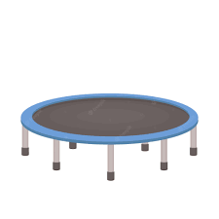 | 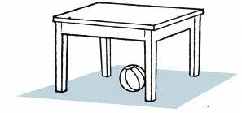 | 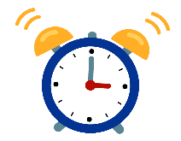
Carrots | Take a bath | Get up | Trampoline | Teacher | Clock
Cheese | Go to bed | clean | Elevator | Doctor | Ring
VI. Choose the correct letter:
  _ ilot |   _ _one |   ri_ _t | 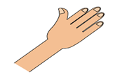  Ha_ _ |   ri_ _
b | gh | ph | gh | ng
p | ph | gh | kn | nk
5

TEACHER :

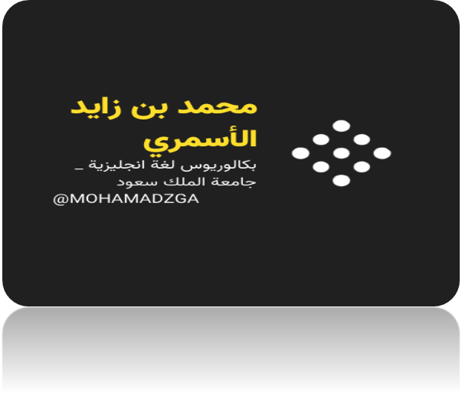

لا تنسوني من صالح دعائكم





M_zaid0

