How is your result ?
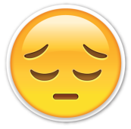
Name : …………………………… Class : ………………
worksheet : ( 16 )
1 ) Color these shapes :

Blue Square Red Rectangle

Yellow Star

Orange Circle Green Triangle

