Unit 3: My Family
This is my family.

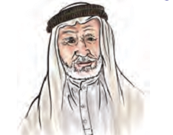
Grandpa
This is my grandpa.

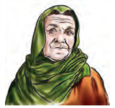
Grandma
This is my grandma.

Dad
This is my dad.

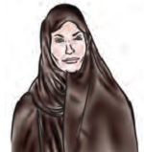
Mom
This is my Mom..

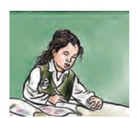
This is my Sister.

This is my Brother.

Nice to meet you!

Nice to meet you, too!

*Match:
Small letters | N0. | Capital letters | No.
c |  | A | 1
d |  | B | 2
b |  | C | 3
e |  | D | 4
a |  | E | 5

*Rearrange the numbers and copy:
3 three | 1 one | 2 two | 5 five | 4 four

