• Vocabulary Match each word to its meaning.
1. devoted |  | A. famous
2. legendary |  | B. trusted to work well
3. reliable |  | C. dedicated
4. invaluable |  | D. thinking the same thing
5. on the same wavelength |  | E. extremely valuable; priceless
6. deficiencies |  | F. polite way to say you don’t like something
7. not my cup of tea |  | G. ways in which something lacks what it needs

devoted / laboratory / radioactivity / reliable / grieving
- Imad and Hussein spent hours in their ------------------------- doing experiments.
- -------------------- can harm people in many ways, but skin burns are the most common injury.
- People usually wear black when they are ------------------- for someone who has died.
- History suggests several steady, ---------------- ways to become well off or even wealthy.
• Mega Goal 3.1 Grammar Choose the right answer :
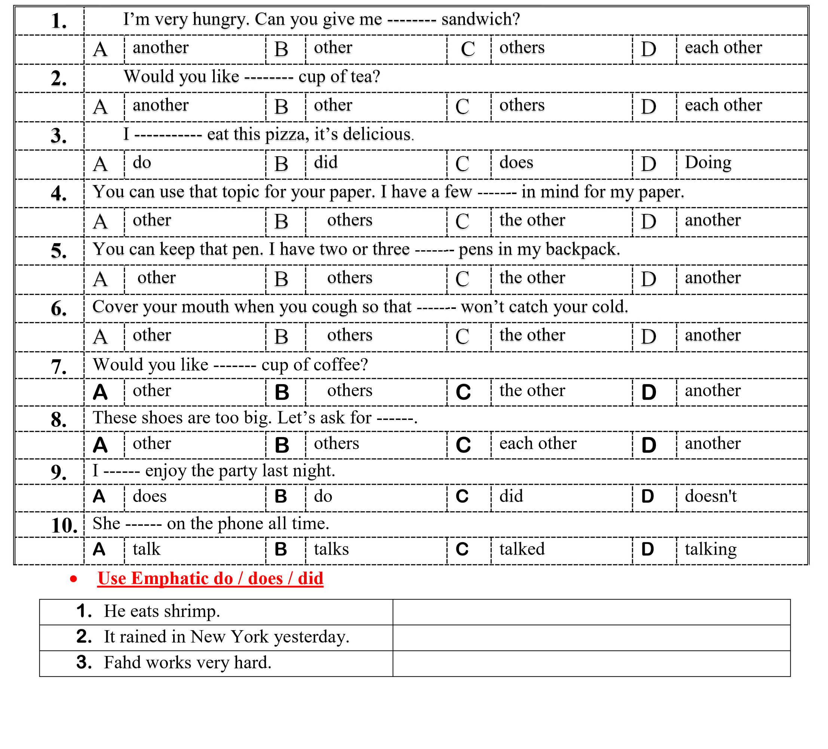
⬥ Vocabulary Match each word to its meaning.
1. No sweat |  | A. airplane manufacture, development, and design
2. fearsome |  | B. a person who starts a new method or activity
3. aviation |  | C. something that covers a wide range of ideas and details
4. predators |  | D. to overcome a weakness with a strength
5. extensive |  | E. No problem.
6. pioneer |  | F. causing great fear
7. compensate |  | G. animals that live by hunting others
pioneer / legendary / compensate /predators / deficiency

- Lions, tigers and bears are examples of ------------------- animals.
- Majed Ahmed Abdullah is ------------------- Even children today have heard his name.
- Suliman Olayan was a ------------------- Saudi who contributed to the Kingdom’s development.
- No amount of money can fully ------------------- for the loss of a limb or for extreme pain.
- Mega Goal 3.1 Grammar Choose the right answer :
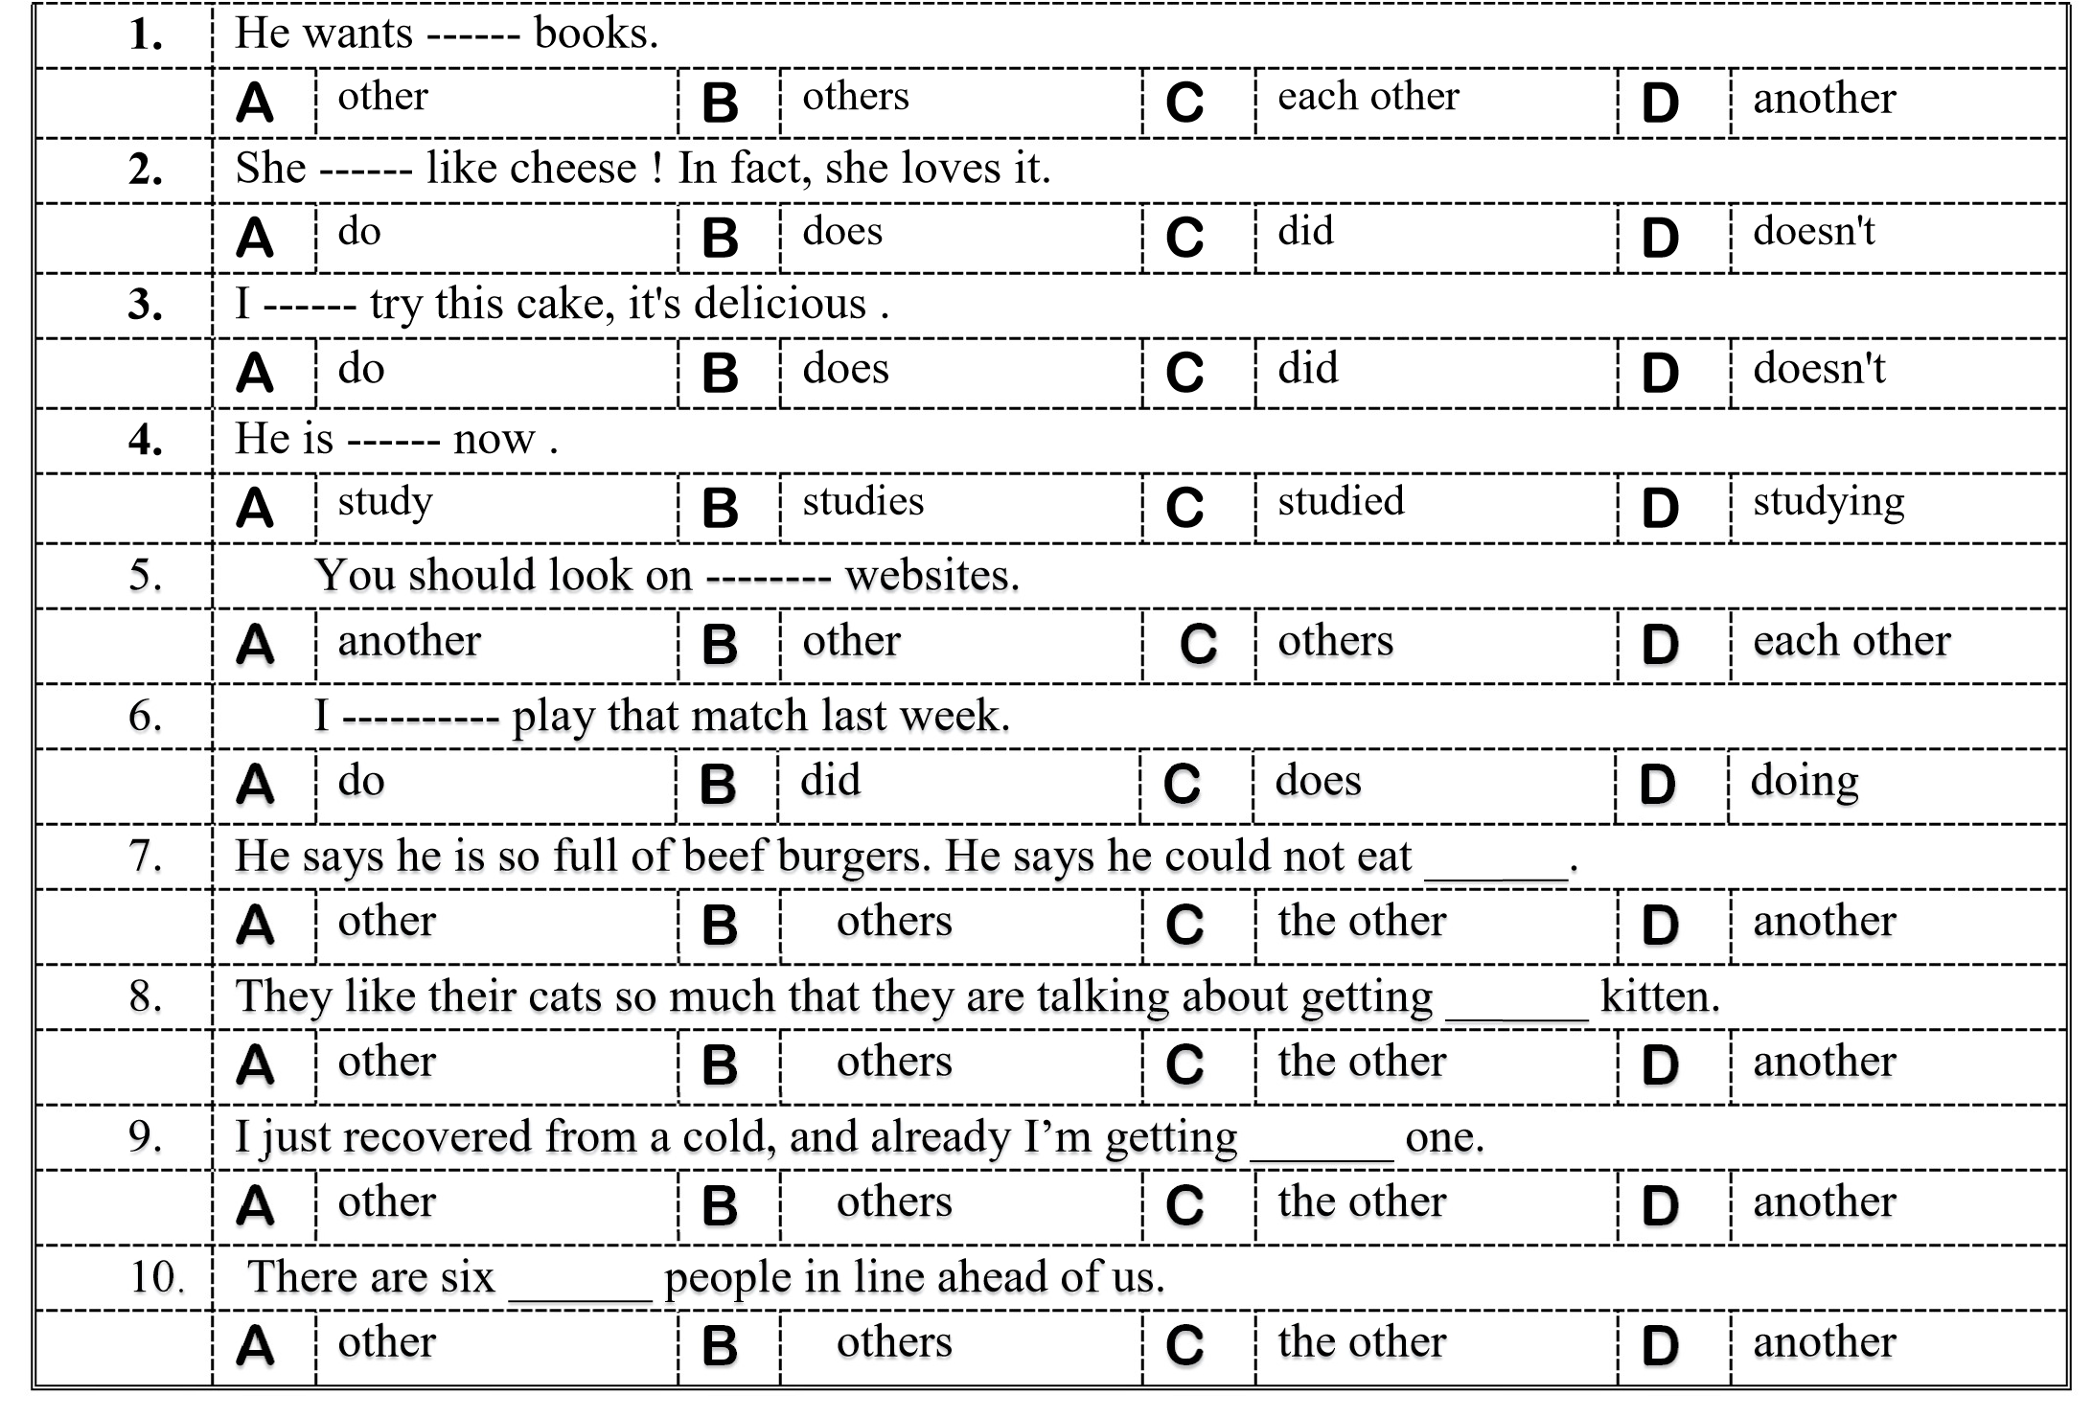

• Use Emphatic do / does / did
1. You need to come with me.
2. The little bird followed us home.
3. We have that game.

 Vocabulary Match each word to its meaning.
1. devoted |  | A. famous
2. fearsome |  | B. trusted to work well
3. No sweat |  | C. dedicated
4. predators |  | D. to overcome a weakness with a strength
5. reliable |  | E. No problem.
6. legendary |  | F. causing great fear
7. compensate |  | G. animals that live by hunting others

devoted / laboratory / pioneer / deficiency / predators /
- He is ------------------- to his research. He spends all of his time working on it.
- Animals alter their behavior to avoid a variety of different types of ------------------- .
- He is a ------------------- in the field of conservation biology and has lectured widely on the subject.
- Excessive consumption of soft drinks has been shown to lead to calcium ------------------- .
- Mega Goal 3.1 Grammar Choose the right answer :
