We Can! Book 6 Unit 1: Fun on the Weekend

1. Read and match sentences and pictures.

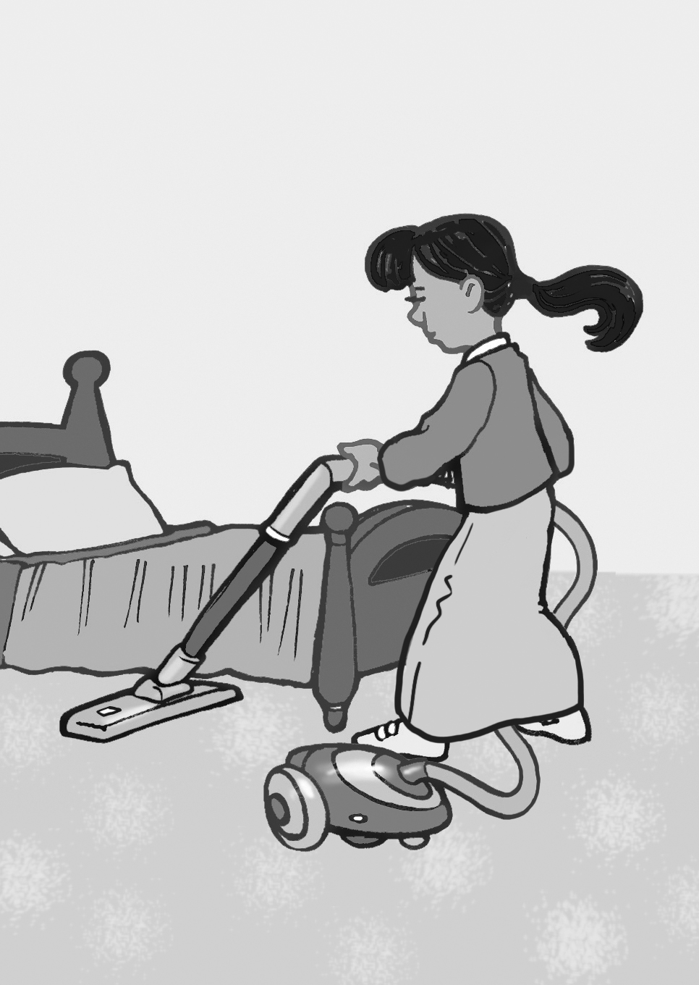 | 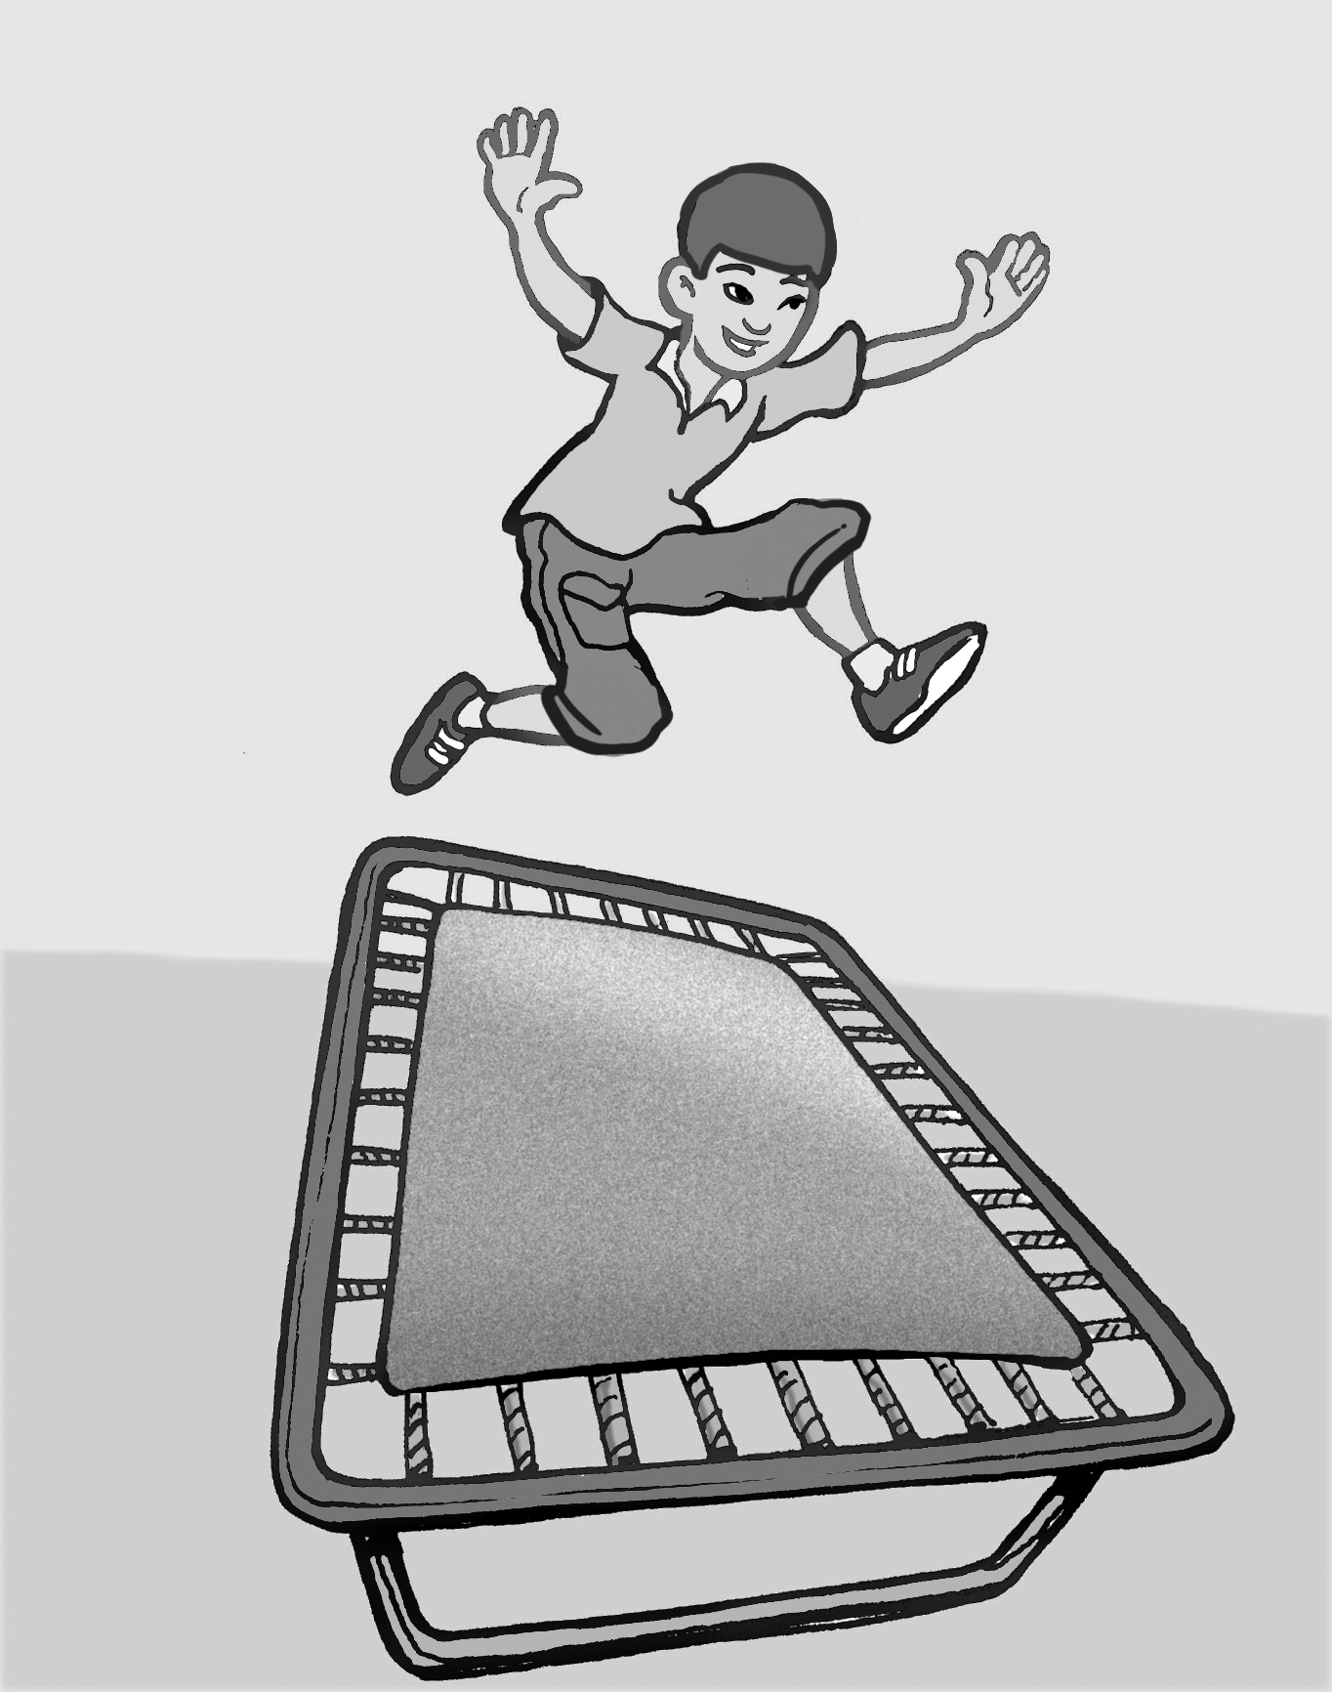 | 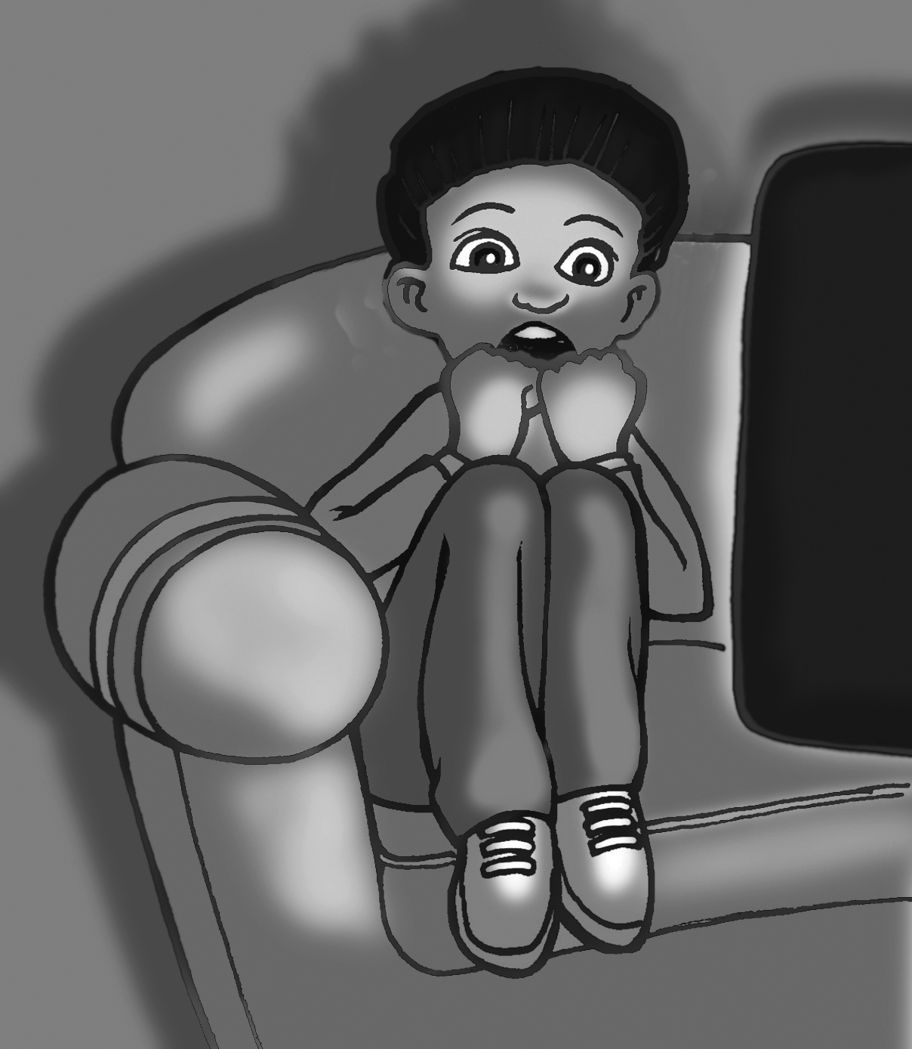 | 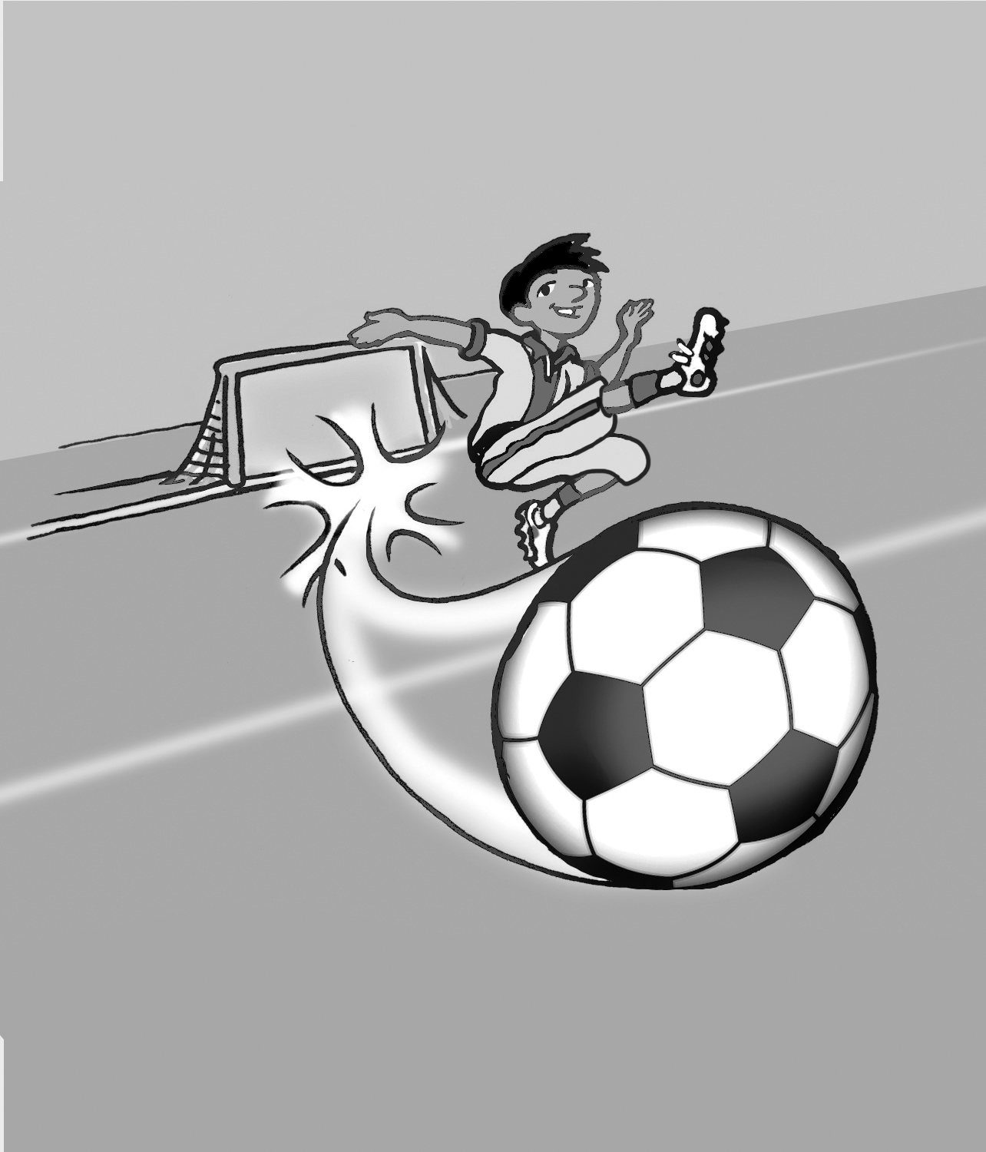
1 | 2 | 3 | 4
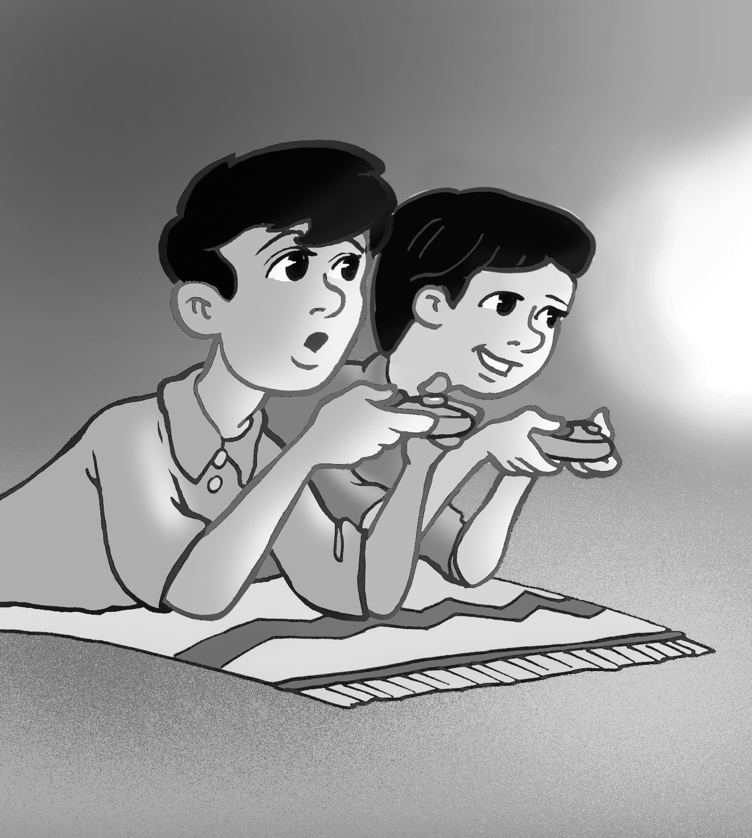 | 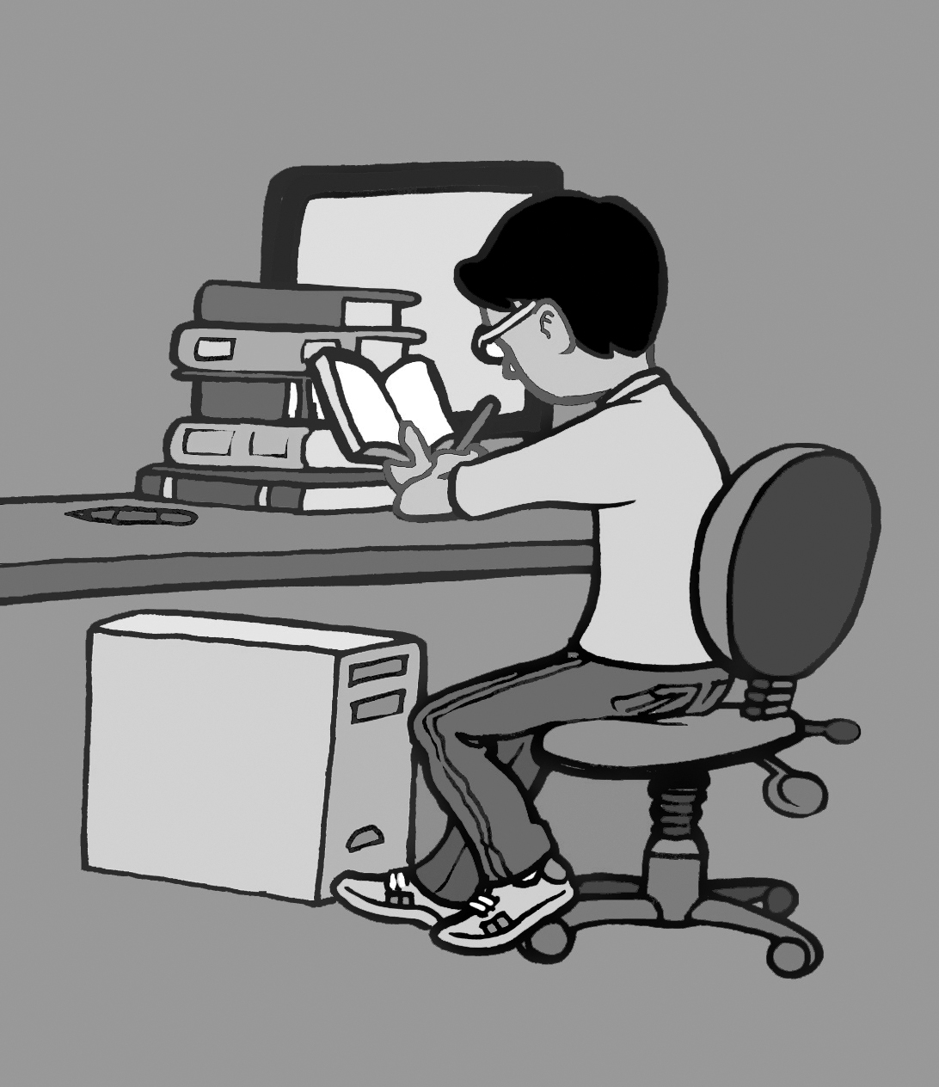 | 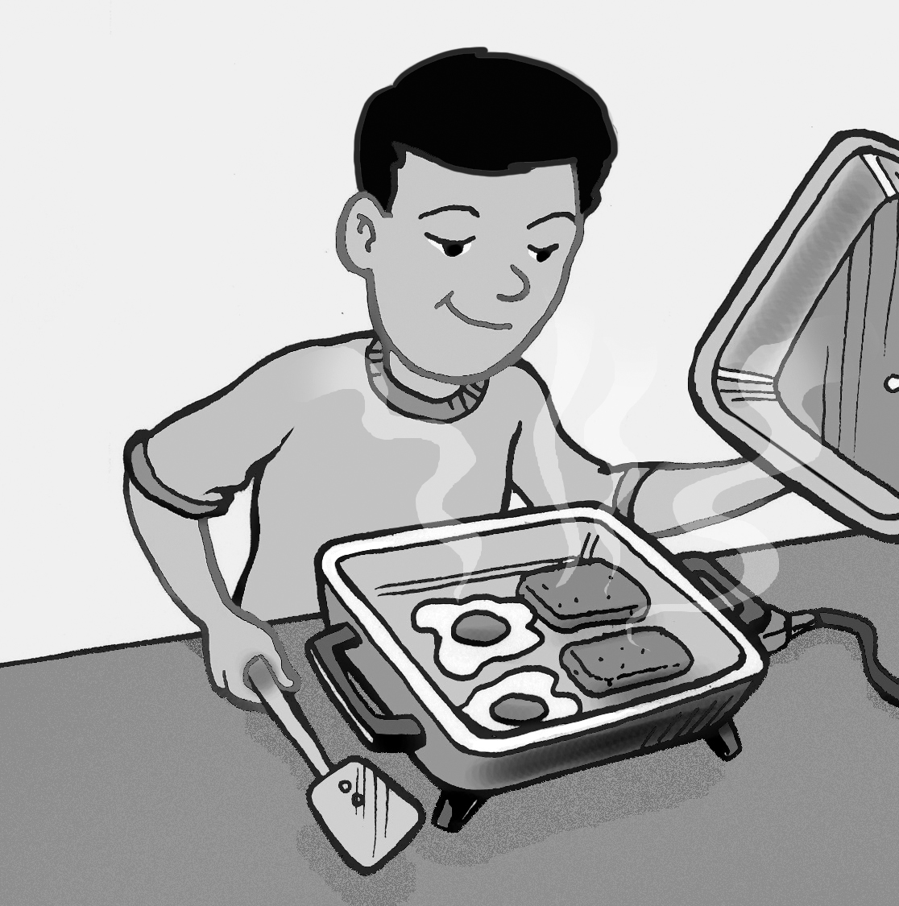 | 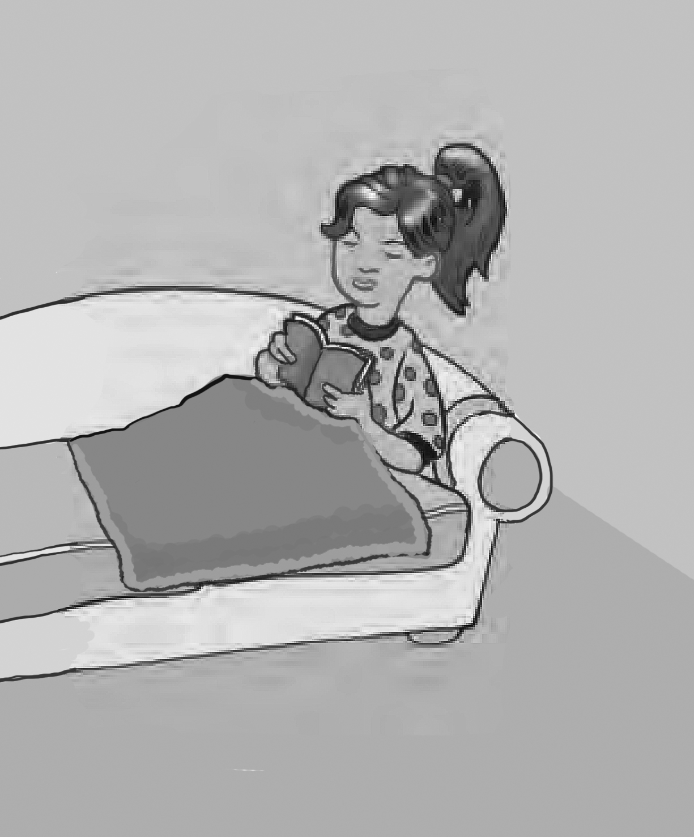
5 | 6 | 7 | 8

8 Nura stayed home.
6 Fahad studied for six hours.
2 Ali practiced on the trampoline.
7 He cooked breakfast.
3 You watched a scary DVD.
4 Saeed kicked the ball.
1 Nura cleaned her room.
5 They played computer games.

2. Listen and fill in with much or many. Then listen again and circle the right answer.
[Play CD3 06 or read.]

1. How much flour do we need to make a cake?
a. 3 cups b. 4 cups
2. How many eggs do we need? I think we need …
a. 5 eggs b. 4 eggs
3. How many tomatoes are there in the fridge?
a. 7 tomatoes b. 6 tomatoes
4. How much milk do you drink in the morning?
a. About 2 cups b. About 10 cups
5. How many apples do we need for the apple pie?
a. I don’t need any. b. I don’t know.

Now listen and fill in with some or any.

6. We have some sugar, but we don’t have any milk.
7. We have some apples, but we don’t have any bananas.
8. There is some orange juice in the kitchen.
9. There isn’t any oil in the bottle.
10. There are some chocolates in the box.

3. Read and write about things in your bag. Use some or any.
pencils/ cookies
There are some pencils in my bag, but there aren’t any cookies.

pens/ flowers
___________________ (answers will vary)________________

books/ toys
___________________ (answers will vary)________________

Now write your own sentences.

___________________ (answers will vary)________________

_____________________________________________________

