( Mega 2.1 )
U 3 , Reading
A – Answer the following questions :
1 – What does ecotourism mean ?
………………………………………………………………………………………………………………………………………………………………
2 – When was ecotourism first heard ?
…………………………………………………………………………………………………………………………………………………………………
3 – Which a country had the highest rate of deforestation in all of Latin America ?
…………………………………………………………………………………………………………………………………………………………………
4 – Give example of renewable sources of energy ?
…………………………………………………………………………………………………………………………………………………………………

B- Mach the words to their suitable picture :
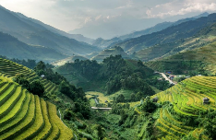
1 – deforestation ( )

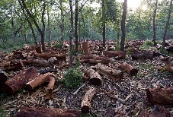
2 – Pristine beach ( )

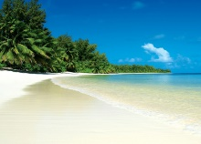
3 – Ecotourism ( )

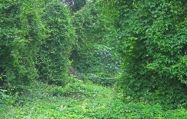
4 – Lush rainforest ( )

