 | 1 | 1 | 1

 | one | one | one

 | 2 | 2 | 2

 | Two | Two | Two

Count and colour the right number:-
 | 1 | 2
 | 2 | 1
Count and write the number:-

Write the missing numbers :-
3

Count and colour :-
1
2

 | 3 | 3 | 3

Three | Three | Three

 | 4 | 4 | 4

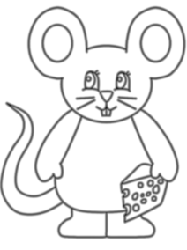
Four | Four | Four

Count and write the number:-

ـــــــــــــــــــــــــــــــــــــــــــــــــــــــــــــــــــــــــــــــــــــــــــــــــــــــ
Draw 2 circles

Draw 4 circles
ـــــــــــــــــــــــــــــــــــــــــــــــــــــــــــــــــــــــــــــــــــــــــــــــــــــــــ
Count, Draw and write the number :
3
Four

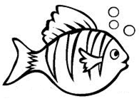
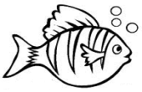
2

1

 | 5 | 5 | 5

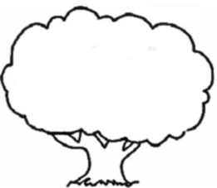
Five | Five | Five

 | 6 | 6 | 6

Six | Six | Six

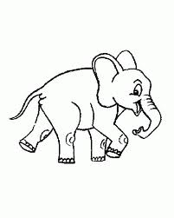

Count, Write the numbers , Then match the groups :

ـــــــــــــــــــــــــــــــــــــــــــــــــــــــــــــــــــــــــــــــــــــــــــــــــــــــــ
Count and colour :-
5
4
6

Count and write the number:-

Count and colour :-
5
4
6
1
3
2
Count, Draw and write the number :
1
One

3
2

1

Six

1

5

Write the missing numbers :-
2

5

6
3

Follow the numbers Draw the lines:-
6
3

6
6
3
3

6
3

6
3
6
3

Draw 2 circles

Draw 5 circles

Draw 3 circles

Draw 1 circle

Draw 4 circles

Draw 6 circles

 | 7 | 7 | 7

Seven | Seven | Seven

 | 8 | 8 | 8

Eight | Eight | Eight

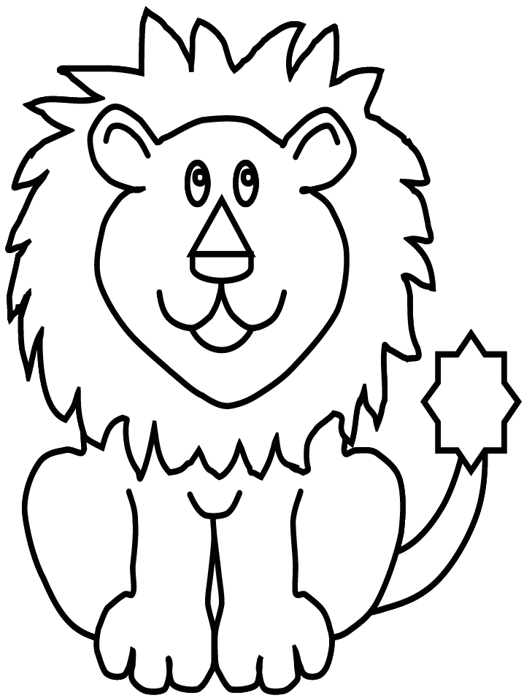

Write the missing numbers :-
6
3
1

Count and write the number :-
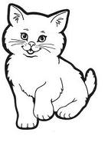

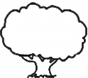
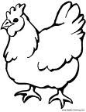

Count , Draw and write the number :-

Three

 | 9 | 9 | 9

Nine | Nine | Nine

 | 10 | 10 | 10

Ten | Ten | Ten

Write the missing numbers :
7
4
1
9
2
5

