Date: | Introduction | Introduction | 2nd 3rd 4th 5th Grades Elementary (We Can 2) Term 1

Let’s play a game, Good idea!, Watch me. Make pairs, Let’s start!, Okay! Stop!, Wow! Good job!, Let’s finish. Please listen to me. You were great! goodbye |  |  | Vocabulary
Verification | Procedure | Aids | Objectives
Evaluation:  - Greet each other.  - Command your friend to open the door.  - Your friend opened the door as you said. What would you say to him? | - I greet the students and say "welcome".  - I write the date and the title on the board.  - I introduce myself to the class and encourage them to do the same.  - Page 2 and 3:  1 listen and point.  - I ask them to greet each other and say "welcome".  - I ask the students to listen and then play the CD twice.  - I read the sentences twice.  - I ask the students to look at the activity1 in the book.  - I practice the commands with each other.  - I give commands to the students and they do it.  - I ask the students to give each other commands and respond with action.  - I ask the students to do the tasks.  - I check their answer and correct their mistakes. | - Student's book  - Workbook  - Poster (s)  - Flashcards  - Wordcards  - CD  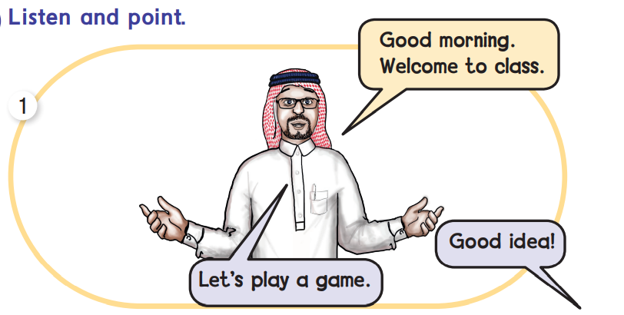 | - To identify [Welcome].  - To give commands.  - To respond to commands.
Students start doing the W.B. exercises in the class and then, I assign the rest for homework. |  |  | Homework

Date: | Talk Time | 1-Feelings | 2nd 3rd 4th 5th Grades Elementary (We Can 2) Term 1

Great – fine- thanks- meet- first- second- third- fourth- fifth |  |  | Vocabulary
Verification | Procedure | Aids | Objectives
Evaluation:  - “How are you?”  - Greet your teacher.  - Complete: "I'm ...." | - I greet the students and say "Hello".  - I write the date and the title on the board.  - Page 4:  - I play the CD and listen to a short simple dialogue.  - I ask the students:"How are you?"  - Get the students to respond.  - I ask the students to open their books and play the CD twice.  - I walk around the class to make sure that the students are finding the correct pictures.  - I ask the students to play the dialogue in pairs, then play the CD twice.  - I write the dialogue on the board, and ask students to act out the talk in pairs.  - Page 5:  - I ask the students to stand in a line.  - I ask the students to listen, then play the CD twice.  - I write the new words on the board.  - They read them, and say "I'm first, second, …….. | - Student's book  - Workbook  - Poster (s)  - Flashcards  - Word cards  - CD | - To ask;"How are you?"  - To greet their teacher  - To say, "I'm first, second, ………
Students start doing the W.B. exercises in the class and then, I assign the rest for homework. |  |  | Homework

Date: | Rhythms and Listening | 1-Feelings | 2nd 3rd 4th 5th Grades Elementary (We Can 2) Term 1

Happy- know-hand- show- cap- clap- lock- clock- sixth- seventh- eighth- ninth- tenth |  |  | Vocabulary
Verification | Procedure | Aids | Objectives
Evaluation:  - Chant the if you're happy and you know it chant on P.6 in pairs.  - Play the confusion game in pairs.  - Is [H] the sixth letter of the alphabet? | - I greet the students and ask one of them, "How are you?" and get the answer.  - I write the date and the title on the board.  - I check the homework.  - Page 6:  1-  - I ask the students to listen, then play the CD.  - I ask the students to chant the song chorally.  2-  - I play the CD twice, and ask students to listen carefully to notice the sounds.  - They match the words with the correct pictures.  - Page 7:  3-  - I write the new vocabulary on the board.  - I ask them to read it one by one loudly.  - I ask them to play the confusion game in pairs. | - Student's book  - Workbook  - Poster (s)  - Flashcards  - Word cards  - CD | - To chant an  educational chant with a partner  - To play the confusion game with a partner  - To say ''sixth, seventh, eighth, …."
Students start doing the W.B. exercises in the class and then, I assign the rest for homework. |  |  | Homework

Date: | Words in Action | 1-Feelings | 2nd 3rd 4th 5th Grades Elementary (We Can 2) Term 1

Matter- thirsty- hungry- hot – cold- sleepy- scared |  |  | Vocabulary
Verification | Procedure | Aids | Objectives
Evaluation:  - "What's the matter?"  - Act out that you are hungry.  - Say your feeling:  I'm… | - I greet the students.  - I revise the previous lesson and check the homework.  - I write the date and the title on the board.  - Page 8:  1-  - I hold up the Student’s Book, point to the pictures and ask them to read loudly.  - I play the CD twice.  2,3-  - I play the CD twice.  - I ask the students to listen and act.  - I go round the class to check that they find the correct pictures.  - They ask in pairs, " What's the matter?", and another one replies.  - Page 9:  4-  - I ask one student to be the leader.  - I ask the rest to do the same action as the leader.  - They do the different Feelings. | - Student's book  - Workbook  - Poster (s)  - Flashcards  - Word cards  - CD | - To ask: "What's the matter?"  - To act out three Feelings  - To answer, "This is….."
Students start doing the W.B. exercises in the class and then, I assign the rest for homework. |  |  | Homework

Date: | Phonics | 1-Feelings | 2nd 3rd 4th 5th Grades Elementary (We Can 2) Term 1

Ink-iron- pin- pine- time |  |  |  |  |  | Vocabulary
Verification | Procedure |  |  |  | Aids | Objectives
Evaluation:  - Look at P.10 and point to the right pictures and words.  - Practice the sounds /a/ and /i/. | - I greet the students.  - I revise the previous lesson and I check the homework.  - I write the date and the title on the board.  - Page 10:  1-  - I ask the students to open their books and play the CD twice.  - I ask the students to repeat after me.  - They point to the right pictures and words.  2-  - I play the CD twice, and write the words on the board.  - I ask the students to number the words with the correct sound.  - I go around the class to check that they number the pictures correctly.  3-  - I play the CD twice and ask them to say the words. Ask them to match the pictures while they are listening to the words.  - I go around the class to make sure that they are matching the correct pictures.  - Page 11:  4-  - I play the CD twice, and ask the students to mime and say in pairs.  - The students mime other sounds. |  |  |  | - Student's book  - Workbook  - Poster (s)  - Flashcards  - Word cards  - CD  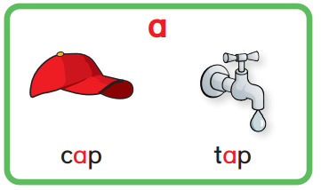 | - To listen and point to the right pictures and words  - To say, read, and I write the sounds for a, I by themselves
Students start doing the W.B. exercises in the class and then, I assign the rest for homework. |  |  |  |  |  | Homework
Date: |  | Talk Time | 2-Things We Wear | 2nd 3rd 4th 5th Grades Elementary (We Can 2) Term 1

Hat- mine- thank –welcome –whose –who-what-white |  |  | Vocabulary
Verification | Procedure | Aids | Objectives
Evaluation:  - Complete:……car is this? - "it's mine"  - Answer, "Whose book is this?"  - Put on order: hat/like/your/i | - I greet the students.  - I revise the previous lesson and check the homework.  - I write the date and the title on the board.  - Page 12:  - I play the CD and listen to a short simple dialogue.  - I ask the students:"Whose book is this?"  - I ask the students to open their books and I play the CD twice.  - I ask the students to act out the dialogue in pairs.  - I play the CD twice, and write the words on the board.  - I ask the students to number the words with the correct sound.  - I go around the class to check that they number the pictures correctly.  - Page 13:  - I explain the task.  - I ask them to ask and answer about their belongings in pairs. | - Student's book  - Workbook  - Poster (s)  - Flashcards  - Word cards  - CD | - To ask, "Whose…is this?"  - To reply, "it's mine"  - To meet someone and say,"I like your…."
Students start doing the W.B. exercises in the class and then, I assign the rest for homework. |  |  | Homework

Date: | Rhythms and Listening | 2-Things We Wear | 2nd 3rd 4th 5th Grades Elementary (We Can 2) Term 1

Wear- green-me-today-look- who- grass- see- ass- blue |  |  | Vocabulary
Verification | Procedure | Aids | Objectives
Evaluation:  - Chant the Who is wearing green? Chant chorally.  - Write three colors that they are wearing. | - I greet the students.  - I revise the previous lesson and I check the homework.  - I write the date and the title on the board.  - Page 14:  - I ask the students to listen, then play the CD.  - I ask the students to chant the song chorally.  - I play the CD twice, and ask the students to listen carefully to notice the sounds.  - They write the missing letters.  - Page15:  - I explain the task.  - I ask them to play the colors the classmates are wearing  EX:  - Who's wearing green today?  - I ask them to play one by one. | - Student's book  - Workbook  - Poster (s)  - Flashcards  - Word cards  - CD  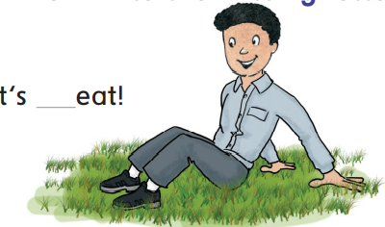 | - To chant the Who is wearing green? Chant  - To say three colors that they are wearing
Students start doing the W.B. exercises in the class and then, I assign the rest for homework. |  |  | Homework

Date: | Words in Action | 2-Things We Wear | 2nd 3rd 4th 5th Grades Elementary (We Can 2) Term 1

Sunglasses- T-shirt- a jacket-blouse- sweater- skirt- jeans- shoes |  |  | Vocabulary
Verification | Procedure | Aids | Objectives
Evaluation:  - I write the names of five things that you can wear.  - " I'm wearing………,…,…….,…….today? | - I greet the students.  - I revise the previous lesson and check the homework.  - I write the date and the title on the board.  - Page 16:  1-  - I write the new vocabulary on the board.  - I hold up the Student’s Book, point to the picture and ask them to read loudly.  - I play the CD twice.  - I hold up the flashcards of clothes. They point and say the words.  2-  - I say the chant, ask them to repeat after me.  - I ask them to say the chant chorally.  - Page 17:  3-  - I ask students to name the pictures.  - I ask them one by one to touch the pictures that I say it.  - Do it again with other pictures. | - Student's book  - Workbook  - Poster (s)  - Flashcards  - Word cards  - CD | - To say the names of five things that they can wear  - To name two things he/she wearing, saying,"I'm wearing…. and…..today."
Students start doing the W.B. exercises in the class and then, I assign the rest for homework. |  |  | Homework

Date: | Phonics | 2-Things We Wear | 2nd 3rd 4th 5th Grades Elementary (We Can 2) Term 1

Parrot-pen-panda-bear-bed-banana-plane-black-blue-tissue-mouth |  |  | Vocabulary
Verification | Procedure | Aids | Objectives
Evaluation:  - Say if these words start with p or b (ball-bat-pin-pine)  - Give two words that start with p and b.  - Play Does it move? In group | - I greet the students.  - I revise the previous lesson and check the homework.  - I write the date and the title on the board.  - Page 18:  - I ask the students to open their books and play the CD twice.  - I ask them to listen carefully.  - They read and say it one by one and then chorally.  - I play the CD twice.  - I ask the students to say the words then they match the words with the correct pictures.  - They write the missing letters to complete the sentence.  - Page 19:  - I play the CD twice  - I ask them to repeat.  - Then, I give everyone a tissue to hold it in front of his/her mouth to say the words.  - I'll be sure that they say the words correctly. | - Student's book  - Workbook  - Poster (s)  - Flashcards  - Word cards  - CD | - To tell if the words start with p or b  - To say two words that begin with p and b  - To play Does it move? in group
Students start doing the W.B. exercises in the class and then, I assign the rest for homework. |  |  | Homework

Date: | Talk Time | 3-Things We Do | 2nd 3rd 4th 5th Grades Elementary (We Can 2) Term 1

Homework-watch-phonics-photo-phone-elephant- snacks |  |  | Vocabulary
Verification | Procedure | Aids | Objectives
Evaluation:  - Act out the telephone talks on P.21 in pairs.  - Make up a telephone conversation in English.  - Practice the sound of /ph/.  - Put the sentence in order :( playing-he-football-is) | - I greet the students.  - Revise the previous lesson and I check the homework.  - I write the date and the title on the board.  - Page 20:  - I play the CD twice, and ask students to listen carefully.  - I ask the students to read the conversation.  - They act out the conversation in pairs.  - I ask them to change the verb as: reading a book, listening to music, ……etc.  - I play the CD twice, and ask them to say the words.  - I ask them to match the pictures.  - They complete the missing letters to make correct sentence.  - Page 21:  - I play the CD, and ask the students to listen carefully.  - They act out the telephone call in pairs to ask what he or she is doing.  - I check that they have understood what’s required. | - Student's book  - Workbook  - Poster (s)  - Flashcards  - Word cards  - CD  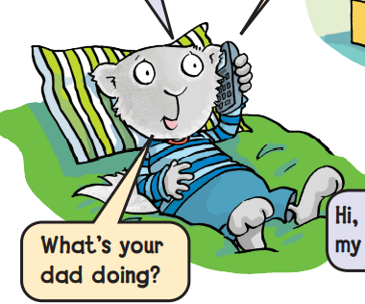 | - To act out the telephone talks with a partner  - To have a telephone conversation in English  - To practice the sounds of /ph/  - To use present continuous to talk about what they are doing at the moment
Students start doing the W.B. exercises in the class and then, I assign the rest for homework. |  |  | Homework

Date: | Rhythms and Listening | 3-Things We Do | 2nd 3rd 4th 5th Grades Elementary (We Can 2) Term 1

Karate-football |  |  | Vocabulary
Verification | Procedure | Aids | Objectives
Evaluation:  - Chant the What are you doing? Chant chorally.  - Play the True or False Action Game in pairs. | - I greet the students.  - I revise the previous lesson and check the homework.  - I write the date and the title on the board.  - Page 22:  1-  - I ask the students to listen, then play the CD.  - I write the new vocabulary on the board and ask them to read it loudly.  - I ask the students to chant the song chorally.  2-  - I play the CD twice.  - I ask the students to read the song loudly.  - Page23:  3-  - I ask them to play [True or False Action Game] in groups.  - I ask them to run to the T or F when I do the action. | - Student's book  - Workbook  - Poster (s)  - Flashcards  - Word cards  - CD  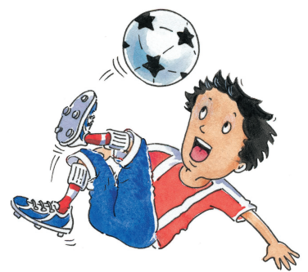 | - To chant the What are you doing? Chant  - To play the True or False Action Game with a friend
Students start doing the W.B. exercises in the class and then, I assign the rest for homework. |  |  | Homework

Date: | Words in Action | 3-Things We Do | 2nd 3rd 4th 5th Grades Elementary (We Can 2) Term 1

Computer games- gring-ring-rink-wink-giwn- wing-speak-peaking |  |  | Vocabulary
Verification | Procedure | Aids | Objectives
Evaluation:  - Play the Card Snap Game in-group.  - What are you doing?  - Put the sentence in order (reading/he/a/is/book/.) | - I greet the students.  - I revise the previous lesson and check the homework.  - I write the date and the title on the board.  - Page 24:  1-  - I explain the task. I play the CD twice and ask students to listen.  - I write the new vocabulary on the board.  - I ask them to point to the actions on the book.  - I go around the class to check that they find the correct exercise.  2-  - I play the CD twice, and ask the students to listen carefully.  - They say the words, then to read and circle.  - Page25:  3-  - I play the CD twice.  - I ask the student to hit the card when the I say the sentence.  - I check that students have understood what’s required. | - Student's book  - Workbook  - Poster (s)  - Flashcards  - Word cards  - CD  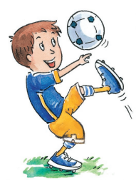 | - To play the Card Snap Game with friends  - To say two things when asked "What are you doing?"  - To put the sentences in order
Students start doing the W.B. exercises in the class and then, I assign the rest for homework. |  |  | Homework

Date: | Phonics | 3-Things We Do | 2nd 3rd 4th 5th Grades Elementary (We Can 2) Term 1

Tiger- tomato-telephone-door-doll-duck |  |  | Vocabulary
Verification | Procedure | Aids | Objectives
Evaluation:  - Say if these words start with t or d (dog-tea-tiger-doll)  - Write two words that start with t and d.  - Name this animal | - I greet the students.  - I revise the previous lesson and check the homework.  - I write the date and the title on the board.  - Page26:  1-  - I ask the students to open their books and play the CD twice.  - I ask them to listen carefully.  - They read and say it one by one and then chorally.  2-  - I play the CD twice.  - I ask the students to say the words then they number the pictures.  - They write the missing letters to complete the words.  - Page 27:  3-  - I play the CD twice  - I ask the students to name the pictures.  - I ask them to touch the pictures that I say it one by one.  - I do it again with other pictures.  - I'll be sure that they say the words correctly. | - Student's book  - Workbook  - Poster (s)  - Flashcards  - Word cards  - CD   | - To tell if the words start with t or d  - To say two words that begin with t or d  - To name objects
Students start doing the W.B. exercises in the class and then, I assign the rest for homework. |  |  | Homework

