**Name: Date:**

**.1) أتقن لم يتقن**

**Sixth / fourth / second / third / first / fifth**

|  |  |  |
| --- | --- | --- |
| **1** |  | **4** |
| **2** | **5** |
| **3** | **6** |

Ali

Sami

Ahmad

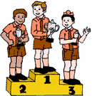

***A) Fill in the spaces:-***

**( First – second – third )**

..........................................................................................................................................................................................................................................................................................................................................................................................................

1. **Sami is the**

**.**

..........................................................................................................................................................................................................................................................................................................................................................................................................

1. **Ahmad is the**

..........................................................................................................................................................................................................................................................................................................................................................................................................

**Ali is the**

**.1) أتقن لم يتقن**

**B ) Write the suitable word under each picture:-**

Jeans - Sunglasses- Skirt- T-shirt – Shoes – Cold – Jacket - Dress

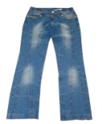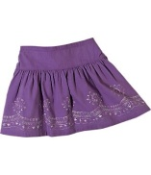

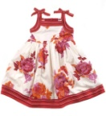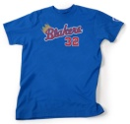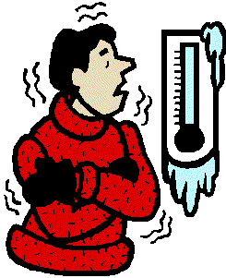

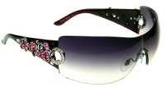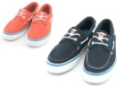

..........................................................................................................................................................................................................................................................................................................................................................................................................

..........................................................................................................................................................................................................................................................................................................................................................................................................

..........................................................................................................................................................................................................................................................................................................................................................................................................

..........................................................................................................................................................................................................................................................................................................................................................................................................

..........................................................................................................................................................................................................................................................................................................................................................................................................

..........................................................................................................................................................................................................................................................................................................................................................................................................

..........................................................................................................................................................................................................................................................................................................................................................................................................

**C) Fill in the missing letters:**

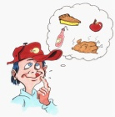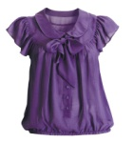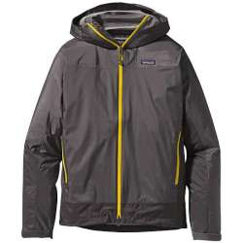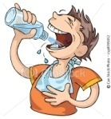

1. –hirsty 2 . J---cket 3. Bl---use 4. Hun---ry

( T – S – H ) ( u – a – e ) (i - w - o) (j - g – q)

**Name: Date:**

**D) Fill in the First letters:**

**.1) أتقن لم يتقن**

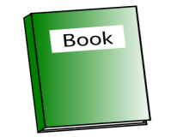

..........................................................................................................................................................................................................................................................................................................................................................................................................

..........................................................................................................................................................................................................................................................................................................................................................................................................

..........................................................................................................................................................................................................................................................................................................................................................................................................

..........................................................................................................................................................................................................................................................................................................................................................................................................

..........................................................................................................................................................................................................................................................................................................................................................................................................

..........................................................................................................................................................................................................................................................................................................................................................................................................

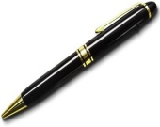

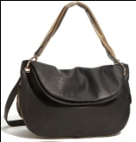

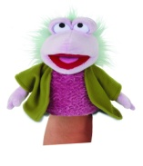

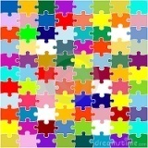

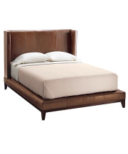

**.1) أتقن لم يتقن**

**F- Give the plural:**

..........................................................................................................................................................................................................................................................................................................................................................................................................

..........................................................................................................................................................................................................................................................................................................................................................................................................

..........................................................................................................................................................................................................................................................................................................................................................................................................

..........................................................................................................................................................................................................................................................................................................................................................................................................

**.1) أتقن لم يتقن**

G- Circle the odd word : - Cap - Hat - Tape - Time -

Tim – pin - pine Cape - Tap.

j0104954[1]