|  |  |  |
| --- | --- | --- |
| **English Language Final Exam** | **شعار وزارة التعليم بدون خلفية بيضاء الجديد مفرغ وشفاف - موقع محتويات** | **Kingdom of Saudi Arabia** |
| **The Second Trimester,1st Session, 1445** | **Ministry of Education** |
| **The 1.2 Secondary Grade** | **General Directorate of Education in Makkah** |
| **Time: 2.30 hours** | **South Education Office** |
| **No. of pages: 3** | **14th Secondary School** |
| **مستعينة بالله أجيبي عن الأسئلة التالية:** | | |

**I- Composition**:

6

**A- Guided Composition:**

**Write an email to advice Nasir that has problem in his new school**

**Guided words**: great school- feeling down- sorry- accepted - new student- short conversation- participate- football team- get better

Dear Nasir

…………………………………………………………………………………………………………………………………………………………………………………………………………………………………………………………………………………………………………………………………………………………………………………………………………………………………………………………………………………………………………………………………………………………………………………………………………………………………………………………………………………………………………………………………………………………………………………………………………………………………………………………………………………………………………………………………………………………………………………………………………………………………………………………………………………………………………………………………………………………………………………………………………………………………………………………………………………………………………………………………………………………………………………………………………………………………………………………………………………………………………………………………………………………………………………………………………………………………………………………………………………………………………………………………………………………………………………………………………………………………………………………………………………………………………………………………………………………………………………………………………………………………………………………………………………………………………………………………………………………………………………………………………………………………………………………………………………………………………………………………………………………………………………………………………………………………………………………………………………………………………………………………………………………………………………………………………………………………………..………………………………………………………………………………………………………………………………………… hope to see you soon

…………….

[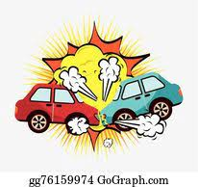](https://www.madty.net/fd2/sf010/exam010/)+++++++++++++++++++++++++++++++++++++++++++++++++++++++++++++++++++++++++++++++

B- **Free Composition:**

**Write an essay about( accidents )**

………………………………………………………………………………………………………………………………………………………………………………………………………………………………………………………………………………………………………………………………………………………………………………………………………………………………………………………………………………………………………………………………………………………………………………………………………………………………………………………………………………………………………………………………………………………………………………………………………………………………………………………………………………………………………………………………………………………………………………………………………………………………………………………………………………………………………………………………………………………………………………………………………………………………………………………………………………………………………………………………………………………………………………………………………………………………………………………………………………………………………………………………………………………………………………………………………………………………………………………………………………………………………………………………………………………………………………………………………………………………………………………………………………………………………………………………………………………………………………………………………………………………………………………………………………………………………………………………………………………………………………………………………………………………………………………………………………………………………………………………………………………………………………

6

[](https://t.me/madtyy/496)II -Grammar:

6

**A-Choose the correct answers:**

1- He bought ( **himself – herself-ourselves** ) a new tablet.

2-​I went to the doctor ( **because – so-no** ) I was sick. -

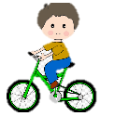3-How  (**many - much** -**any**)  cell phones have you bought ?

4-When I was young, I _(**used to- would-could**) have a lot of energy. I was always outside playing

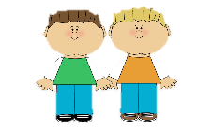or riding my bike.

5-Ali and Ahmad were (**boy-a boy-boys**) who we saw them at the local school

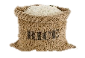6- I bought **( some- any-not**) rice.

**B-Do as shown between brackets:**

1-projector - no - There - is - in the class [**Unscramble to make a sentence**]

----------------------------------------------------------------------------------------------

2- You __________ eat while driving. **[ Give advice**]

3- You ought to ignore speed limits. **[Make it negative**]

-----------------------------------------------------------------------------------------------

**III- Vocabulary:**

6

**A-Match between the words and their pictures:**

1-

1-feeling down 2- **drums** **3- ostrich 4-** telegraph **5-junkfood**

( ) ( ) ( ) ( )

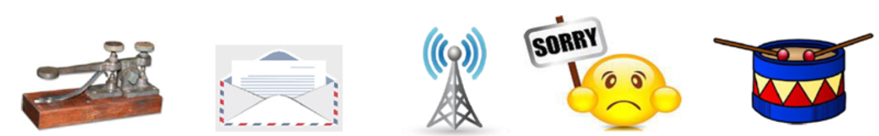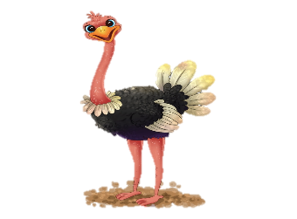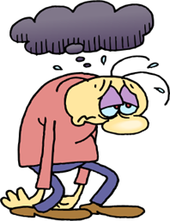

[](https://t.me/akhtbarnhae)

2**- Match the words with the meanings**:

|  |  |
| --- | --- |
| 1-challenge | ( ) being in good health |
| 2- recover | ( ) a period in the history |
| 3-stone age | ( ) get better |
| 4- keep fit | ( ) "fight against |
| 5-Of course |  |

**3- Circle the Odd words** :

a**-** money - prize - tea - news b- ankle – eye – finger – kneepad

**4-Give the antonyms for the words:**

a- healthy #..................................... b**-**gain weight #...............................

**IV-Reading**

6

**Read the following passage and answer the questions below:**

The Eiffel Tower

The *Eiffel Tower* is one of the most famous building in the world. It is a 324m high structure in the center of Paris, France. Over the years, it has become a symbol of the city and the country. When they built it, *The Eiffel Tower* was the tallest building in the world. The tower got its name from its designer, Gustave Eiffel, and it build, from 1887 to 1889. The tower opened to the public on 6 May 1889. Today, it is without doubt one of the most recognizable memorial in Europe, one that can be compared to the Statue of Liberty in New York, and the Big Ben in London.

However, soon after opening, newspapers were full of angry letters from people saying how much they hated the new building. This soon changed, and today it is very popular with millions of tourists who visit it every year. You can even find smaller copies of the structure in many cities around the world.

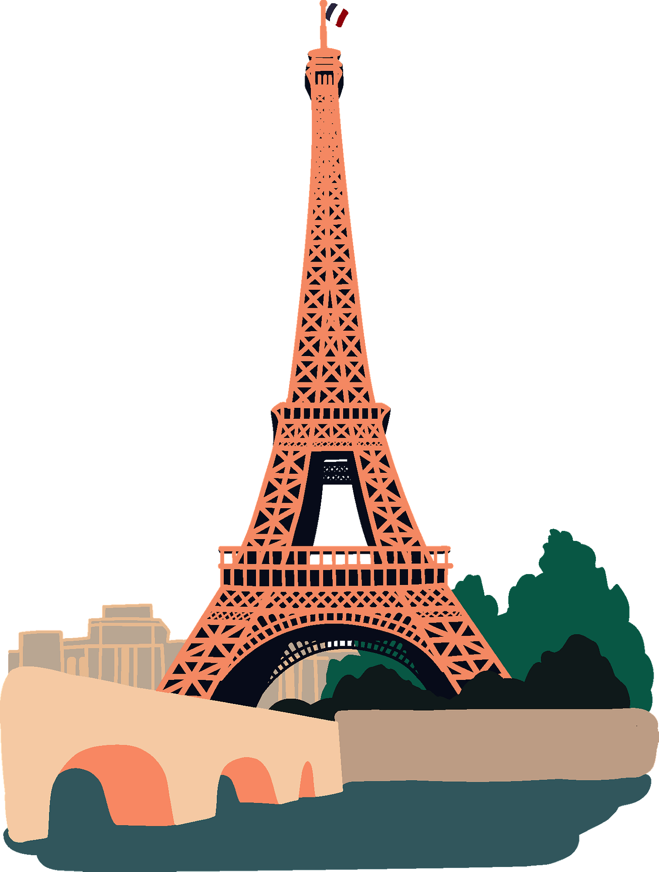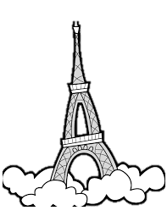

**A-Answer these question:**

1 – What is of the most famous building in the world.?

………………………………………………………………………………………………………………………………………………………………………………

2 - Was it the tallest building in the world?

………………………………………………………………………………………………………………………………………………………………………………

3- Where can you find smaller copies of Eiffel Tower?

……………………………………………………………………………………………………………………………………………………………………………

**B- Write [ T ] for True or [ F ] for False :**

|  |  |
| --- | --- |
| 1. The tower got its name from its designer,. |  |
| 1. At present, it is without doubt one of the most recognizable memorial in Europe. |  |

**C- Choose the right answer :**

1. The tower opened to the public on

**a-**5 May 1889  **b-**6 May 1889  **c-**7 May 1889

2. Eiffel Tower is a ,,,,,,,,,, high

**a-**324m **b-**325m **c-** 326m

**D-Find the antonym** :

a- ****bigger #..................................... b- shorter #......................

|  |  |  |
| --- | --- | --- |
| **English Language Final Exam** | **شعار وزارة التعليم بدون خلفية بيضاء الجديد مفرغ وشفاف - موقع محتويات** | **Kingdom of Saudi Arabia** |
| **The Second Trimester,1st Session, 1445** | **Ministry of Education** |
| **The 1.2 Secondary Grade** | **General Directorate of Education in Makkah** |
| **Time: 2.30 hours** | **South Education Office** |
| **No. of pages: 3** | **14th Secondary School** |
| **مستعينة بالله أجيبي عن الأسئلة التالية:** | | |

**I- Composition**:

**Model Answer**

6

**A- Guided Composition:**

**Write an email to advice Nasir that has problem in his new school**

**Guided words**: great school- feeling down- sorry- accepted - new student- short conversation- participate- football team- get better

Dear Nasir

………………………………………………………………………………………………………………………………………………………………………………………………………………………………………………………………………………………………………………………………………………………………………………………………………………………………………………………………………………………………………………………………………………………………………………………………………………………………………………………………………………………………………………………………………………………………………………………………………………………………………………………………………………………………………………………………………………………………………………………………………………………………………………………………………………………………………………………………………………………………………………………………………………………………any possible answer

……………………………………………………………………………………………………………………………………………………………………………………………………………………………………………………………………………………………………………………………………………………………………………………………………………………………………………………………………………………………………………………………………………………………………………………………………………………………………………………………………………………………………………………………………………………………………………………………………………………………………………………………………………………………………………………………………………………………………………………………………………………………………………………………………………………………………………………………………………………………………………………………………………………………………………………………………………………………..……………………………………………………………………………………………… hope to see you soon

…………….

+++++++++++++++++++++++++++++++++++++++++++++++++++++++++++++++++++++++++++++++

B- **Free Composition:**

**Write an essay about( accidents )**

…………………………………………………………………………………………………………………………………………………………………………………………………………………………………………………………………………………………………………………………………………………………………………………………………… any possible answer ………………………………………………………………………………………………………………………………………………………………………………………………………………………………………………………………………………………………………………………………………………………………………………………………………………………………………………………………………………………………………………………………………………………………………………………………………………………………………………………………………………………………………………………………………………………………………………………………………………………………………………………………………………………………………………………………………………………………………………………………………………………………………………………………………………………………………………………………………………………………………………………………………………………………………………………………………………………………………………………………………………………………………………………………………………………………………………………………………………………………………………………………………………………………………………………………………………………………………………………………………………………………………………………………………………………………………………………………………………………………

6

II -Grammar:

**½** for each

6

**A-Choose the correct answers:**

1- He bought ( **himself – herself-ourselves** ) a new tablet.

2-​I went to the doctor ( **because – so-no** ) I was sick. -

3-How  (**many - much** -**any**)  cell phones have you bought ?

4-When I was young, I _(**used to- would-could**) have a lot of energy. I was always outside playing

or riding my bike.

5-Ali and Ahmad were (**boy-a boy-boys**) who we saw them at the local school

6- I bought **( some- any-not**) rice.

**1** for each

**B-Do as shown between brackets:**

1-projector - no - There - is - in the class [**Unscramble to make a sentence**]

There is no projector in the class.

2- You _should_ eat while driving. **[ Give advice**]

3- You ought to ignore speed limits. **[Make it negative**]

You ought not to ignore speed limits.

**III- Vocabulary:**

**½** for each

6

**A-Match between the words and their pictures:**

1-

1-feeling down 2- **drums** **3- ostrich 4-** telegraph **5-junkfood**

**( 4 ) ( 3 ) ( 2 ) ( 1 )**

[](https://t.me/madtyy/495)



2**- Match the words with the meanings**:

|  |  |
| --- | --- |
| 1-challenge | ( 4 ) being in good health |
| 2- recover | ( 3 ) a period in the history |
| 3-stone age | ( 2 ) get better |
| 4- keep fit | ( 1 ) "fight against |
| 5-Of course |  |

**3- Circle the Odd words** :

a**-** money - prize - tea - news b- ankle – eye – finger – kneepad

**4-Give the antonyms for the words:**

a- healthy #.....unhealthy b**-**gain weight #. lose weight.

**IV-Reading**

6

**Read the following passage and answer the questions below:**

The Eiffel Tower

The *Eiffel Tower* is one of the most famous building in the world. It is a 324m high structure in the center of Paris, France. Over the years, it has become a symbol of the city and the country. When they built it, *The Eiffel Tower* was the tallest building in the world. The tower got its name from its designer, Gustave Eiffel, and it build, from 1887 to 1889. The tower opened to the public on 6 May 1889. Today, it is without doubt one of the most recognizable memorial in Europe, one that can be compared to the Statue of Liberty in New York, and the Big Ben in London.

However, soon after opening, newspapers were full of angry letters from people saying how much they hated the new building. This soon changed, and today it is very popular with millions of tourists who visit it every year. You can even find smaller copies of the structure in many cities around the world.



**1** for each

**A-Answer these question:**

1 – What is of the most famous building in the world.?

The *Eiffel Tower*

2 - Was it the tallest building in the world?

Yes, it was.

3- Where can you find smaller copies of Eiffel Tower?

in many cities around the world.

**½** for each

**B- Write [ T ] for True or [ F ] for False :**

|  |  |
| --- | --- |
| 1. The tower got its name from its designer,. T | t |
| 1. At present, it is without doubt one of the most recognizable memorial in Europe.T |  |

**C- Choose the right answer :**

**½** for each

1. The tower opened to the public on

**a-**5 May 1889  **b-**6 May 1889  **c-**7 May 1889

2. Eiffel Tower is a ,,,,,,,,,, high

**a-**324m **b-**325m **c-** 326m

**D-Find the antonym** :

**½** for each

a- ****bigger #....smaller b- shortest #....tallest



**الصف الأول ثانوي مسارات**

**Mega Goal 1.2**

**اختبار الاستماع النهائي للفصل الدراسي الثاني لعام 1445هـ**

**المملكة العربية السعودية**

**وزارة التعليم**

**الإدارة العامة للتعليم ب.....................**

**مكتب التعليم ب......................**

**مدرسة ...................**

بسم الله الرحمن الرحيم

**المجموع**

**Total / 5**

**اسم الطالب:**

……………………………………………………………………………………

**الشعبة: ...**

**الرقم: ...**

**Listen and then answer**

|  |
| --- |
| **1. 1st Summer Olympics** |
| **1.**Host country: Athens, Greece | | |
| **2.** Year: | A) 1896 | B) 1869 | |
| **3.**Country that won the most medals: | A) The United States | B) UK | |
| **4.**Number of gold medals: | A) 18 | B) 11 | |

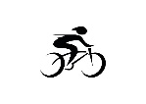

Listening

|  |
| --- |
| **2. 1st Winter Olympics** |
| **1.**Host country: Chamonix, France | | |
| **2.**Year: 1924 | | |
| **3.**Country that won the most medals: | A) The Netherlands | B) Norway | |
| **4**.Number of gold medals: | **……** |

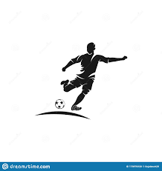



|  |
| --- |
| **3. 24th Summer Olympics** |
| **1.**Host country: | A) Seoul, Korea | B) Tokyo, Japan | |
| **2.**Year: | A) 1988 | B) 1980 | |
| **3.**Country that won the most medals: The Soviet Union | | |
| **4.**Number of gold medals: | A) 55 | B) 15 | |



|  |
| --- |
| **4. 29th Summer Olympics** |
| **1.**Host country: Beijing, China | | |
| **2.**Year: | **……………….** |
| **3.**Country that won the most medals: | A) Russia | B) China | |
| **4**.Number of gold medals: 51 | | |





**المملكة العربية السعودية**

**وزارة التعليم**

**الإدارة العامة للتعليم ب...................**

**مكتب التعليم ب...................**

**مدرسة...............**

**الصف الأول ثانوي مسارات**

**Mega Goal 1.2**

**اختبار الاستماع النهائي للفصل الدراسي الثاني 1445هـ**

بسم الله الرحمن الرحيم

Audio Script



1. The first Summer Olympics were held in Athens,

Greece in 1896. Amongst 14 participating nations, the

United States won the most medals. They took home

11 gold medals.

2. The first Winter Olympics were held in Chamonix,

France in 1924. Amongst 16 participating nations,

Norway won the most medals. They took home 4 gold

medals, 7 silver medals, and 6 bronze medals.

3. The 24th Summer Olympics were held in Seoul, Korea

in 1988. Amongst 159 participating nations, the Soviet

Union won the most medals. They took home 55 gold

medals, 31 silver medals, and 46 bronze medals.

4. The 29th Summer Olympics were held in Beijing,

China in 2008. Amongst 204 participating nations,

China won the most medals. They took home 51 gold

medals, 21 silver medals, and 28 bronze medals.



**Kingdom of Saudi Arabia**

**Ministry of Education**

**Gen. Dept. of Education (Women)**

**14th Secondary School Credit System**

**English Language Final Listening Exam**

**Mega Goal 1.2**

**Term:** 2nd Term – 1443/1444

**Time:** 25 minutes

**A**

|  |  |
| --- | --- |
| Total Mark out of 5 | |
| ……………………………  …………………………… |  |
| 5 |

Name : ………………………………………….Class: ……………..

**2**

**Listen to the conversation " Bus-Trip ", and then answer the following questions**

1. **Put ( ✓ ) for true and ( 🗶 ) for false :** (½ mark each)
2. The women had been waiting for over two hours for the bus to come. […………]
3. The bus broke down about 60 miles back**.** […………]
4. The bus driver lost control of the bus when he spilt hot chocolate on himself, […………]
5. He hit a rock and the bus blew a tire.[…………]
6. **Circle the correct alternative:** (½ mark each)

**2**

**1-**The man is from**…………..**

1. small town in Texas **b-** New York City **c**- he does not know

**2-** His parents has a **………..**

1. farm **b-** cows  **c**- herd

**3**- He grew up in…………..

1. farming **b-** cows  **c**- milking cows and herding sheep

4- He is on his ……………….to visit them

1. train **b-** road  **c**- way
2. **Fill the blanks with the correct words:** (½ mark each)

**1**

**Oil- upset -heading**

**1-** His parents discovered …………………… in their farm

**2-**The driver got really **…………….**when the last passenger made a similar mistake





**Kingdom of Saudi Arabia**

**Ministry of Education**

**Gen. Dept. of Education (Women)**

**14th Secondary School Credit System**

**English Language Final Listening Exam**

**Mega Goal 1.2**

**Term:** 2nd Term – 1443/1444

**Time:** 25 minutes

**A**

|  |  |
| --- | --- |
| Total Mark out of 5 | |
| **Model answer** | 5 |
| 5 |

**Name : ………………………………………….Class: ……………..**

**Listen to the conversation " Bus-Trip ", and then answer the following questions**

**2**

**2**

**1-Put (** ✓ **) for true and (** 🗶 **) for false :** (½ mark each)

1-The women had been waiting for over two hours for the bus to come. [**✓**]

2-The bus broke down about 60 miles back**.** [**🗶**]

3- The bus driver lost control of the bus when he spilt hot chocolate on himself, [**✓**]

**4--** he hit a rock and the bus blew a tire.[✓]

**2)-Circle the correct alternative:** (½ mark each)

**2**

**2**

**1-**The man is from**…………..**

1. small town in Texas **b-** New York City **c**- he does not know

**2-** His parents has a **………..**

1. farm **b-** cows  **c**- herd

**3**- He grew up in…………..

1. farming **b-** cows  **c**- milking cows and herding sheep

4- He is on his ……………….to visit them

1. train **b-** road  **c**- way
2. **Fill the blanks with the correct words:** (½ mark each)

**1**

**1**

**Oil- upset -heading**

**1-** His parents discovered …… **Oil-**…… in their farm

**2-**The driver got really **… upset ….**when the last passenger made a similar mistake





**Kingdom of Saudi Arabia**

**Ministry of Education**

**Gen. Dept. of Education (Women)**

**14th Secondary School Credit System**

**English Language Final Listening Exam**

**Mega Goal 1.2**

**Term:** 2nd Term – 1443/1444

**Time:** 25 minutes

**B**

|  |  |
| --- | --- |
| Total Mark out of 5 | |
| ……………………………  …………………………… |  |
| 5 |

**Name : ………………………………………….Class: ……………..**

**Listen to the conversation " Bus-Trip ", and then answer the following questions**

**2**

**1)-Put (** ✓ **) for true and (** 🗶 **) for false :** (½ mark each)

1-The bus broke down about 60 miles back**.** […………]

2- The bus driver lost control of the bus when he spilt hot chocolate on himself, […………]

3-he hit a rock and the bus blew a tire.[…………]

4-The women had been waiting for over two hours for the bus to come. […………]

**2-Circle the correct alternative:** (½ mark each)

**2**

**1-**The man is from**…………..**

a-small town in Texas **b**- he does not know **c-** New York City

**2-** His parents has a **………..**

**a-** cows b-farm **c**- herd

**3**- He grew up in…………..

a-farming **b**- milking cows and herding sheep **c-** cows

4- He is on his ……………….to visit them

a-train **b-** road  **c**- way

**3-Fill the blanks with the correct words:** (½ mark each)

**1**

**Oil- upset -heading**

**1-** His parents discovered …………………… in their farm

**2-**The driver got really **…………….**when the last passenger made a similar mistake





**Kingdom of Saudi Arabia**

**Ministry of Education**

**Gen. Dept. of Education (Women)**

**14th Secondary School Credit System**

**English Language Final Listening Exam**

**Mega Goal 1.2**

**Term:** 2nd Term – 1443/1444

**Time:** 25 minutes

**B**

|  |  |
| --- | --- |
| Total Mark out of 5 | |
| **Model Answer** | 5 |
| 5 |

**Name : ………………………………………….Class: ……………..**

**Listen to the conversation " Bus-Trip ", and then answer the following questions**

**2**

**2**

**1)-Put (** ✓ **) for true and (** 🗶 **) for false :** (½ mark each)

1-The bus broke down about 60 miles back**.** [🗶 ]

2- The bus driver lost control of the bus when he spilt hot chocolate on himself, [✓ ]

3-he hit a rock and the bus blew a tire.[✓ ]

4-The women had been waiting for over two hours for the bus to come. [✓…]

**2-Circle the correct alternative:** (½ mark each)

**2**

**2**

**1-**The man is from**…………..**

a-small town in Texas **b**- he does not know **c-** New York City

**2-** His parents has a **………..**

**a-** cows b-farm **c**- herd

**3**- He grew up in…………..

a-farming **b**- milking cows and herding sheep **c-** cows

4- He is on his ……………….to visit them

a-train **b-** road  **c**- way

**3-Fill the blanks with the correct words:** (½ mark each)

**1**

**1**

**Oil- upset -heading**

**1-** His parents discovered … **Oil-**…… in their farm

**2-**The driver got really **…… upset ….**when the last passenger made a similar mistake



|  |  |  |
| --- | --- | --- |
| Grade: 1st | **Listening test**  **2023** | Kingdom of Saudi Arabia |
| Subject: English | Ministry of Education |
| Time: |  |
| Date: / /2023 |  |
| **Name: ………………………………………………………….. Class: 1/**…. | | |

***Listen to the child psychologist talk about household dangers for children.then answer the questions:***

5

***Choose the correct answer: (2 marks) 1-***

1- The children think the pills are ……………

**a-pizza b- candy c-chicken d-meat**

2- Most of the accidents involving young children happen in the …………...

**a-** **home b- street c-market d-mall**

3- The……………. is a common place for children to have accidents.

**a- living room b- garden c-bedroom d-** **kitchen**

4-Don’t let your child believe that he or she can ……………

**a-run b- swim c-** **fly d-jump**

***2- Put (T) for true sentences or (F) for false ones:* *(3 marks)***

5- Most of the accidents involving young children happen in the street. ( )

6- Children are naturally curious. ( )

7- Parents should try to keep anything dangerous out of the reach of young children. ( )

8- It’s very uncommon for children to swallow their parents’ pills. ( )

9- Electric sockets are another children’s favorite. ( )

10- Wearing a superhero costume makes anyone a superhero who can fly. ( )

*Best of luck,*

***Mr. Mohamed Ali***