
المملكة العربية السعودية الصف: الرابع الابتدائي
وزارة التعليم الفترة الدراسية: الثانية
المدرسة الإبتدائية ........................ العام الدراسي 1447 هـ
الزمن: ساعتان
الاختبار النهائي لمادة اللغة الإنجليزية – الصف الرابع الابتدائي – الفترة الدراسية الثانية (الدور الأول) لعام 1447 هـ
عزيزتي الطالبة:
- استعيني بالله ثم اجيبي عن الأسئلة
- فضلا تأكدي من كتابة اسمك الرباعي ورقم الجلوس
- الإجابة باللون الأزرق فقط

اسم الطالبة رباعيا
رقم الجلوس: |  | الصف: الرابع الابتدائي | المادة: اللغة الإنجليزية
اليوم: | التاريخ: / 1 / 1448 هـ

المدققة وتوقيعها | المراجعة وتوقيعها | المصححة وتوقيعها | الدرجة كتابة | الدرجة رقما | السؤال
 |  |  | فقط |  | General  Questions
 |  |  | فقط |  | Guided  Composition
 |  |  | فقط |  | Reading  Short Sentence
 |  |  | فقط |  | Grammar
 |  |  | فقط |  | Vocabulary
 |  |  | فقط |  | Orthography
 |  |  | فقط | 40 | المجموع


Kingdom of Saudi Arabia 4th Elementary Grade
Ministry of Education Time: Two Hours
……….. Elementary School Number of papers: 3 . Final Exam – Second Term – 1447 AH
- General Questions:
/ 7
  - Match the questions with the correct answers:
A |  | B
1. What’s your favorite season? |  | I work at the zoo.
2. Where do you work? |  | Yes, I do.
3. What can you do at the beach? |  | I can swim there.
4. Do you need a doctor? |  | I like spring.
  - Choose the correct answer:
/ 7
1. What is the weather like today?
a- It is very hot. | b- It was windy.
2. How is the tortoise moving?
a- It is moving fast. | b- It is moving slowly.
3. Could you ride a horse?
a- No, I couldn’t. | b- No, I can’t.
- Guided Composition:
  - Complete the paragraph about Your Favorite Season. Use the words from the box.
family – sunny – summer – swim – weather – green – enjoy
My Favorite Season
My favorite season is ……………. I like it because it is warm and …………….. The sky is blue and the trees are …………….. The ……………. is hot and nice. I like to ……………. and eat ice cream in summer. I ……………. spending time with my ……………. outside.

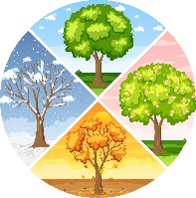

- Reading Short Sentences:
/ 7
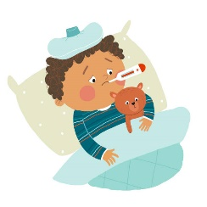

  - Read the sentences then match them with the correct pictures:
 |  | 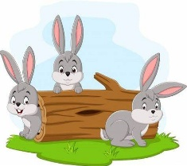 |  | 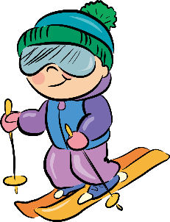
a-_It is a lake.  b-_It is a waterfall. | a-_I am ill.  b-_I am all right. | a-_I like parrots.  b-_I like rabbits. | a-_It is summer.  b-_It is winter. | a-I’m going to go cycling.  b-I’m going to go skiing.
  - Look at the text and choose the correct option.
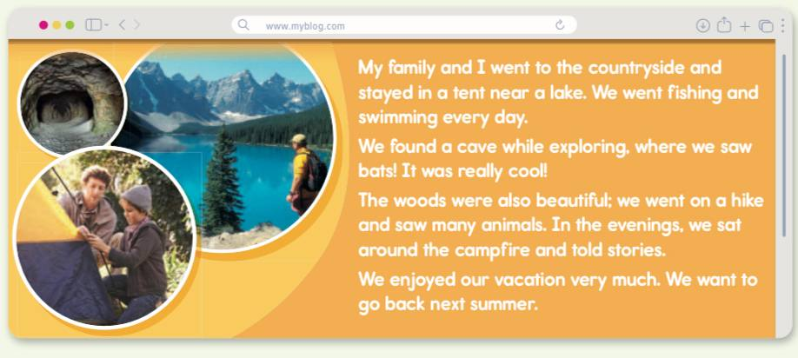
    - This text is from:
      - a book.
      - a website.
      - a newspaper.

    - The text is about:
a- a football game.
b- a school trip.
c- a family vacation.

- Grammar:
/ 7
  - Choose the correct answer:
    - He decided (play – to play – playing) soccer.
    - Is there (anything – something – everything) to eat? I’m very hungry.
    - The mouse is (fast – faster – fastest) than the frog.
    - It was October (who – when – where) I visited Jeddah
    - You (have to – don’t have to – shouldn’t) brush your teeth.
    - What (am – is – was) the weather like yesterday?
    - I could (read – reads – reading) when I was 2.

- Vocabulary:
/ 7
  - Write the words under the correct pictures:
flashlight – dragon – melting – giraffe – medicine

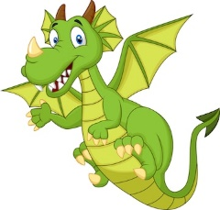 |  | 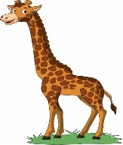 |  | 

  - Circle the correct answer:
1- The opposite of ‘put on’: take care – take off – take out
2- The opposite of ‘dangerous’: safe – clean – huge

- Orthography:
/ 5
  - Choose the correct missing letters:
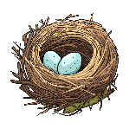  __est |  | 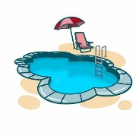  __ool |  | 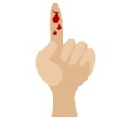  c__t |  | 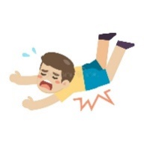  f__ll |  |   s__art
w | n | p | b | a | u | a | o | n | m
  bra__e |  |   pan__a |  | 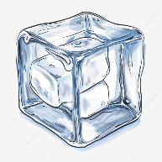  i__e |  |   rai__ |  |   s__ow
v | f | b | d | c | s | l | n | h | n

END OF QUESTIONS
BEST OF LUCK
Ms. Tahani AlGhamdi

