**Test 4**

**20**

TOTAL

# Name .



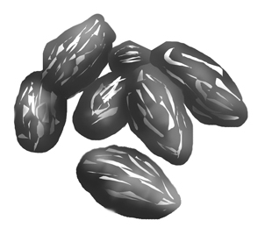**1. Listen and circle.**

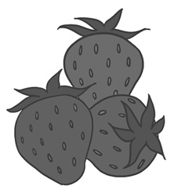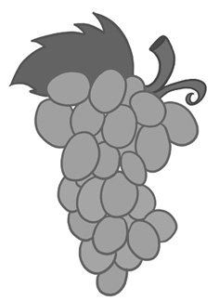

3.

2.

1.



**6**

score

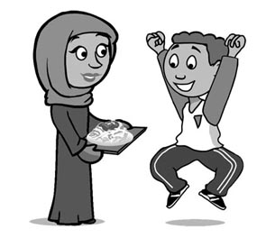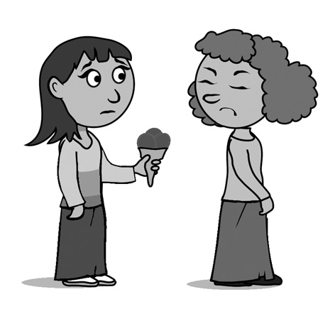**2. Look and circle.**

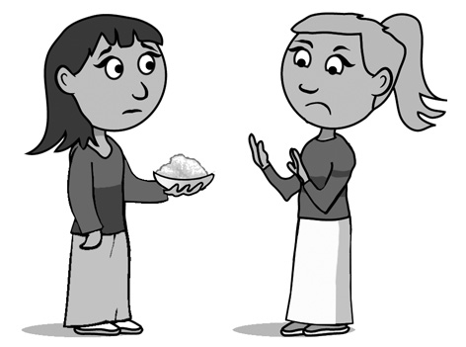

3.

2.

1.

I **like** / **don’t like**

ice cream.

I **like** / **don’t like**

rice.

**6**

score

I **like** / **don’t like**

pasta.



**3. Listen and tick (**✓**).** **4. Draw and write.**

**16**

**30**

**15**

**30**

**100**

**80**

**18**

**40**

**50**

**60**

**70**

**90**

What’s your favourite food?

1.

2.

3.

4.

5.

6.



**2**

score

I like .

**6**

score