

Department of Biomedical Technology

BASIC MECHANICAL SKILLS
BMT 221 Lab Manual

Lab 7: Creating 2-D Working Drawing

2nd Semester 1438-1439

Biomedical Technology
King Saud University
Riyadh, Kingdom of Saudi Arabia

1. Open the Housing drawing.

2. The first enhancement we will add to the drawing will be layers. Figure 1 indicates the route to the layer toolbar. Go ahead and open the layer toolbar. The toolbar may ‘float’ or may be ‘anchored, (fixed) at a convenient location on your screen.

Figure 1
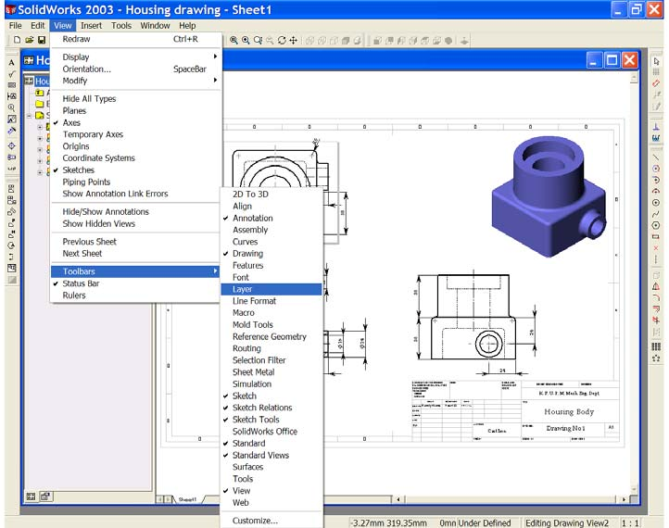

3. Open the layers Property Manager, Figures 2 & 3.
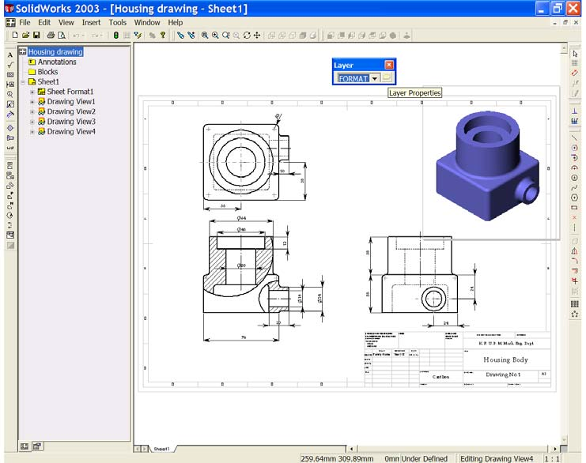
Figure 2

Figure 3
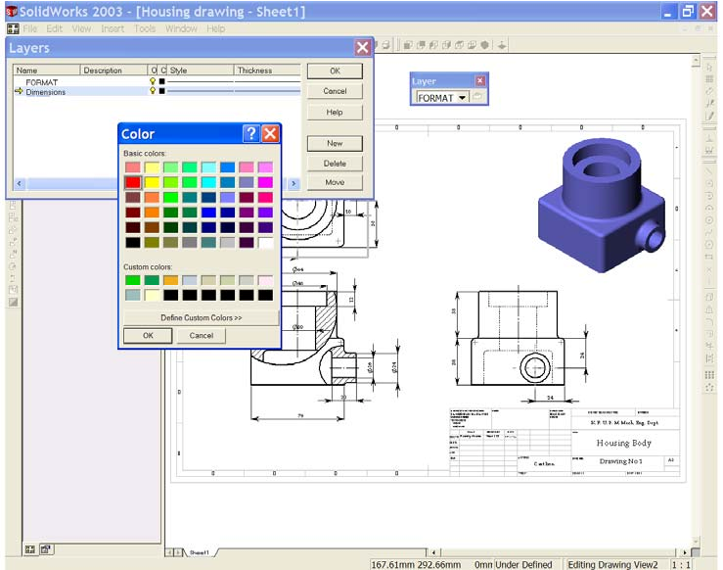

4. In the Layers Property Manager create a new layer by selecting the ‘New’ button. Give this layer a new name ‘dimensions’, and a new colour (you may choose your own colour for the layers).

5. Create two more layers. One called ‘Machine Symbols’ and the other called
‘Tolerances’. Give each layer a different colour. See Figure 3.
6. We may now change from one layer to another by using the ‘down arrow’ of the layer toolbar.

7. To place the dimensions on the dimension layer. Holding the control key down, select each dimension in turn. As each dimension is selected, it is identified on screen by green markers. When all dimensions are selected, use the down arrow of the layer toolbar to select the ‘dimension’ layer. The active dimensions are now transferred to this layer and take on the colour you have set. See Figure 4. Select OK  from the dimensions Property Manager to end the command.

Figure 4
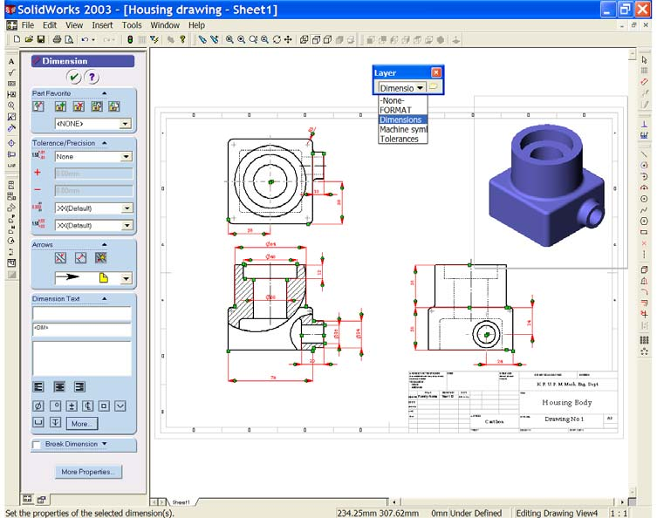

8. Line thicknesses may be changed from the ‘Tools’, ‘Options…’ drop down menu. Open the Systems Options window and select ‘Document Properties’. Select ‘Line Font’. See Figure 5. From this window we may choose many
‘types’ or ‘styles’ of lines and choose their ‘thicknesses’. Make the following settings in this window;

i. | Visible Edges……… Style: ‘Solid’ | Thickness: | ‘Thick’
ii. | Hidden Edges…….... Style: ‘Dashed’ | Thickness: | ‘Normal’
iii. | Dimensions………... Style: ‘Solid’ | Thickness: | ‘Thin’

Choose OK to close the window and view the results on screen. See Figure 6.

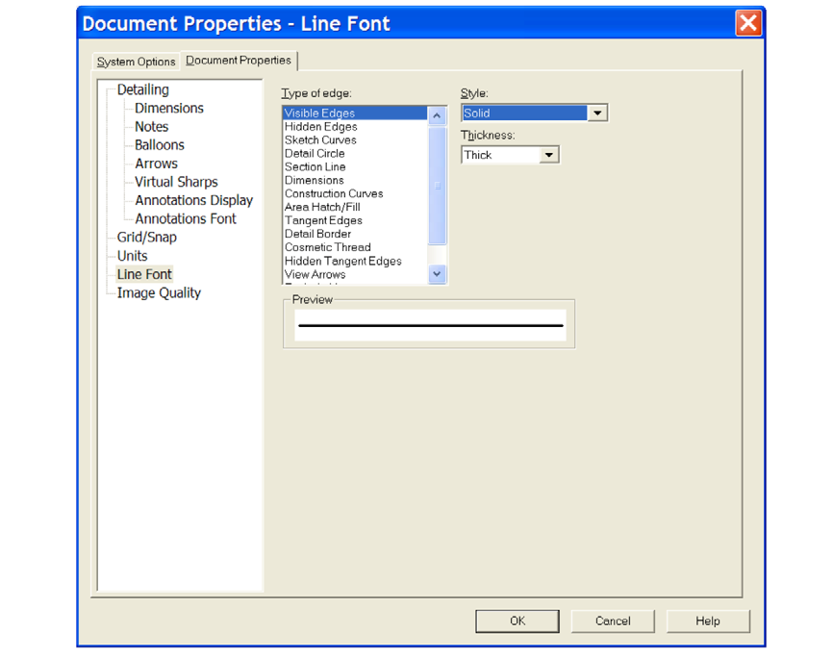
Figure 5

Figure 6
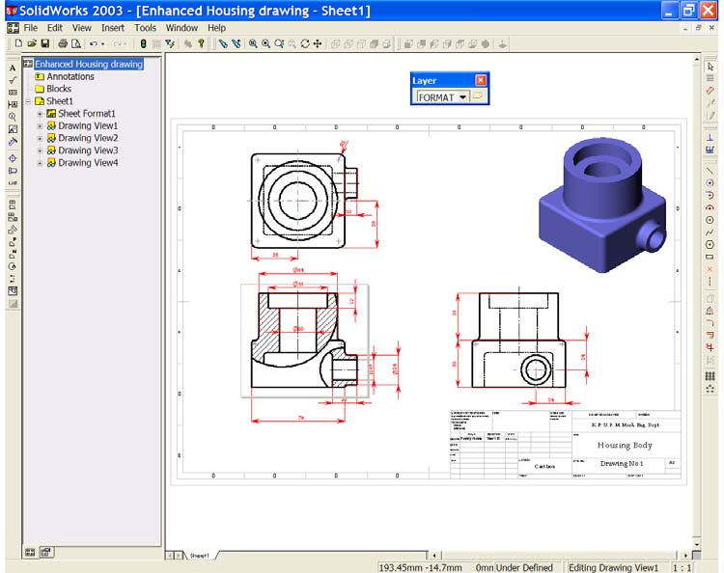

9. Save your drawing as ‘Enhanced Housing Drawing xxx’.
10. Three of the diameters require limits. These are the Ø30 bore, the Ø48 bore and the Ø16 bore. The assignment sheet asks for an ‘H7 tolerance’ on each of these diameters. To add tolerances to dimensions first, select Ø30 to activate it, See Figure 7, this will open the dimension properties manager. In the ‘Tolerance Type’ window choose ‘Fit with tolerance’. From the
‘Classification’ window choose ‘Press’. From the ‘Hole Fit’ window choose
‘H7’. From the ‘Primary Unit Precision’ and ‘Tolerance Precision’ windows choose (.XXX [three decimal places]). See Figure 8, and select OK to complete the command.

Figure 7
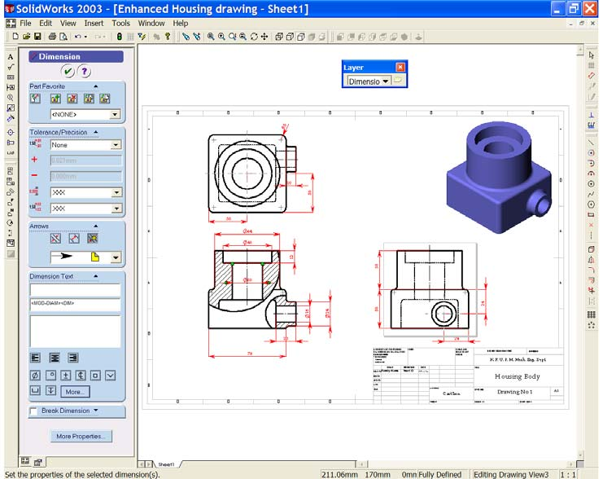

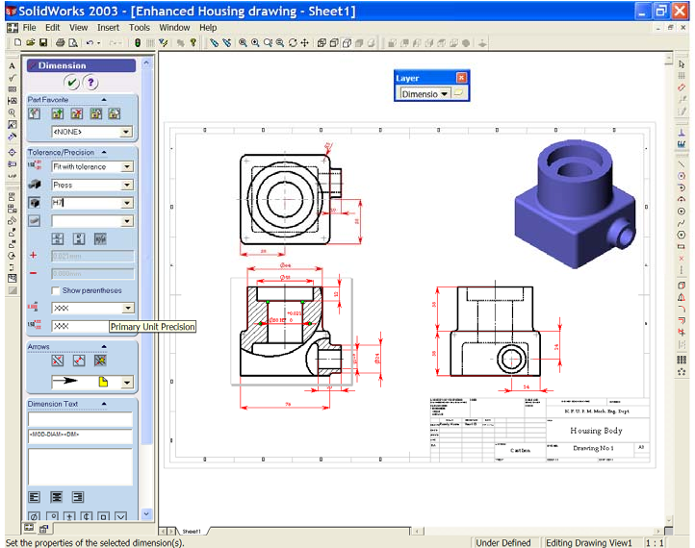
Figure 8

11. Select the Ø30 dimension and place it on the tolerances layer. Notice the change of colour as it moves from one layer to the other. See figure 9.

Figure 9
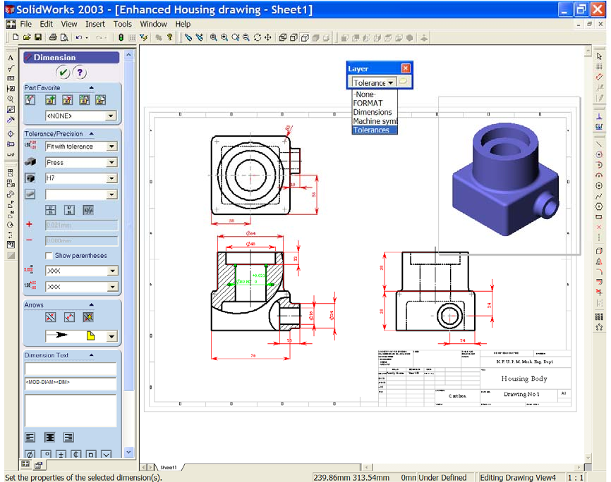

12. Now add an H7 tolerance to the other two diameters. When complete, move these two diameters to the tolerance layer.

13. Use the ‘Zoom to Area’ tool to look more closely at Ø16. You will notice that the data does not fit well into the available space. We can display the data in several ways. In the ‘Tolerance Type’ window select ‘Limit’. Notice that the maximum and minimum limits are now displayed for this dimension, and that it fits better into the space. Use ‘Zoom to Fit’ to return to the full drawing. See Figure 10.

SAVE YOUR WORK!!

14. We need to add machine symbols (surface texture/finish) to the drawing where they are needed. Set the ‘Machine Symbols layer’ active. From the
‘Annotations Toolbar’ select ‘Surface Finish’ See Figure 10.

Figure 10
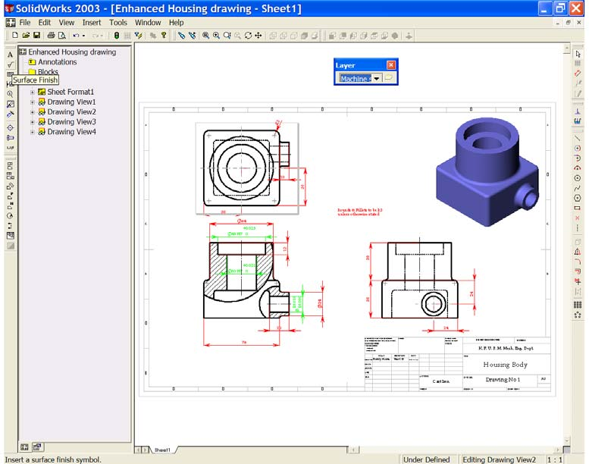

15. The Surface Finish Symbol Properties window opens. Notice the preview window. In the ‘Symbol Window’ choose ‘Machining required’. Notice the change in the preview window. In the ‘Direction of Lay’ window choose
‘Circular’. In the ‘Roughness Maximum’ window enter a value of 0.8 (µm). In the ‘Material removal Allowance’ window enter a value of 3.5 (mm). Notice the symbol being built in the preview widow. We DO NOT WISH to use Leader Lines to place the symbols, so ensure that ‘No Leaders’ is selected. We may control the size of the symbol by using the ‘font’. Un- check the ‘Use documents font’ box and open the font dialog box. Change
the font to ‘Book Antigua’ with a height of 12 points. Notice that the symbol in the preview box shows these changes as they are entered. See Figure 11.

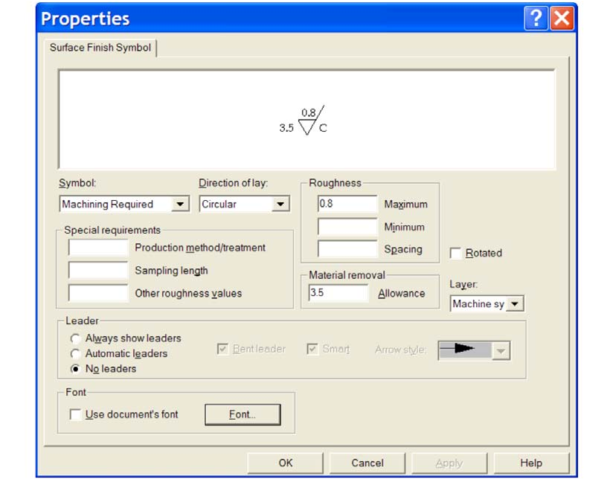
Figure 11

16. We are now ready to place the symbols in the drawing. Move the cursor into the drawing/graphics area of the screen. DO NOT CLICK THE MOUSE!

Notice that the machine symbol is attached to the cursor. The symbol may now be attached to all surfaces that have to be machined. See Figure 12. However, the Properties Window is covering most of the drawing. The window must be moved out of the way. (Note; DO NOT CLOSE THE WINDOW).

To move the window place the cursor into the blue bar at the top, hold down the left button and drag the window to the left of the screen. This will uncover the drawing. Most of the window is now ‘out of sight’. Place the symbols, one by one, onto the surfaces indicated in Figure 12. Notice that you may place as many symbols as are needed. When all symbols are in place we may close the Properties Window to end the command.
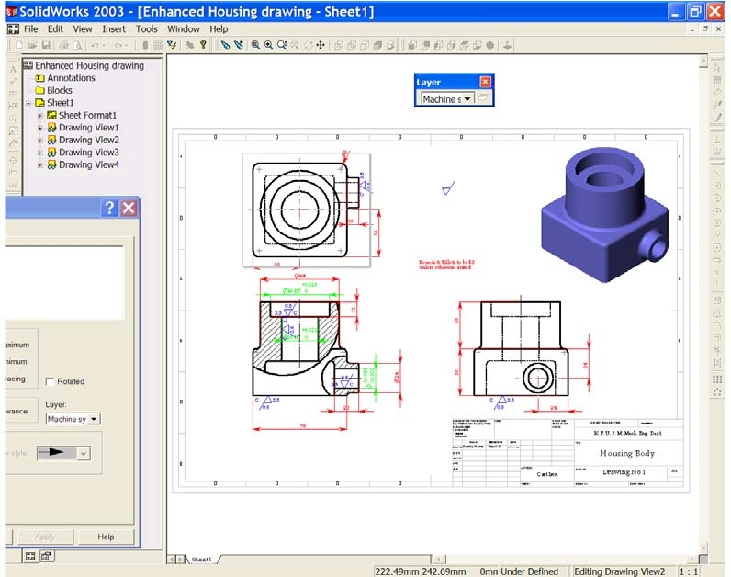
Figure 12

17. The dimensions and machine symbols may need to be moved a little if they overlap each other or if they are too close together. We may drag the dimensions or the symbols to better locations within the views by selecting them with the left button of the mouse and holding the button down as we drag. When you are finished your drawing should look similar to Figure 13.

SAVE YOUR WORK!!
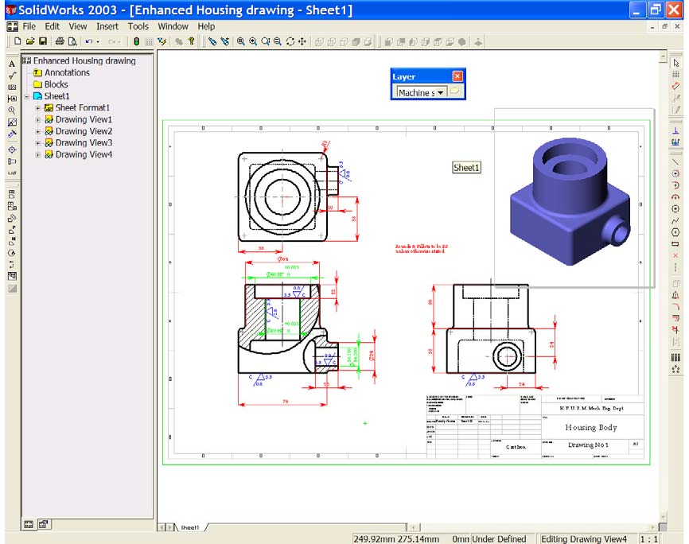
Figure 13

