Lab 16: Inserting Standard Parts from the ‘Toolbox’

1. Open the ‘Hand Rail Column’ assembly file.

2. Open the ‘Hand Rail Column Cap’ part file.

3. Drag & drop the ‘Cap’ into the ‘Assembly’ file.

4. Use ‘Coincident’ and ‘Concentric’ Mates to align the Cap with the
Main Part.

Figure 1
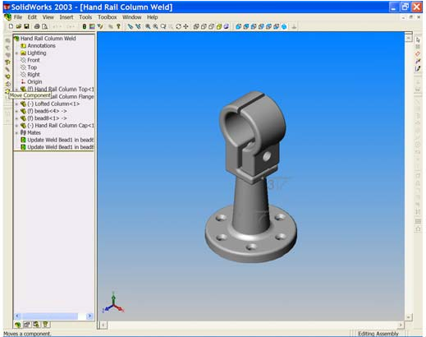

5. Use ‘Move Component’ to position the Cap as shown in Figure 1.

The parts are now aligned so that a standard Bolt, Nut and Lock Nut may be added. We may gain access to the ‘Toolbox Browser’ by selecting the tab at the bottom of the ‘Feature Manager Design tree’. See Figure 2.
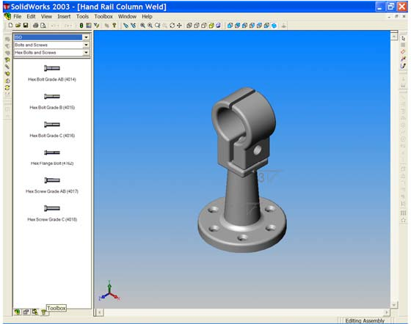
Figure 2

6. When the ‘Toolbox Browser’ is open we may drag and drop many ‘Standard
Parts’ into an assembly. In this exercise we are going to use a standard M12
x 65 lg. Bolt, Nut and Lock Nut. At the top of the Toolbox Browser there are three drop down windows that are used to navigate to the parts we require. To drag and drop these parts we must put some settings in place;

• Choose ‘ISO’ from the ‘Catalog’ window (top window).
• Choose ‘Bolts and Screws’ from the ‘Chapter’ window
(centre window).
• Choose ‘Hex Bolts and Screws’ from the ‘Page’ window
(bottom window).

7. With the ‘Rotate’ button, manoeuvre the parts so that you can see the bolt hole in the main feature. See Figure 3.
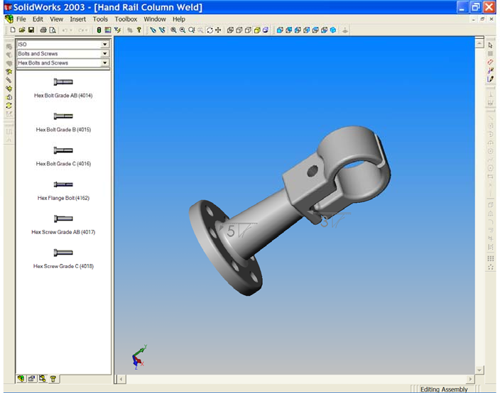
Figure 3

8. Drag a ‘Hex bolt Grade AB (4014)’ from the Toolbox Browser to the graphics area and drop it into the bolt hole of the main part.

The software will apply a ‘Smart Mate’ between the hole and the bolt and you will see the bolt snap into place.

9. The bolt dialog box appears. Set the parameters of the bolt as follows;

• Size ‘M12’
• Length ‘65’
• Thread Length ‘30’
• Thread Display ‘Schematic’

Left click OK to add the bolt to the assembly. See Figures 4 & 5.
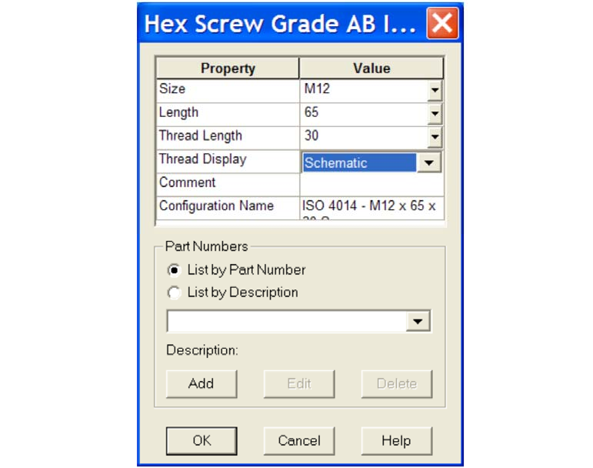
Figure 4

Figure 5
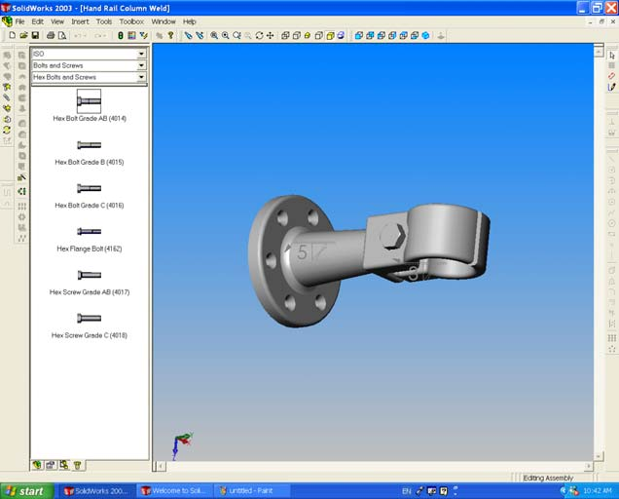

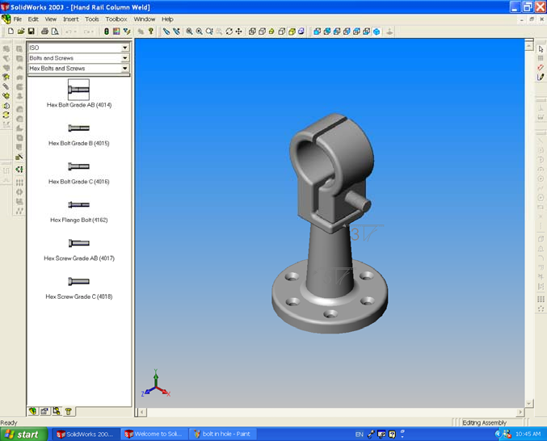
Figure 6

10. Select ‘Isometric’. You can now see the Bolt passing through the two parts.
See Figure 6. From the ‘Chapter’ window choose ‘Nuts’. The ‘Page’ is automatically selected and opens at ‘Hex Nuts’. Drag a ‘Grade C (4034) Nut into the assembly and drop it on the edge of the hole where the bolt protrudes. Set the parameters of the nut to suit those of the bolt;

• Size ‘M12’
• Thread Display ‘Schematic’

Left click OK to add the nut. See Figures 7 & 8. SAVE YOUR WORK!!!
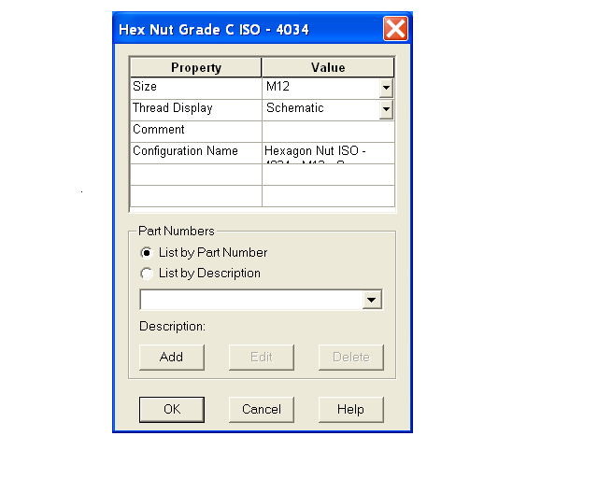
Figure 7

11. Drag a ‘Thin (Chamfered) (4035)’ Nut and drop in the graphics area of the screen. Once more enter the nut parameters to match the standard nut. Click OK to place the nut near to the assembly. See Figure 8.

Figure 8
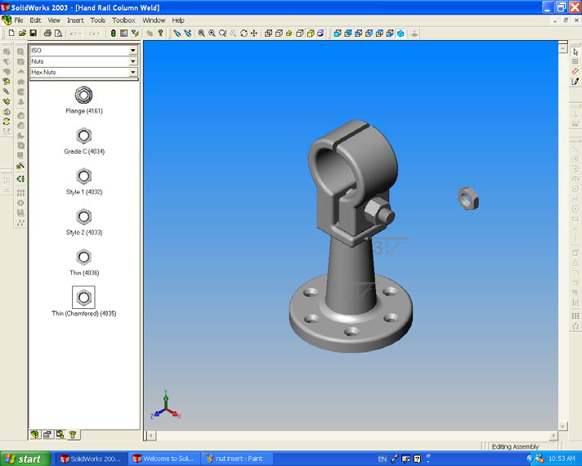

12. Mate the locknut coincident to the end face of the Standard Nut and concentric with the bolt. See Figures 9, 10 & 11.

Figure 9
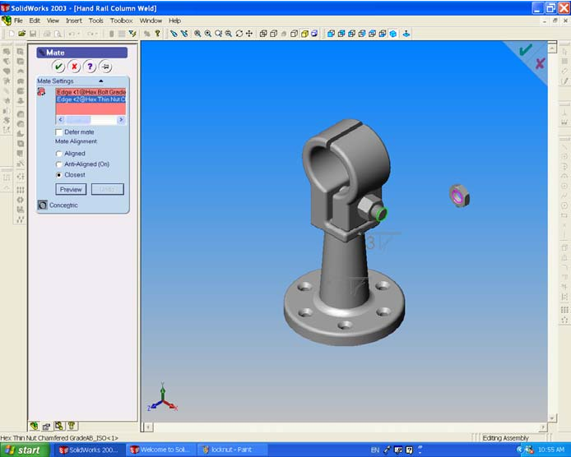

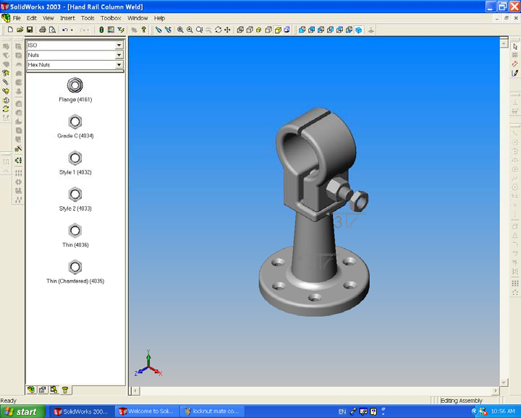
Figure 10

Figure 11
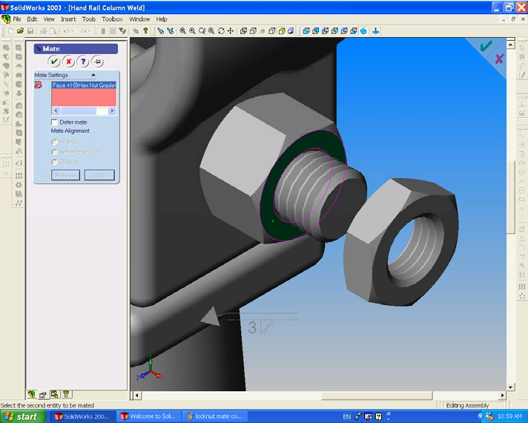

13. The assembly is now complete. See Figure 12. SAVE YOUR WORK!!
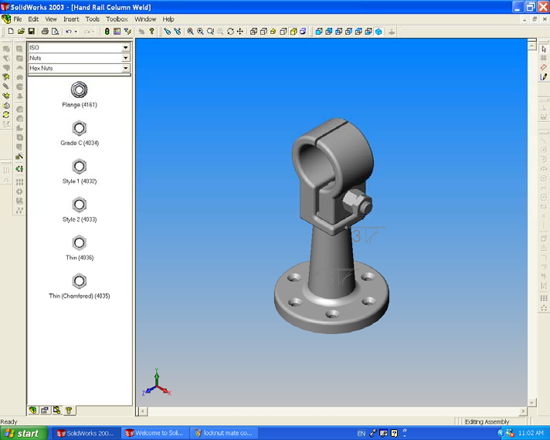
Figure 12

